Map Instructions

The map of Webster’s High School is saved in the Class Materials folder in Files.
There are two tabs at the bottom of the page – Main Building and Extension.
In the Main Building tab, you will see Upstairs first and can scroll down to see the Ground Floor. The Upstairs map looks like this:

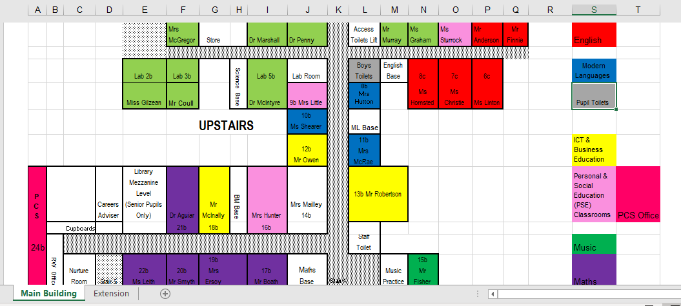

In the Extension tab, you will see the Ground Floor first and can scroll down to see Floor 1.

You will see lots of rooms on the map, including staff bases and meeting rooms. The ones you need to know about – your classrooms, the hall, the library etc. – have been colour coded so that you can spot them more easily.

Can you find the rooms that are featured in the video on the map?

