Counselling in Schools – Tayside

Information for Parents & Carers

What?

As part of Scottish Government plans, all schools in Tayside now have access to counselling services for those aged 10 years and up. All schools aim to support children and young people as part of their approach to Getting it Right for Every Child.

Research shows that in most cases where children and young people experience mental health issues, they are best supported by adults who know them well. Our schools and counsellors work together to make sure counselling is used at the right time to support young people.


Why?

Feeling worried, anxious or upset is a normal, healthy reaction to certain situations. However, being able to react well to emotions and cope with difficulties sometimes needs a bit of extra support.

Young people face issues and situations that could affect their mental health. At times, they may need some extra support to manage things. That’s why schools work with all learners on resilience and mental wellbeing. Alongside existing supports, counselling has now been made available to help too.

Who?

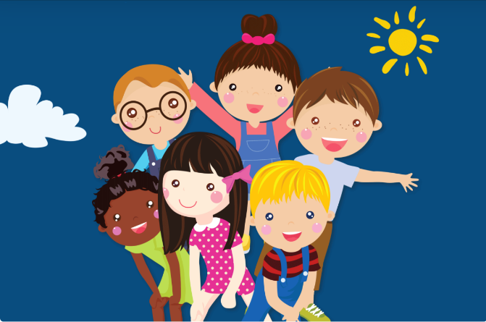
Children and young people who are experiencing emotional distress may benefit from different supports. For some, counselling might be helpful. This would be discussed with the staff in school responsible for your child’s wellbeing.

It is important that any young person taking part understands what counselling involves and that they want to take part. The counsellor in the school will be able to share detailed information with you about how they work with young people.

How?


If you have any concerns about your child’s emotional and mental health, these can always be discussed with the school to try and provide appropriate support.

When it is possible and helpful, parents and carers will be involved in the process to access counselling. Occasionally, it may be helpful for a young person (aged 12+) to take part without parental input and there is an option for young people to self-refer to see a school based counsellor.

If you require any further information about counselling services, staff at your child’s school will be able to help.

