Useful Apps
Name of app | App | Description
Calm Harm |  | Calm Harm is an app designed to help people resist or manage the urge to self-harm. It's private and password protected.
Catch it |  | Learn how to manage feelings like anxiety and depression with Catch It. The app will teach you how to look at problems in a different way, turn negative thoughts into positive ones and improve your mental wellbeing.
Chill panda |  | Learn to relax, manage your worries and improve your wellbeing with Chill Panda. The app measures your heart rate and suggests tasks to suit your state of mind. Tasks include simple breathing techniques and light exercises to take your mind off your worries.
Cove |  | Create music to capture your mood and express how you feel with the Cove app. Instead of words, create music to reflect emotions like joy, sadness, calm and anger. You can store your music in a personal journal, or send them to someone and let the music do the talking.
distrACT |  | The distrACT app gives you easy, quick and discreet access to information and advice about self-harm and suicidal thoughts.  The content has been created by doctors and experts in self-harming and suicide prevention.
SilverCloud |  | SilverCloud is an online course to help you manage stress, anxiety and depression. You work through a series of topics selected by a therapist to address specific needs. The eight-week course is designed to be completed in your own time and at your own pace.
Calm | 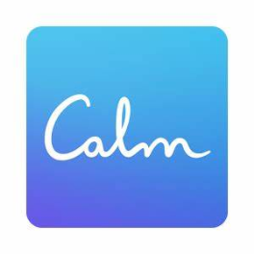 | Calm is the perfect mindfulness app for beginners, but also includes hundreds of programs for intermediate and advanced users.
Suicide? Help! | 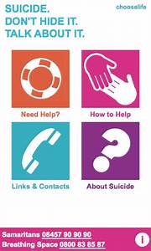 | Suicide? Help! - An information website as well as an Apple and Android app for people who are thinking about suicide or are worried about someone else.

