

Webster's High School Christmas Newsletter 2024

Dates For Next Term
- Monday 6th January 2025 - pupils return to school
- Monday 13th January 2025 - S2 Course Choice begins. S2 course choice assemblies will take place during this week
- Tuesday 28th January 2025 - S4-S6 Targeted Parents' Evening (Subject teachers will indicate in the S5/6 Tracking report being sent home on Wednesday 22nd January whether parents should make an appointment.)
- Thursday 13th February 2025 - In-service day (school closed to pupils)
- Friday 14th February 2025 - Monday 17th February (inclusive) Mid term Holiday
- Wednesday 26th February 2025 - S3 Parents' Evening
- Friday April 4th 2025 - Last day of spring term
- Tuesday 22nd April 2025 - Pupils return to school after Eater break


Christmas Greetings

Dear parents/carers,
I hope that you enjoy reading our Christmas newsletter. We are very proud of the achievements of our young people and all the work they undertake - both in school and in the wider community. As you are aware, we reviewed our values this year and they are now: Kindness, Respect, Appreciation and Ambition and, on a daily basis, we see these values in action from many of our pupils, staff, parents/carers and partners in the community. We appreciate everyone's support in upholding these values and many more.
While this time of year can be joyous, it can also bring sadness to those who have lost loved ones. With this in mind, we remember our dear colleague Jennifer Downie (School Business Manager) who was a valuable part of our school community for over thirty years and who sadly passed away in August this year. Jennifer is sorely missed by both colleagues and pupils alike. Our thoughts are with everyone who is missing a loved one or can't be with a loved one this Christmas.
Yours faithfully
Jane Esson
Head Teacher

Working Together LfS Goal 17 - Partnerships For The Goals

Learning for Sustainability Goals: 1,2,3: No poverty, Zero hunger and Good health and wellbeing
House Captains, Halloween, S3 Prefects and Christmas Hampers
Our House captains did a terrific job again this year in organising the Halloween event to raise money to purchase the Christmas Hampers for people in the community. Every year our S6 House captains organise the Halloween day where pupils can choose to pay £1 and dress up.
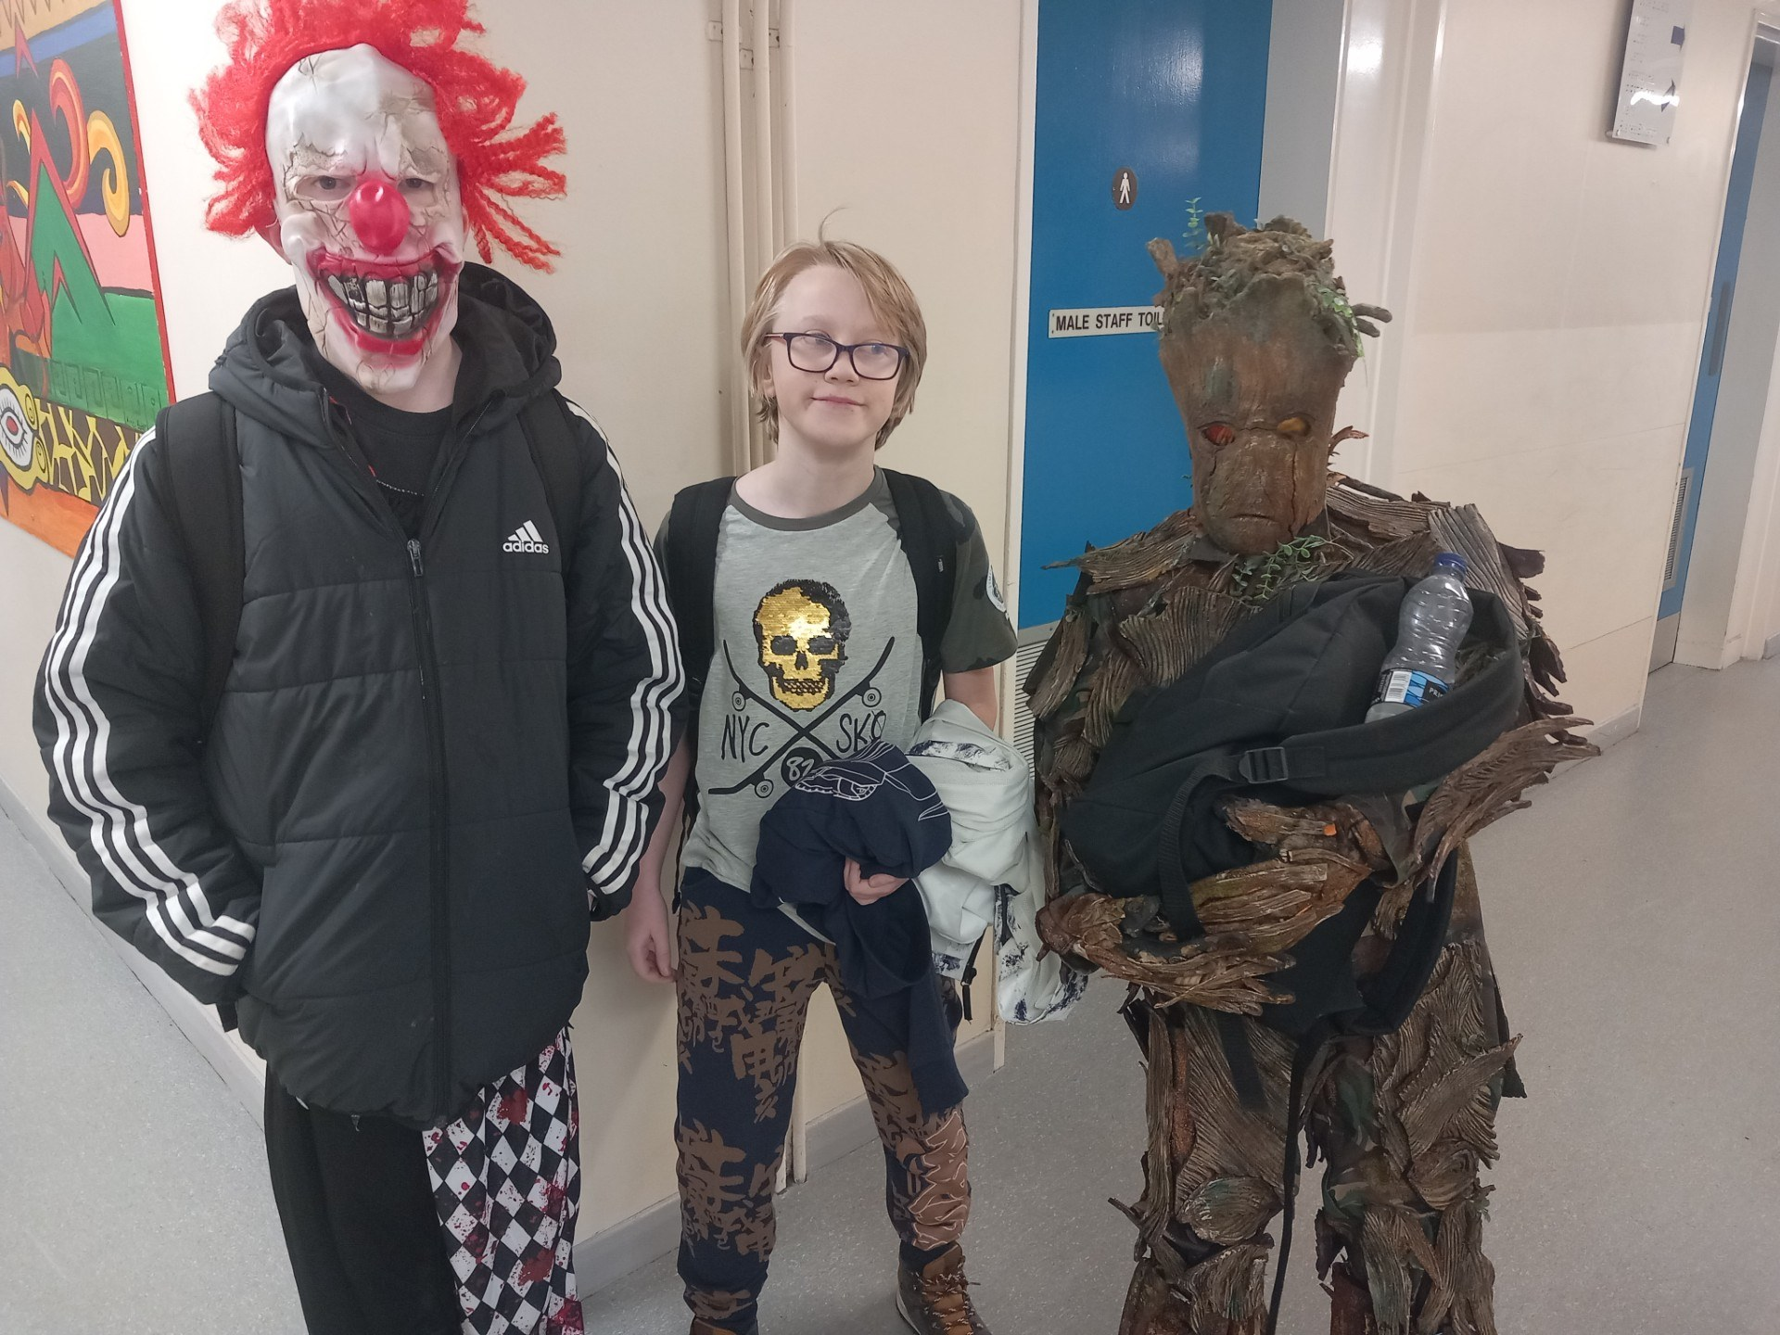
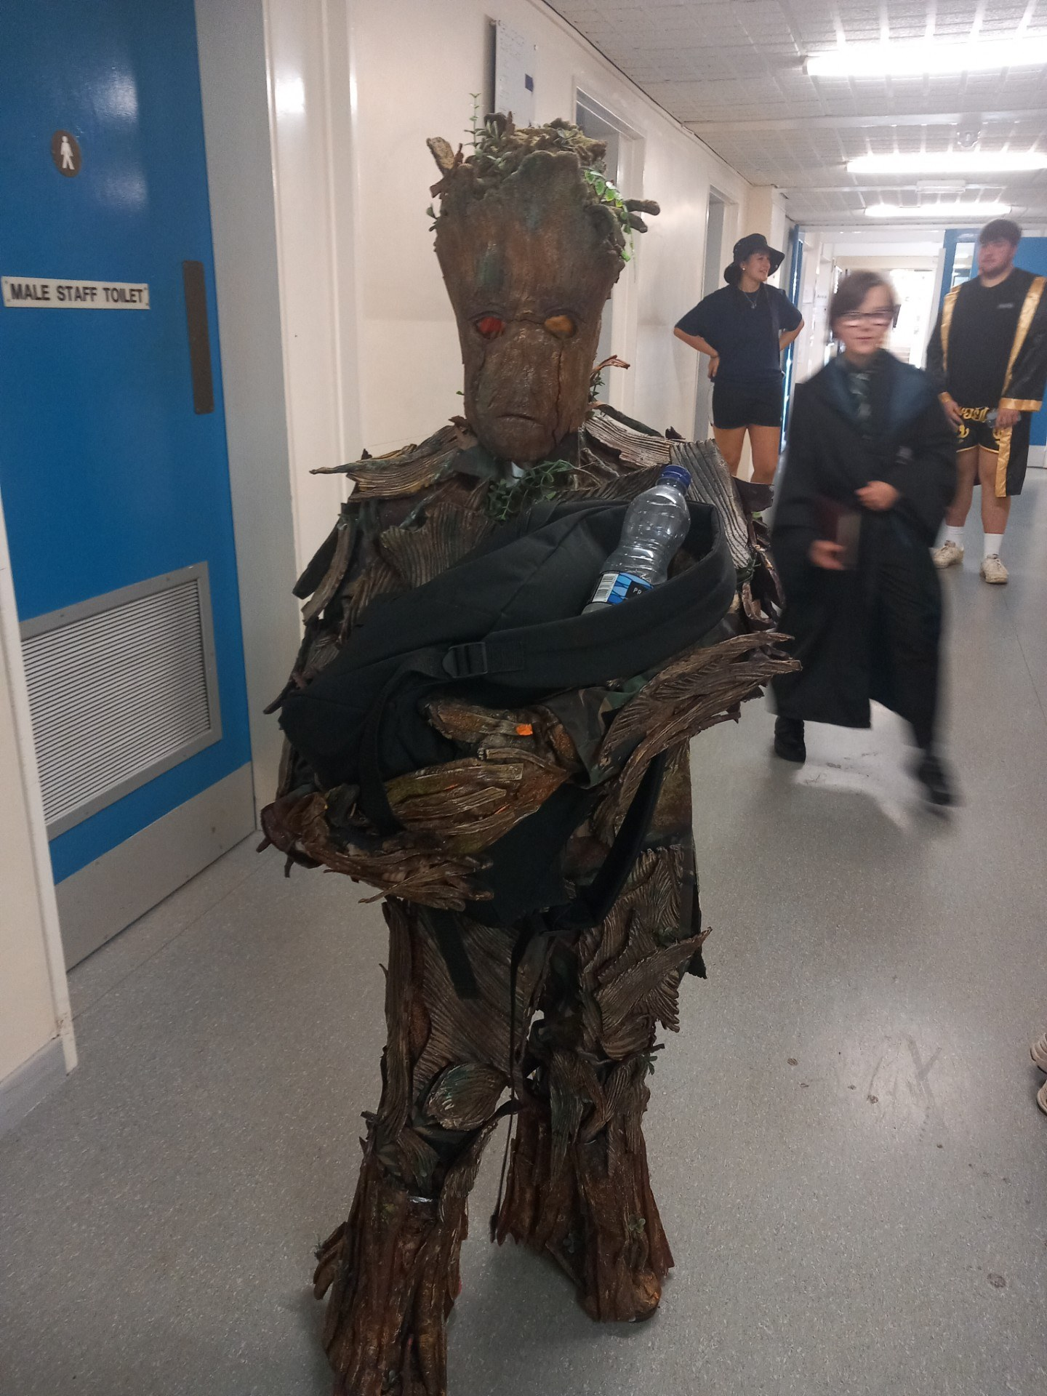
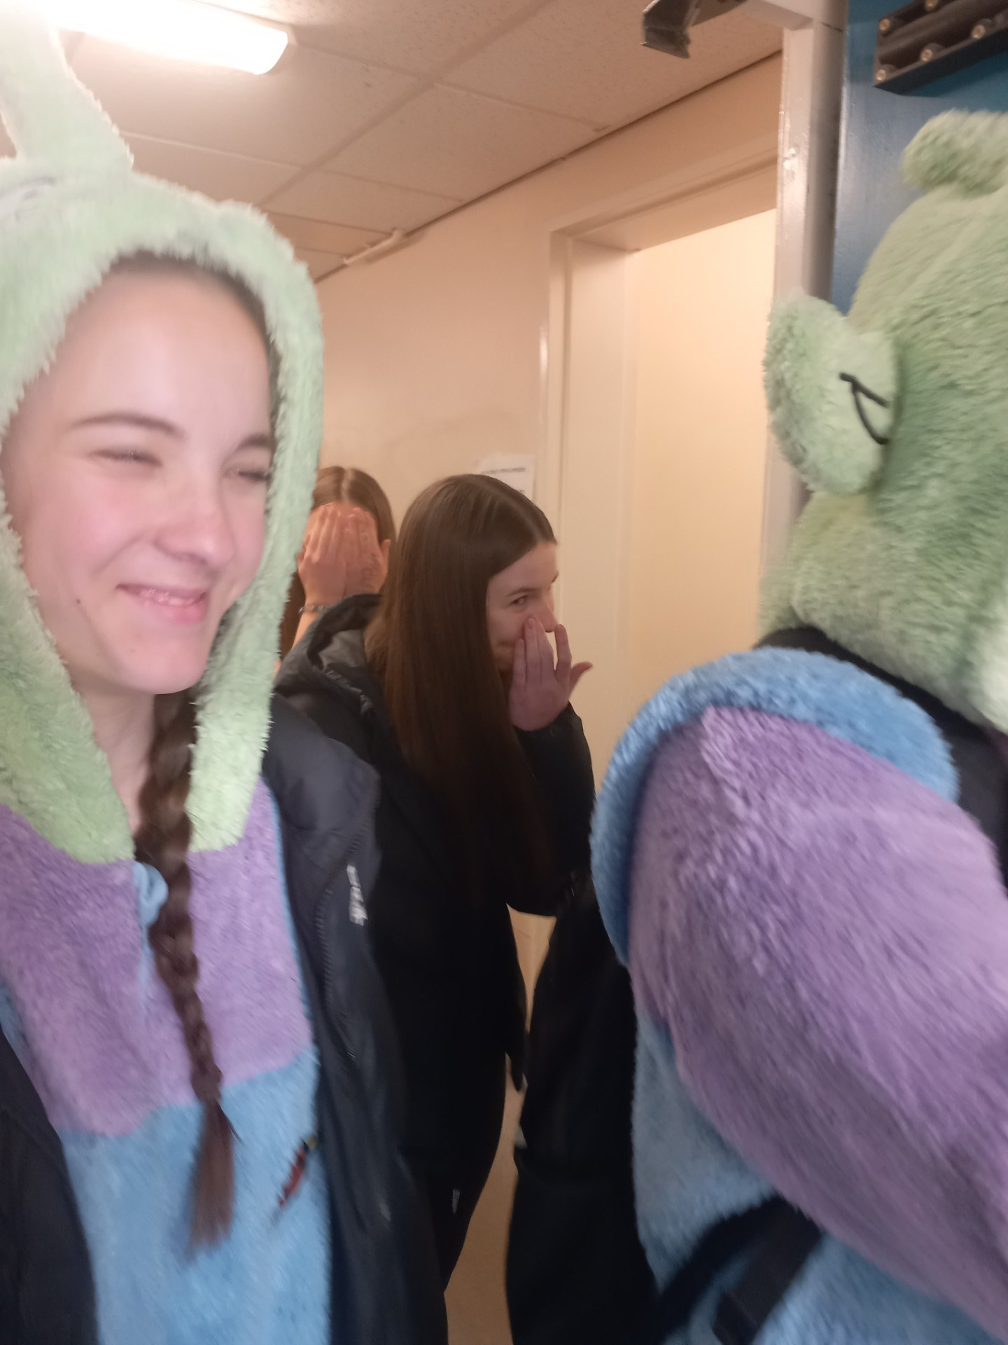
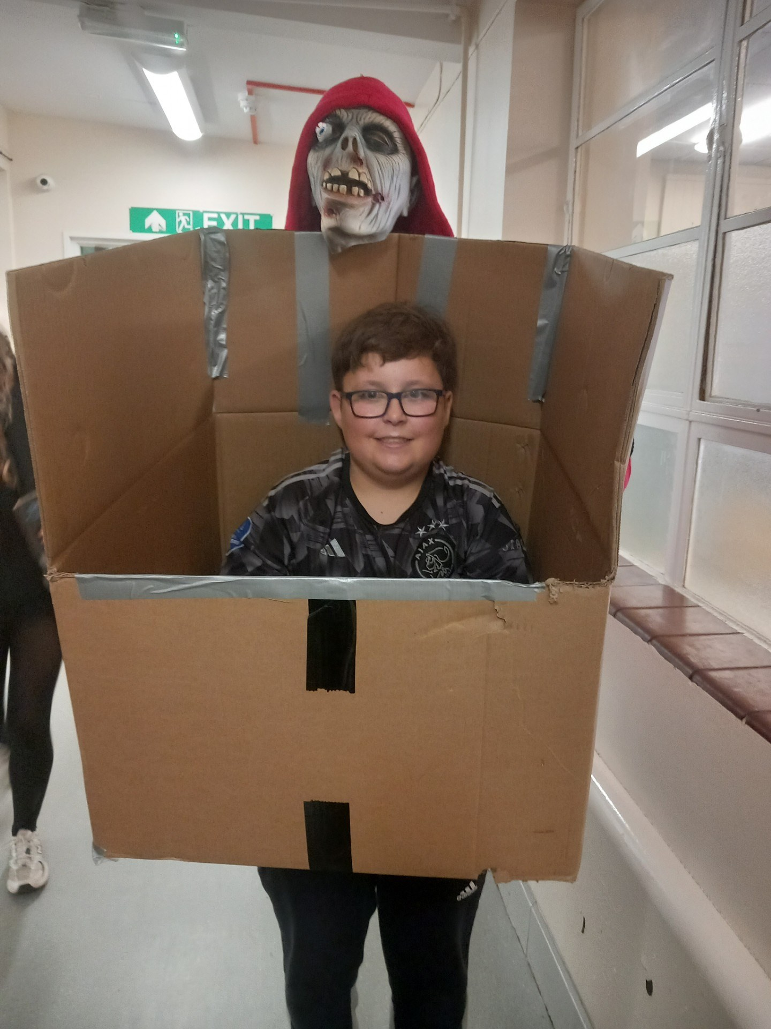
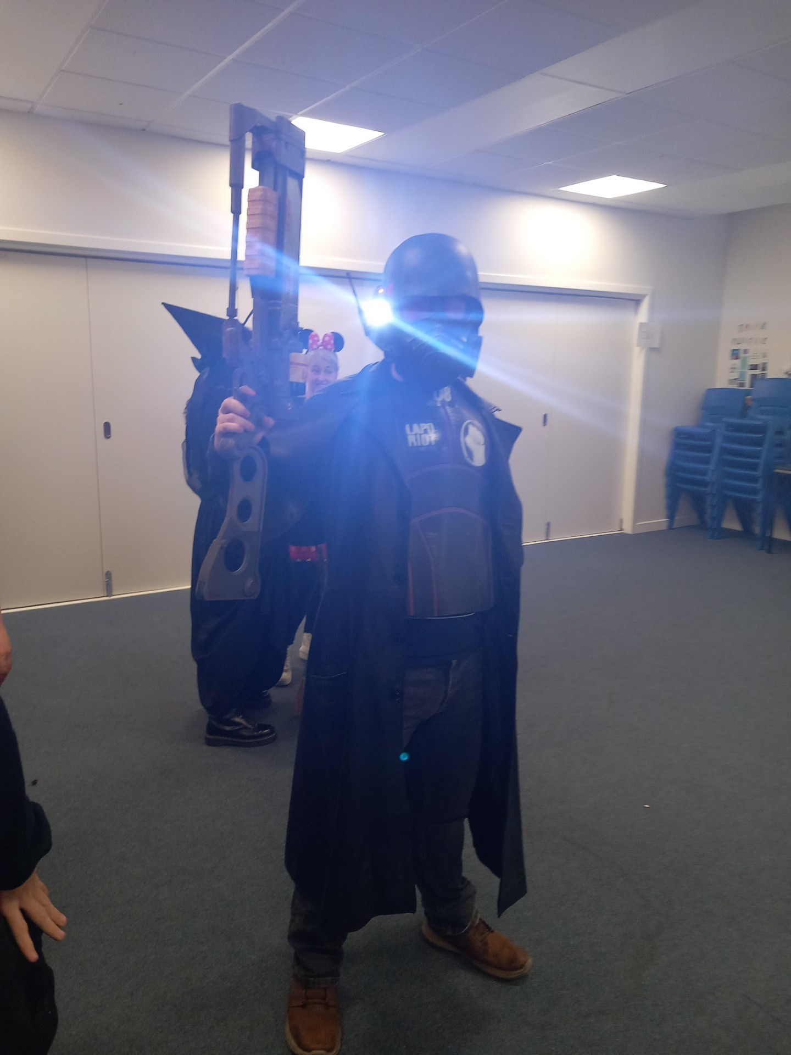
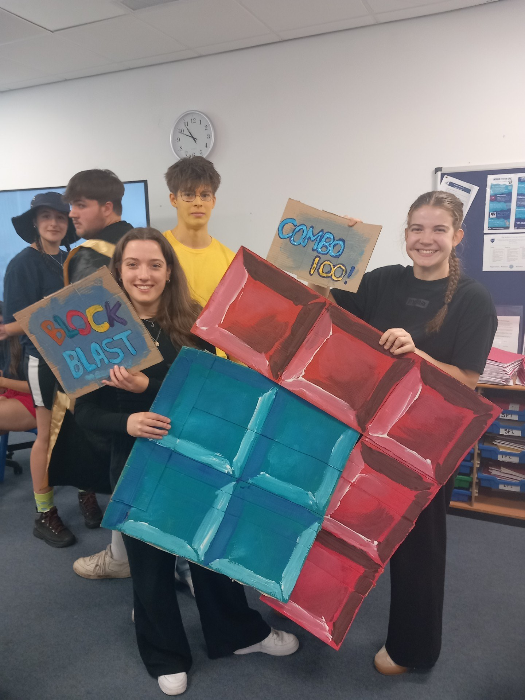
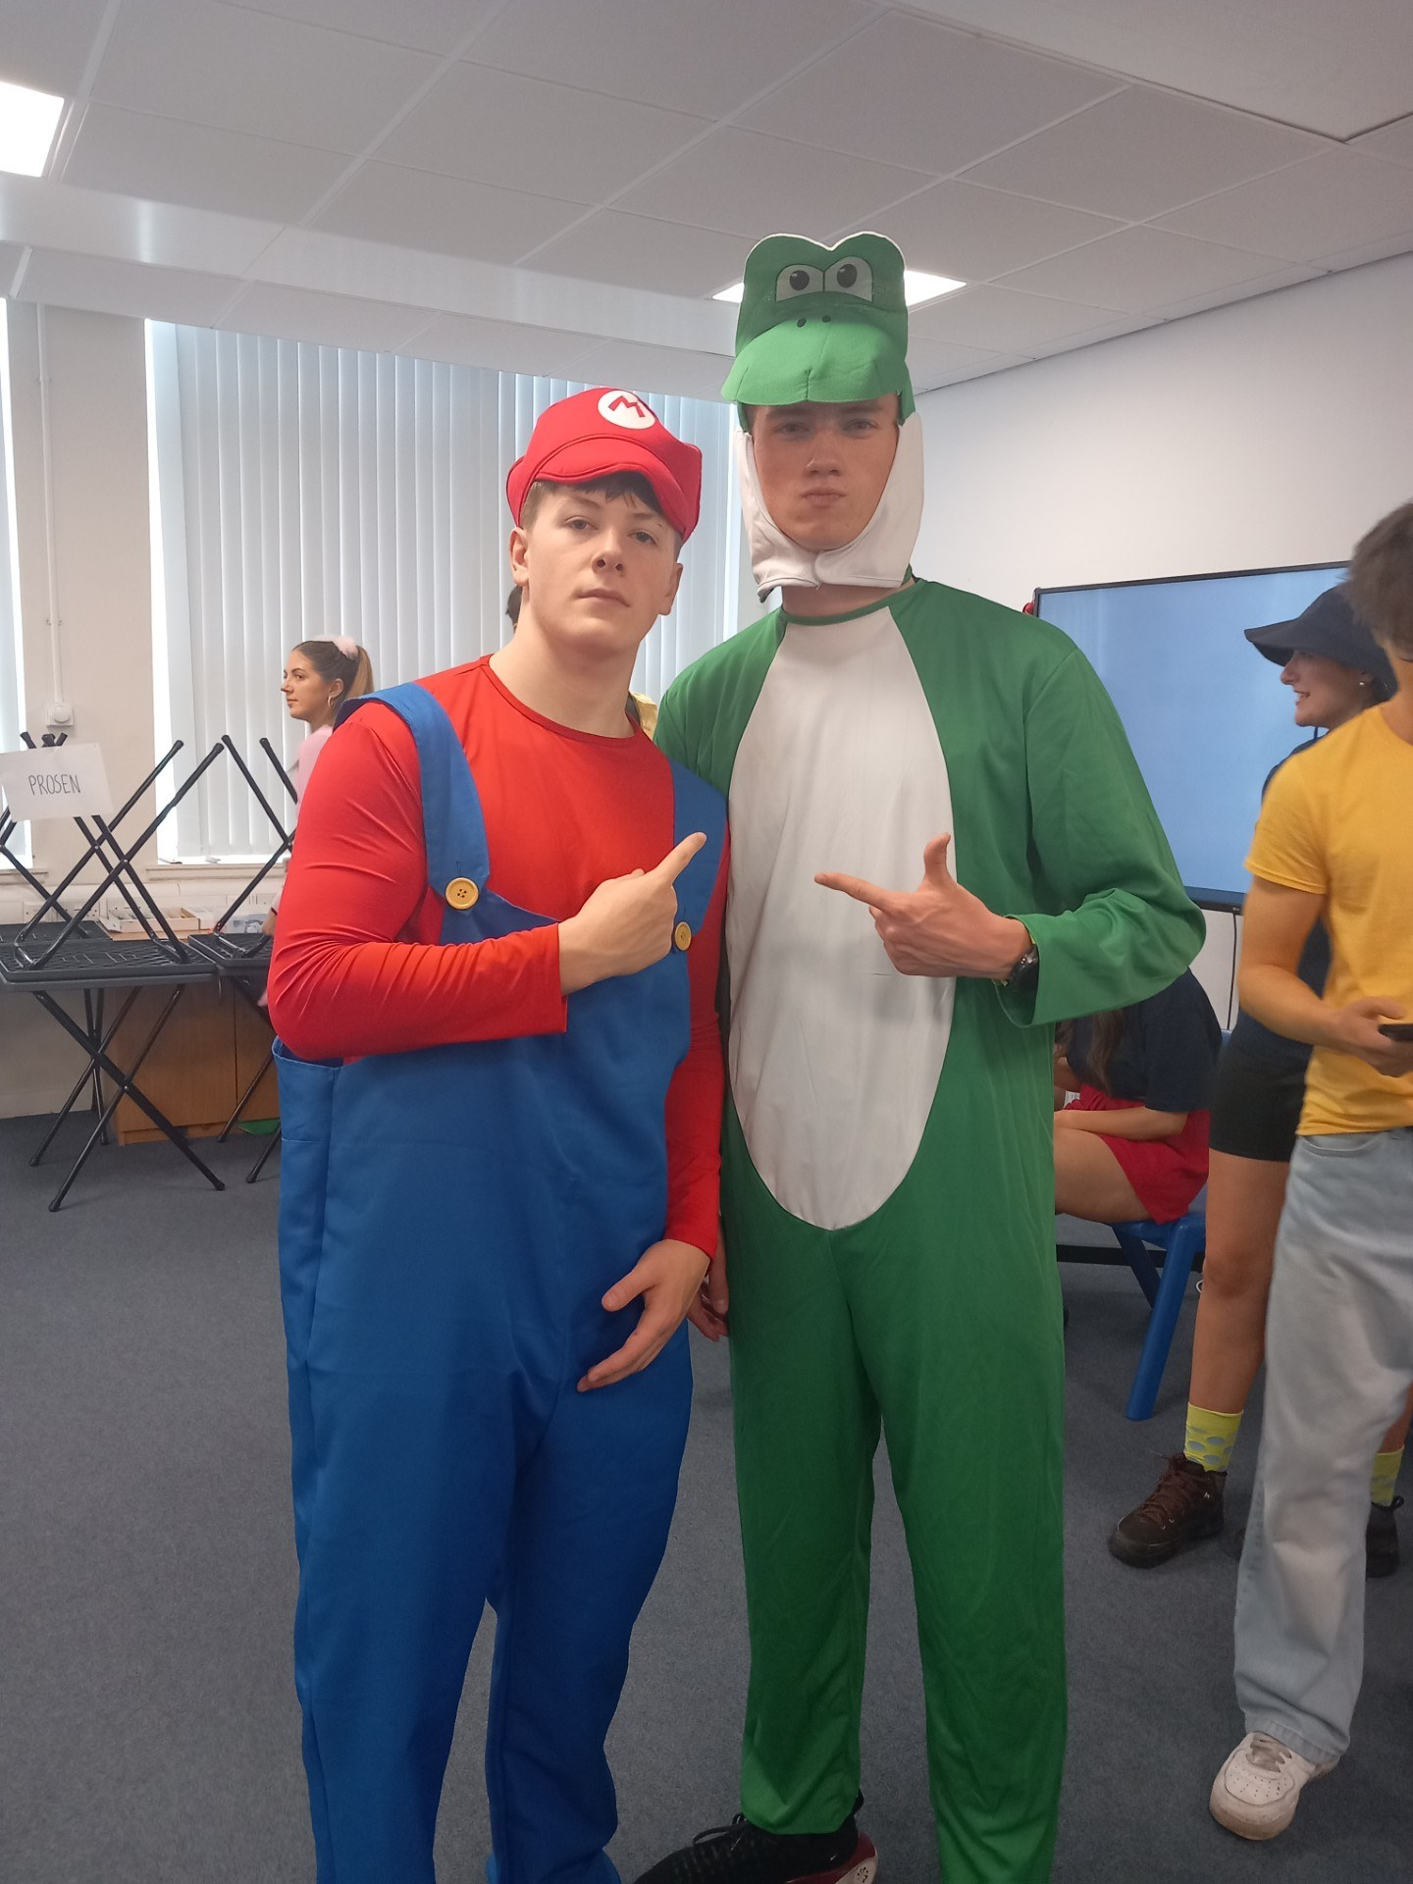
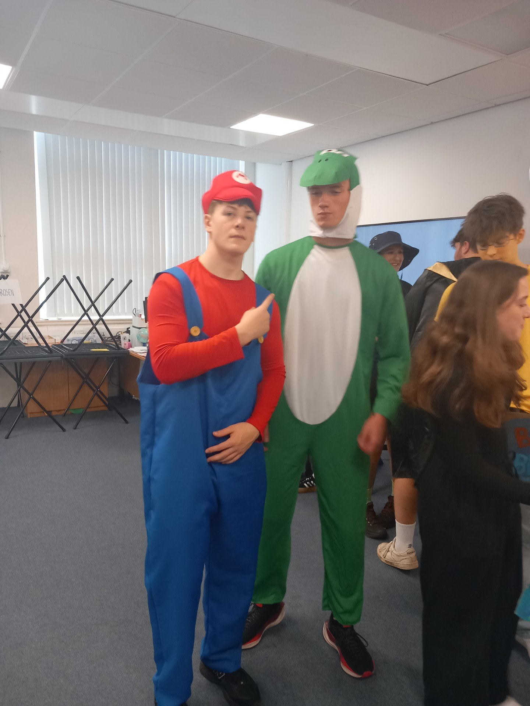
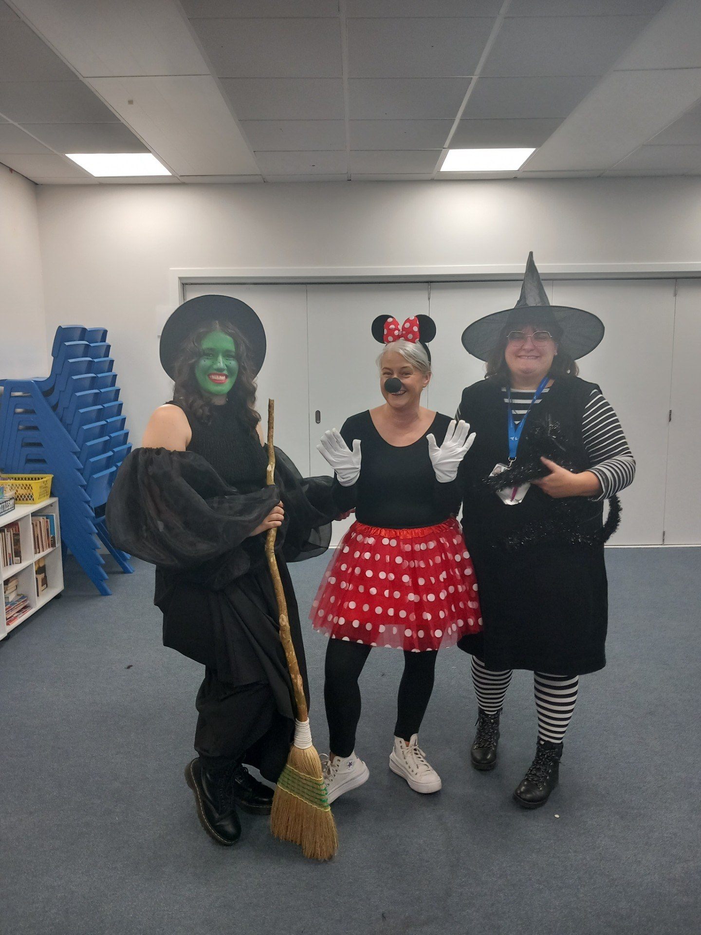
With the money raised from the Halloween event, the S3 Prefects then helped Mrs Foggarty (PT Raising Achievement) to prepare Christmas Hampers to be delivered to people in the community. Every year the school asks for nominations of people - which may include people who struggle to get out, are unable to see their loved ones over Christmas or who have suffered a bereavement- to receive the hampers. Angus Glen's Rotary and Kirriemuir Rotary, accompanied by the S3 Prefects, deliver the hampers, which are always appreciated. We would like to thank both Rotary clubs as well as all our pupils and staff for making this happen every year.
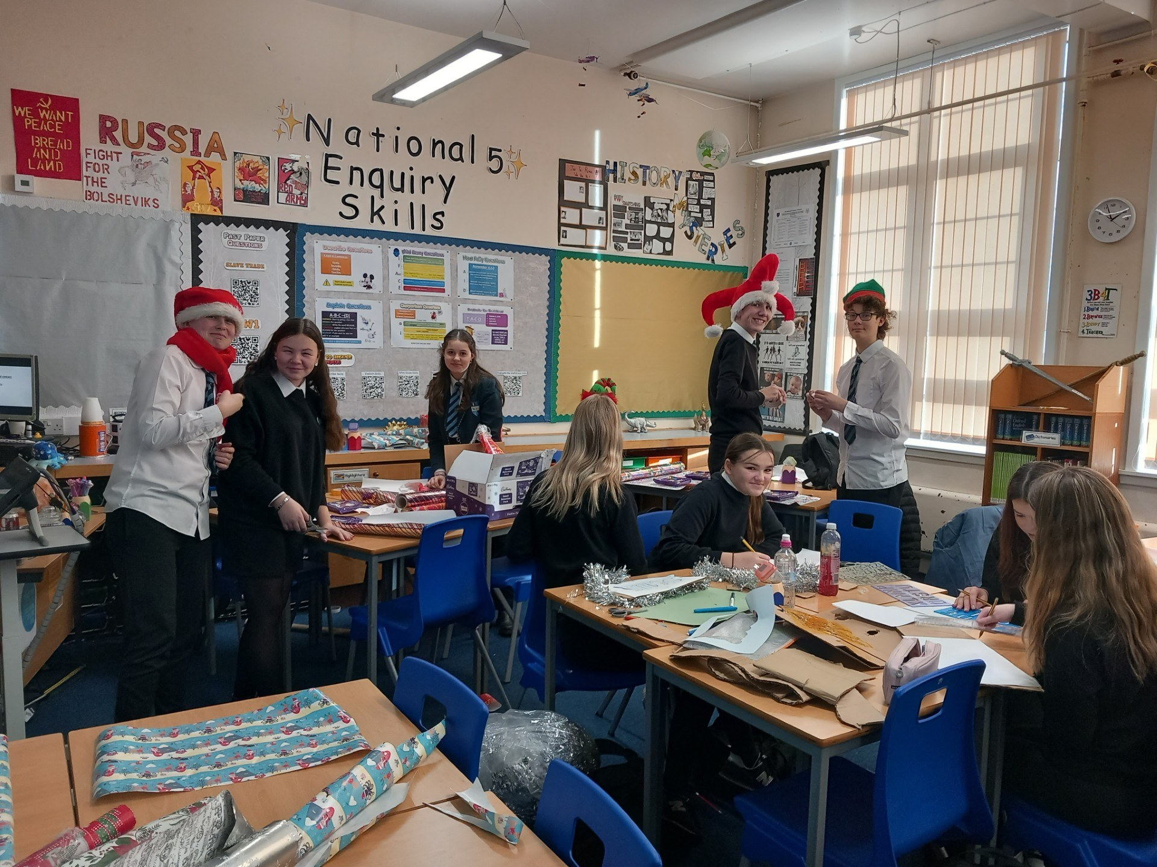
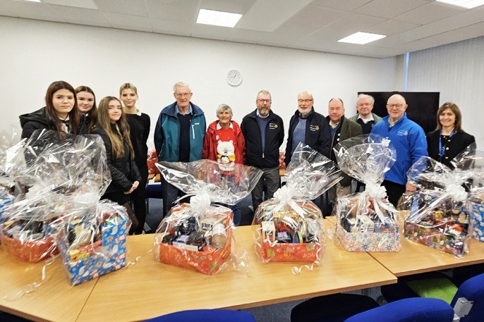

Interact fundraising for My Doddie’s Foundation – MND Charity.
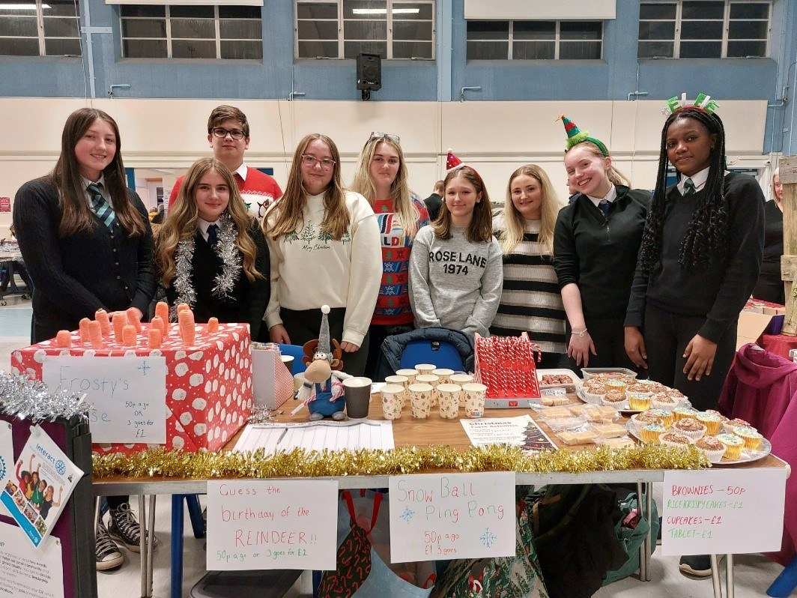
The Interact team have been busy raising funds for their chosen global charity for 2024, My Doddie’s Foundation – MND Charity. The pupils organised a Halloween bake sale and ran a stall at the Christmas Fair, which included lots of fun activities such as ‘snowball ping pong’, ‘Frosty’s nose’, and ‘guess the reindeer’s birthday’. In total over £300 has been raised for this worthwhile cause. The pupils continue to exemplify many of our school values, including kindness, ambition and appreciation as they give up their time and put in an abundance of energy and enthusiasm into making a difference in our world. In doing this they have supported our status as a Rights Respecting School and helped the Webster’s to strive towards the Sustainable Development Goals, for example, Goal 3: Good Health and Wellbeing. A huge thank you to the Kirriemuir Rotary Club, and to all the Webster’s pupils, parents and staff who have supported our events. Interact are looking forward to continuing to make a positive difference for their chosen local charity next term, Roxburgh House in Dundee.
School House Captains and Kirrie Food Bank
Our House captains also organised the usual House Competition to collect donations for Kirrie Foodbank. Due to the generosity of our pupils, their families and our staff, the school was able to hand in four boxes to the foodbank.
Thank you to everyone and thank you to the House Captains for organising.
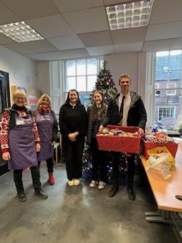

Christmas Fair -Thank you

We would like to say a big thank you to Webster's and Southmuir's Parent Voice Groups who worked together to organsie the Campus Christmas Fair. We would also like to thank all the pupils and the staff who assisted as well as the community for their support, with specific thanks to Angus Glen's Rotary who donated a luxury hamper to be won at the raffle and who helped out with Santa's grotto.
It was a great evening and it was lovely to see the school so busy. Over £1200 was raised to be split between both schools. At Webster's, this money always contributes to purchasing food/water for the soft exam start for our S4-S6 pupils as well as various events. This would not be possible without the support of the Parent Voice Group and the community.

Anti Bullying Week November 2024
Anti-Bullying Week 2024
Annual national Anti-bullying week took place from Monday 11th-Friday 15th November. The focus for 2024 was "Respect: What does it mean to you?" The aim of the campaign was to encourage respectful relationships as a way of fostering an environment where bullying simply cannot happen.
As part of our anti-bullying week activities, all pupils attended house assemblies where they were asked to reflect on how they show and receive respect in their daily lives. S1 and S2 pupils completed work on respectful relationships and children's rights in their PSE lessons and were also invited to take part in a poster competition. We received some incredible entries from pupils, which were creative, informative and thought-provoking. The standard was incredibly high and Mrs Tosh had a tough job as judge! Our winners were:
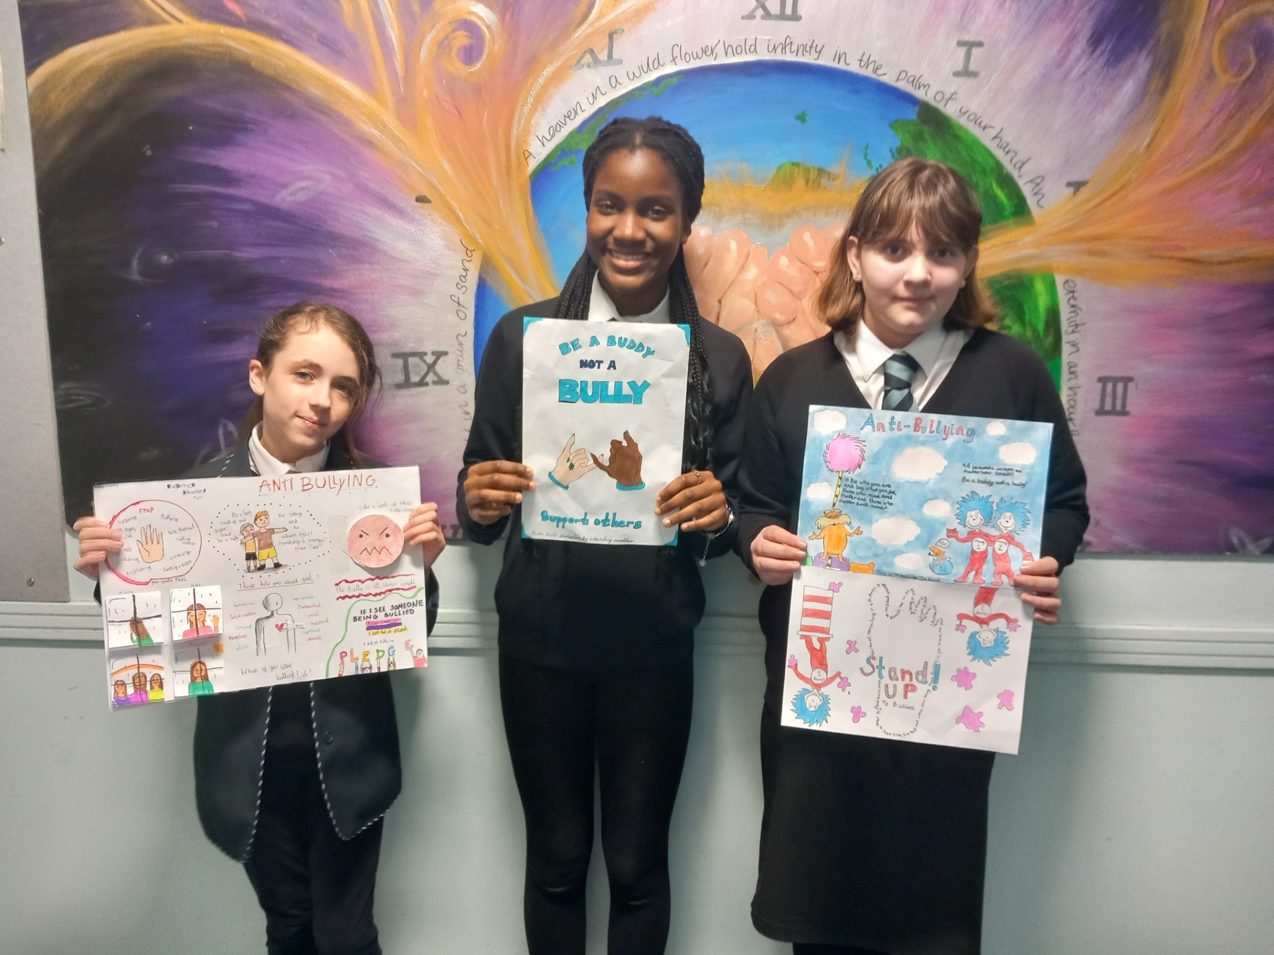
1st place - Zite Okoye John (1C2)
2nd place - Stacey Donald (1C2)
3rd place - Emily Mumby (1P1)

All three received a prize as well as points for their respective houses for their efforts. Congratulations to our winners on their fantastic work and a huge well done to everyone else who entered the competition.
With 'respect' being one of our school values, we will continue to reflect on the learning from anti-bullying week and to promote a culture of kindness and respect amongst our full school community, where positive relationships thrive and bullying cannot.
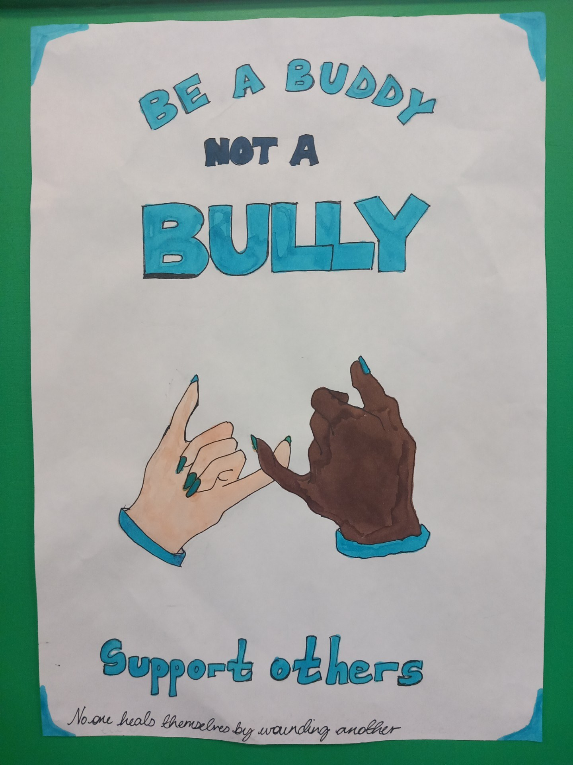
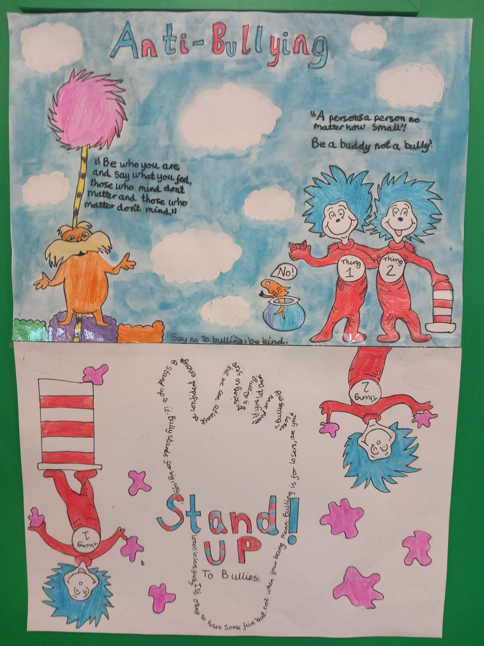
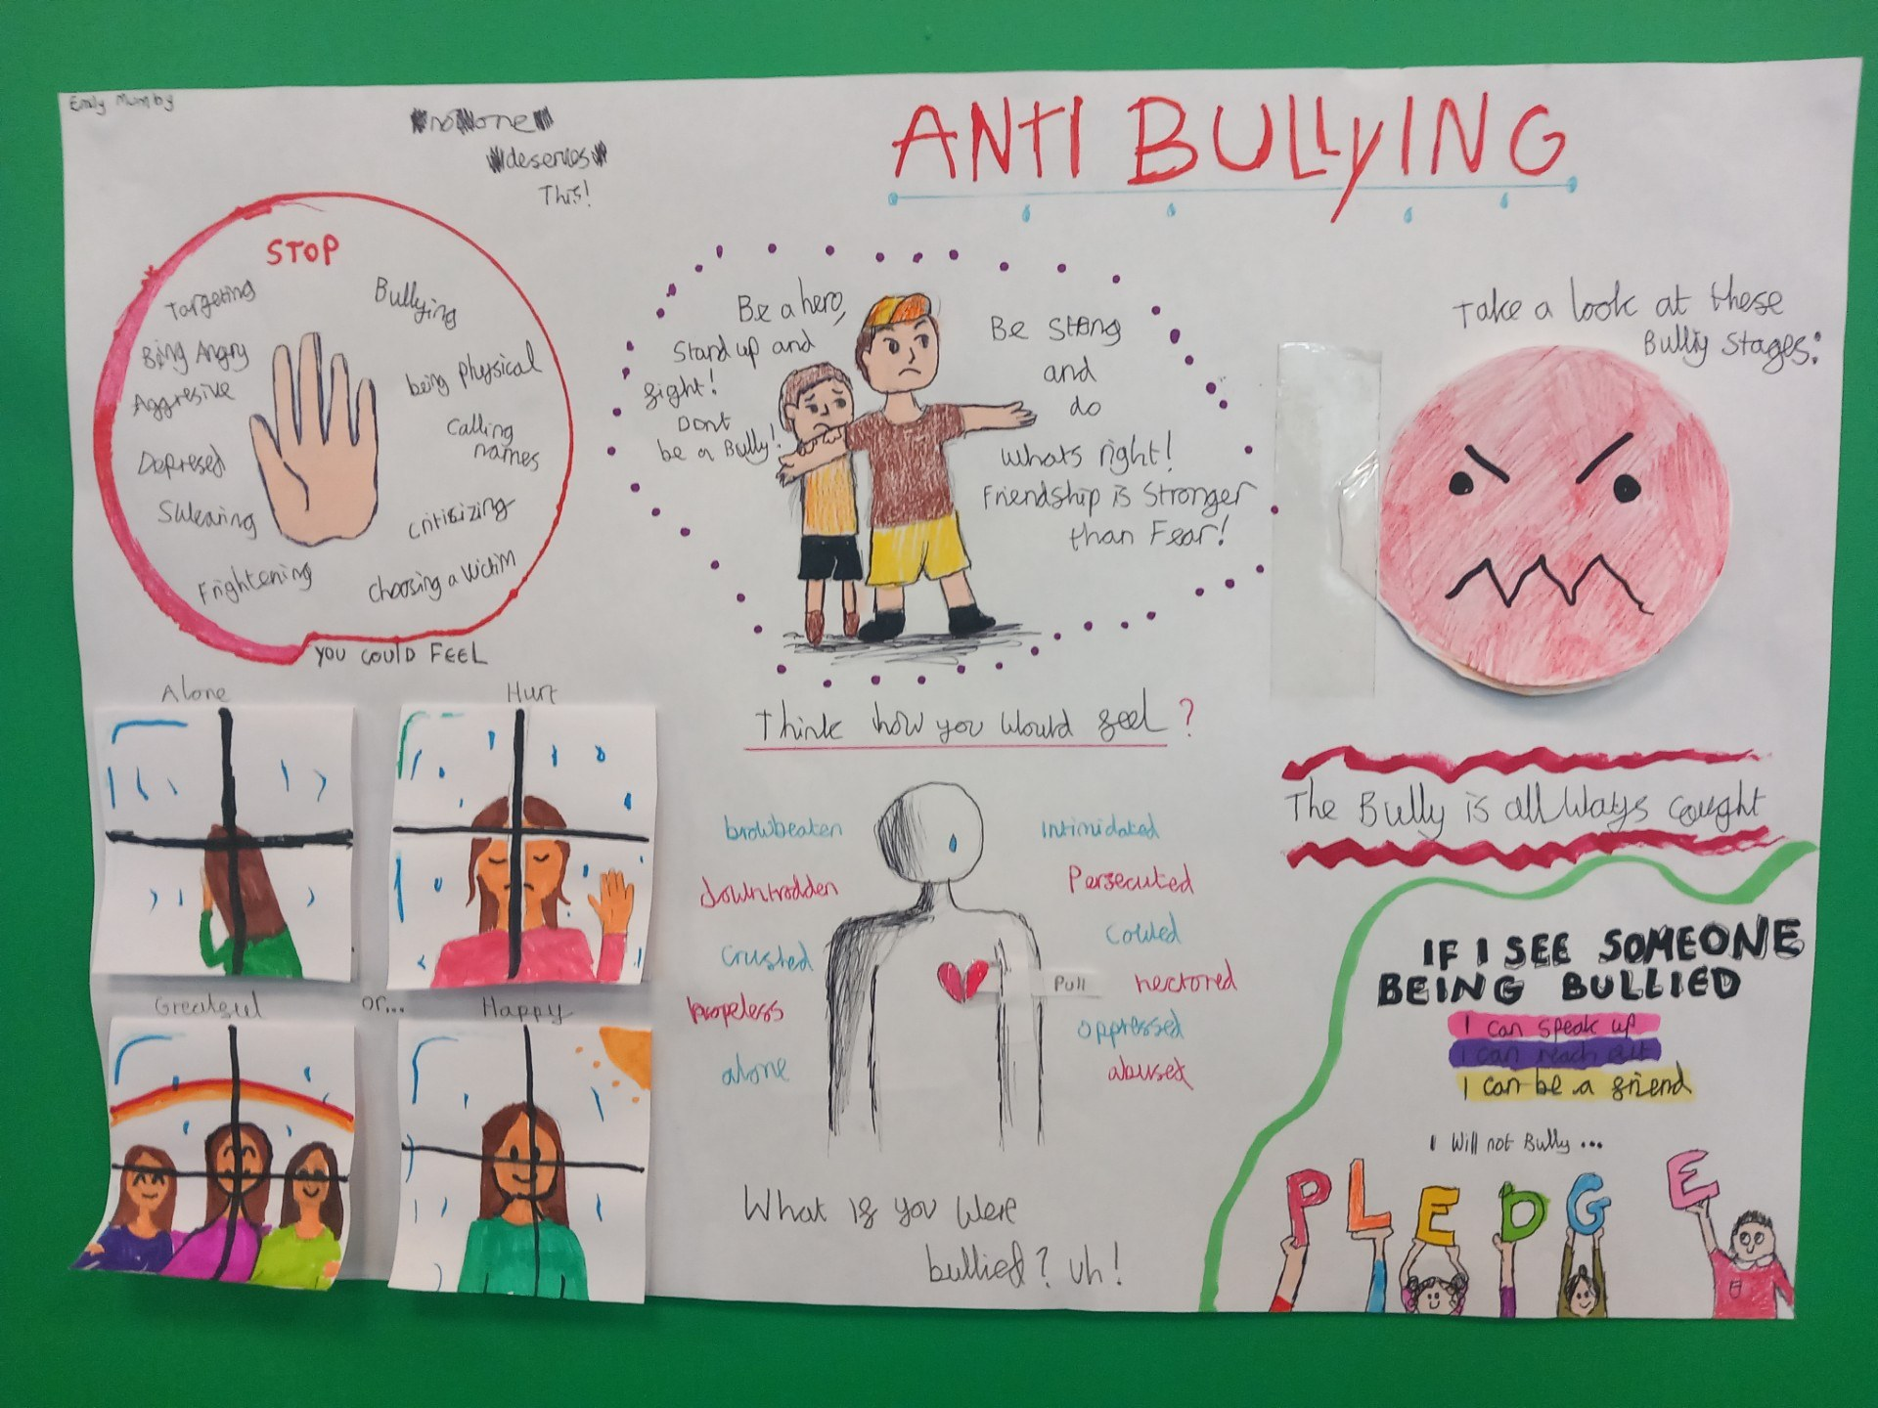

Developing the Young Workforce
Career Bus
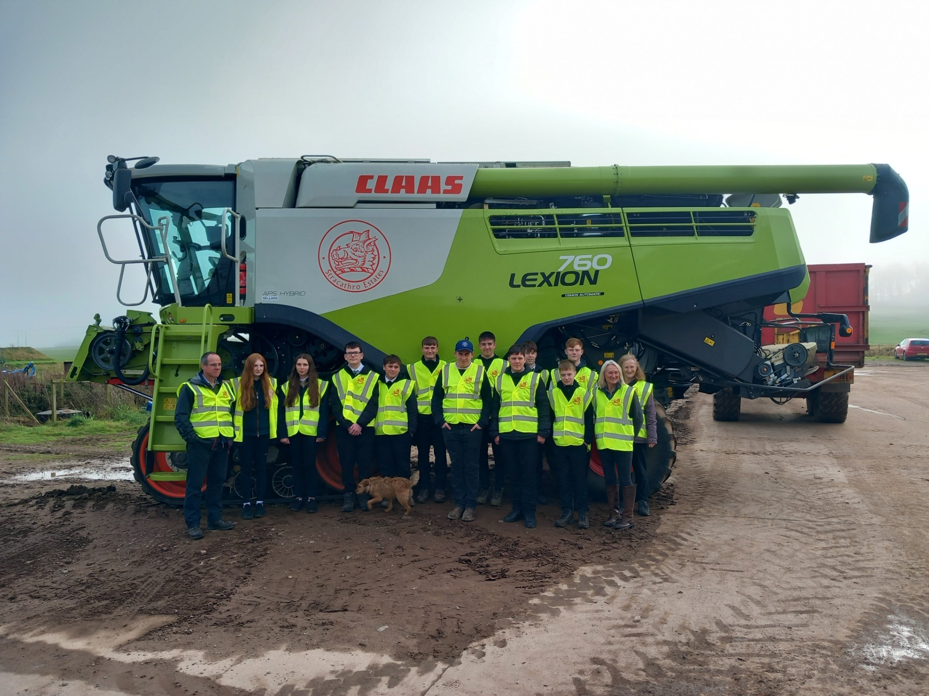
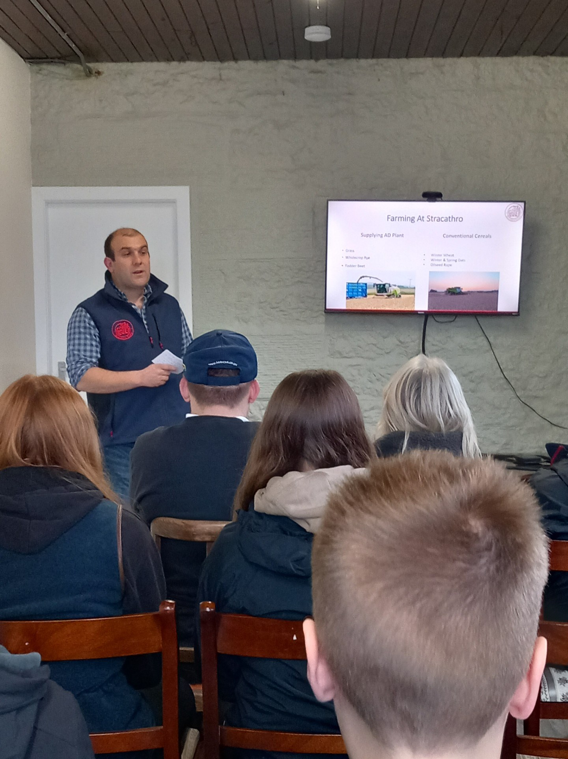
In October our popular Career Bus headed to Stracathro Estates for a glimpse into the farming/land based sector. A forward thinking and diverse family owned 4,000 acre estate. Our visit started with fascinating talks from Farm Manager Iain Wilson and owner James Campbell-Adamson. We learned of the progression of farming over the years, precision techniques and modern sustainable farming.Our twelve passengers, Miss Lees, Mrs Ferguson and Mr Milton were fascinated to learn about renewables, forestry, residential properties and their sporting interests. We were also educated on the AD (Anerobic Digester) where microorganisms break down biodegradable material in the absence of oxygen. This process is used for industrial or domestic purposes to manage waste and produce fuels. Pupils were commended by Estate staff for their behaviour and obvious interest. Another great stop for the Career Bus.
Fire Skills Course
We have been very fortunate that Kirriemuir Fire Brigade have been able to offer a Fire skills course to some of our pupils this term.
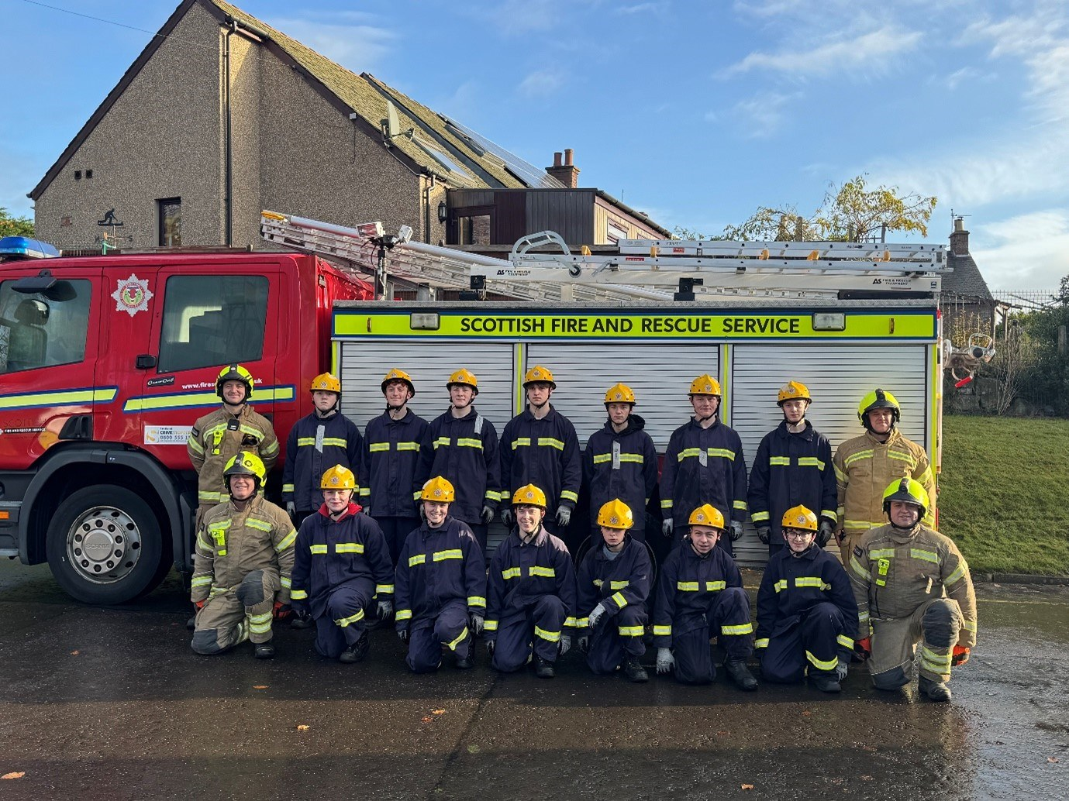
In September, a group of S3-6 pupils completed application forms and were interviewed for a place in the course. Thirteen of our students then participated in the course over the week of 11th -15th November.
The young people had to learn about the apparatus on an appliance, specific drills with the hoses and breathing apparatus, how to perform CPR and they also received input from the Police and Mountain rescue services. They had both a day out to Arbroath Fire Station so they could complete some activities in enclosed spaces, and a visit to the 999-command centre in Dundee to see how operators handle the emergency calls.
On the final day, parents and carers were invited to a demonstration of a rescue drill followed by a presentation of certificates by the Area Watch commander.
All of the young people who participated engaged in the tasks with merit, and the feedback from the fire crew was exemplary. The group have spoken extremely positively about their experience and said that they would recommend the course to others.
A very big thank you to Watch Commander Judi Young, Kenny Petrie CSA and the rest of the crew for giving up their time to run the course.
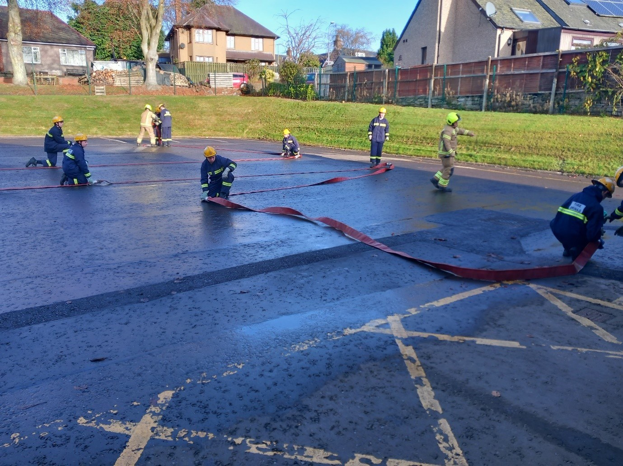
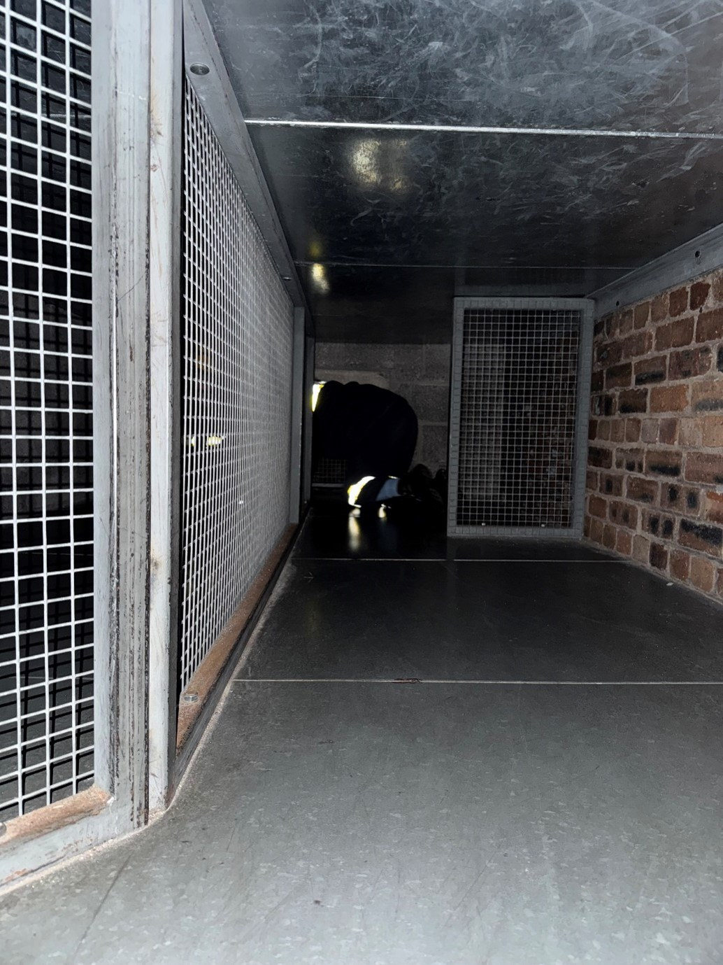
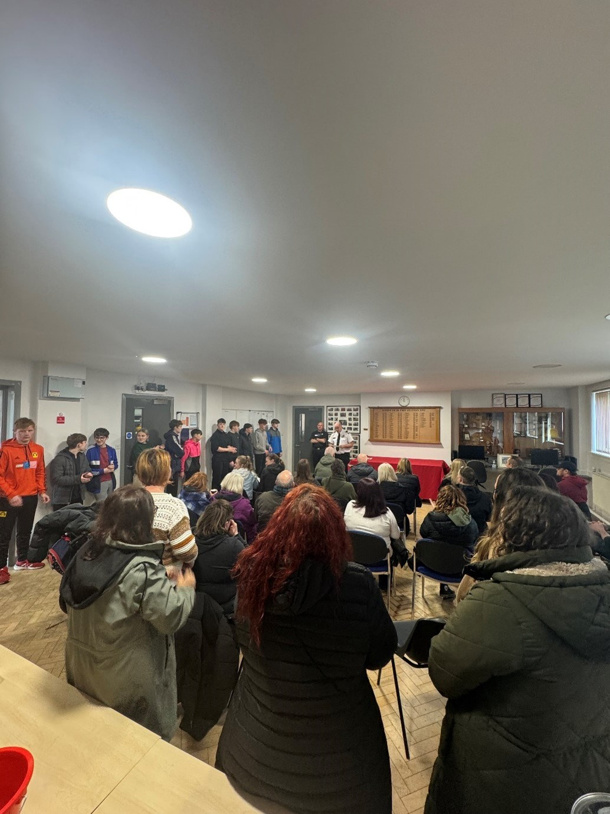
Industrial Cadets SSEN Challenger Experience
On Thursday 12th December, 12 S2 pupils took part in an Industrial Cadets SSEN Challenger Experience run by a team from the Engineering Development Trust and a graduate Engineer from Scottish Southern Energy Network.
This workshop was funded by SSEN and focused on electricity transmission, giving our pupils some theory around electricity and renewable energy, along with practical challenges including a Transmission Tower Challenge and robot programming with Ozobots. The team also highlighted options of Apprenticeship programmes and career pathways in STEM.
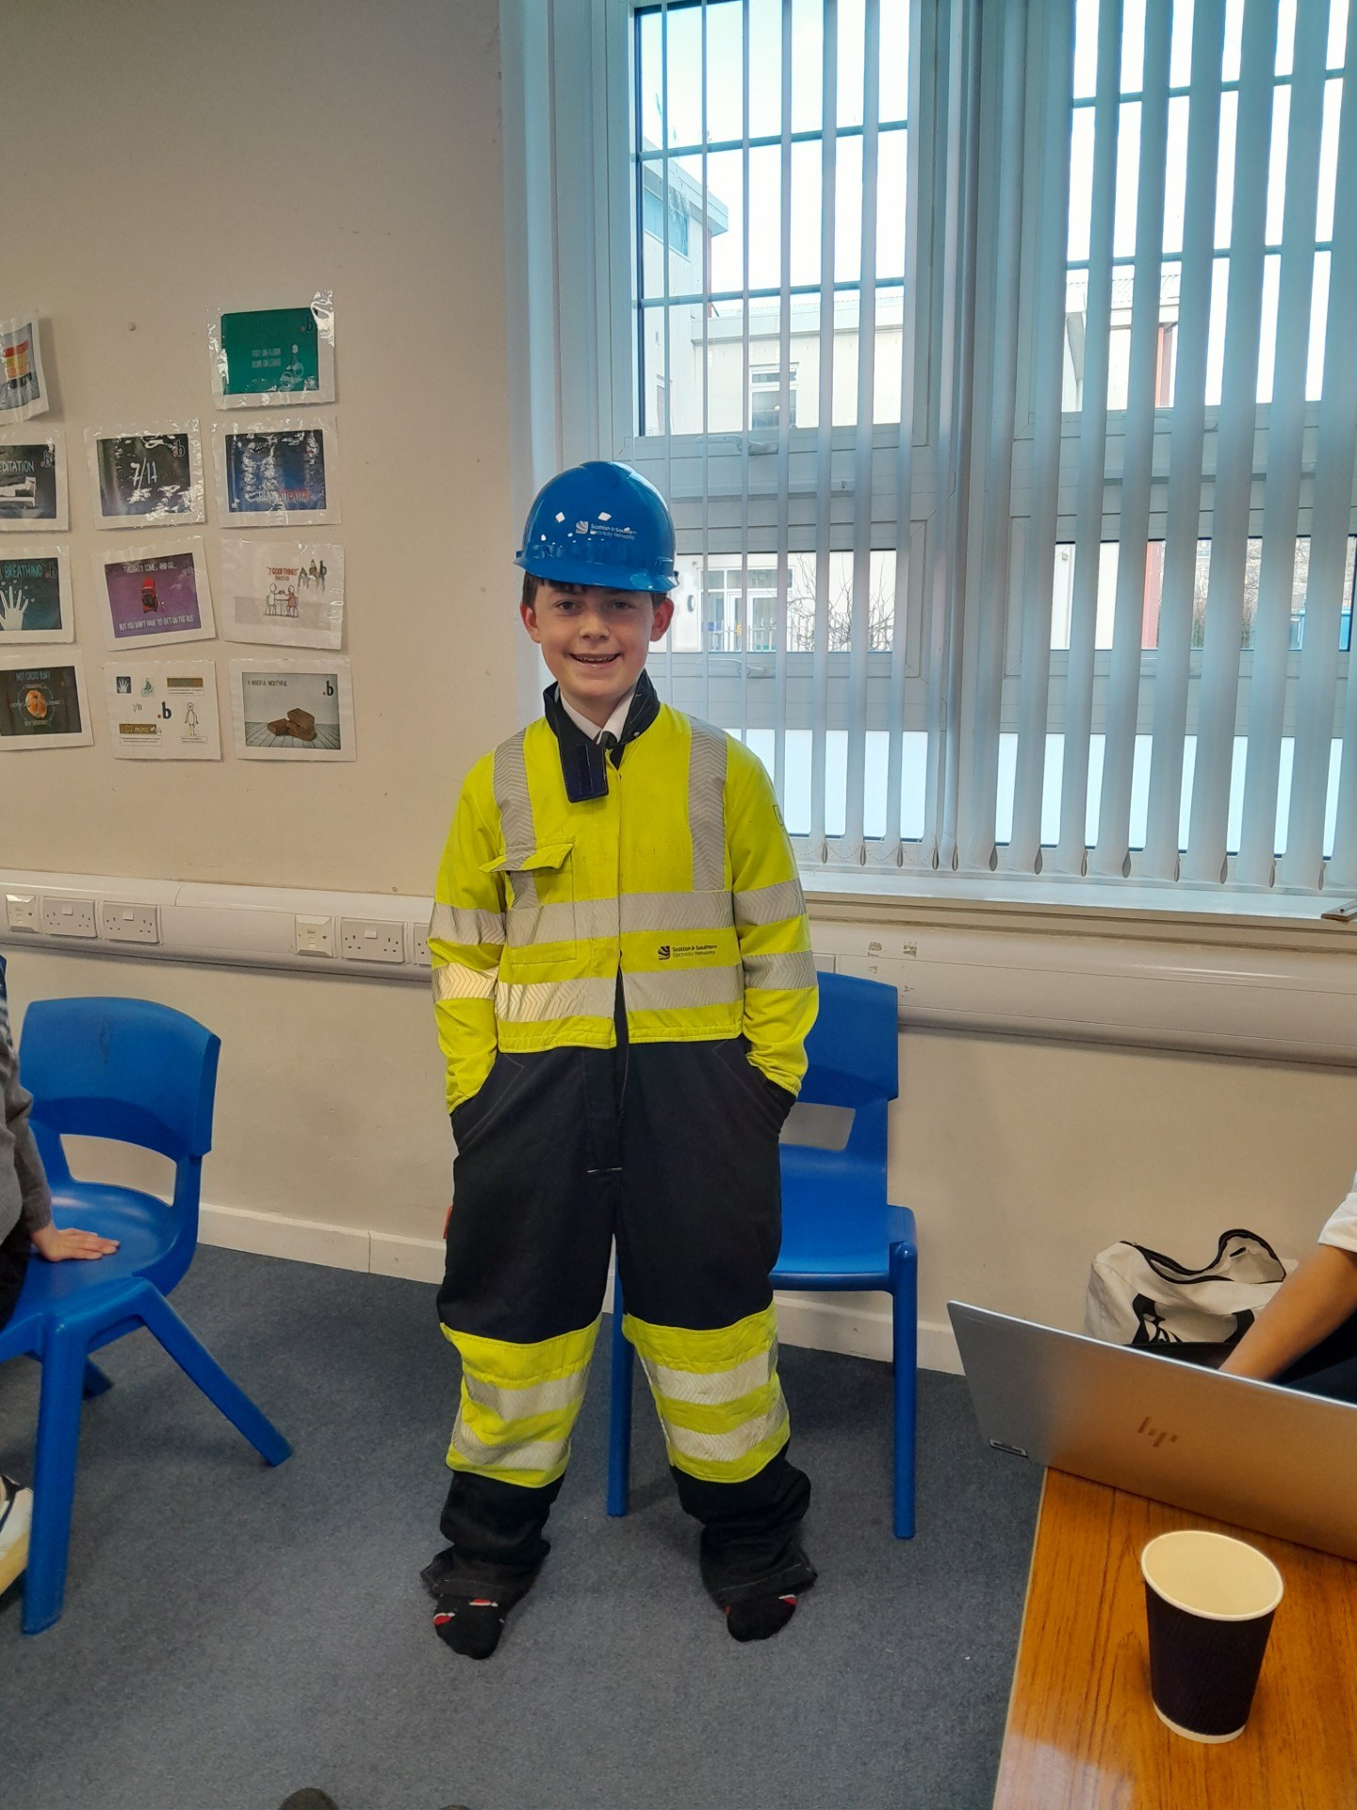
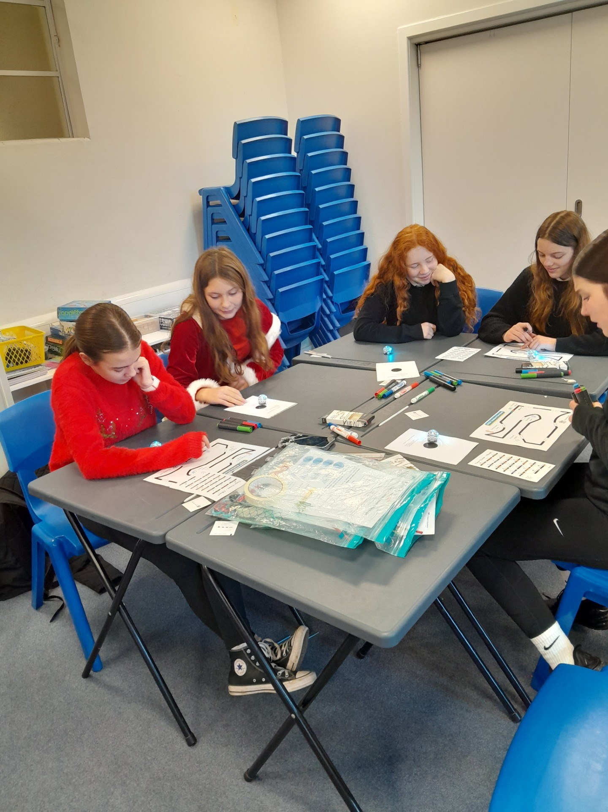
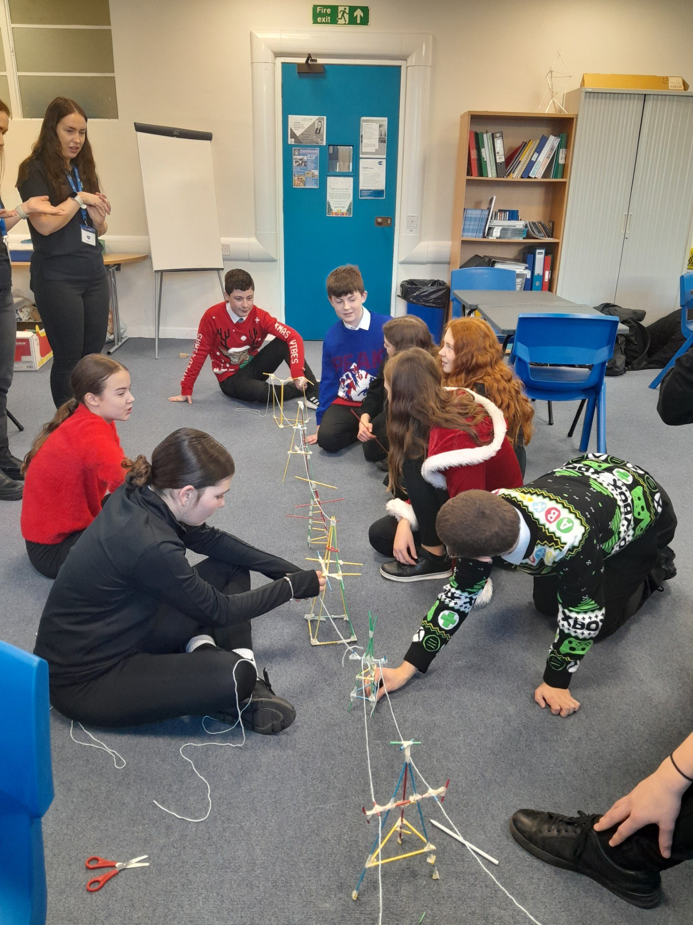
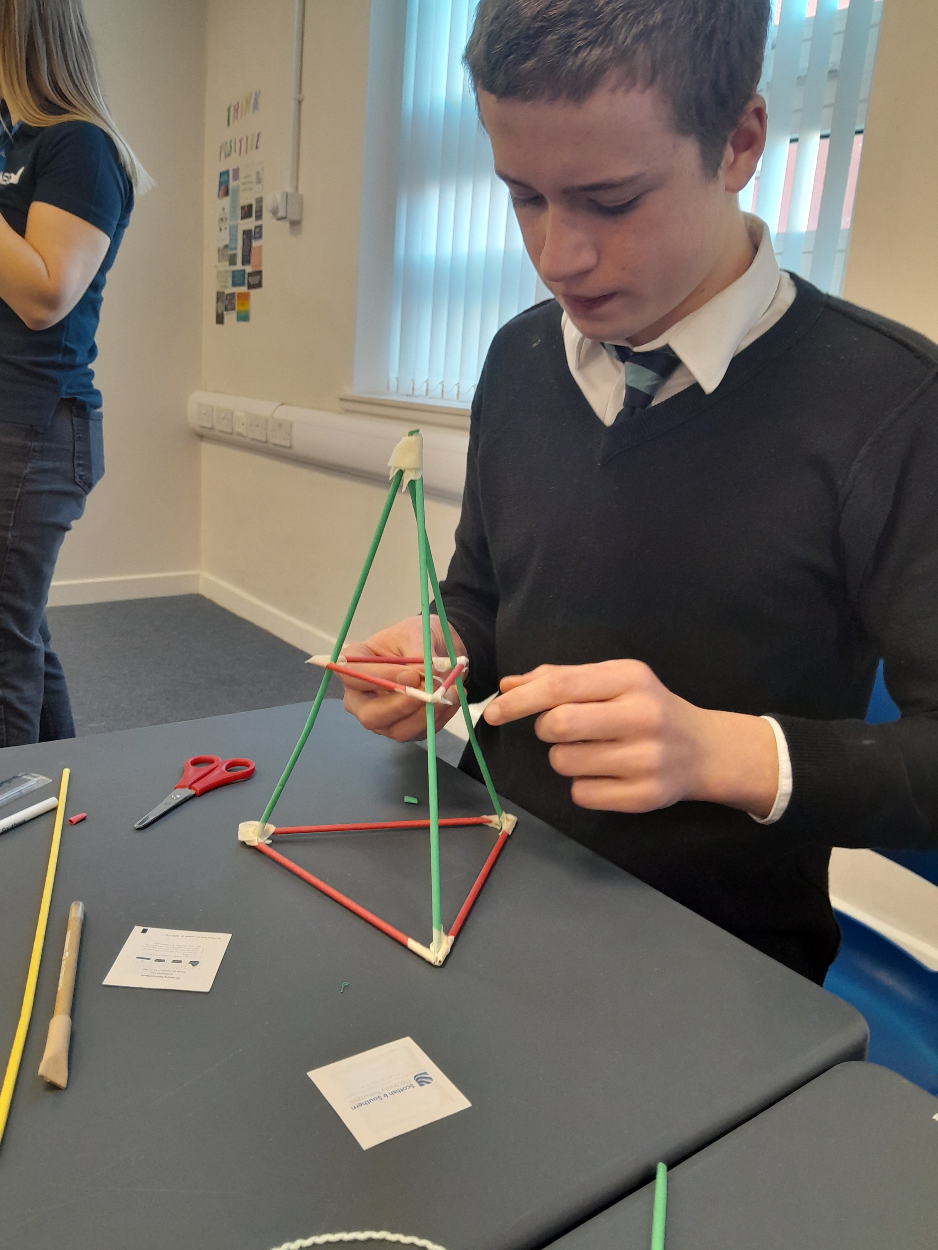
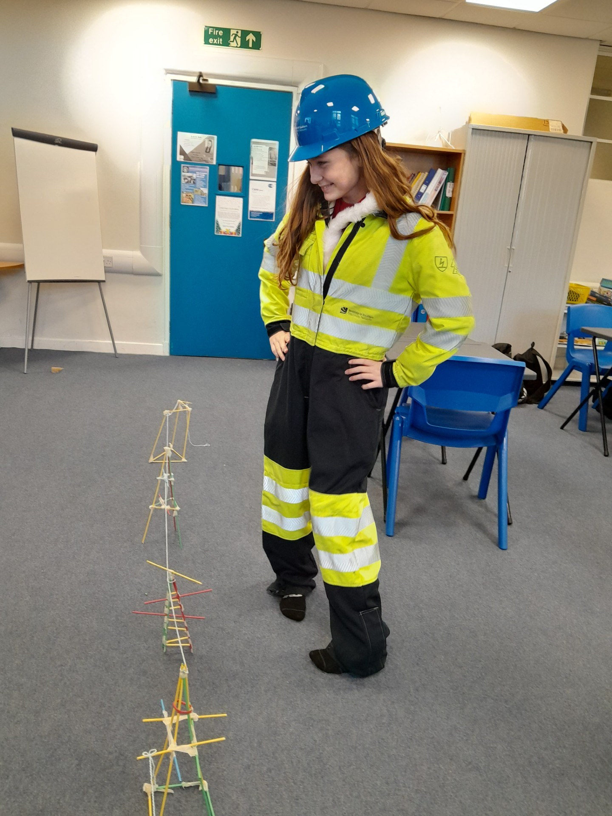
The pupils taking part in the workshop had signed up for the event with initial interest in STEM subjects. All of the pupils showed great enthusiasm, teamwork skills, communication skills and effective collaboration whilst building their Transmission Towers. At the end of the morning, all of the Transmission Towers were connected together showing the reality of how they are seen in our environment. The pupils were proud to see their end results.
All of the pupils’ creativity skills were revealed in their programming of the robots. Each pupil created individual codes and an HVDC Station Floor plan for their individual Ozobots. Some pupils in the group even created a civilised society amongst the Ozobots by joining up with others and creating order with the robots such as through a prison for them if they misbehaved…
Feedback from the S2 pupils was that this event was amazing, fun, epic and educational.
EDT’s Industrial Cadets is a widely recognised skills-based awards scheme, whose patron is HM King Charles III. EDT's range of projects, workshops and activities have been designed specifically to help students get future-ready by developing their key skills and by bringing the wide array of STEM careers to life with input from some of the most exciting names in Industry. By completing the activities, students will receive a Challenger level award and can celebrate their achievements with a digital certificate and badge.

Expressive Arts
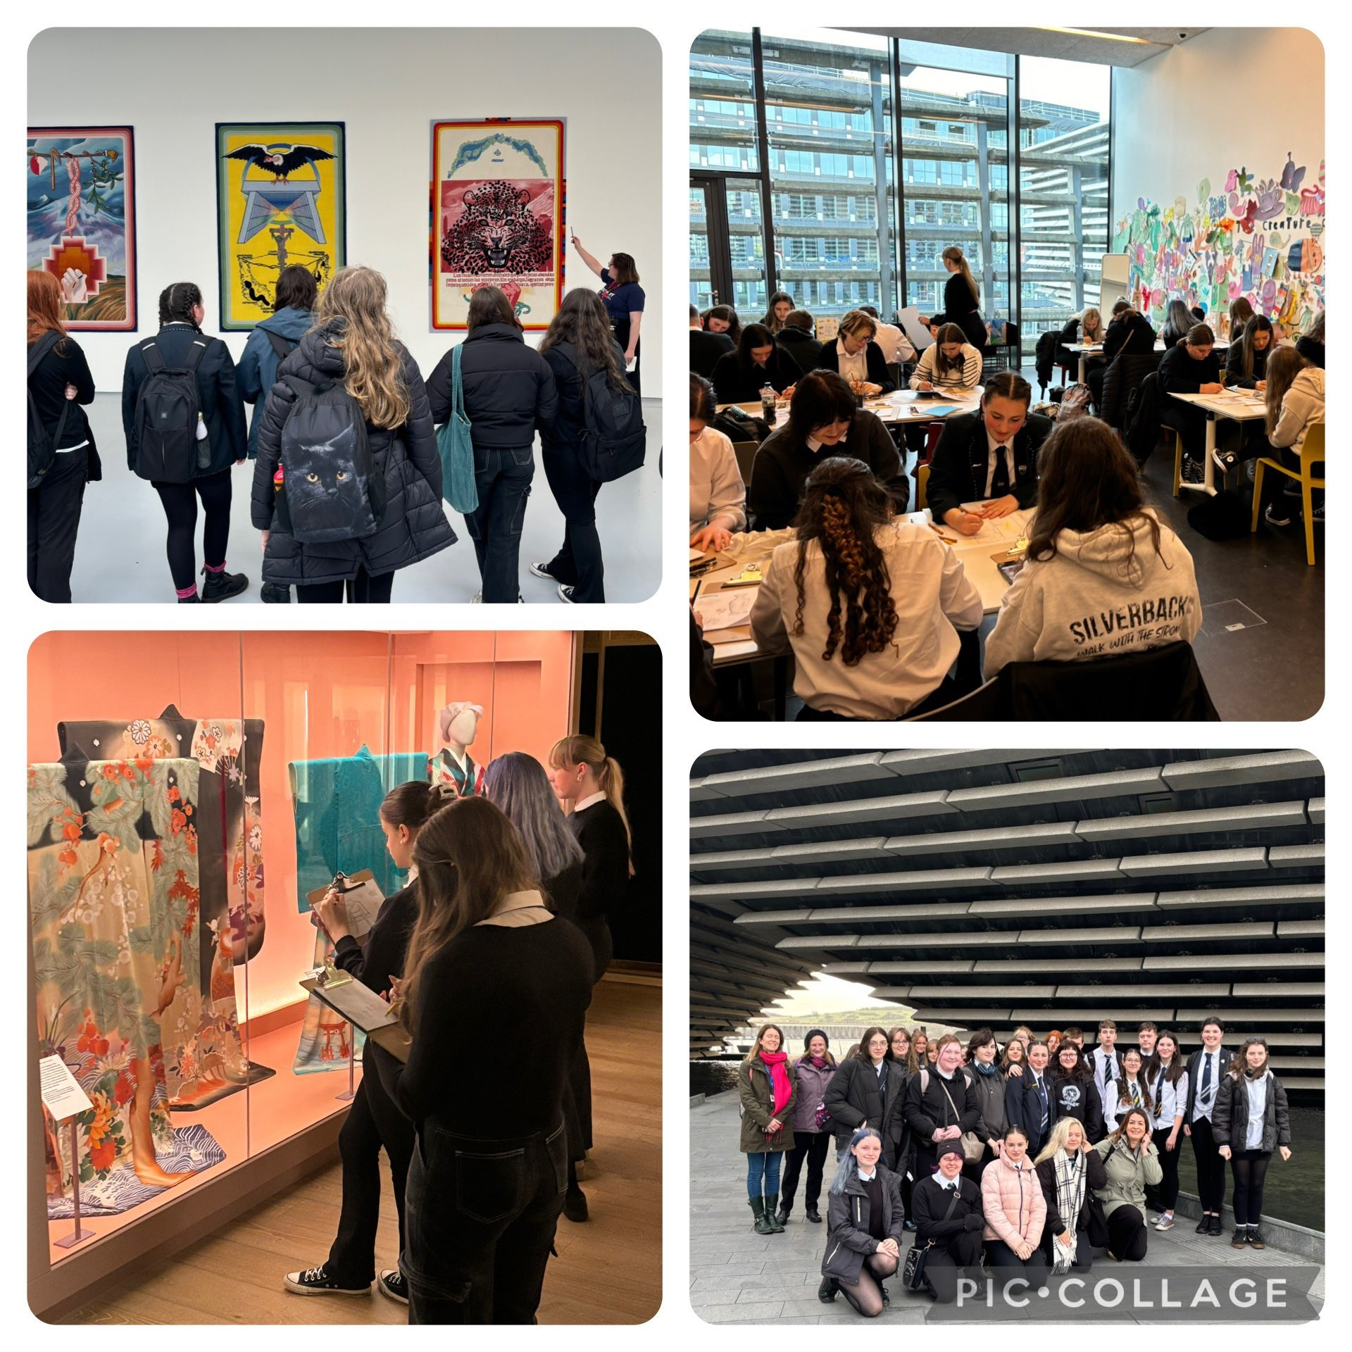
A fantastic day out at the V&A Dundee, DCA and McManus Galleries in Dundee. Our artists were engaged & inspired. Gallery staff commented on how impressed they were with Webster's pupil's behaviour & manners.
Creative Careers
At the start of November, the Expressive Arts Faculty hosted a Creative Careers Event. On Tues 5 November, some of our senior pupils went to a Backstage Pass event hosted by the RSNO. They heard from industry experts about how to build a career in the arts - including the idea of a portfolio career - creating a unique role for yourself by bringing together interests and skills across multiple disciplines. They also had the opportunity to network with employers in the industry such as Scottish Opera, National Theatre Scotland, Scottish Ballet, RSNO, Dunedin Consort and more.
Later in the week our S2 pupils took part in a variety of Creative Workshops, which included things such as an Introduction to Sound Engineering, Creative Sketchbooks, Musical Theatre, Stage Make-Up, Illustration and Computer Game Design. At the end of the week, a group of pupils were treated to a performance by former Katie Nicoll who is now working as a musician and artist. This has become a regular feature in the S2 calendar and is a great opportunity for our youngsters to learn about the broad range of careers available within the arts
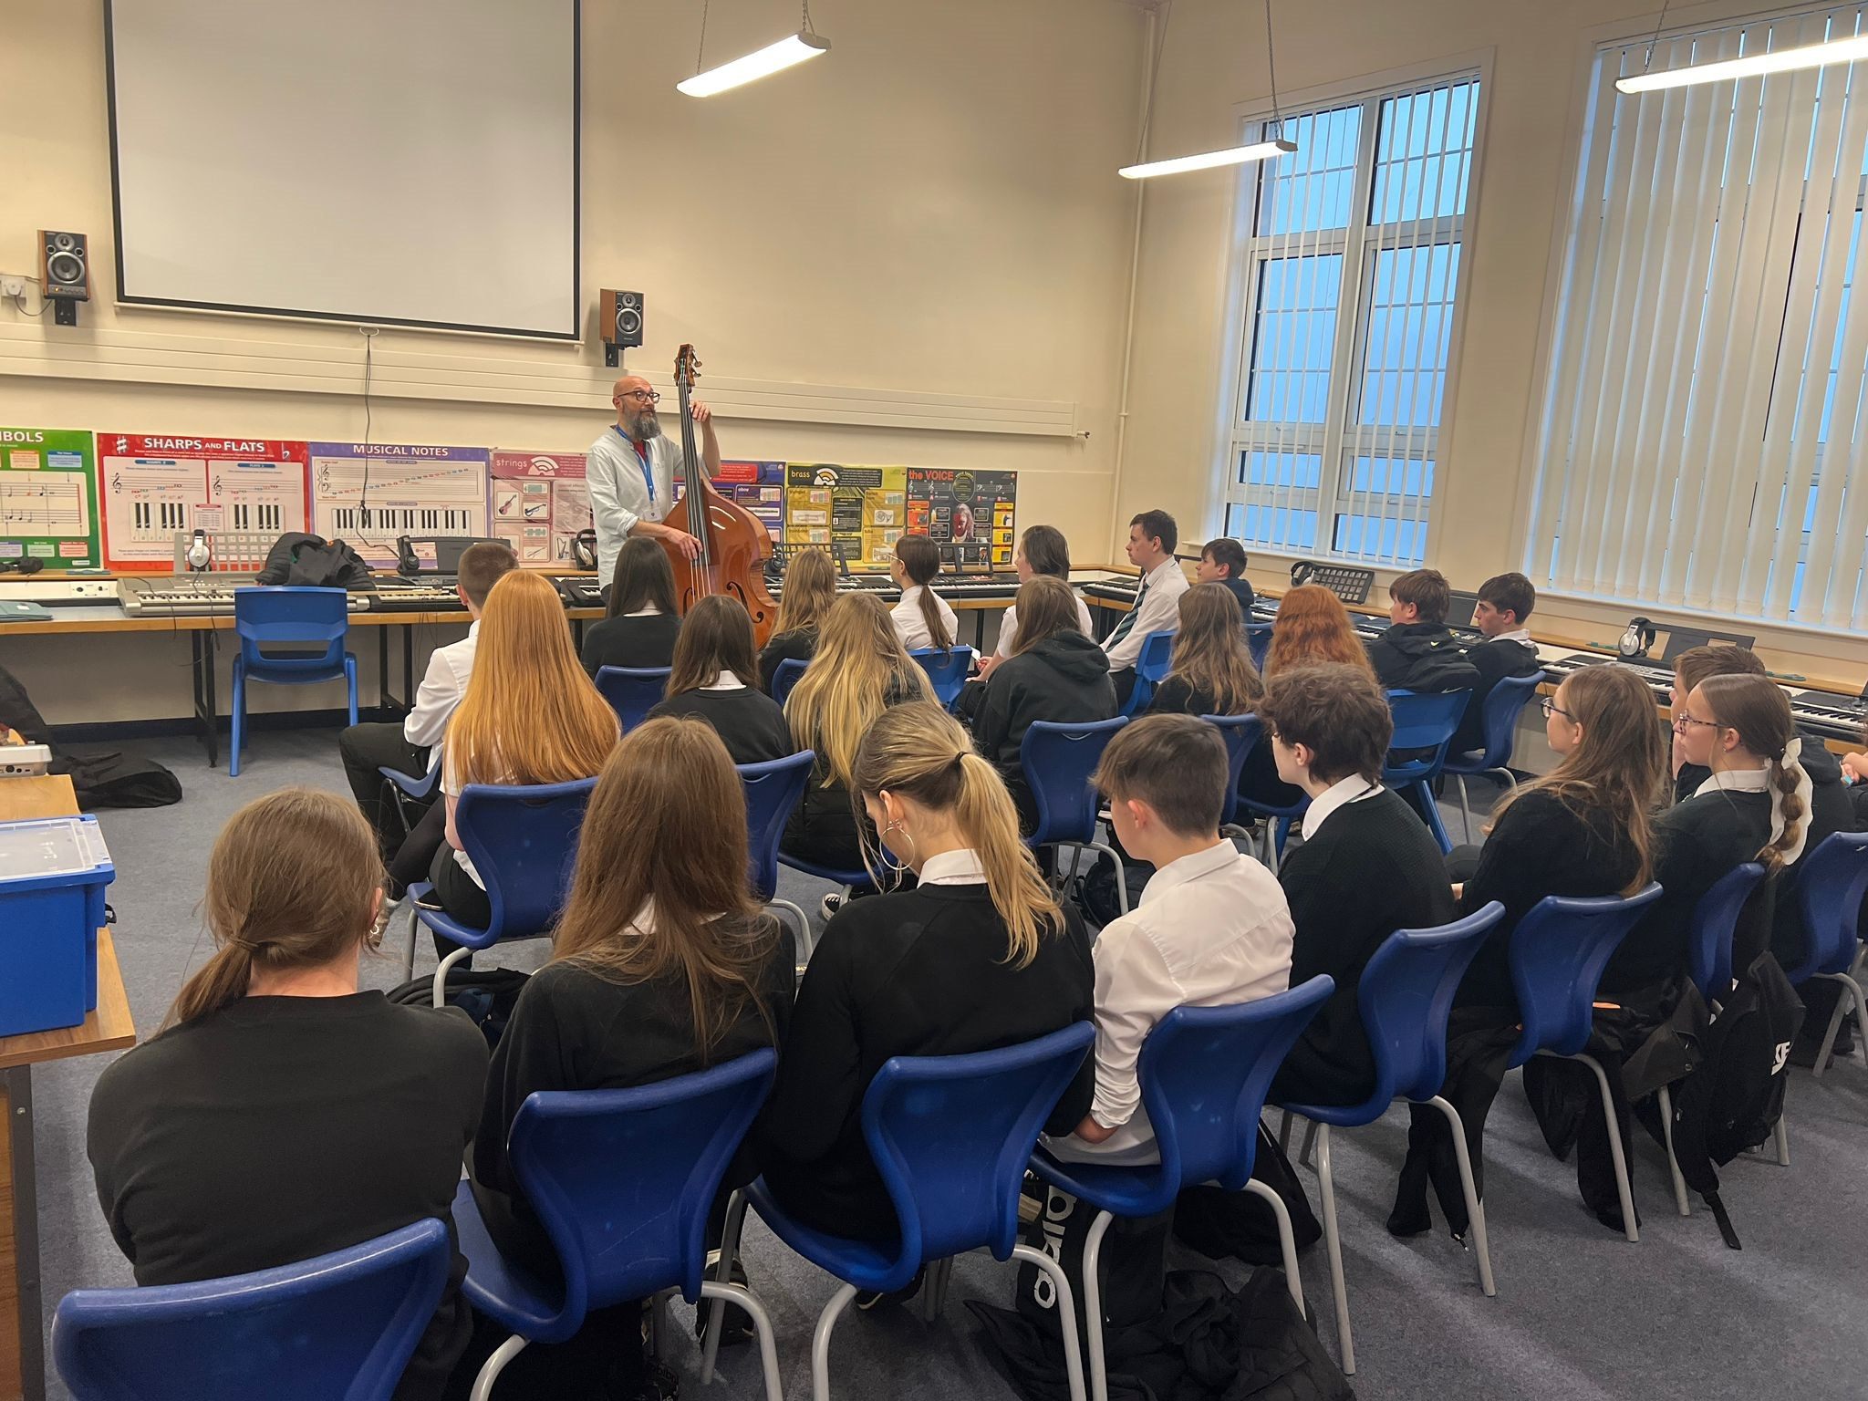
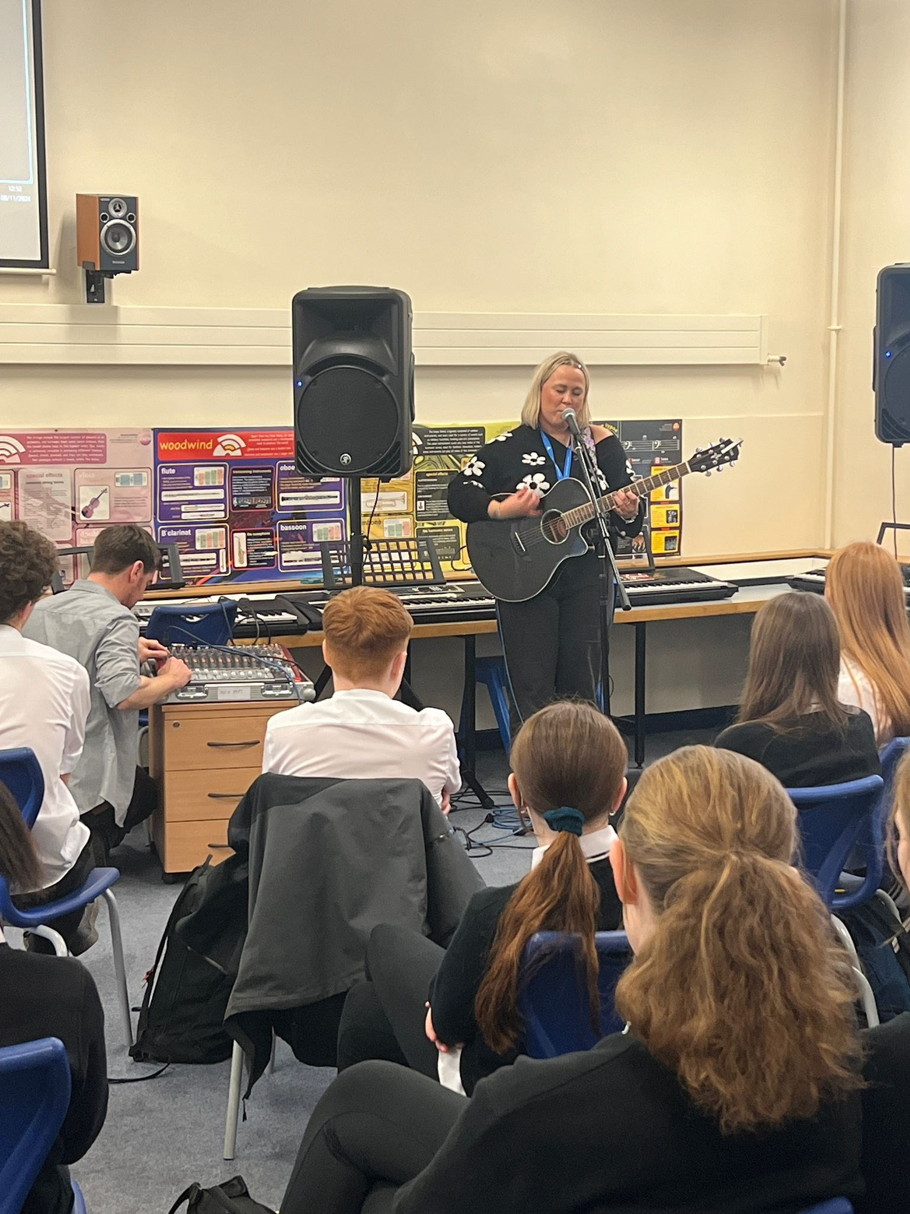
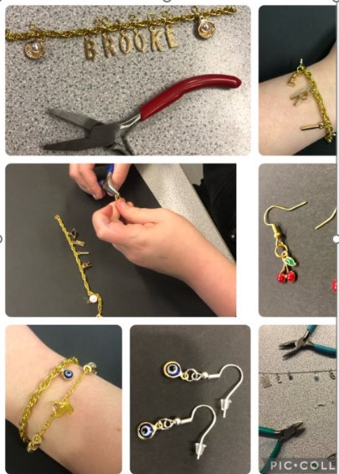
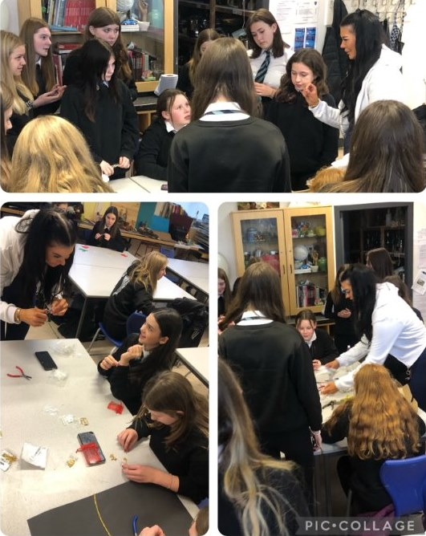
Christmas Show
Congratulations to all pupils who were involved in both the Webster's Christmas Concert and the Angus Regional Christmas Concerts which took place this week. The performances were superb and we are really proud of each and every one of you! We would like to say another thank you to Angus Glen's Rotary Club who donated a further luxury Christmas Hamper to be raffled off. They are proving to be very popular! Sales from raffle tickets raised approx. £170 for the expressive arts Department and, including a few donations £2000 was raised in total..
Enjoy your holidays and a well earned rest!
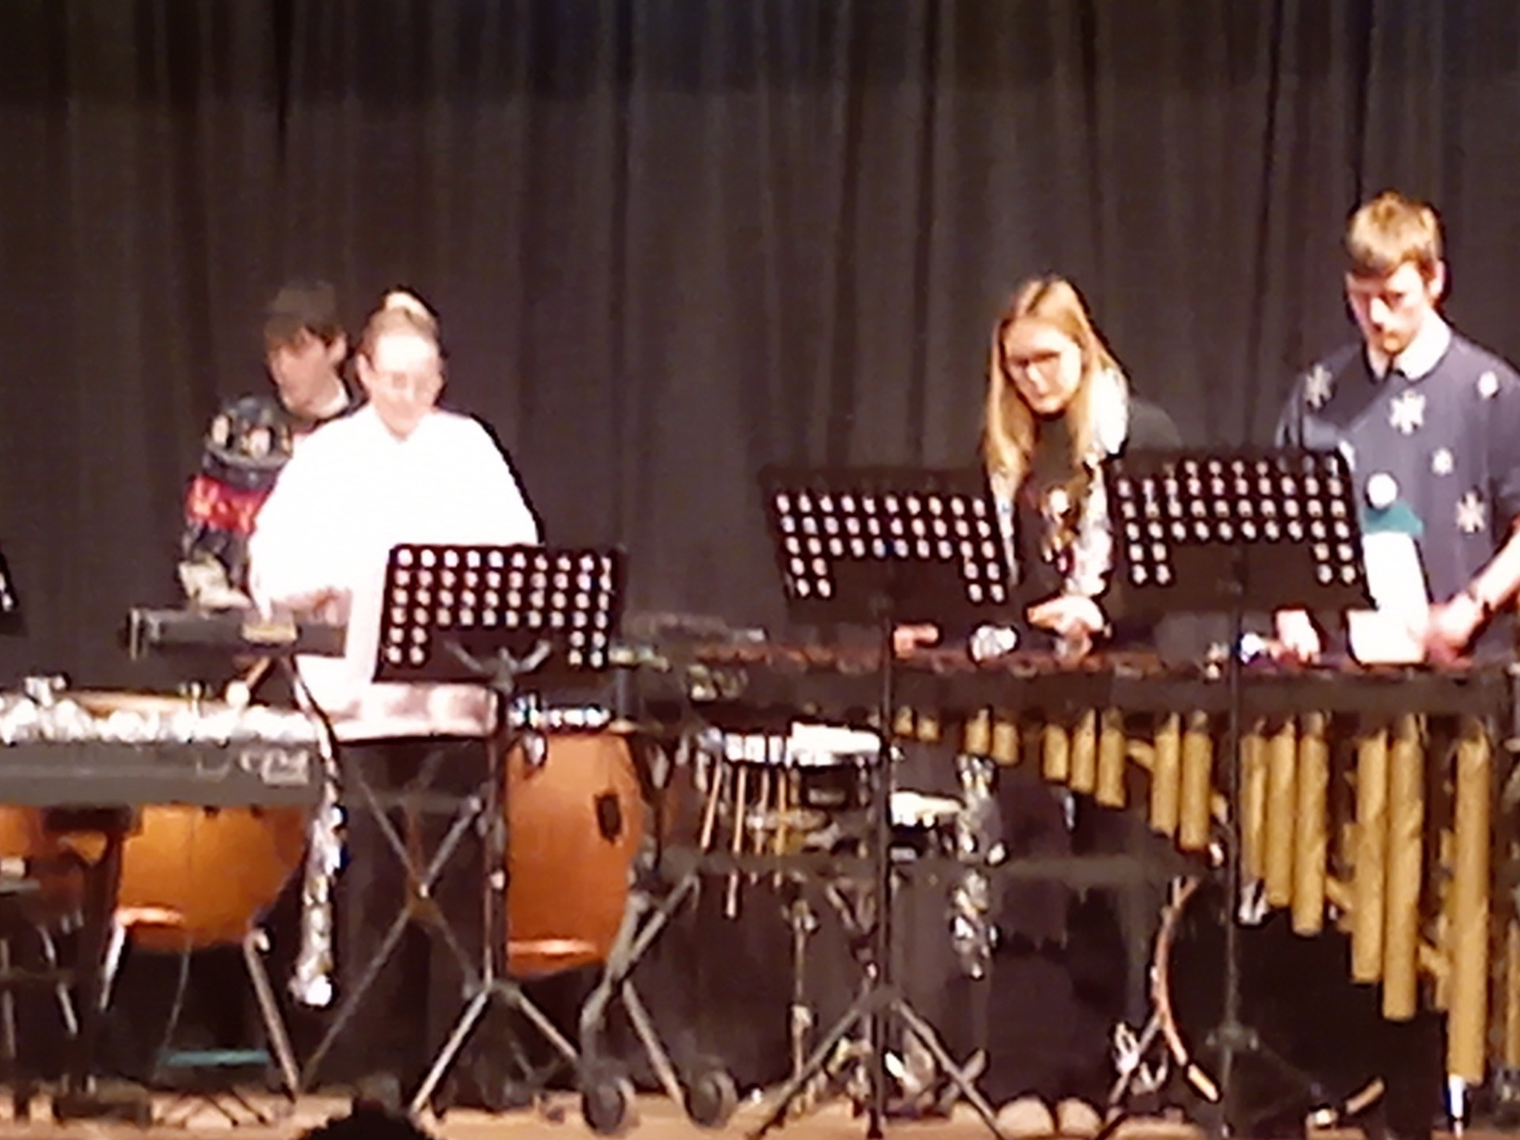
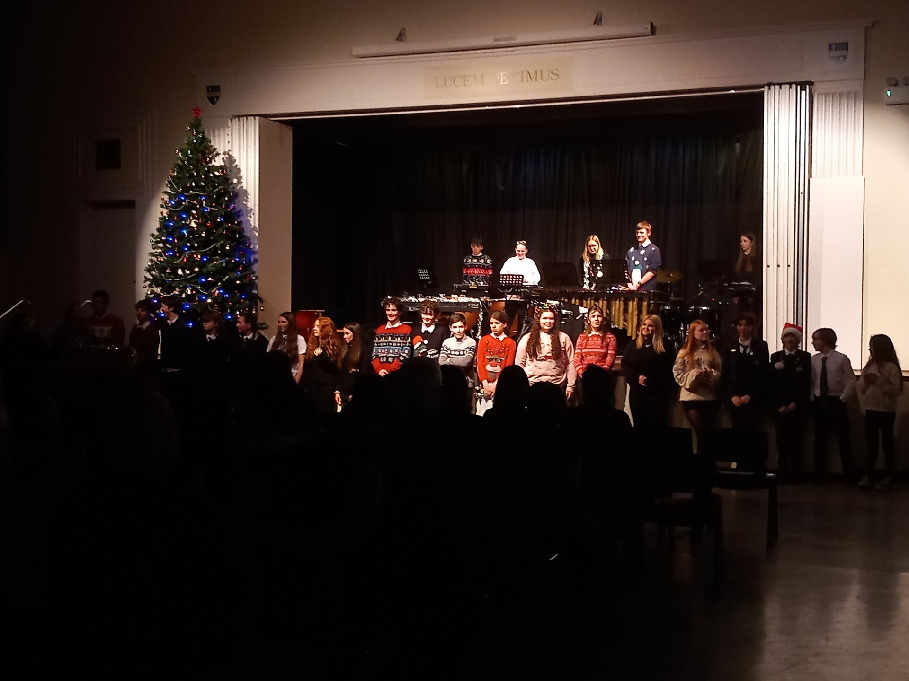
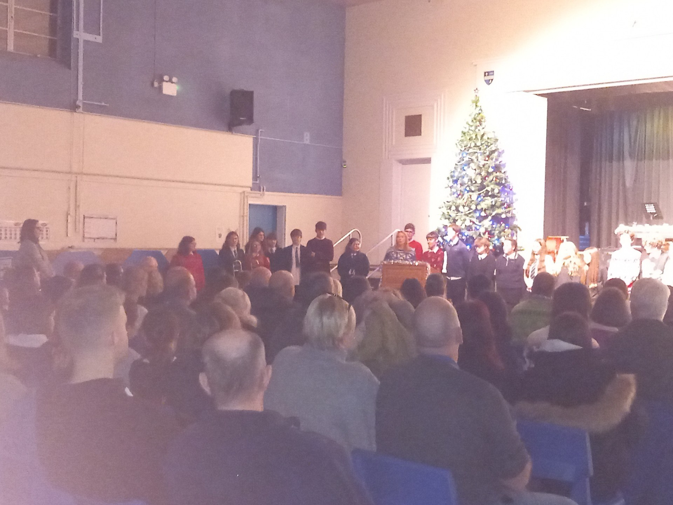
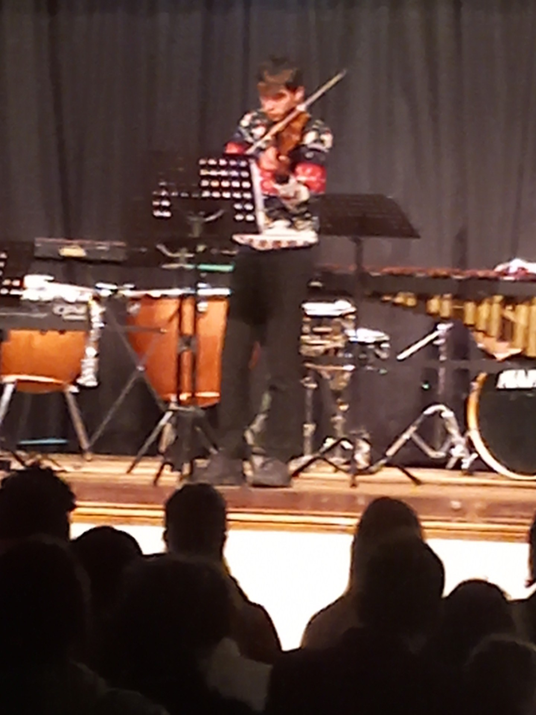
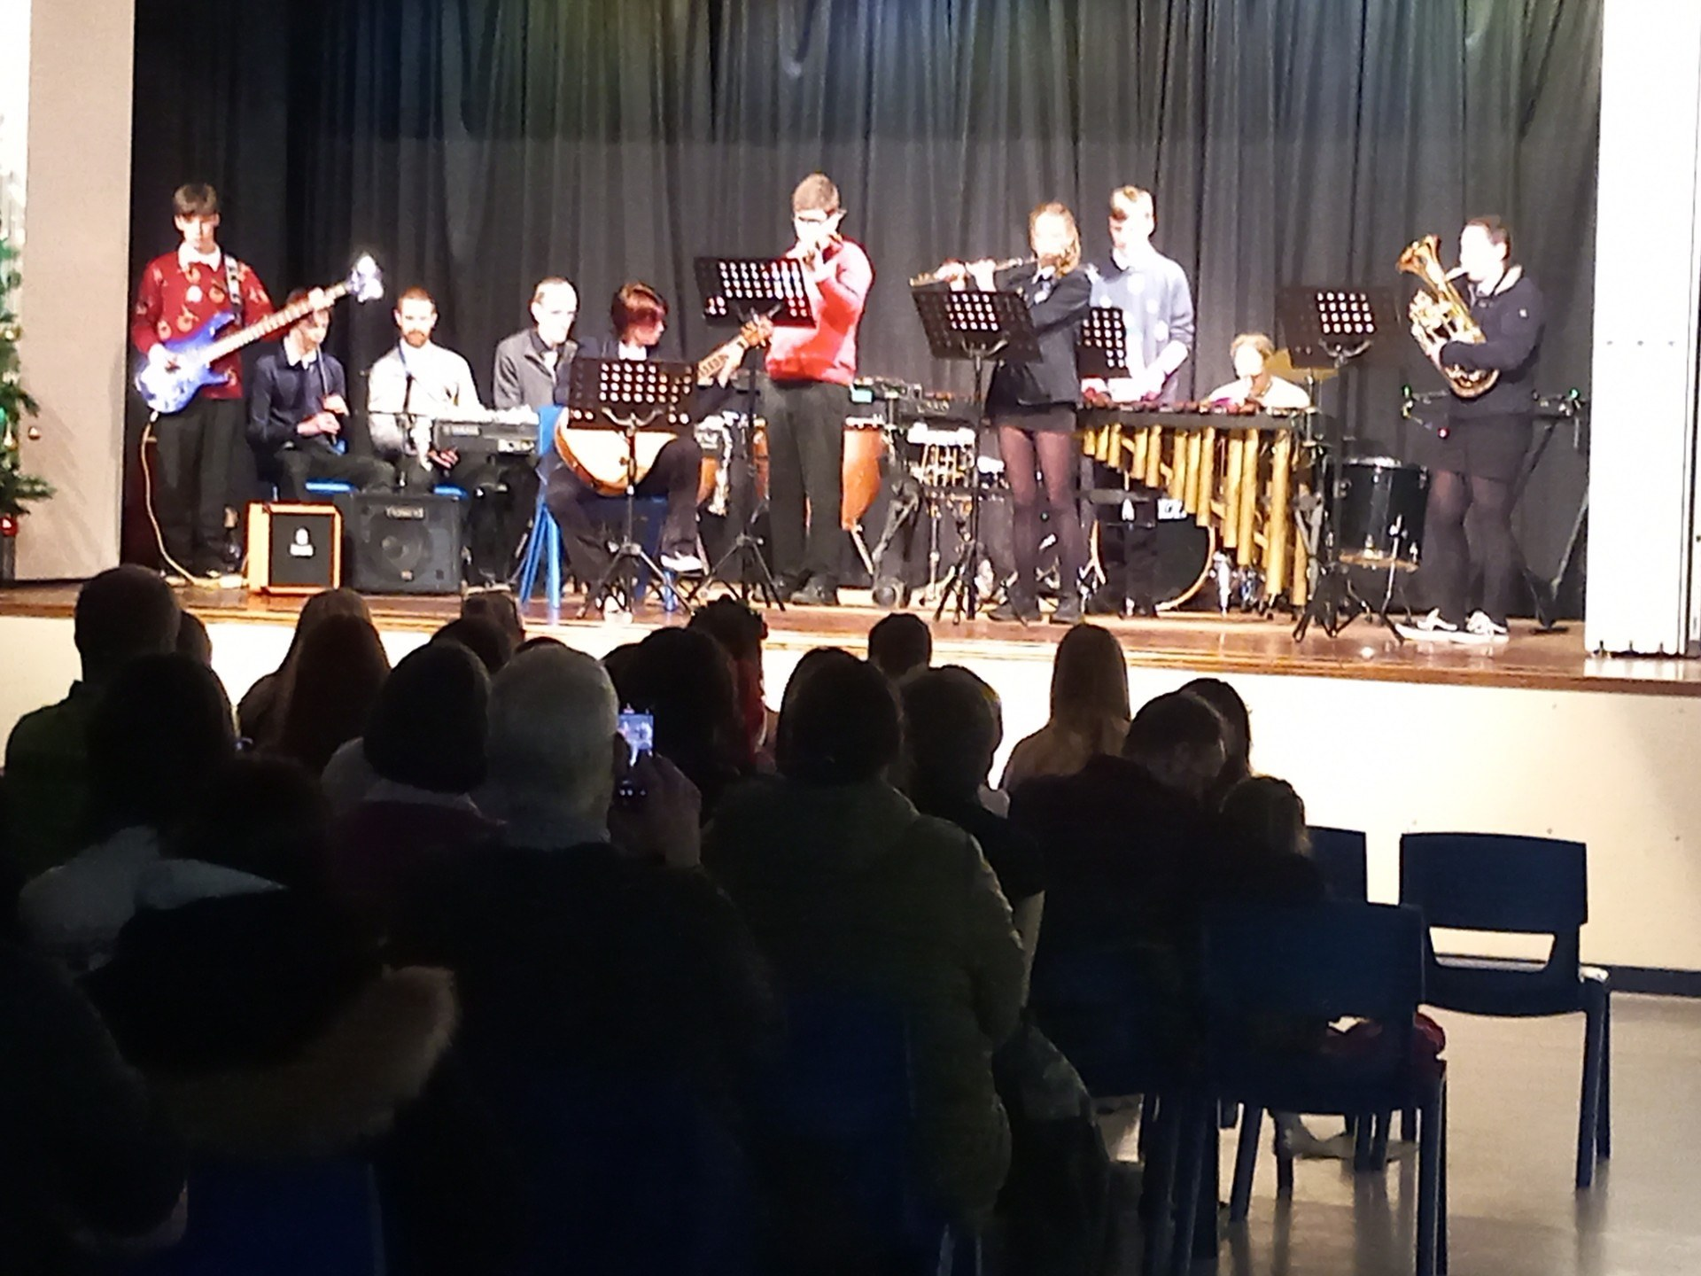
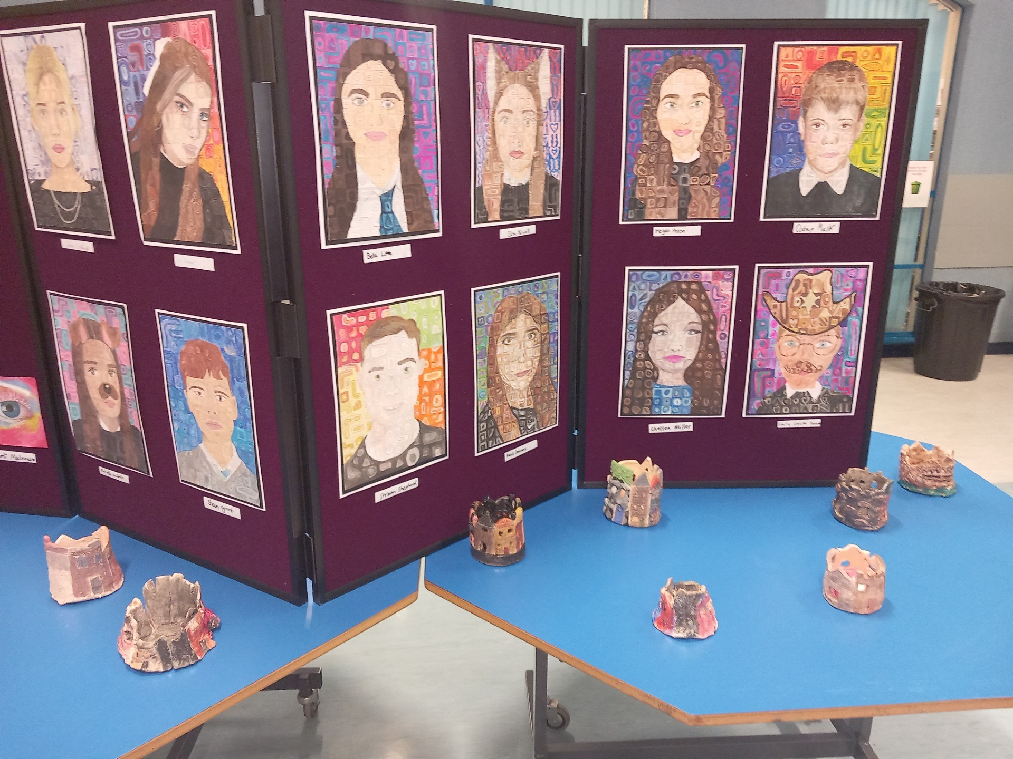
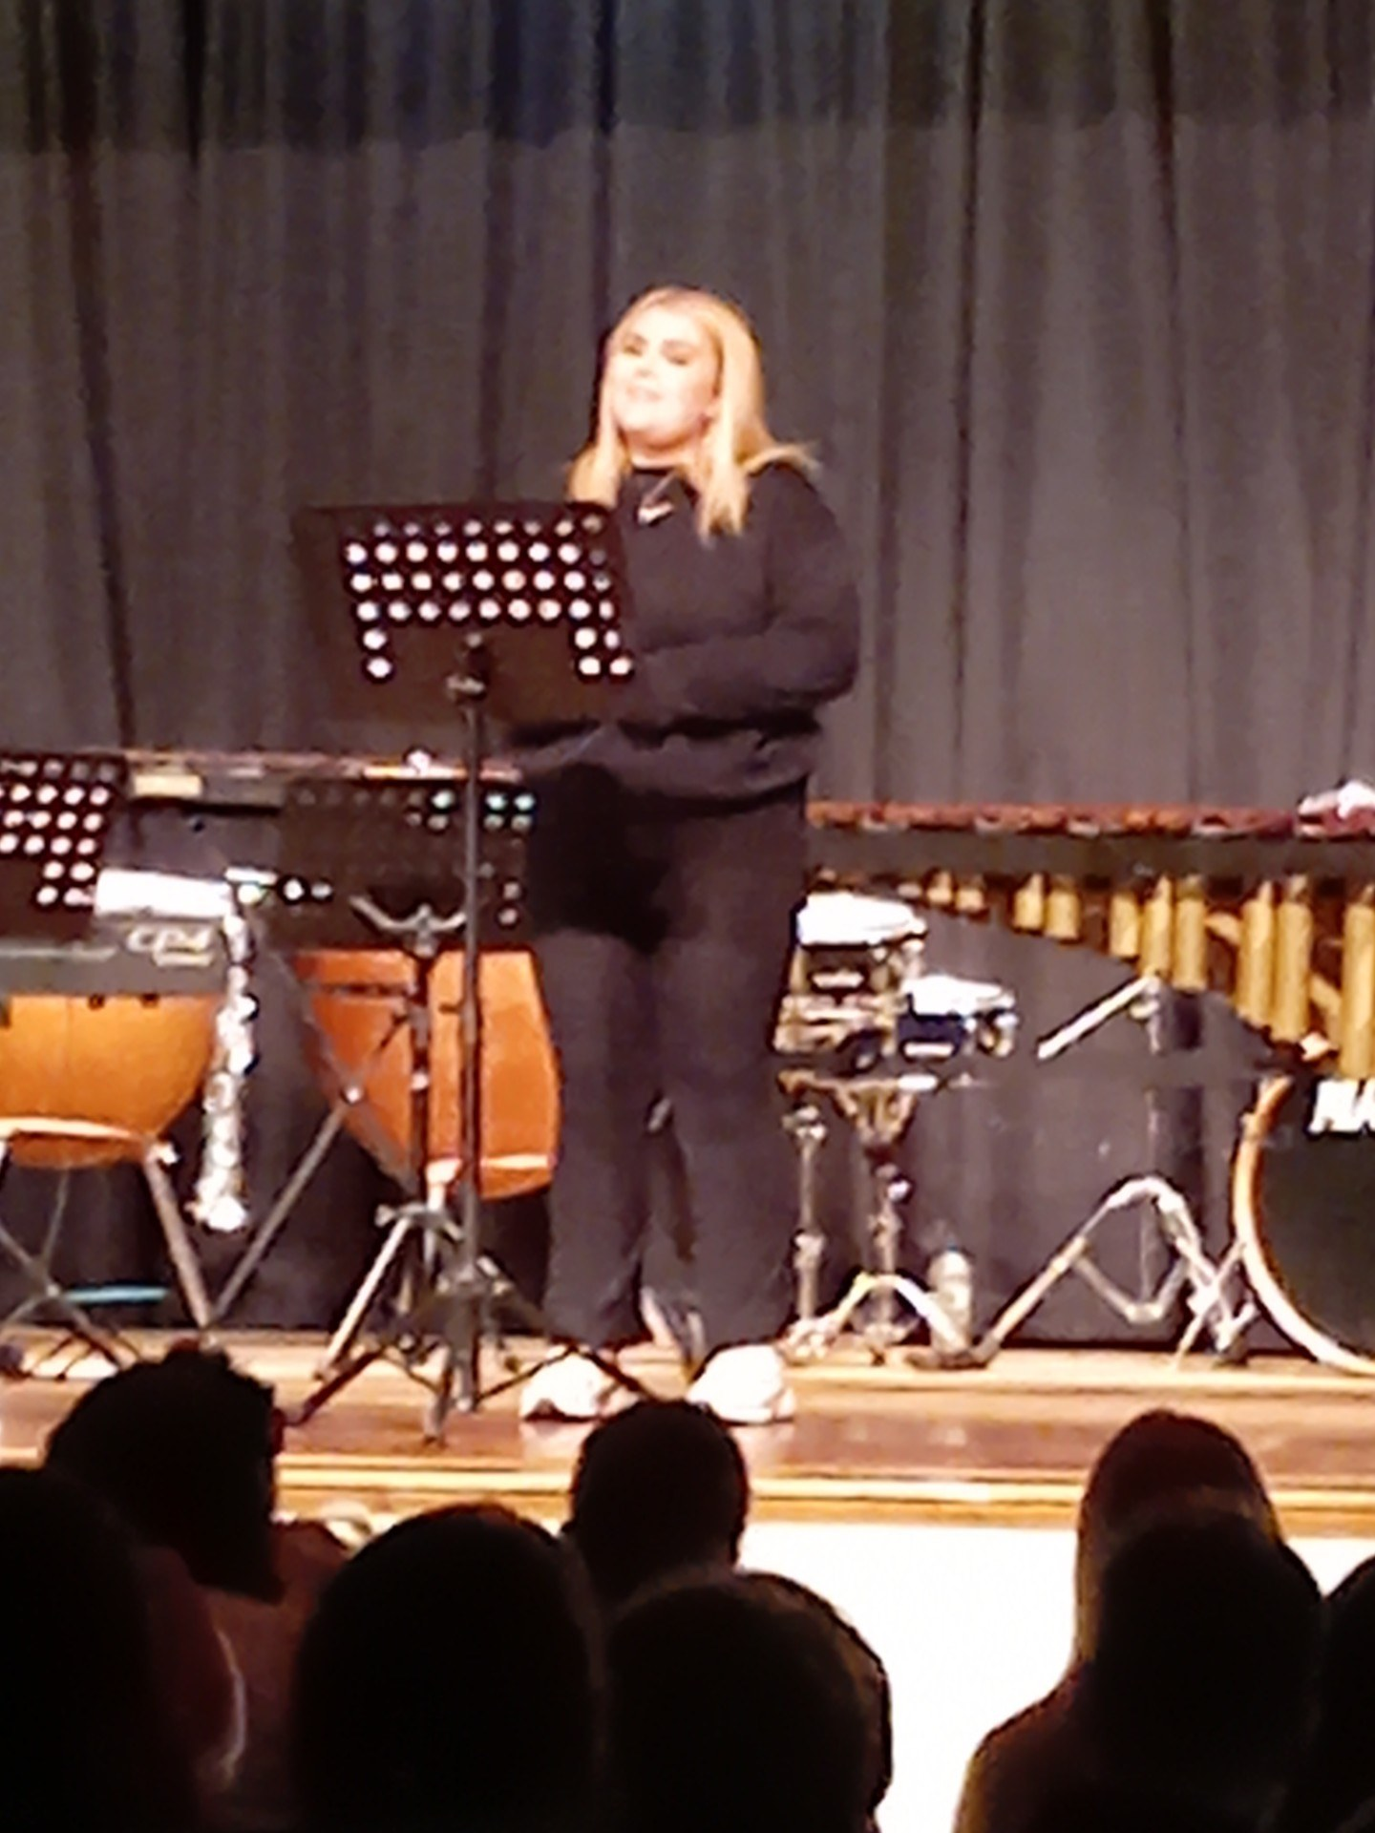
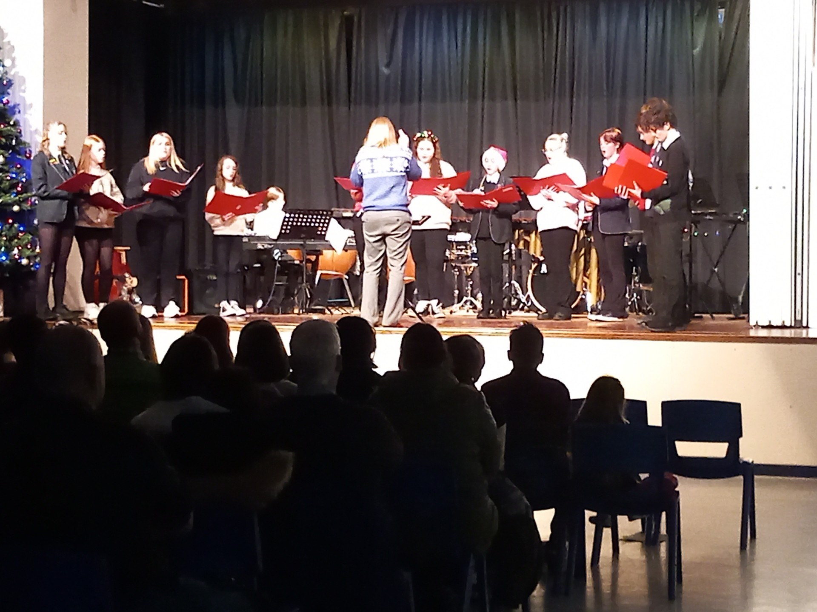
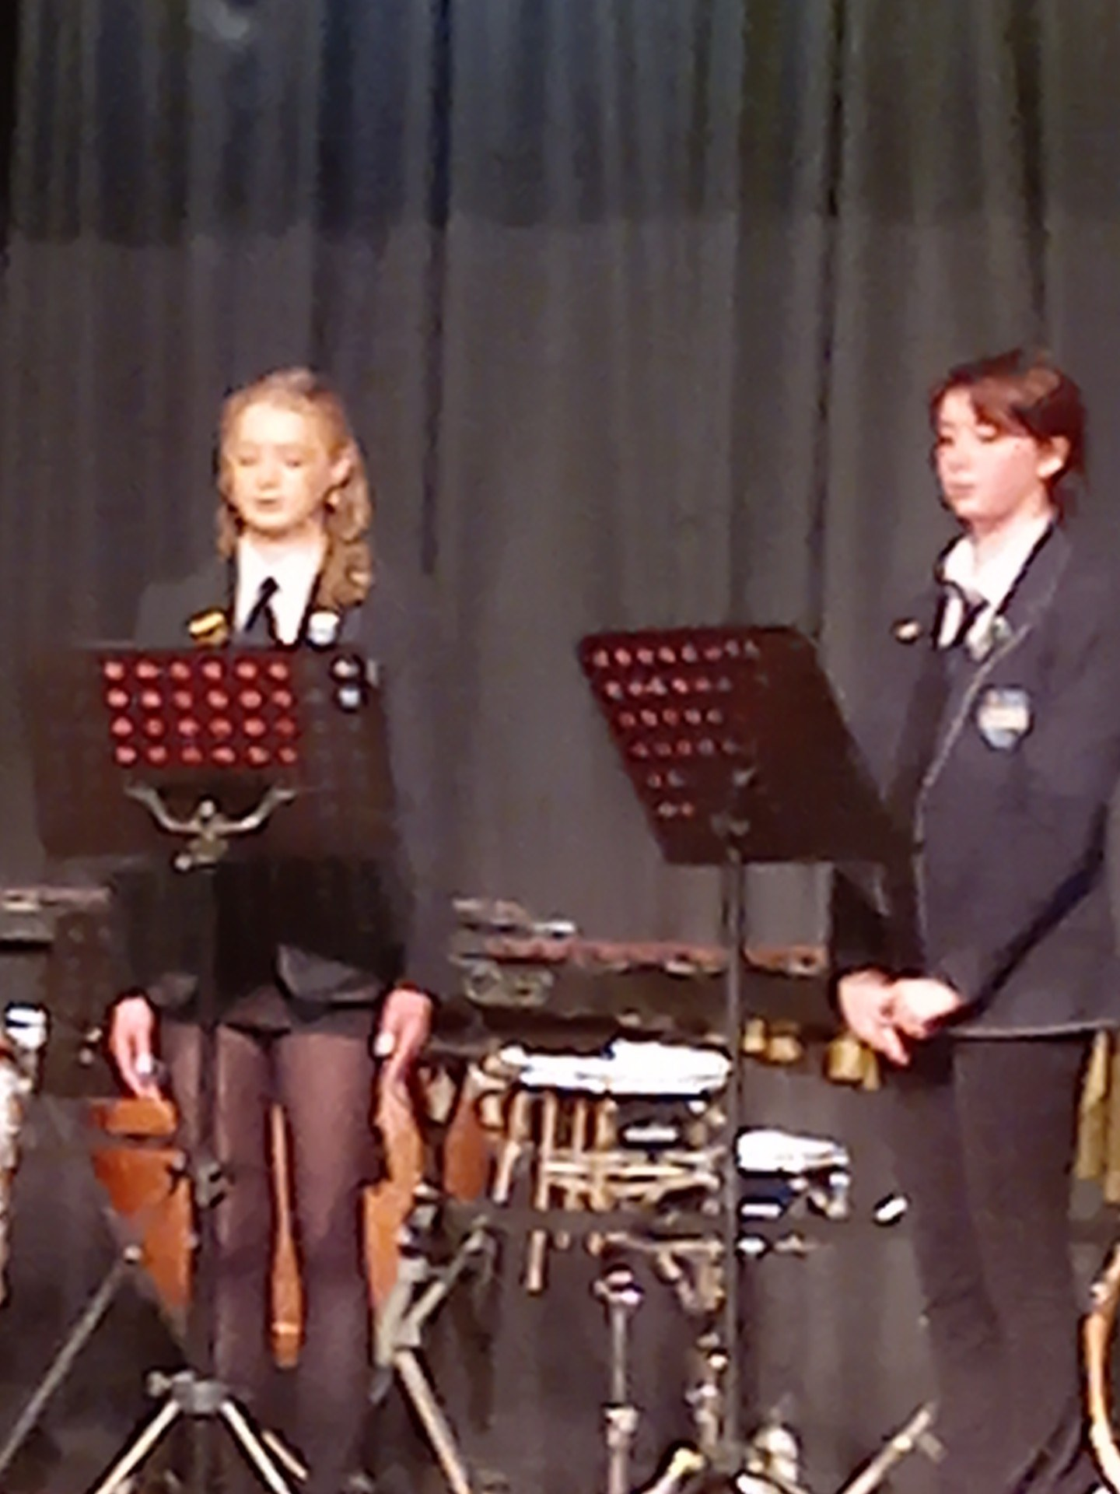
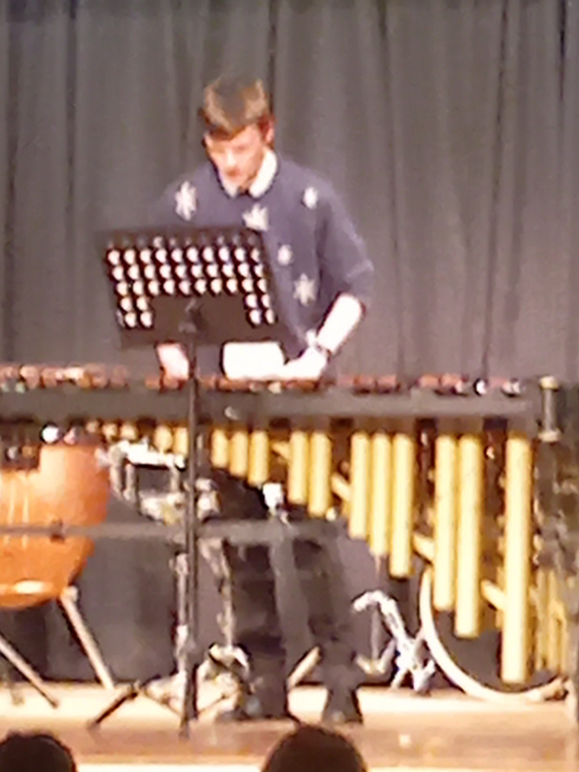
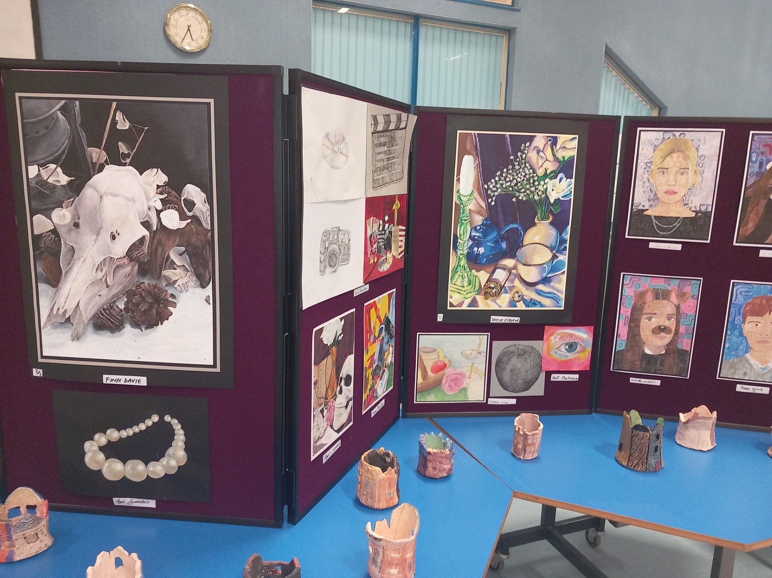

Language and Culture

French - Volvic – Collège Victor Hugo
This year we are delighted to have re-established our link with the high school in Volvic, as this is Kirriemuir’s twin town in France. It is our S3 French classes who have been communicating with pupils at Collège Victor Hugo and both schools wrote and exchanged letters in September.
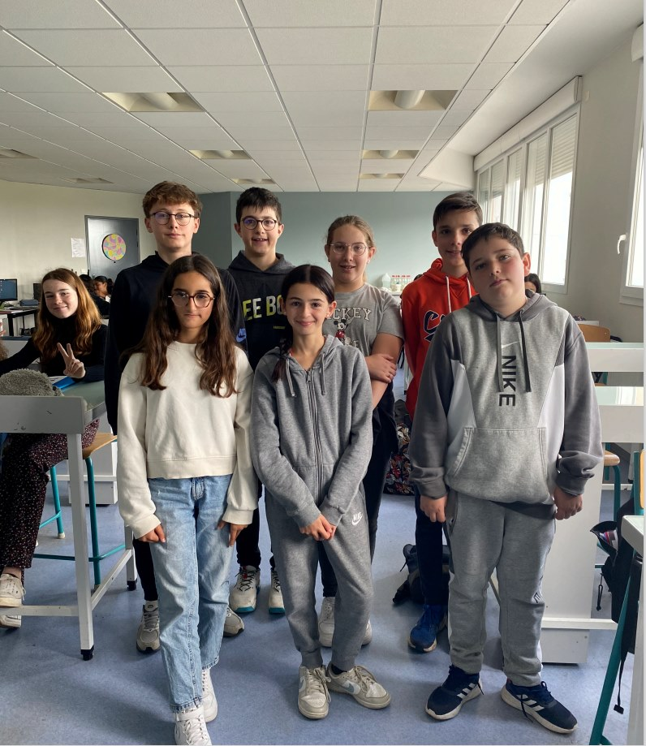
In term 2 both schools have been creating a digital magazine, using the language which they are learning, about our towns of Kirriemuir and Volvic and these will be shared between schools before the Christmas break. Both of these tasks have allowed the pupils to improve their foreign language skills as well as making new friendships. The photo show some of the pupils from Volvic who have been communicating with our S3 pupils.
Spanish
On Wednesday 13th November pupils from S3 - 6 Spanish classes hosted pupils from Foramontanos secondary school. They enjoyed participating in a range of communicative activities and making new friends. The Spanish pupils were very impressed with Webster's and were envious of the wide range of subjects on offer here. Our pupils enjoyed the opportunity to practise their Spanish and became more confident as the day progressed!
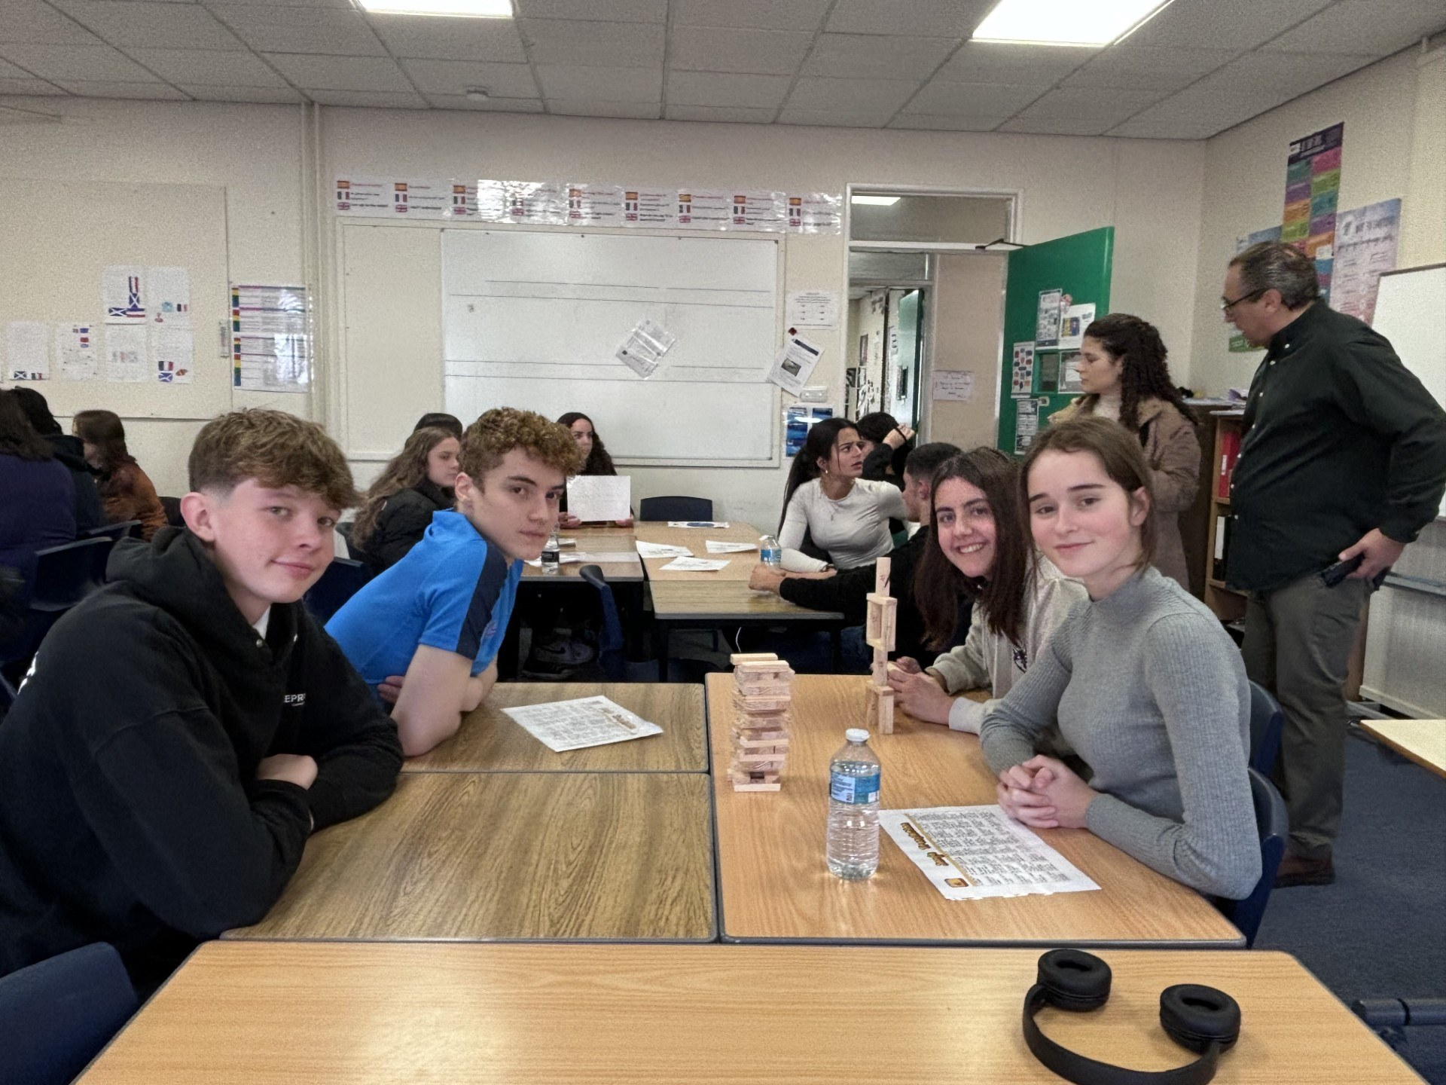
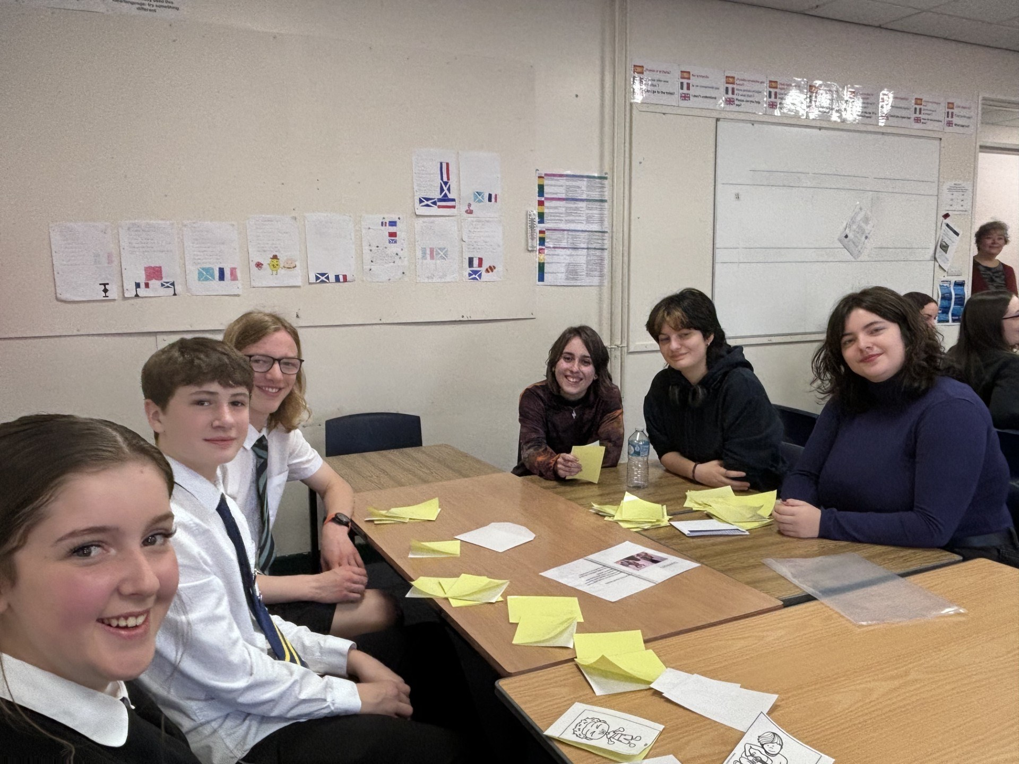
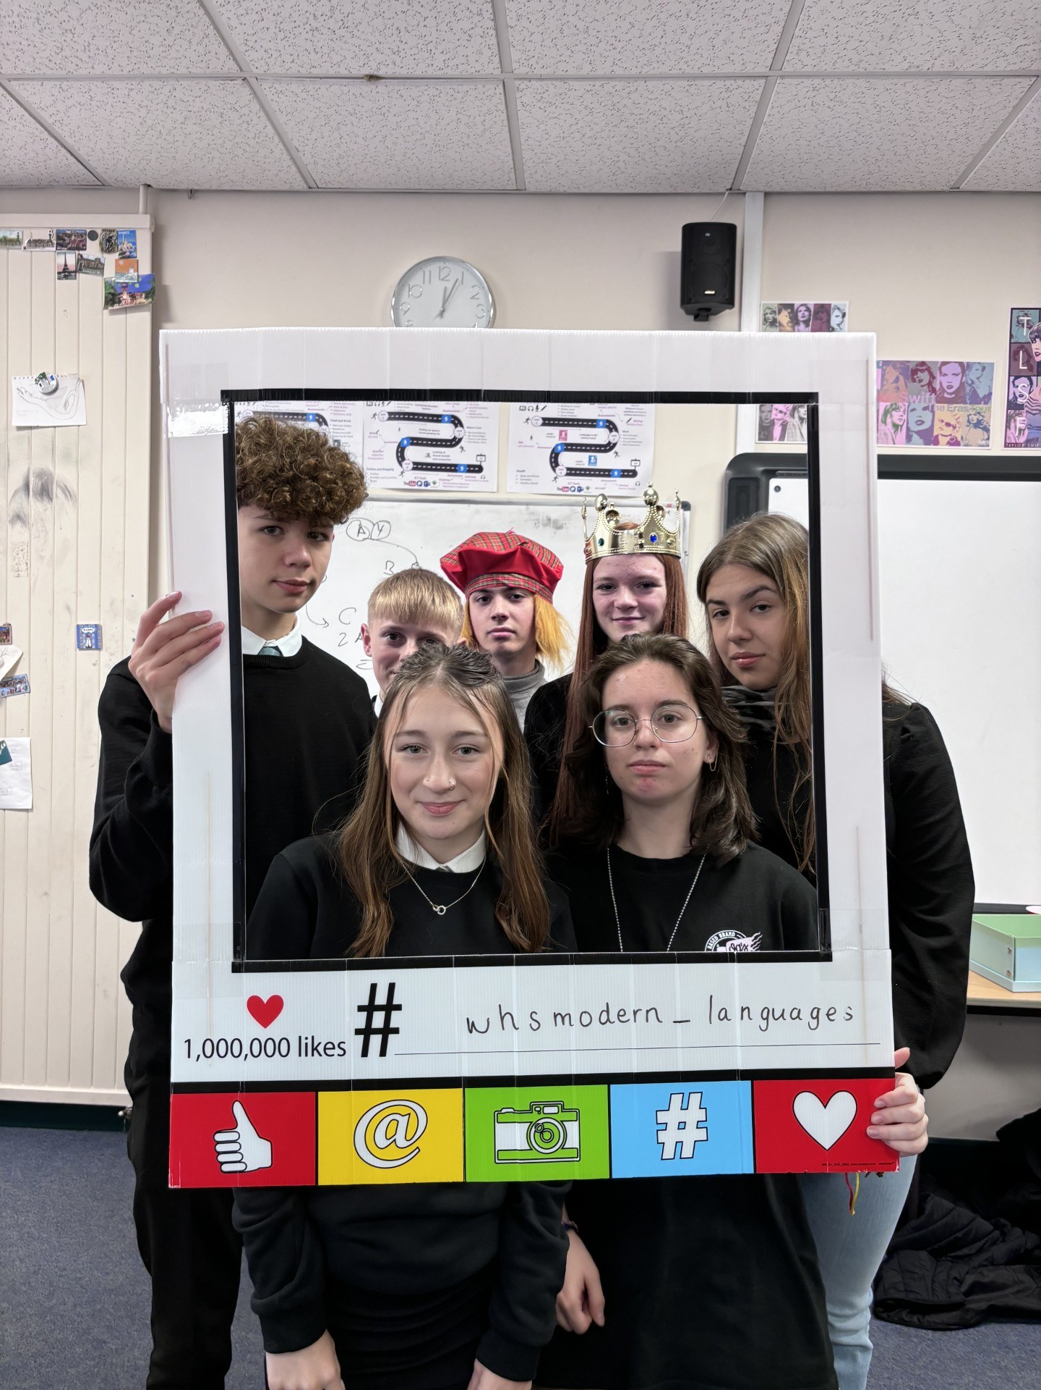

Literacy
Update from the School Library
This past term, the school library has been very busy:
- The paired reading scheme is back up and running, with S6 volunteers helping S2 pupils read through books and stories. It has had visible benefits for both parties’ confidence. Reading is crucial to developing vocabulary, which helps pupils access the wider school curriculum. It also great for relaxation.
- The reading group put together a quiz in November, with a book token prize (see photo).
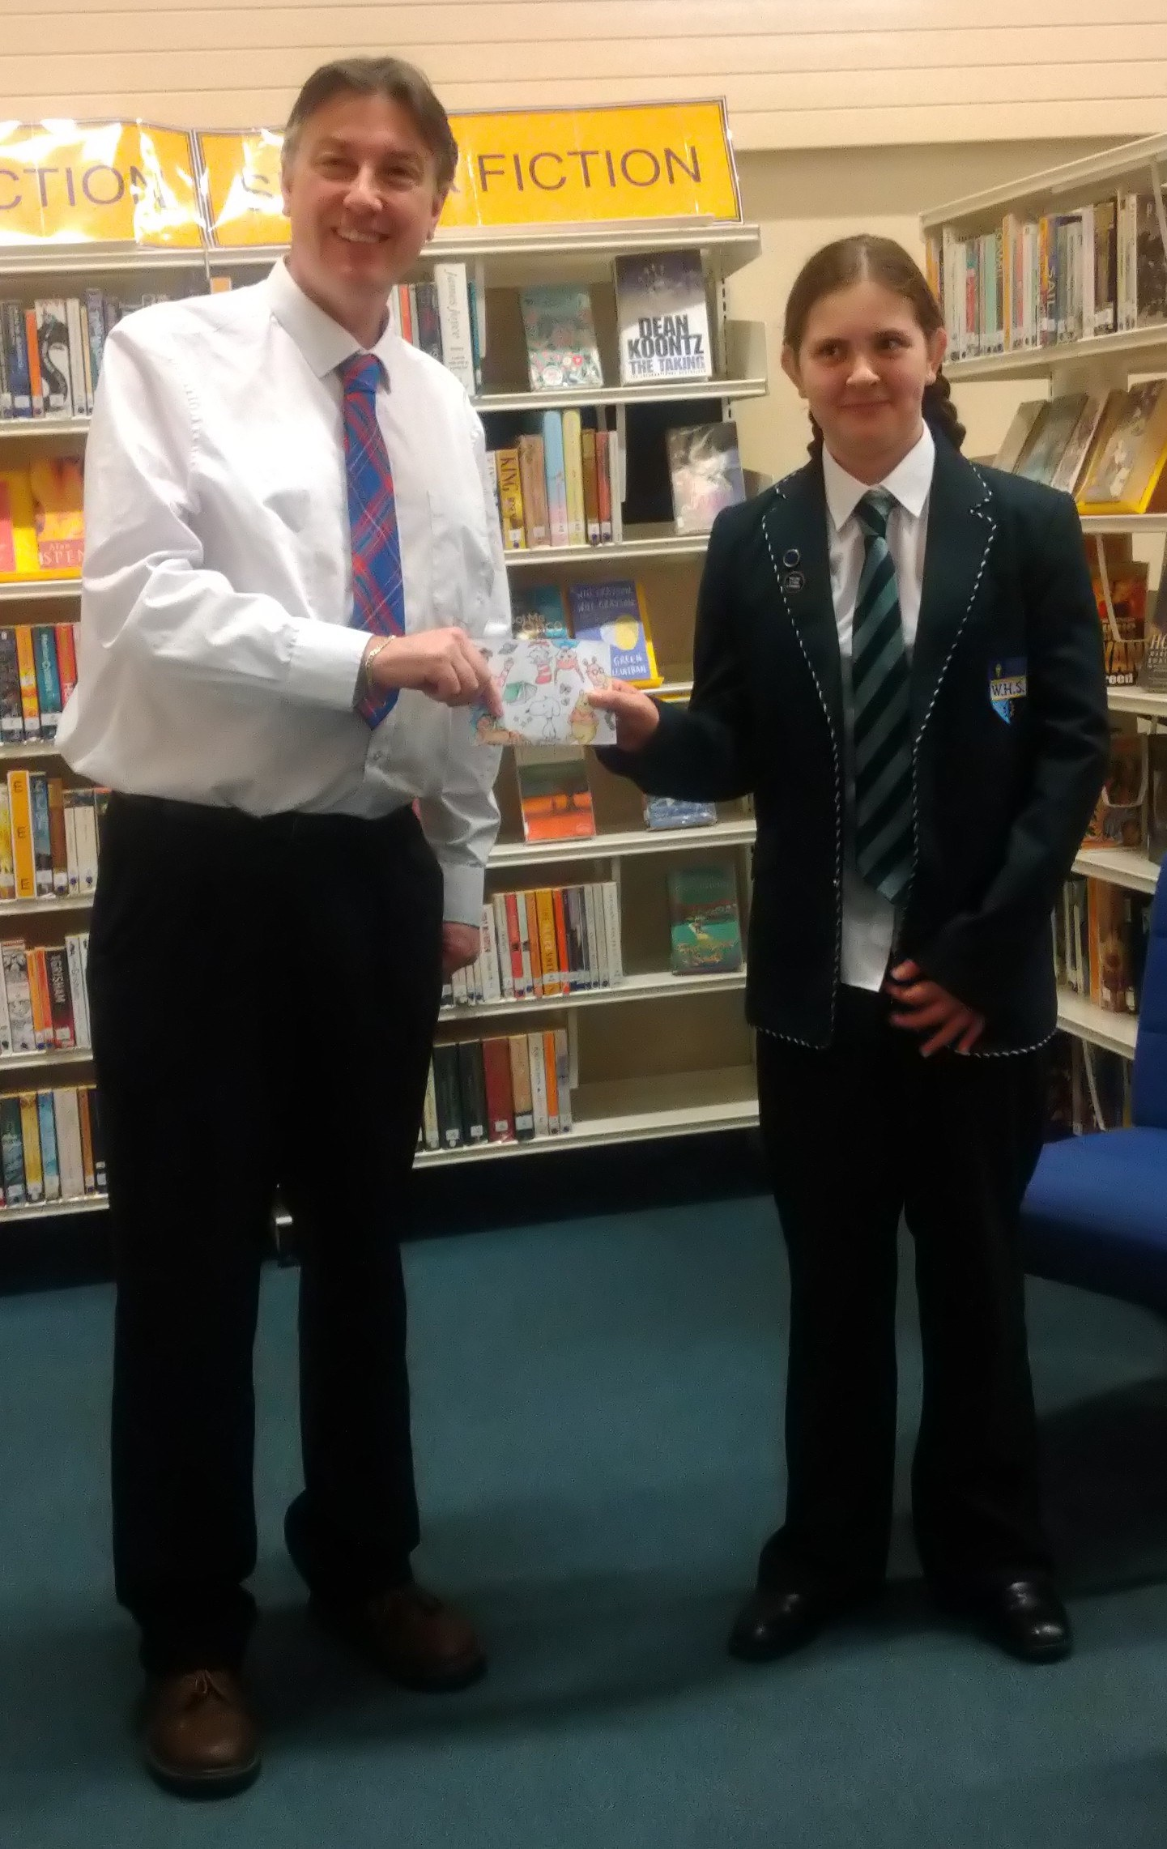

- The Scholastic Book Fair was held in November and proved even more successful than last year’s, due to having a stall at the Christmas Fair this time round.
- The library colouring sessions continue on Thursday lunchtimes for mindfulness and relaxation. It’s amazing how therapeutic this can be for people of all ages!
- The Christmas Quiz was held and Leah McDonald S4 won! Leah won a tub of Quality Street, and four new books: The Little Pocket Book of Pug Wisdom; The Vampire Prince; This is How You Fall in Love; and A Different Sort of Normal.
- We had our author video talk on Wednesday 18th December with Rebecca Yarros, who wrote Fourth Wing and the Romantasy series
- We rounded off the year with a showing of Elf starring Will Ferrell, over two lunchtimes on 16th and 17th December.
Thank you to all the pupils and staff for making 2024 a good year.
Have a great Christmas and have a Happy New Year. Keep on enjoying reading over the holidays!
Mr. Robertson

Parliament Trip – S5
On Monday 4th November, 6 pupils from S5 were given the opportunity to visit the Scottish Parliament in Edinburgh to find out more about the importance of language and how is used in the day-today-function of the Scottish Government, and in making law.
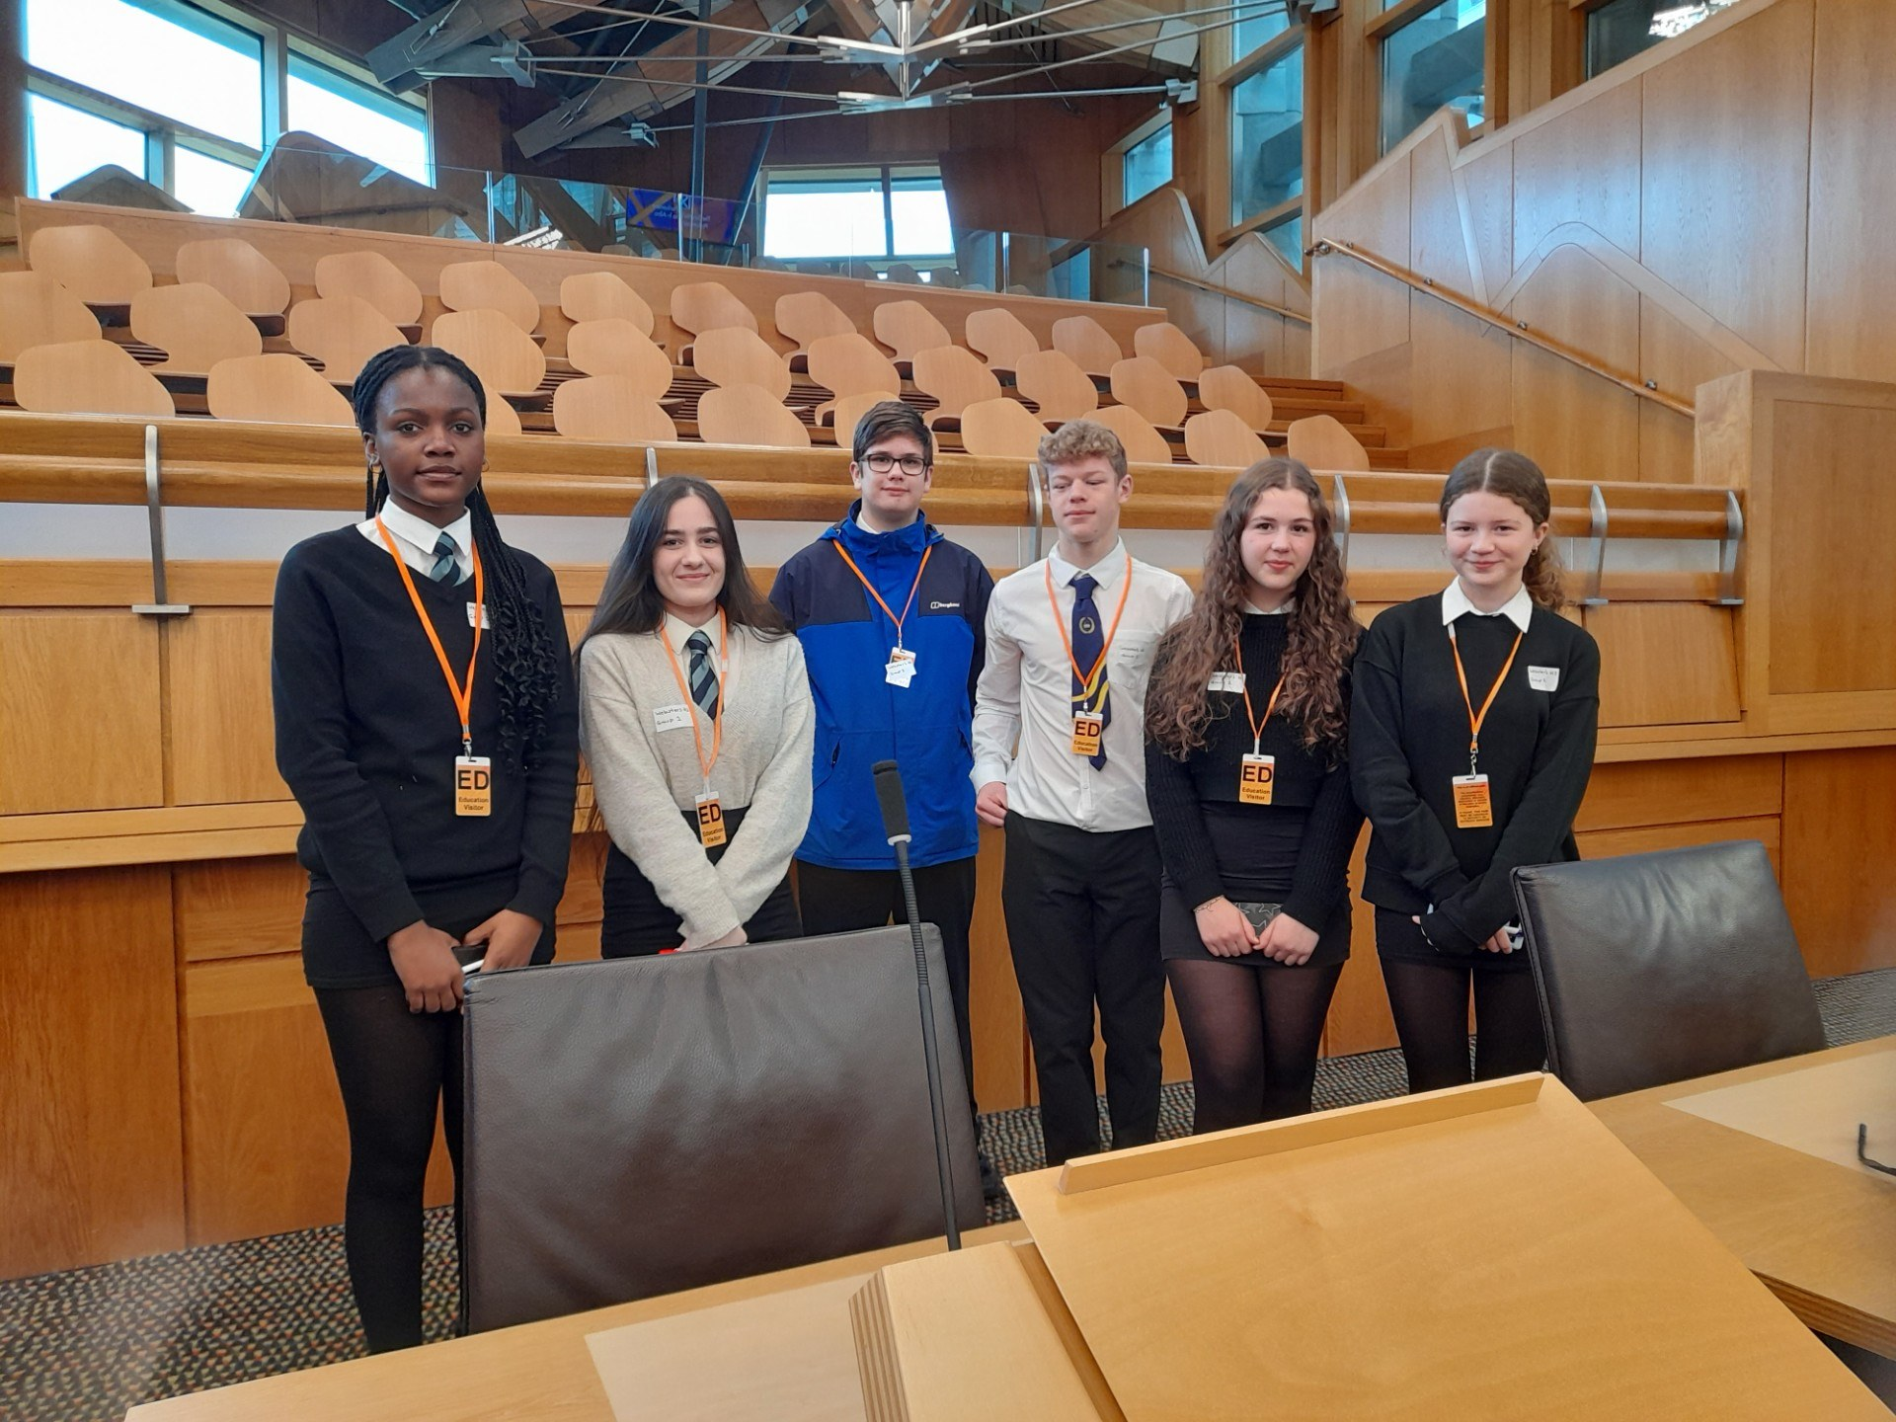
The first session was a SPICe workshop. Parliament’s internal research centre provide impartial, factual, accurate and timely information and analysis. MSPs and Parliament staff use this for parliamentary business so the emphasis was on the importance of clarity and brevity.

The second session was on the Official Report where the woman who spoke to the pupils, Claire Bennett and her team, prepares an almost word for word written record of everything said in public meetings of the Parliament and committee. Here, we explored the skills involved in creating an exact record of what MSPs say whilst emphasising the importance of editorial judgement.

After lunch, we learned about the construction of Bills & Legislation. The Legislation team manage all parts of parliamentary bill processes. Through a presentation and use of a mock bill, the pupils explored how language must be unbiased, persuasive, and clear when making laws.

Before the trip, I never appreciated just how much language was used in politics and the passing of bills. I realized how much difference the wording of a sentence can make to our understanding of any sentence which was really interesting, and now has also allowed me to notice the structuring and syntax of language more often.

Learning for Sustainability -or as Webster's like to call it: learning to make the world a better place!
Bee Keeping
As you may remember, Webster's received their first two beehives during the summer holidays from Baldragon Beekeeping Association (Baldragon Academy, Dundee). With support from the Angus Glen's Rotary Club and Pathhead Stables, the hives were established at Pathhead Equestrian Centre. This term, Mr Robertson (computing teacher) and Mrs Hunter (DHT) have taken interested pupils to visit the hives and have shown them how to feed the hives during Summer/Autumn and and in winter. The school is excited to offer the National 5 Beekeeping qualification to senior pupils next session and would like to say a big thank you to the Angus Glen's Rotary Club and Pathhead for supporting them with this adventure.
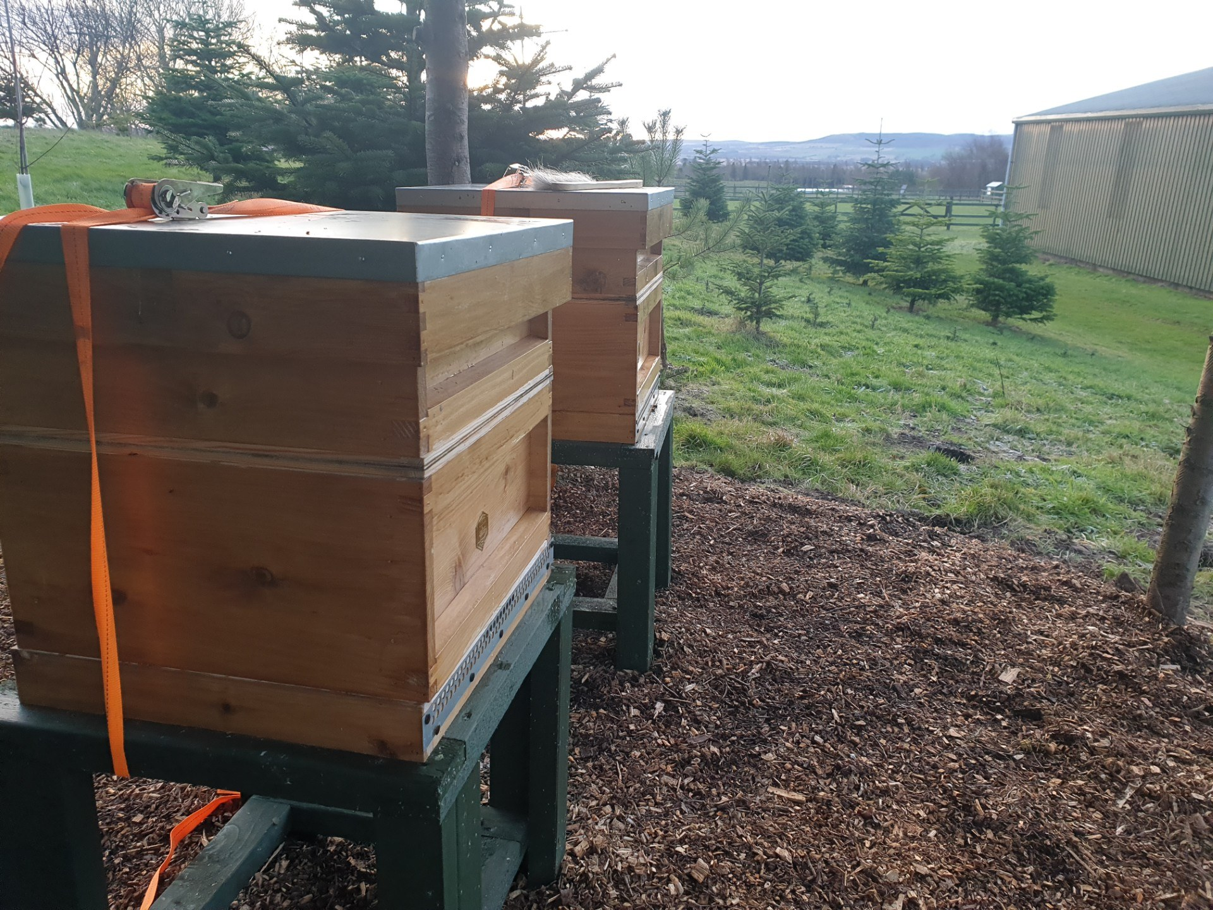
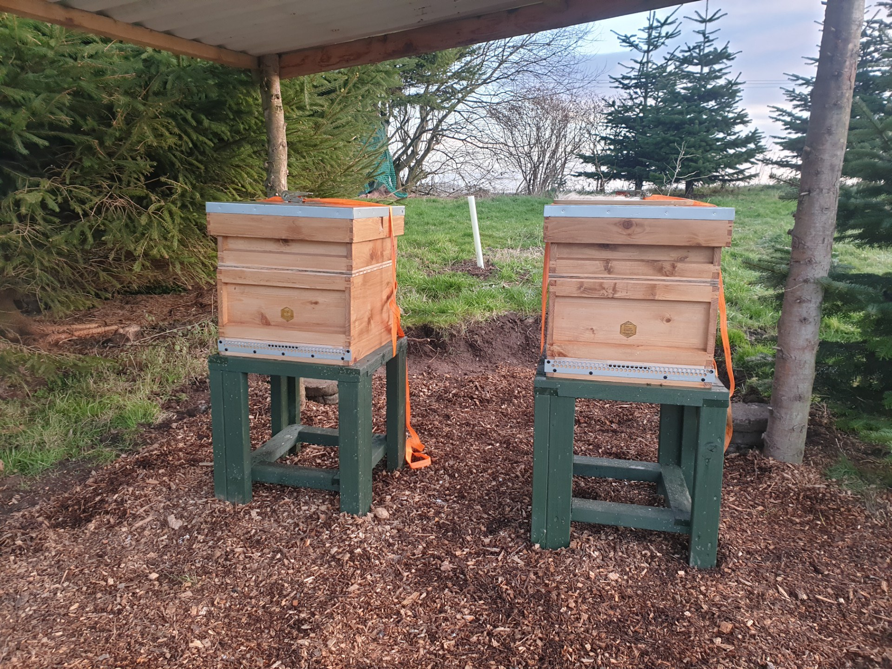
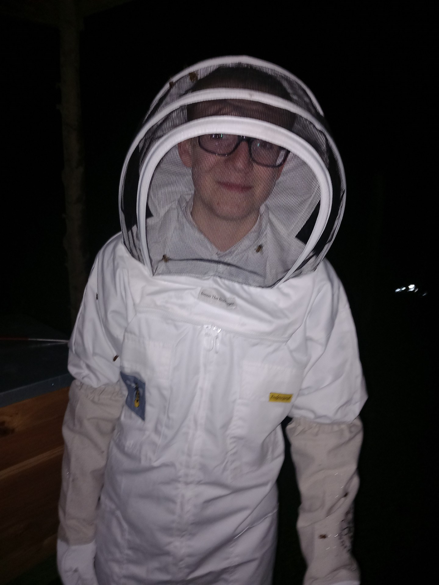
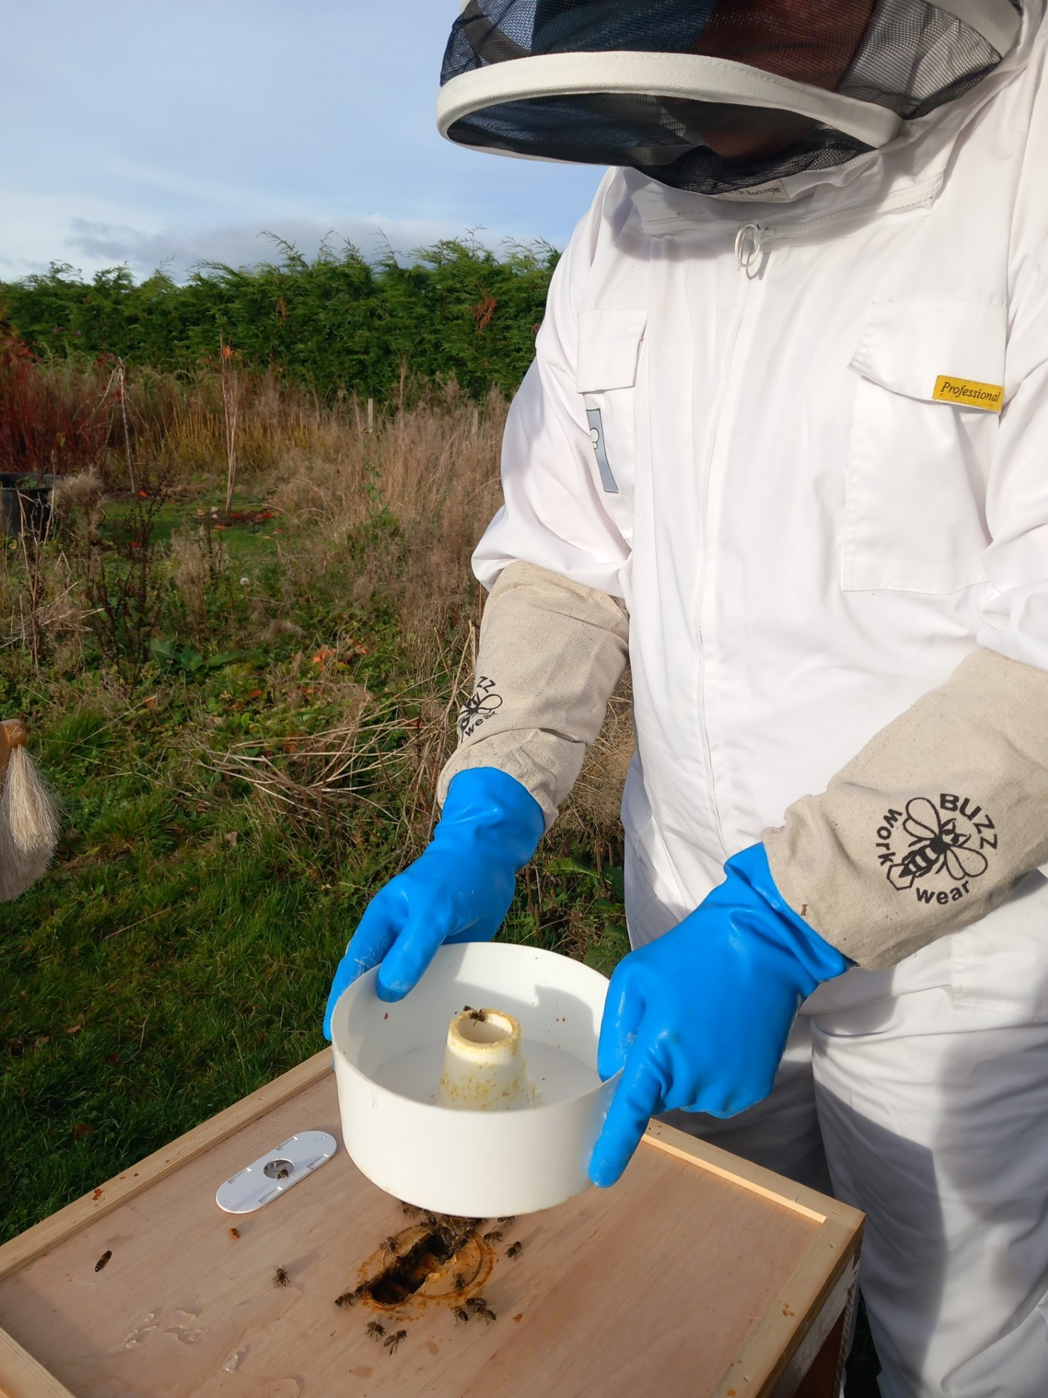
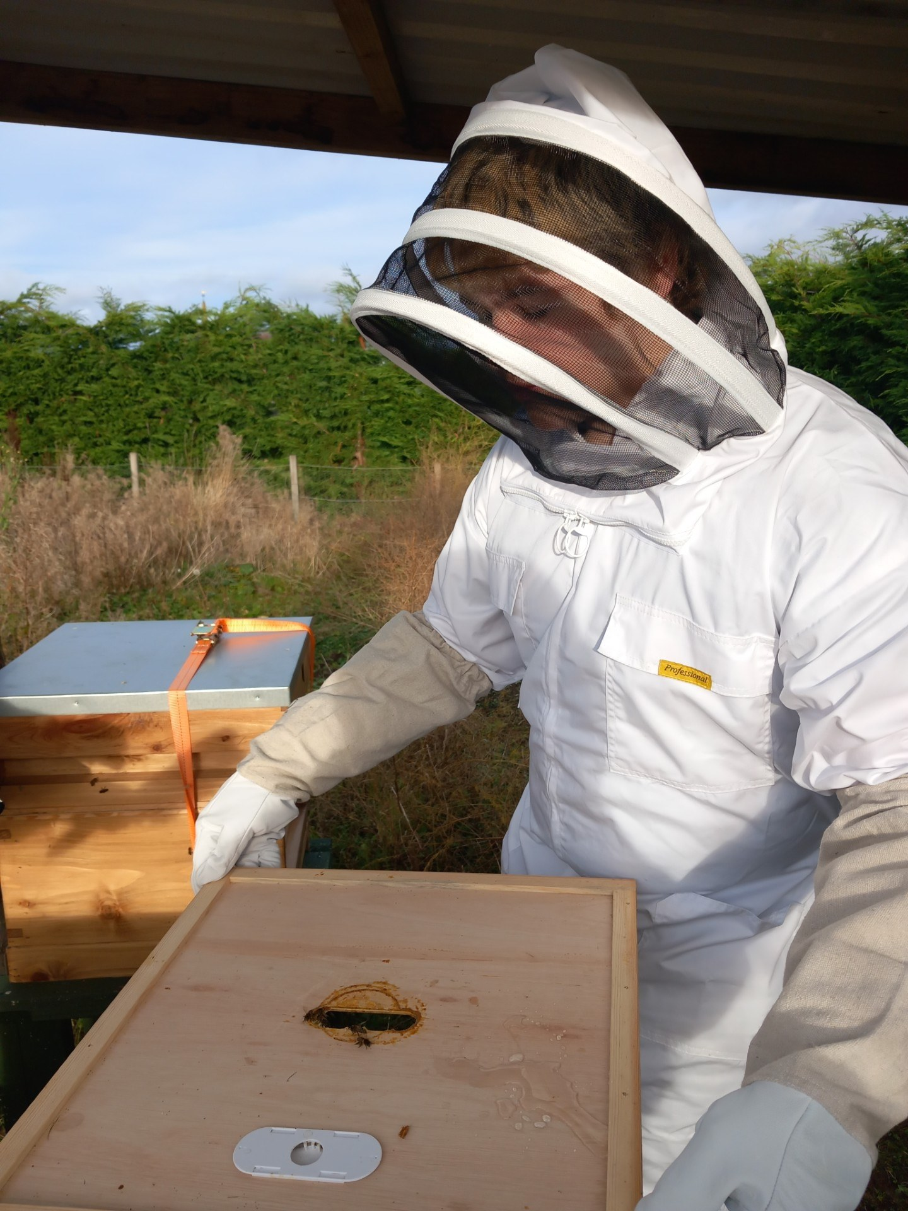
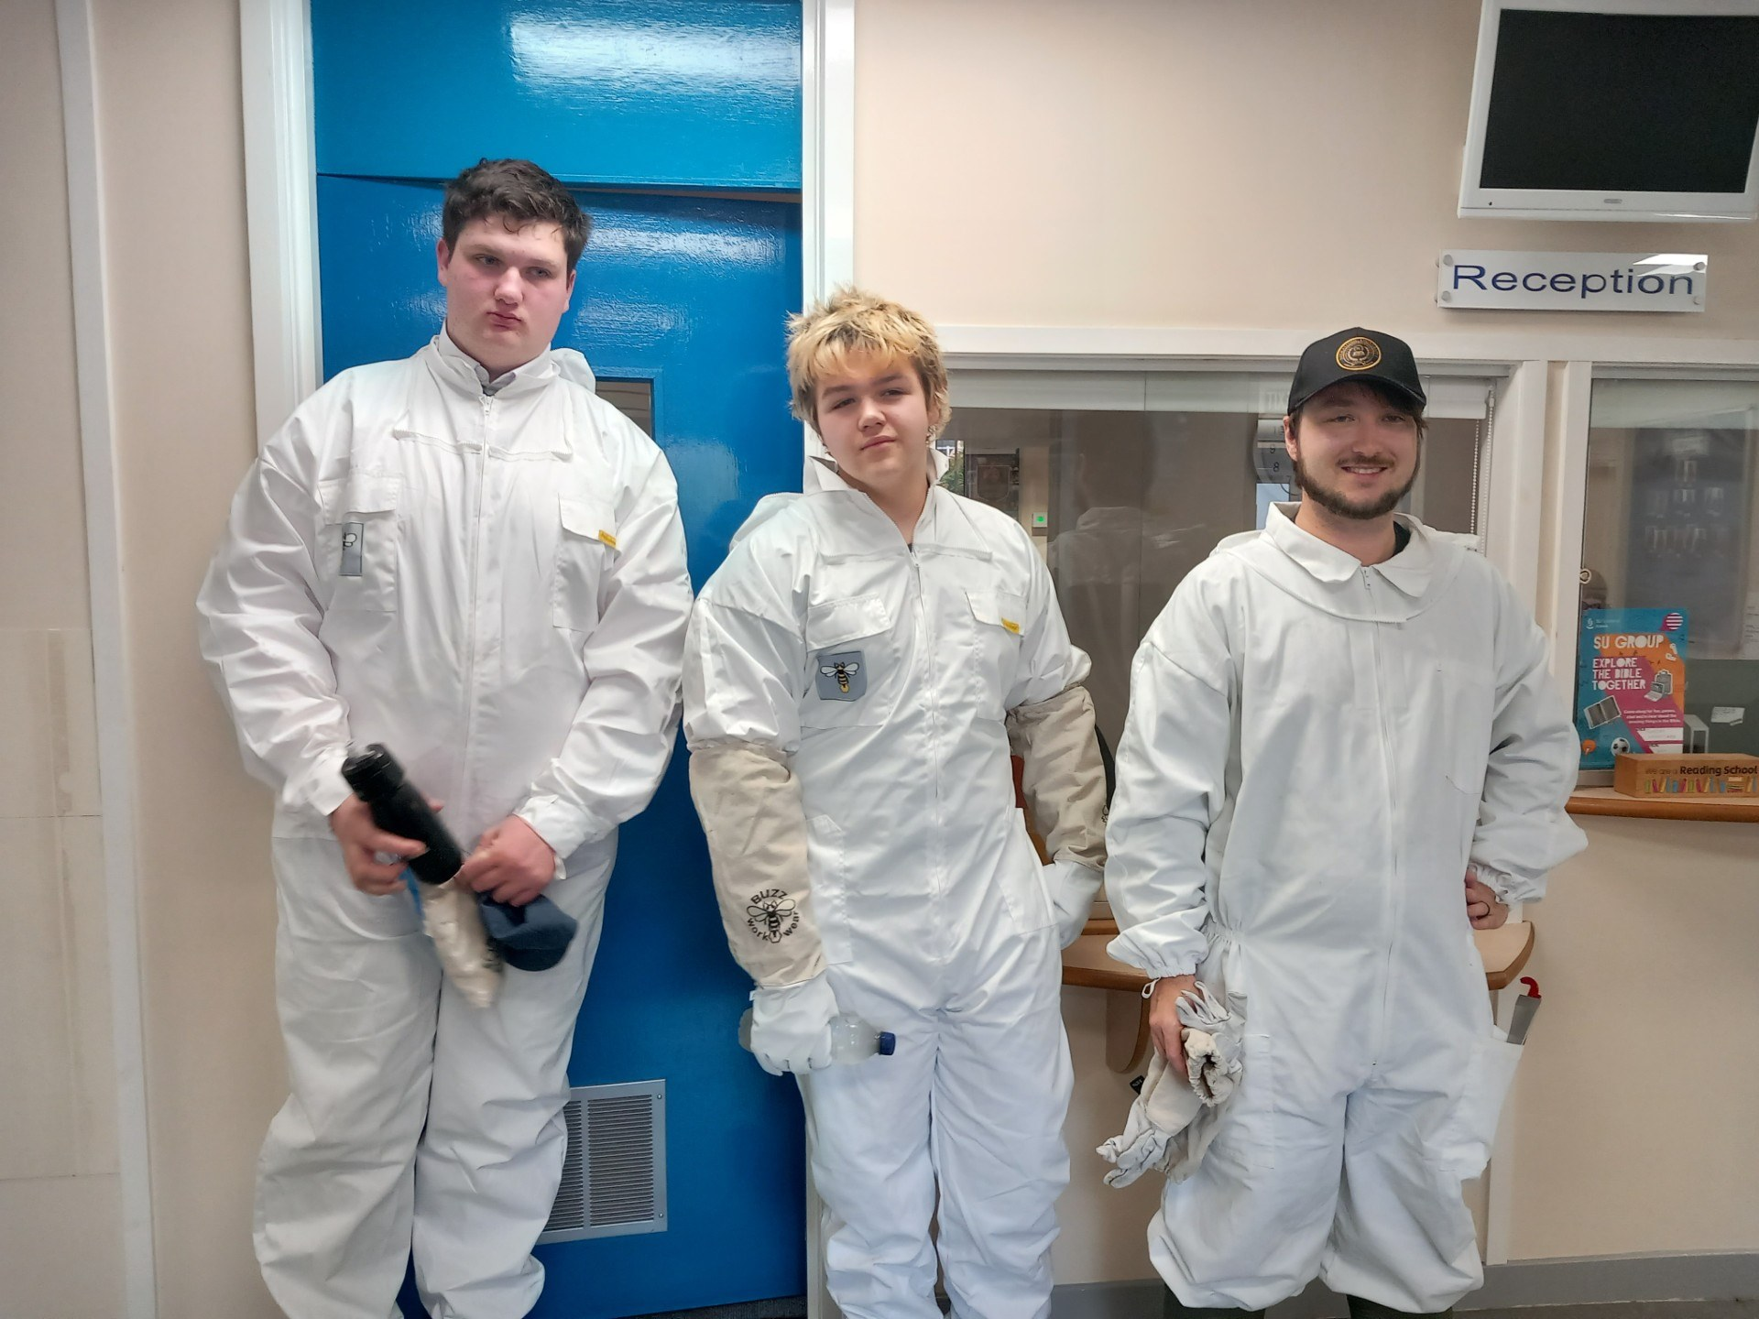
Rural Skills and outdoor education
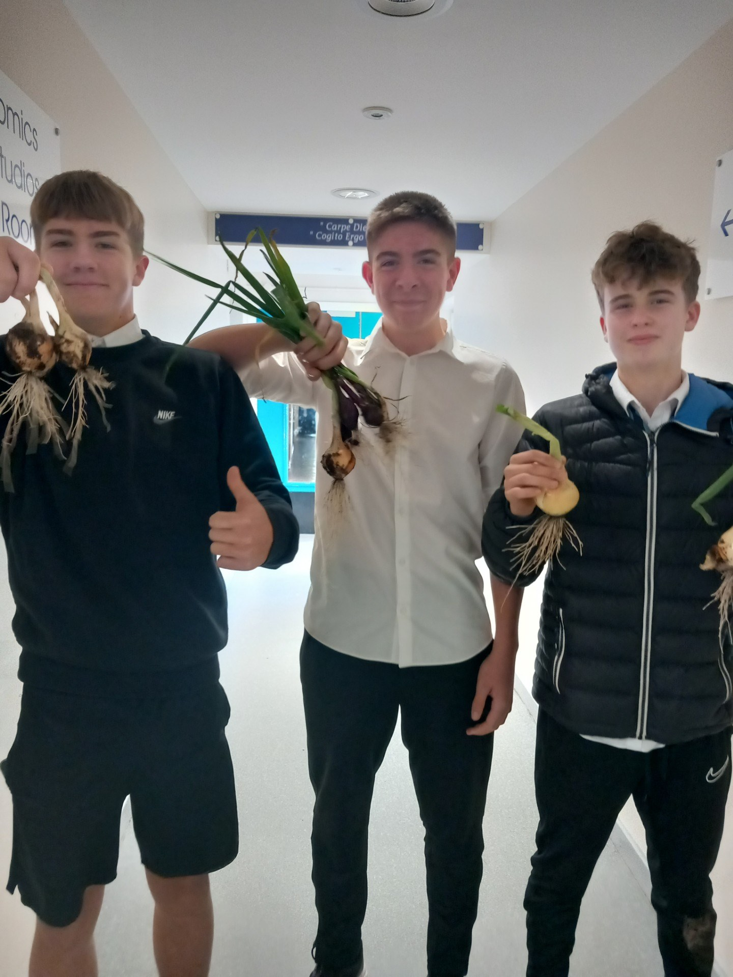
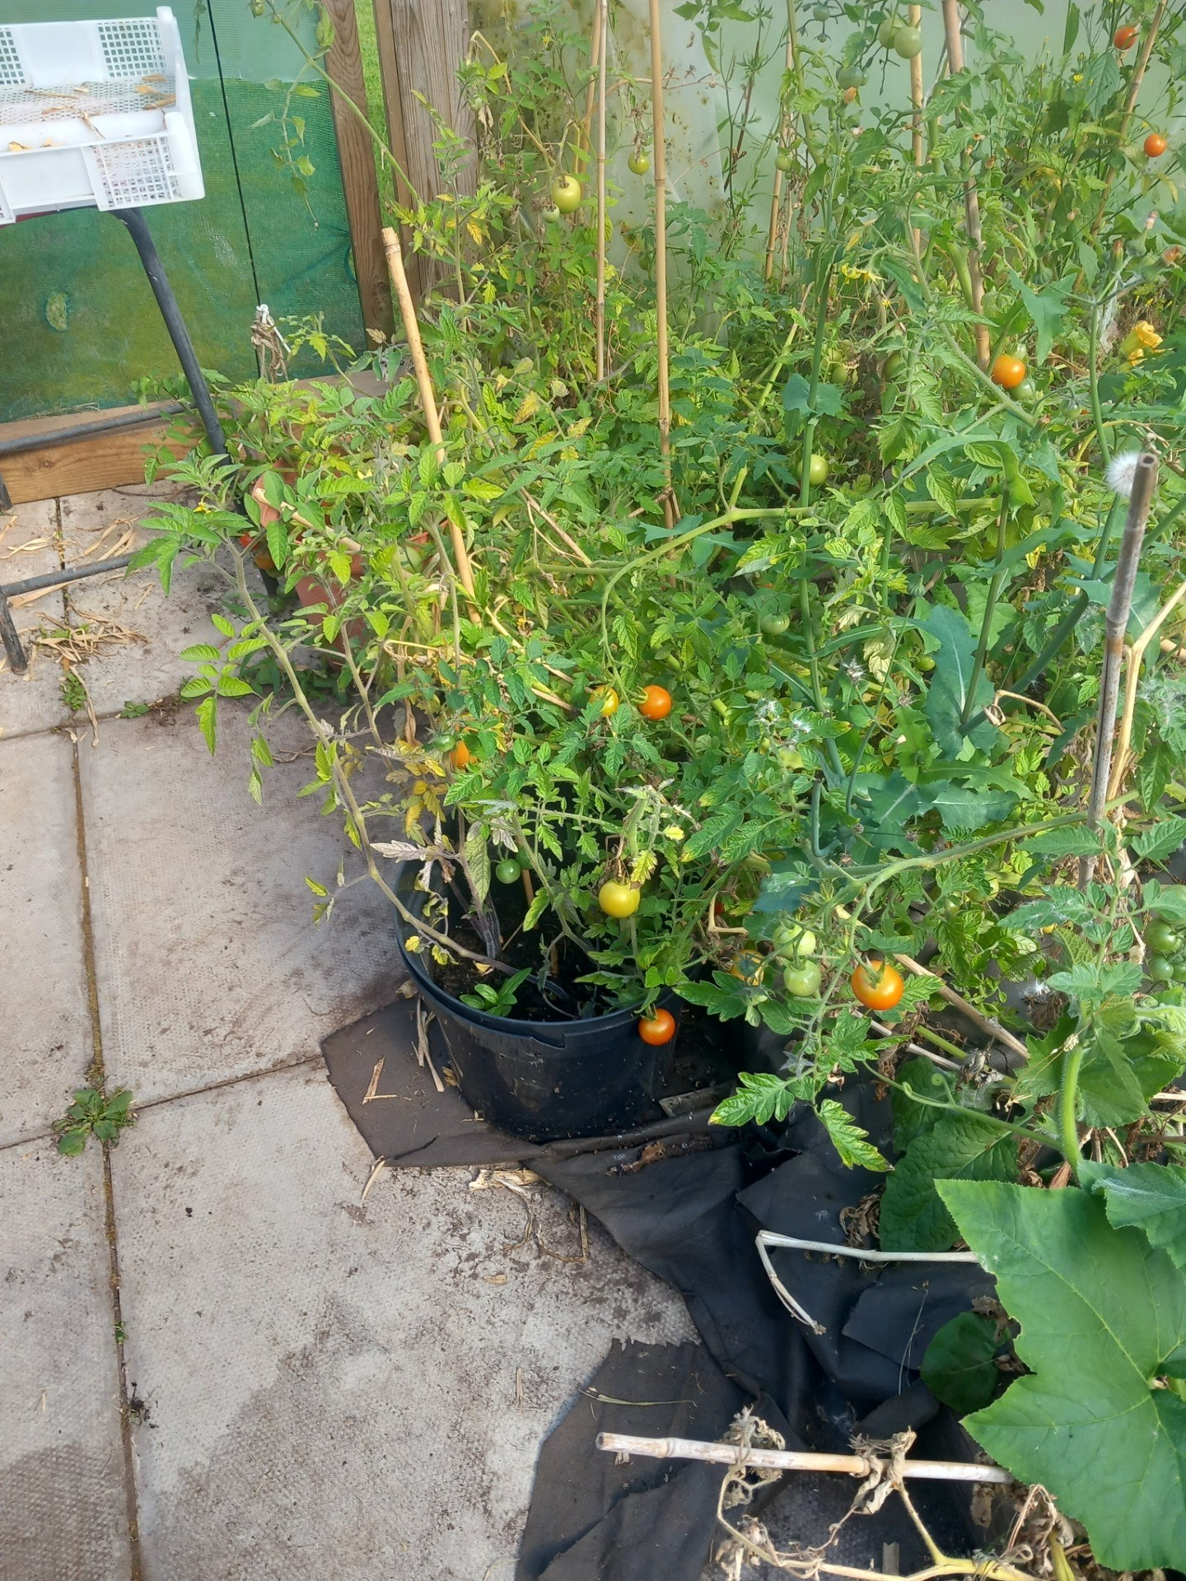
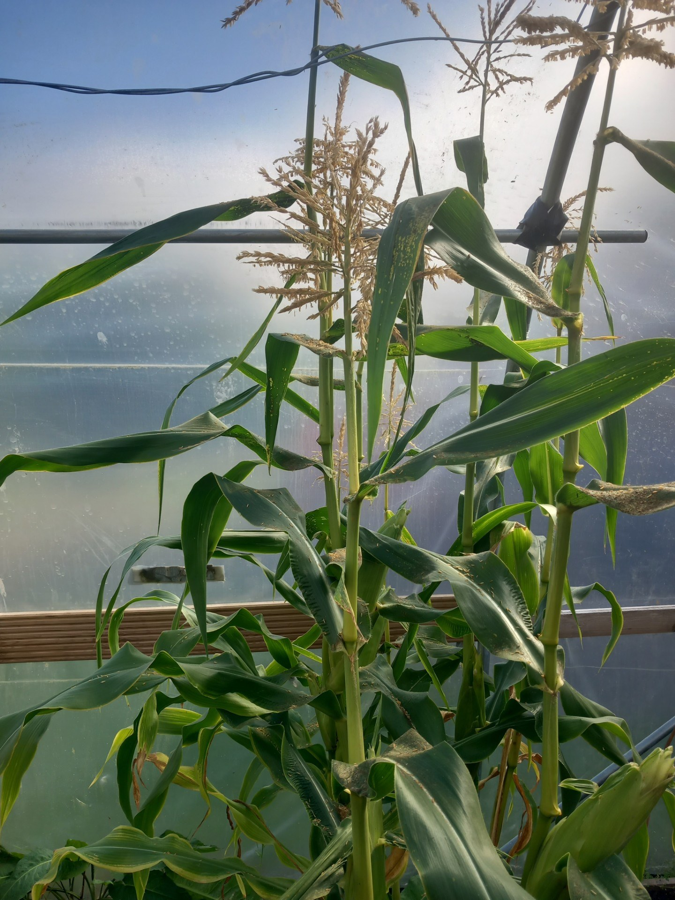
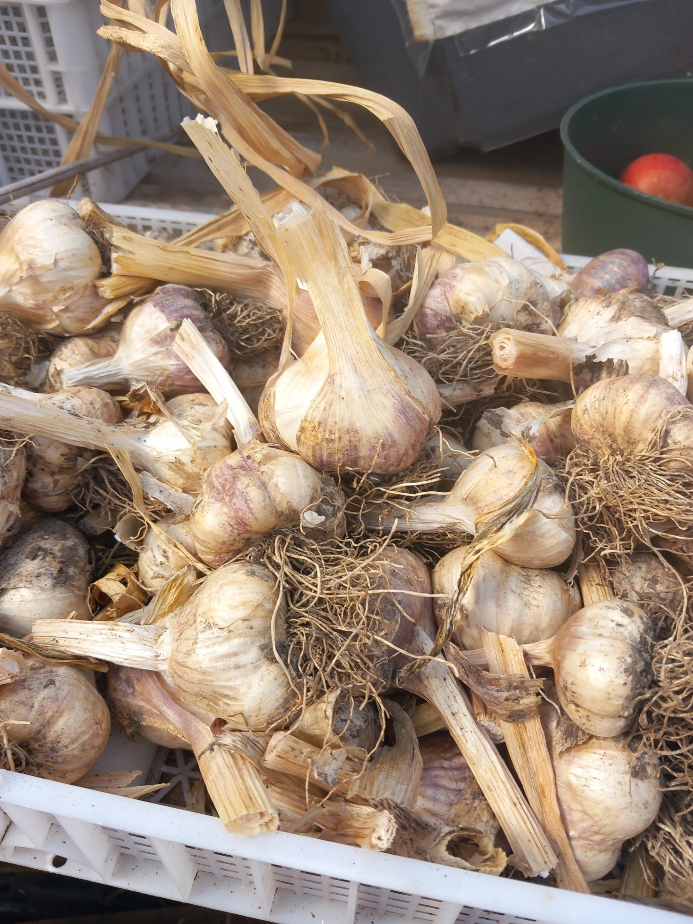
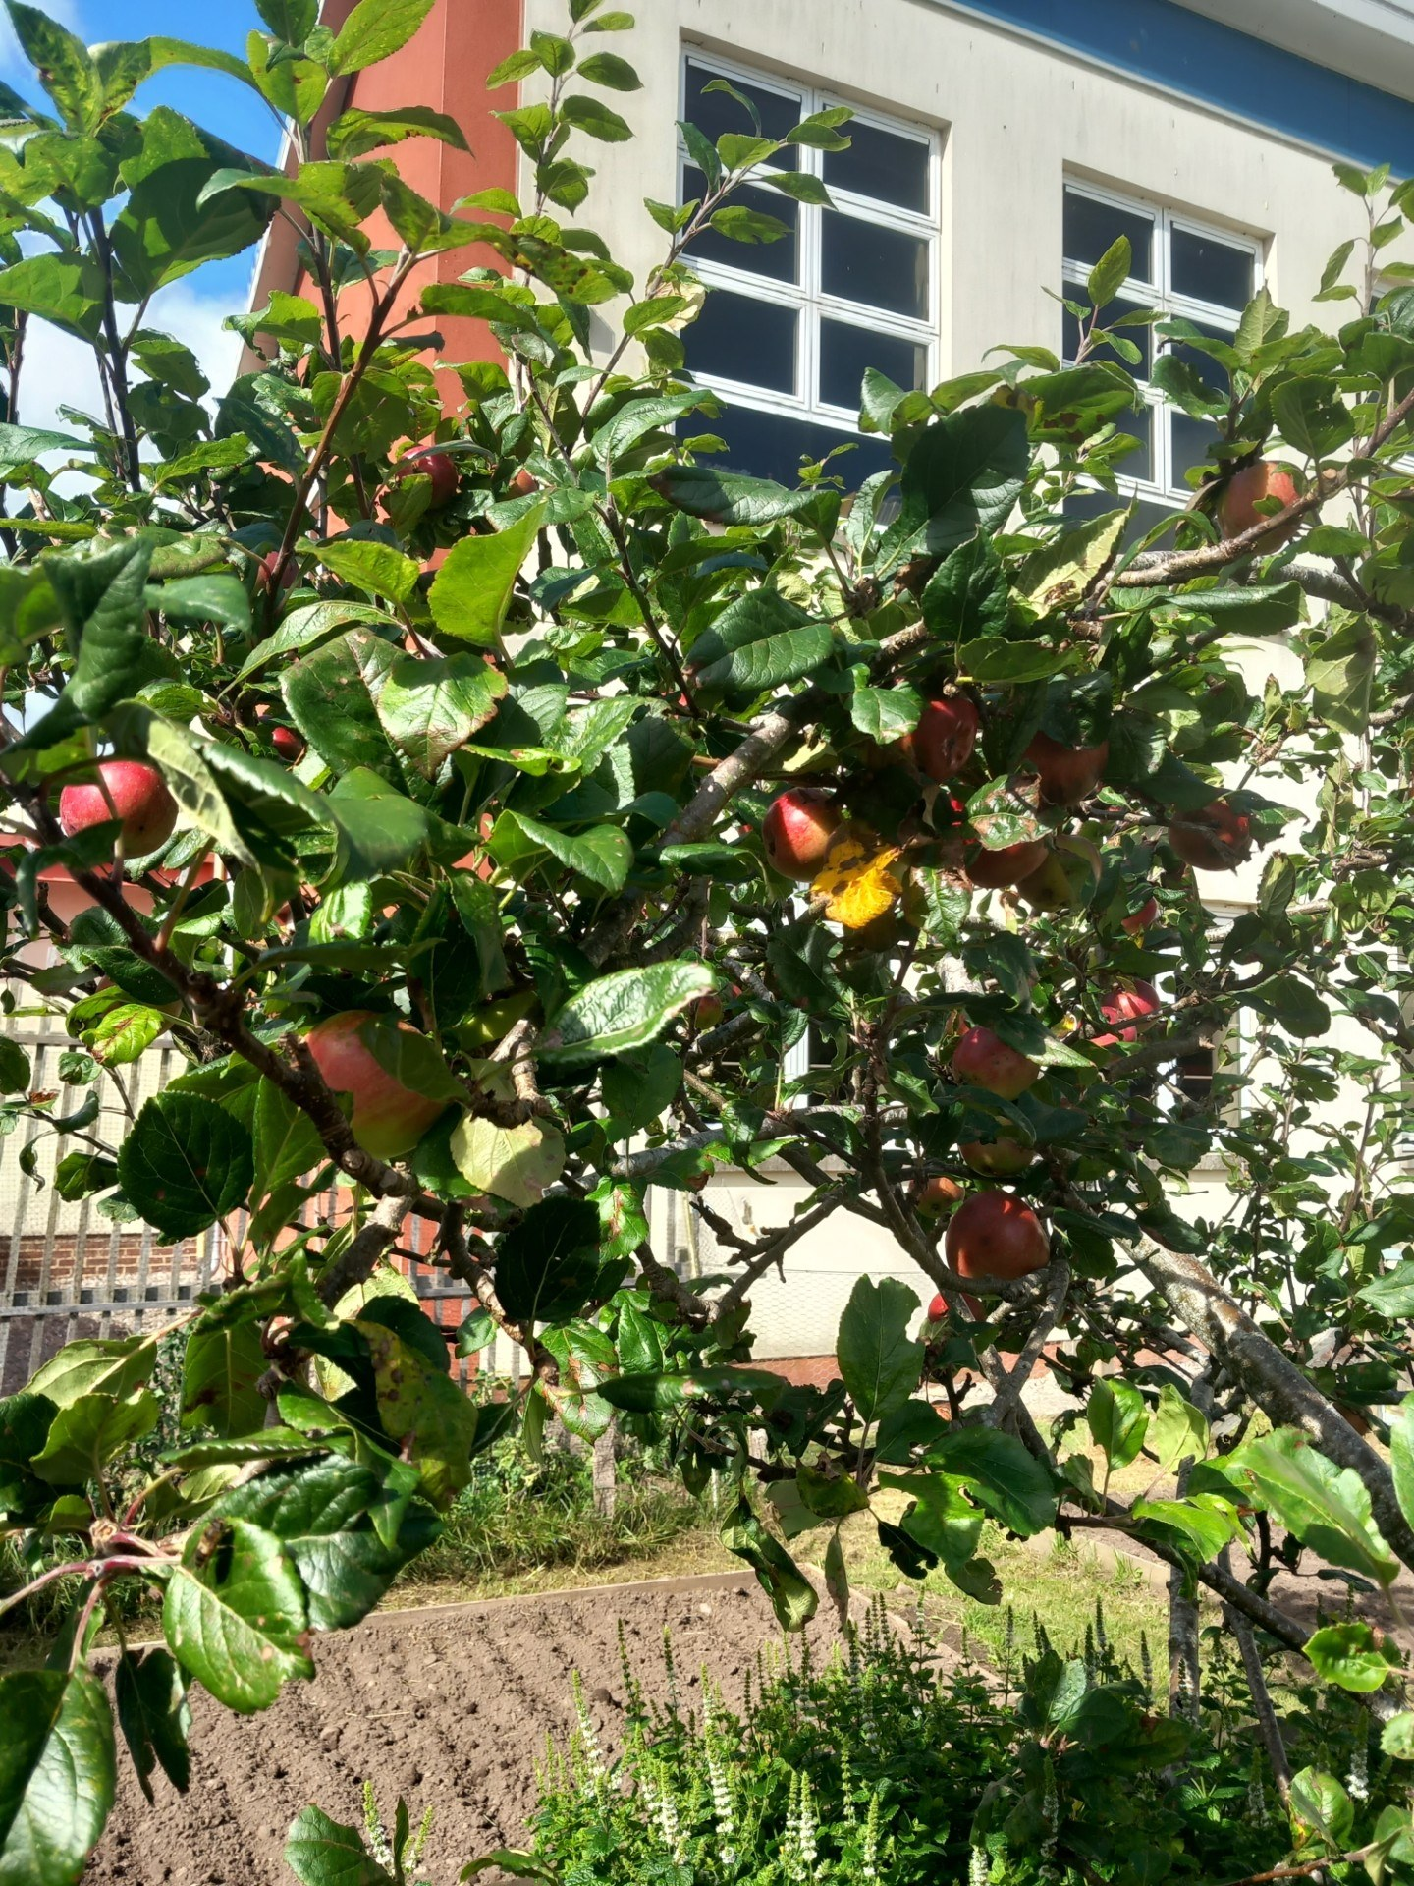
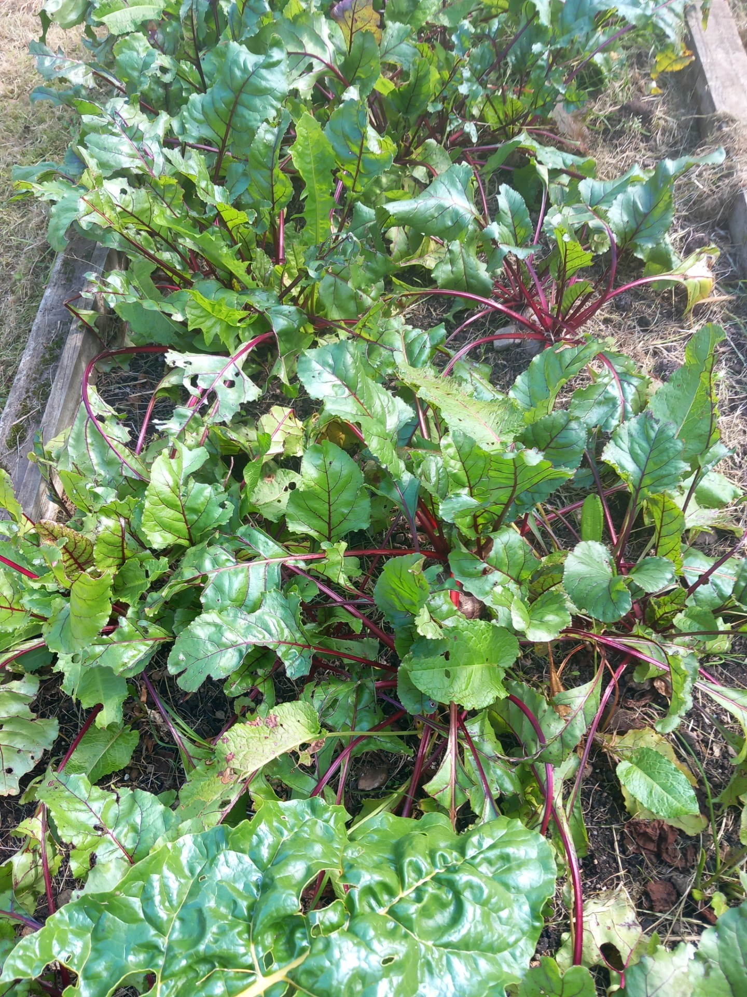
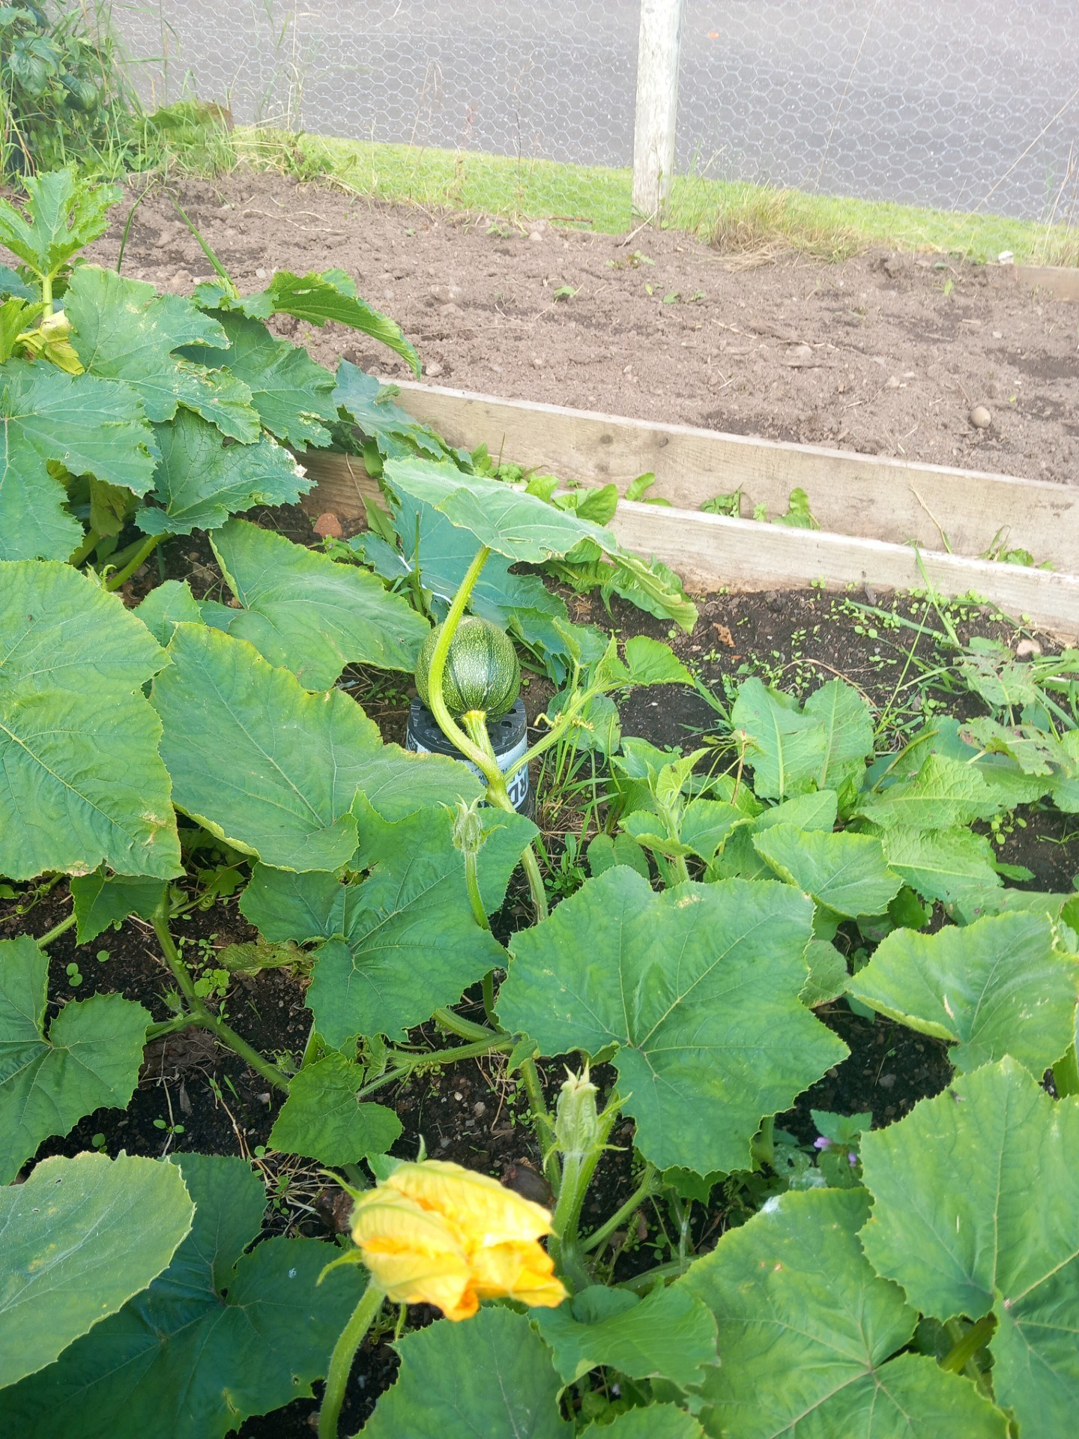
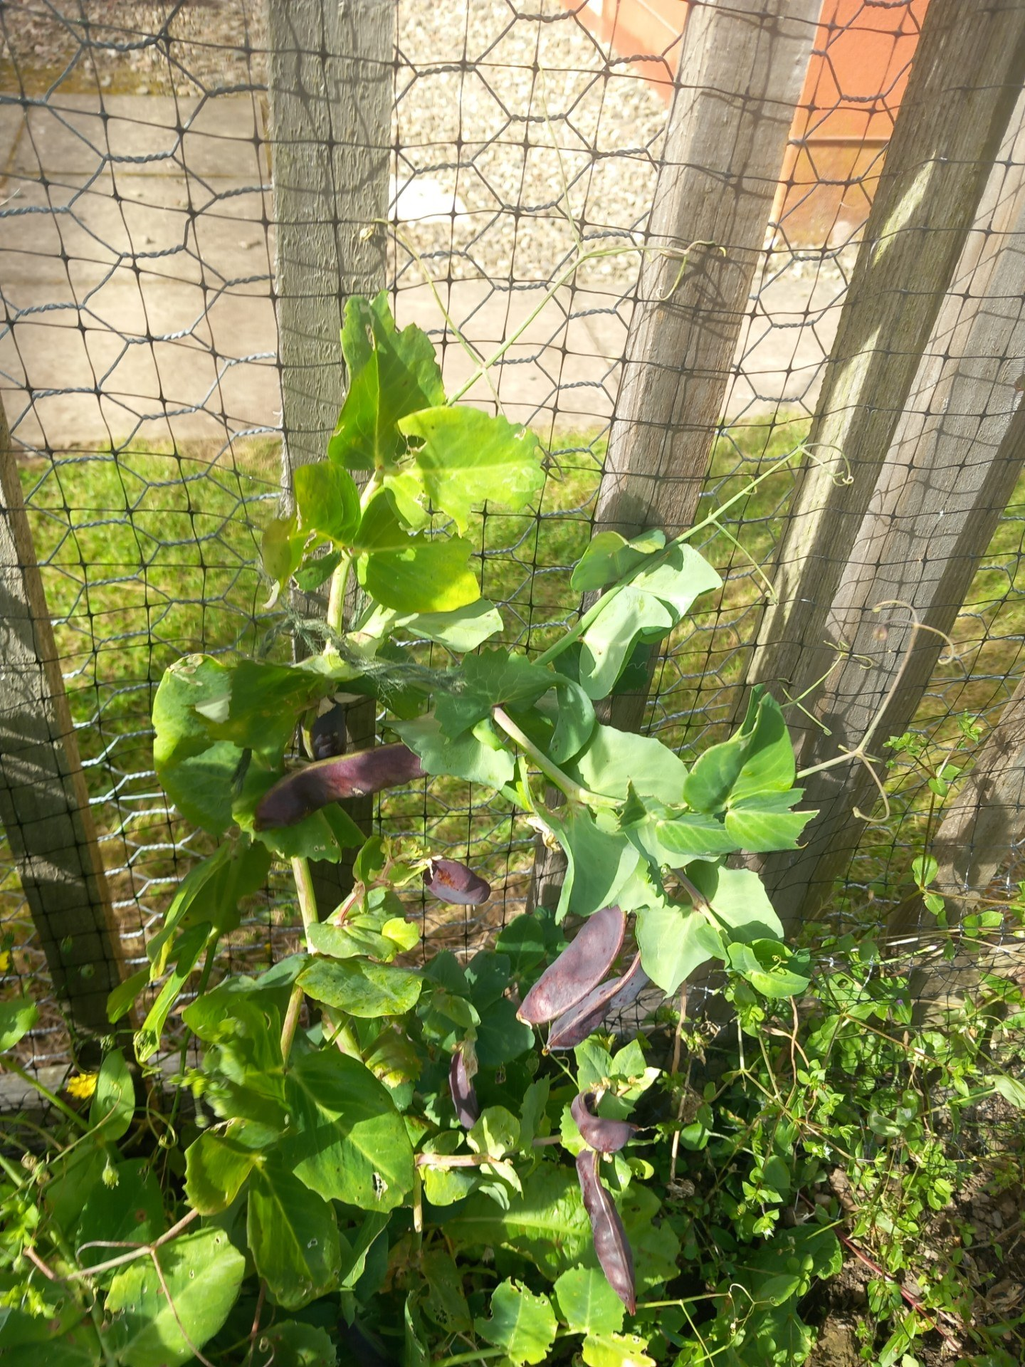
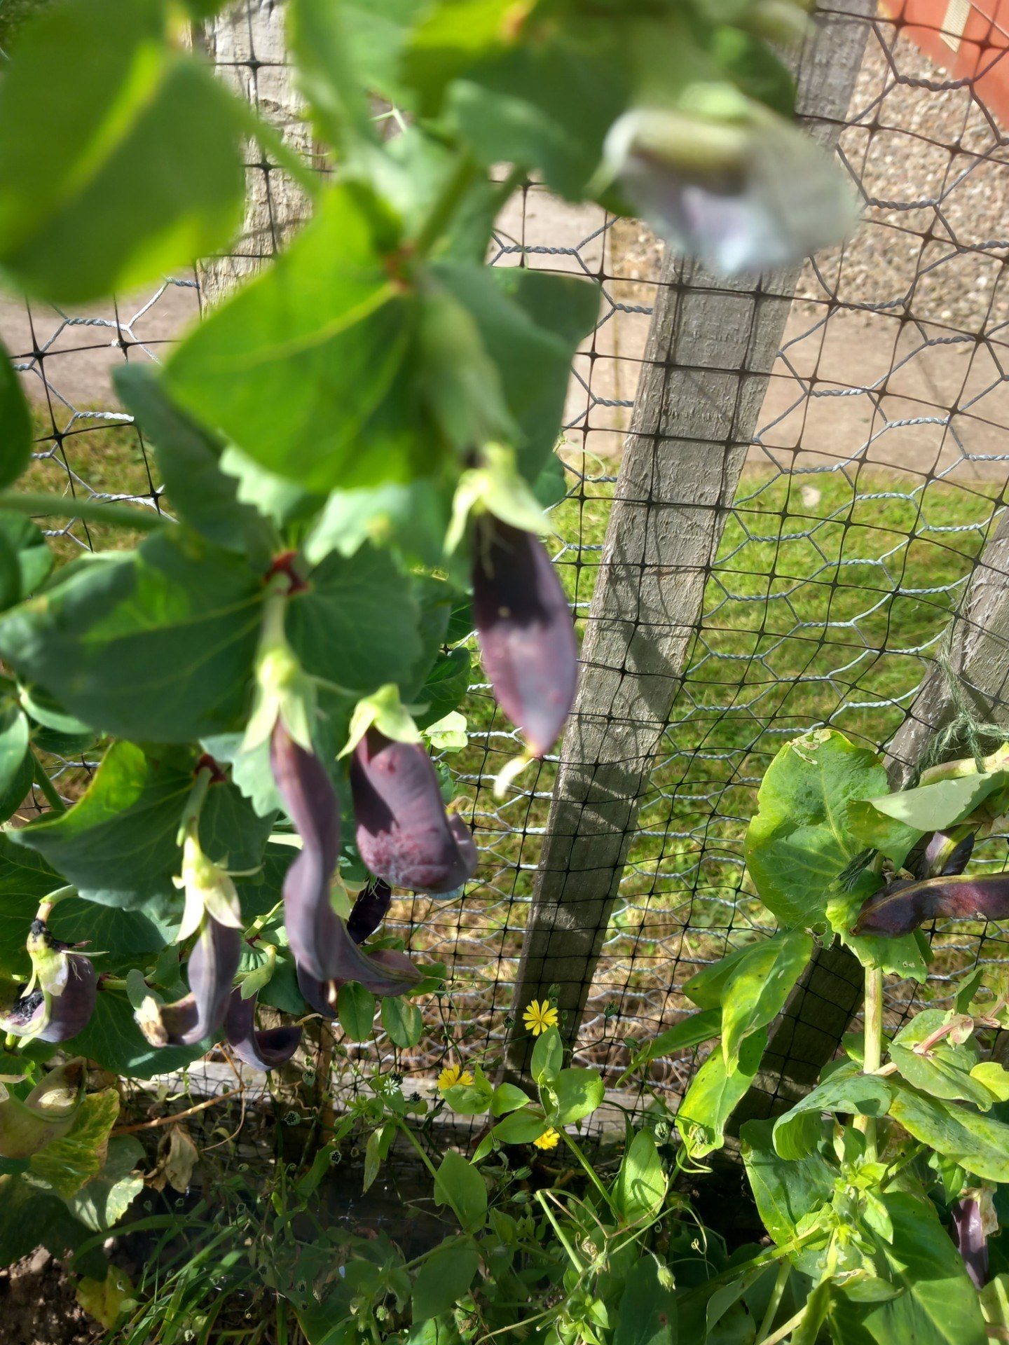
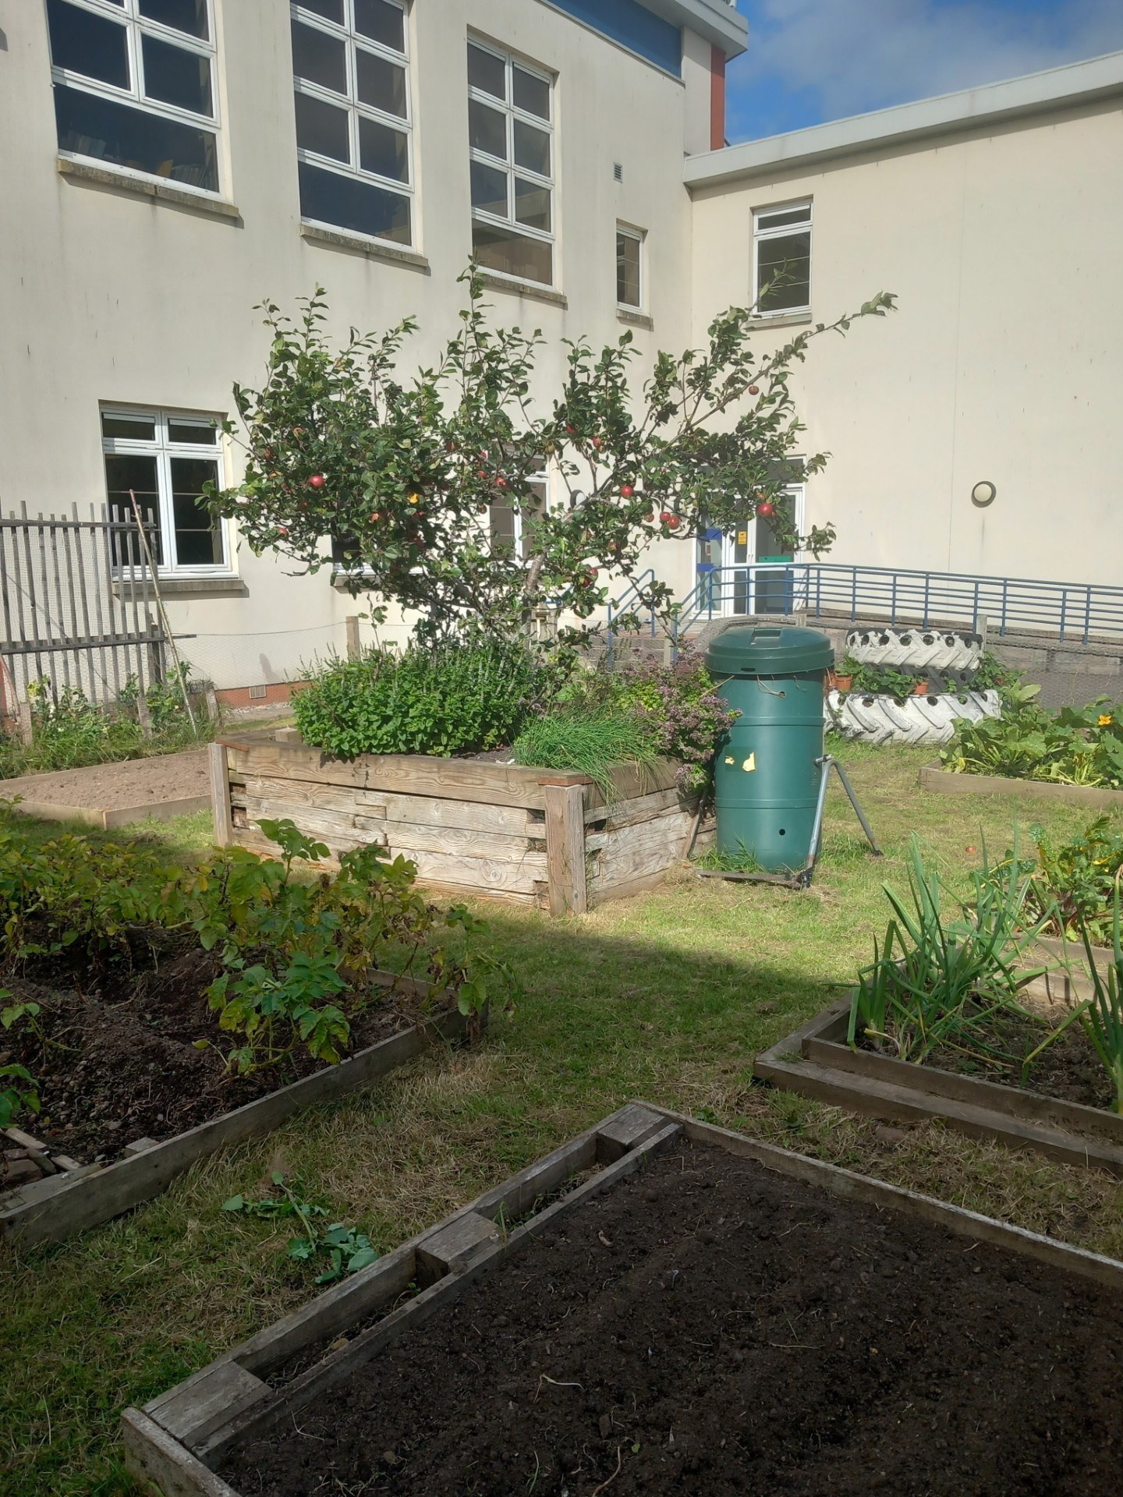
Our Rural Skills class and outdoor education group continue to be very busy with Mr Milton, Mr Clark, Mr Collin and Dr Inche. It is amazing to see everything they are growing in the school garden and the polytunnel. In addition to their work in the garden, the S3 Rural Skills class have just completed their animal handling and animal husbandry units at Murton Wildlife reserve while the S4 Nat 5 class have been out visiting farms in the local area.
We are also very excited about the work the pupils and staff have undertaken developing the outdoor classroom in Webster's and Southmuir Forest. We look forward to the day when groups of pupils and staff can use it.
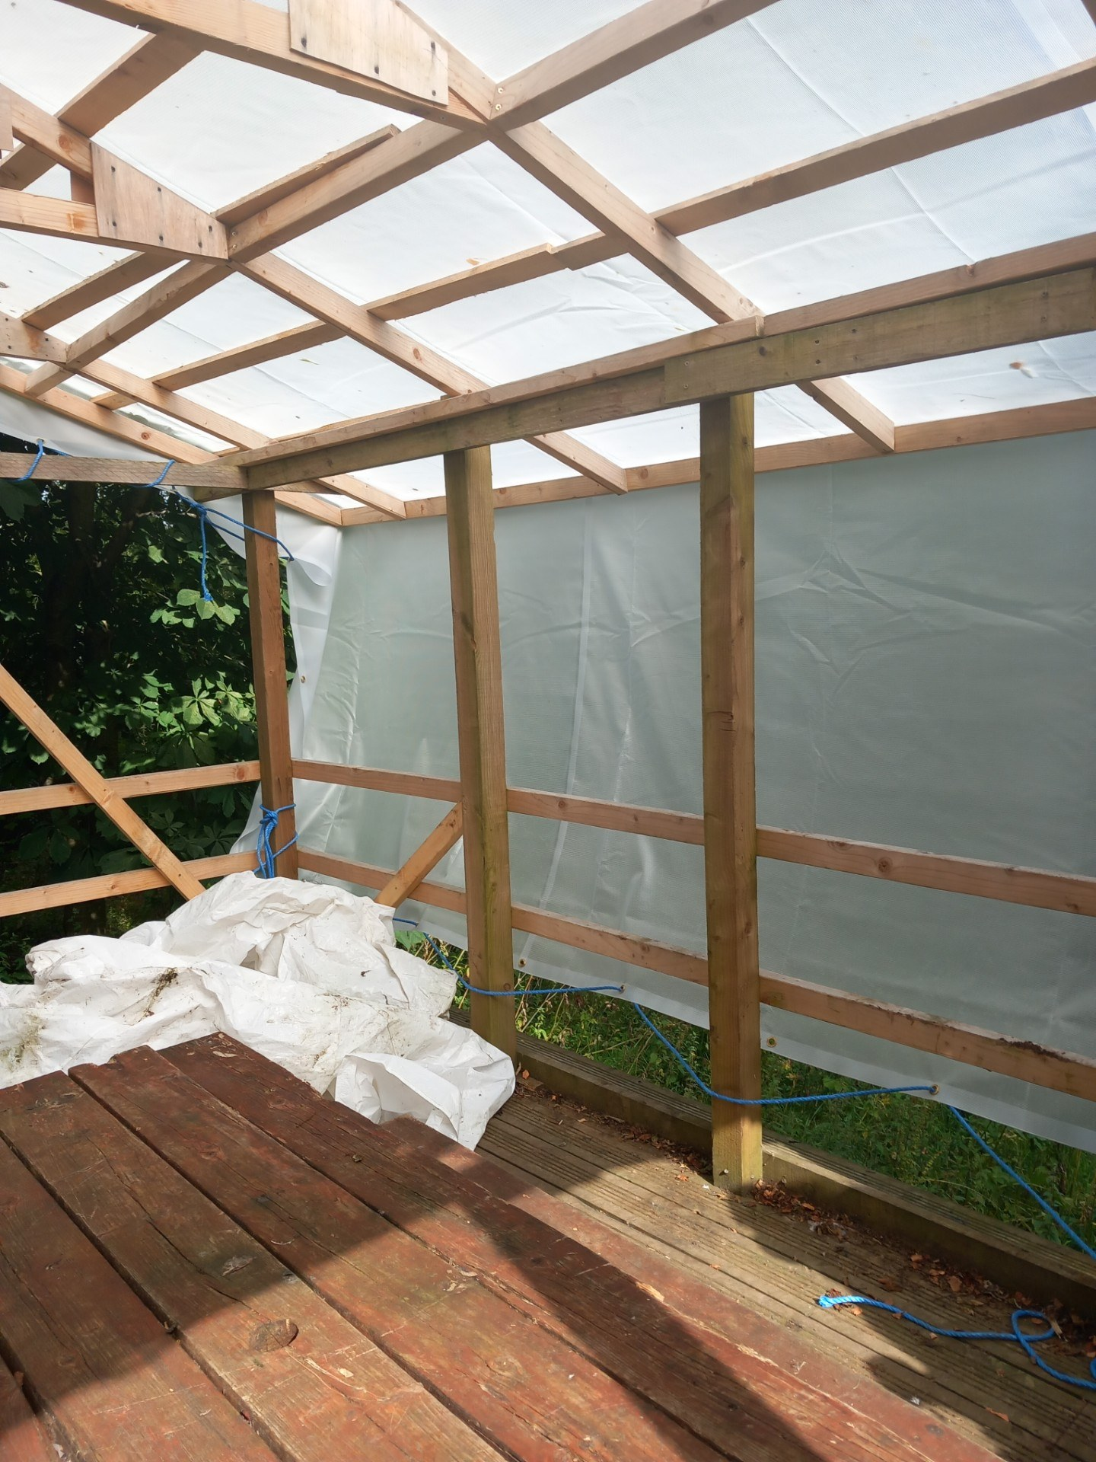
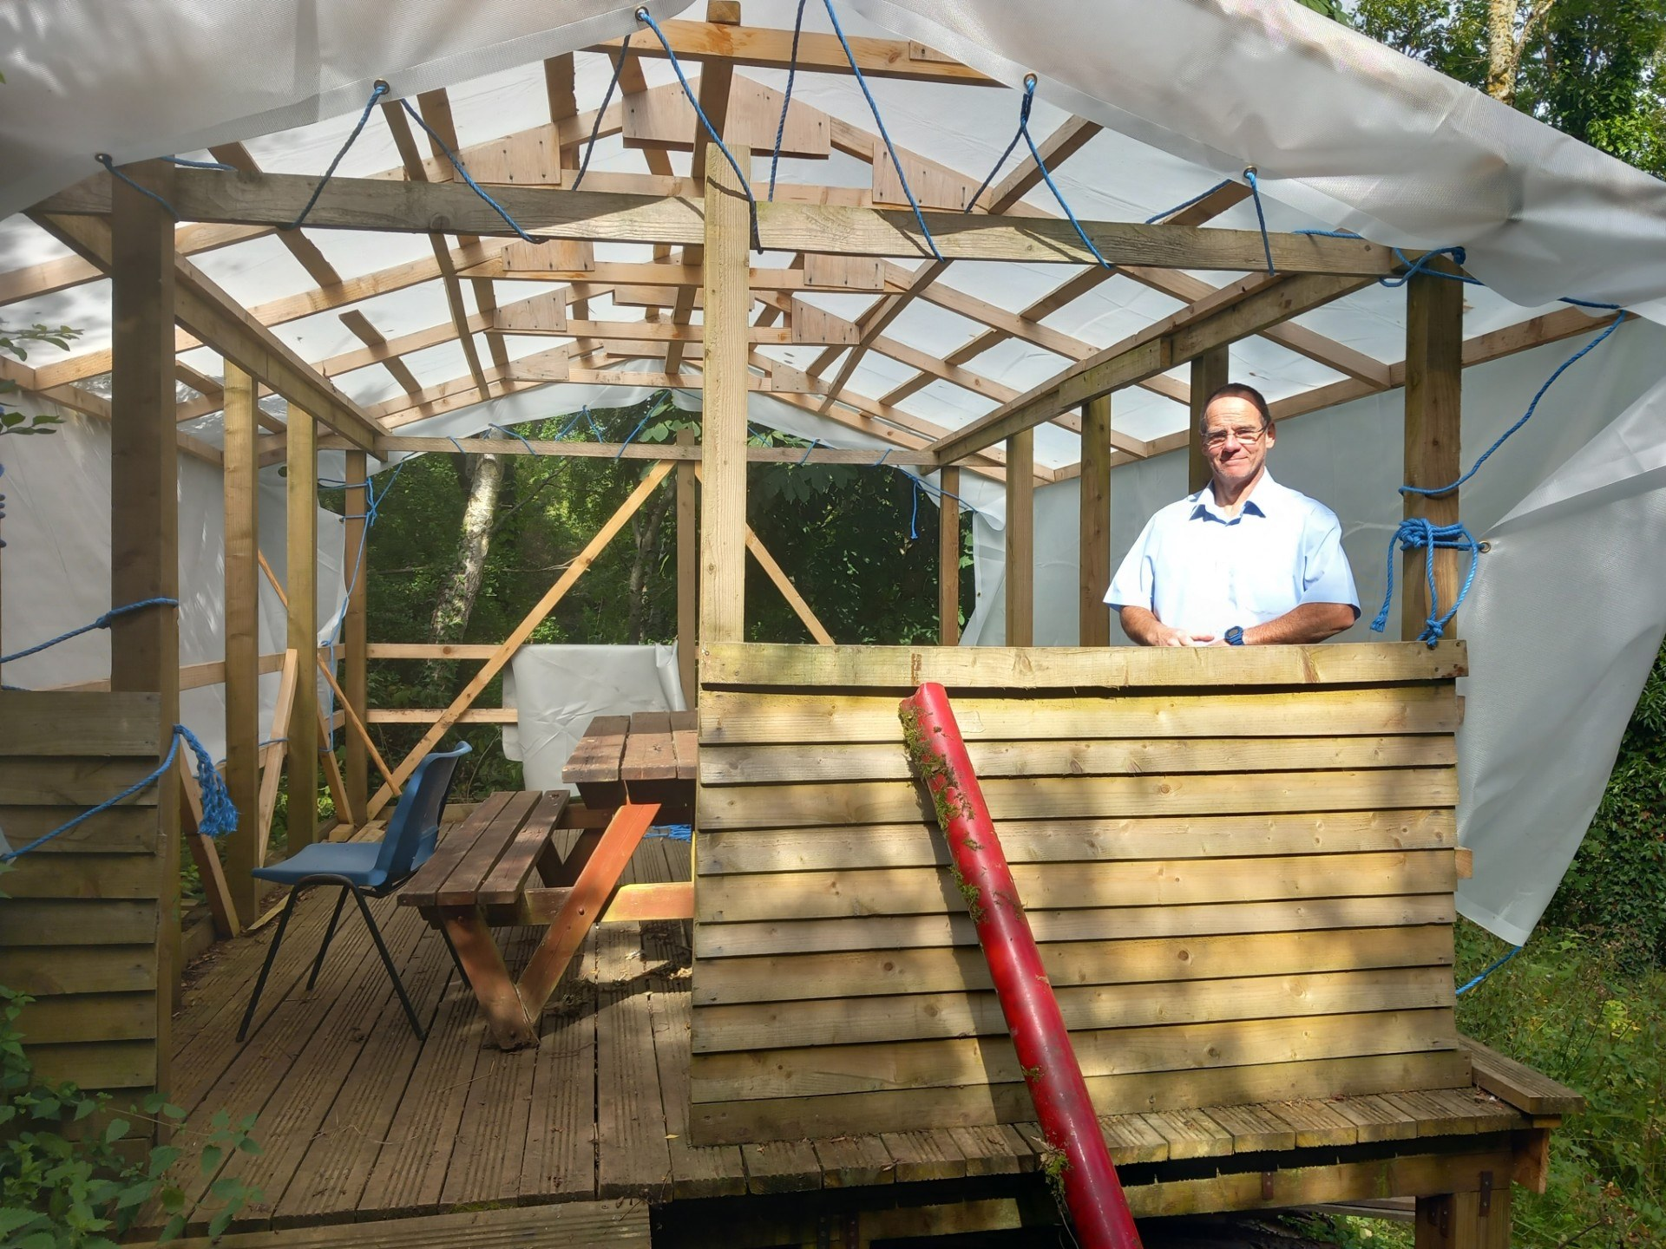

We would like to wish everyone a Merry Christmas and a Happy New Year

Everyone was in the Christmas spirit today leading to an impromptu Christmas carol singsong in the dinner hall. Enjoy the holidays!
