

Webster's High School Summer Newsletter
Key Dates Next Term:
Autumn Term
- Tuesday 19th August 2025 - pupils return to school
- Friday 3rd October 2025 - term ends
Winter Term
- Monday 20th October 2025 - term starts
- Wednesday 3rd December 2025 - in service day, schools closed
- Thursday 4th December 2025 - in service day, schools closed
- Friday 5th December 2025 - St Andrew's Day holiday, schools closed
- Tuesday 23rd December 2025 - term ends

A few of our STEM Activities
Webster’s Pupils Head to London for Prestigious Science Exhibition
A group of six pupils from Webster’s High School, accompanied by biology teacher Mr Coull and school technician Mrs MacDonald, are set to travel to London to take part in the prestigious Royal Society Summer Science Exhibition, running from 1st to 6th July. The group will present the findings of an exciting science project conducted in collaboration with researchers at The James Hutton Institute.

1 - Learning for Sustainability Goal 11
Their project focused on sequencing the genome of different daffodil varieties to explore how genetic information could help identify relationships between various cultivars. Webster’s High is one of just sixteen UK schools selected by The Royal Society to take part in this high-profile national event. Over the six-day exhibition, the pupils will engage the public with interactive exhibits, hands-on activities, and talks, sharing their scientific journey and discoveries with a wide audience. As part of the event the pupils will discuss their project on the BBC Radio 4 programme - Inside Science. Mr Coull, who led the project, praised the pupils’ dedication: “This is a fantastic opportunity for our students to showcase real scientific research on a national stage. They’ve worked incredibly hard and should be very proud.” The school community wishes the team the best of luck as they represent Webster’s High – and the next generation of scientists – in London.
Young Enterprise

We are delighted to be offering Young Enterprise Scotland to our S6 pupils this year at WHS with two groups entering the programme. Both teams have been busy fundraising to raise finance to enter the competition and buy supplies for their products. As a group we would like to thank the wonderful community from the businesses who donated raffle prizes, the public who have bought raffle tickets, pupils who spent some money at the Young Enterprise stall during sports day and the teachers for buying tickets and allowing pupils to throw wet sponges at them (what team spirit)! We are excited to get started with producing products after the summer and selling them at local events and the Dundee Christmas market. Teams will have social media platforms where you can follow their journey.
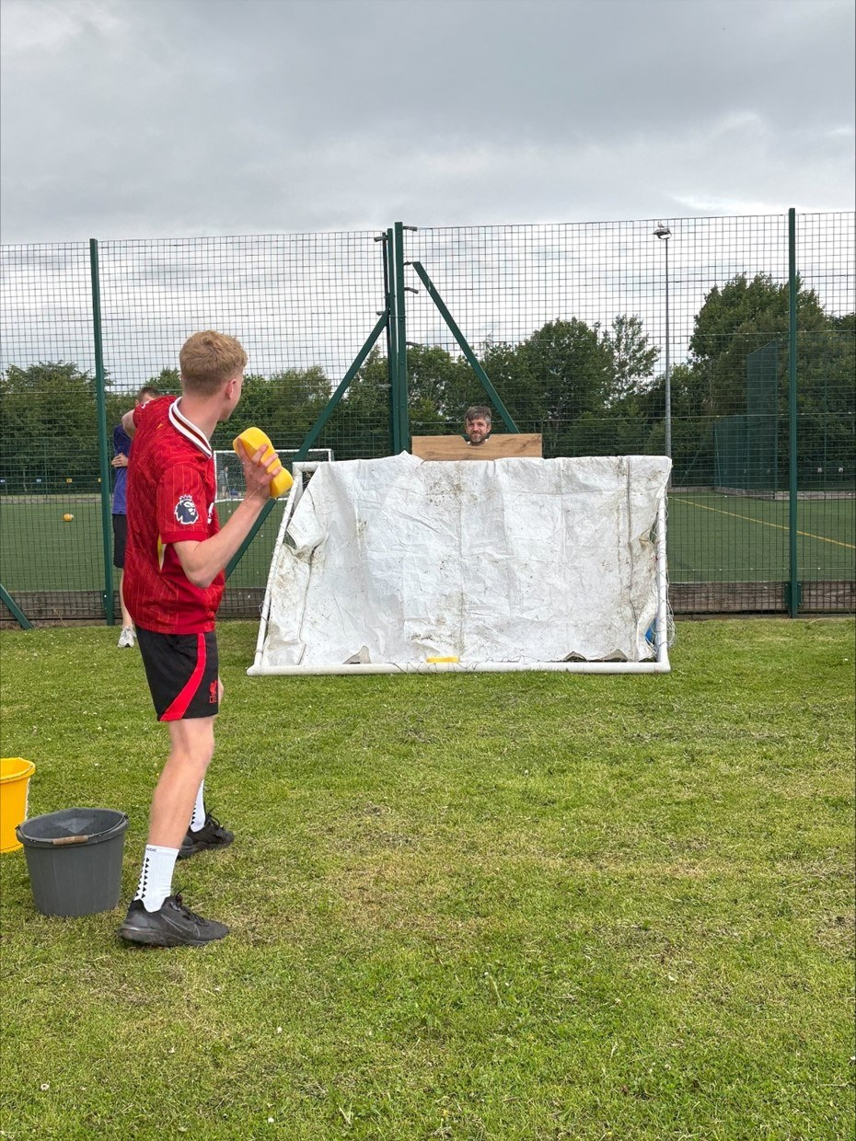
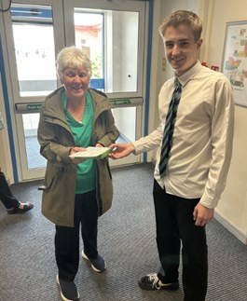
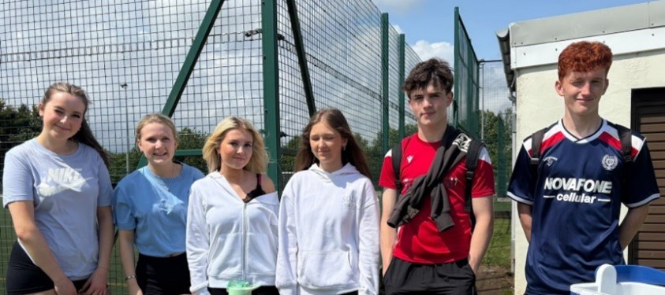
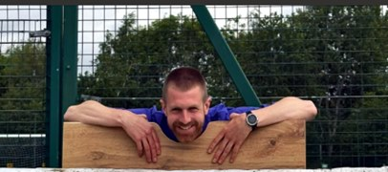
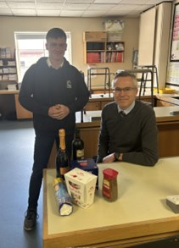

Promoting Literacy
Learning for Sustainability goal 4: Quality education
Article 31 Every child has the right to relax, play and take part in a wide range of activities.
The World Book Day in March featured many events, including a graphic novel challenge, Kahoot Quiz, and Relay. The library, English, and PE departments, along with Junior prefects worked together to create an enjoyable day for the S1s.
We have had a couple of Author talk video showings in the library, including Cassandra Clare (Mortal Instruments) and Rick Riordan (Percy Jackson). A good chance to learn about how they work. Thank you to the Pupil reading group for suggesting the authors.
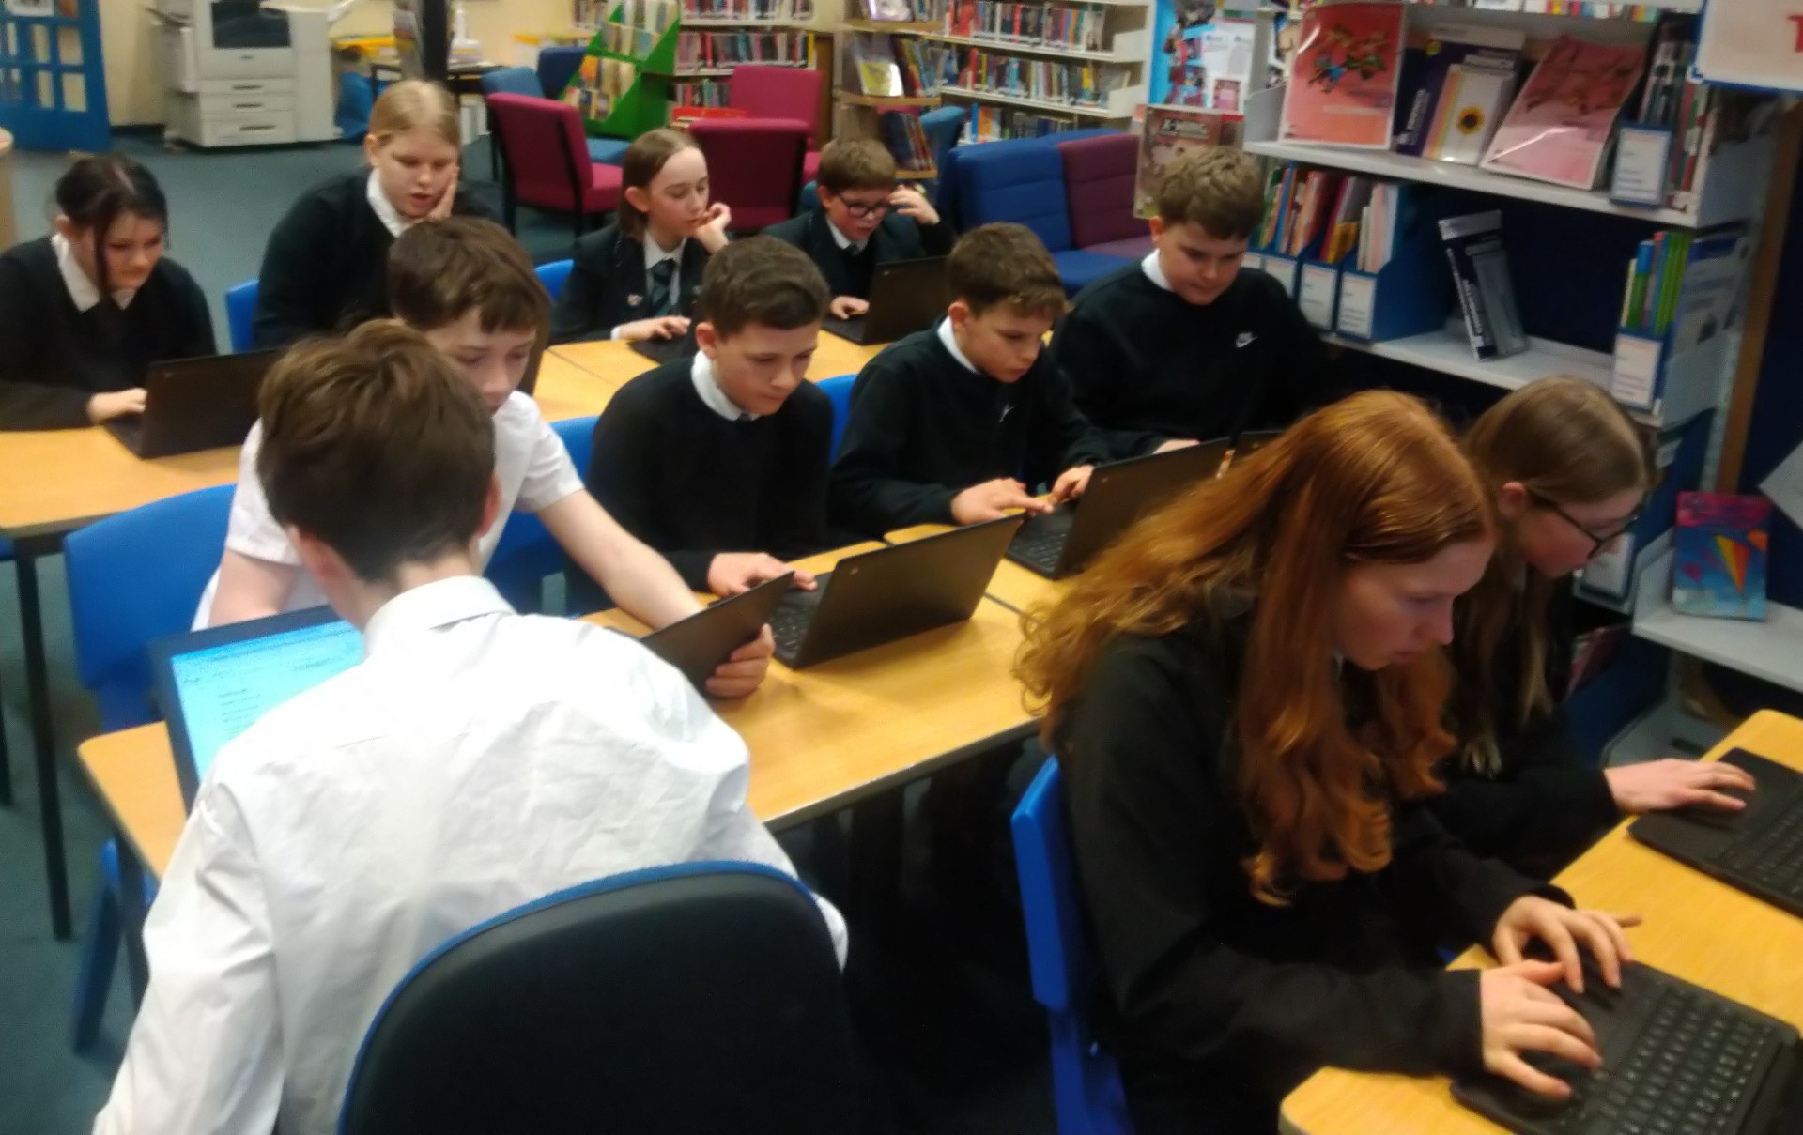
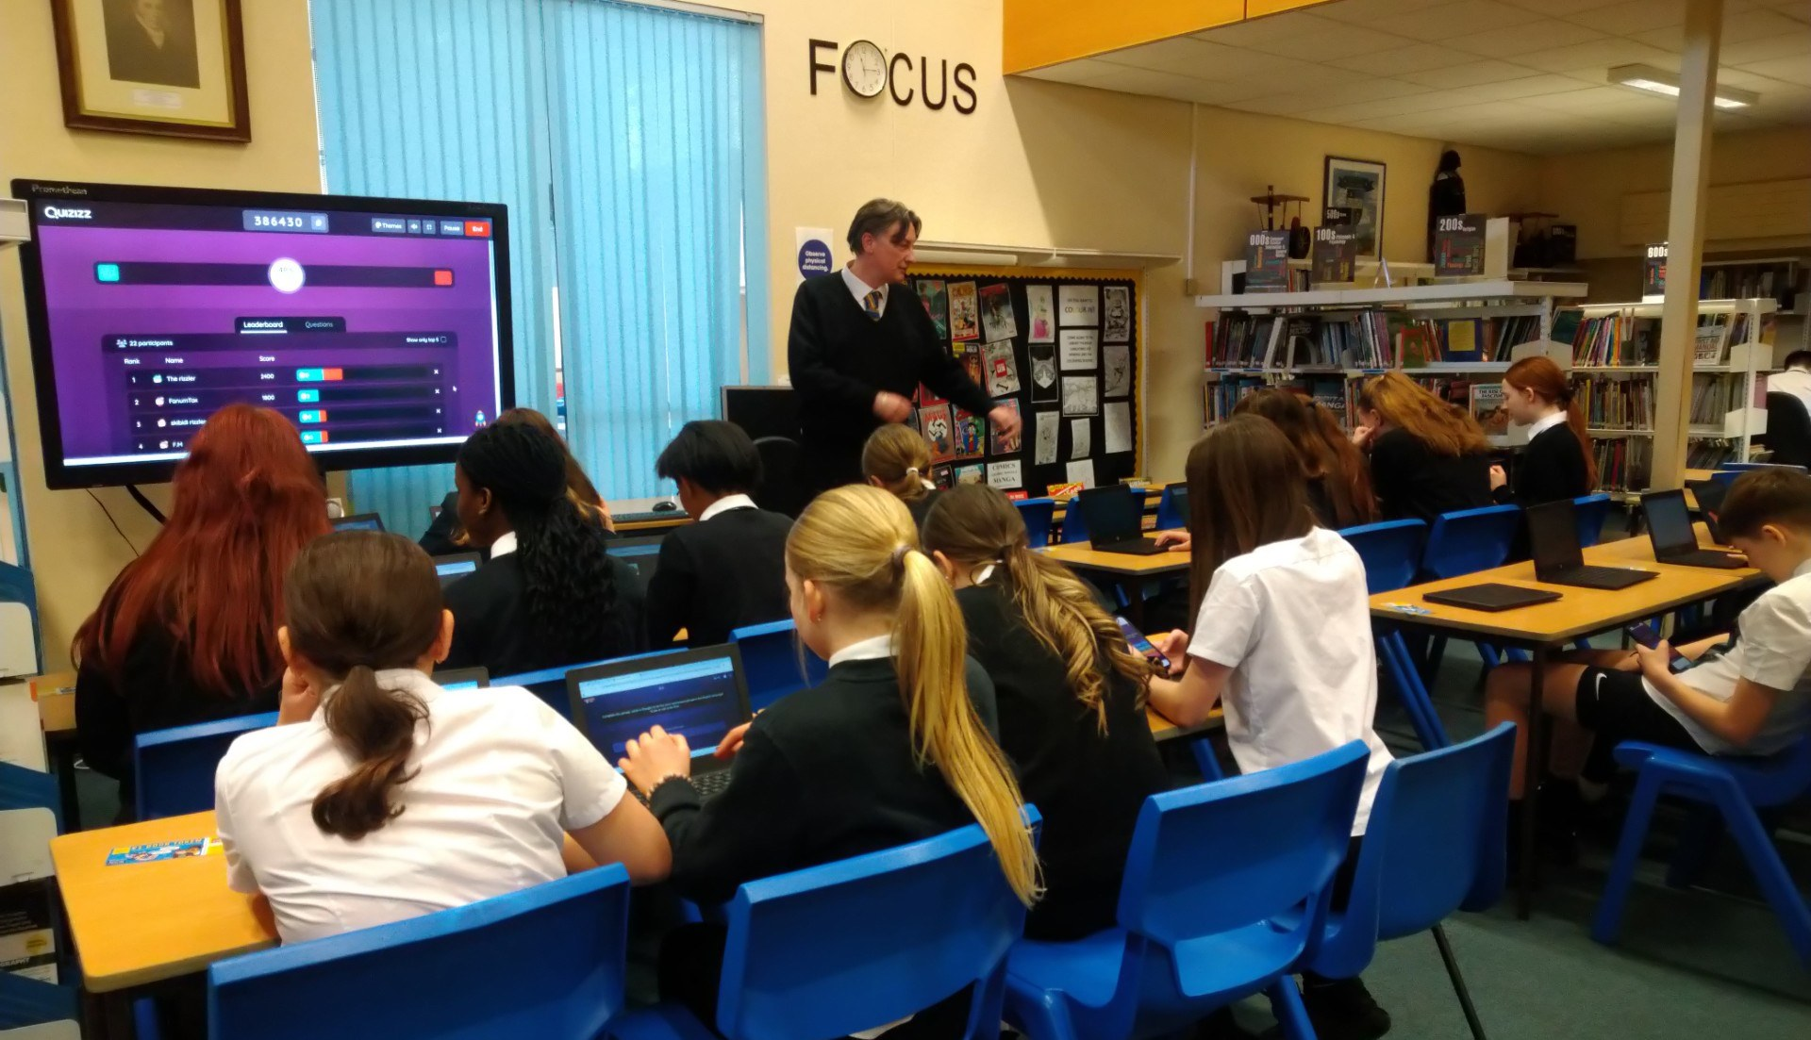
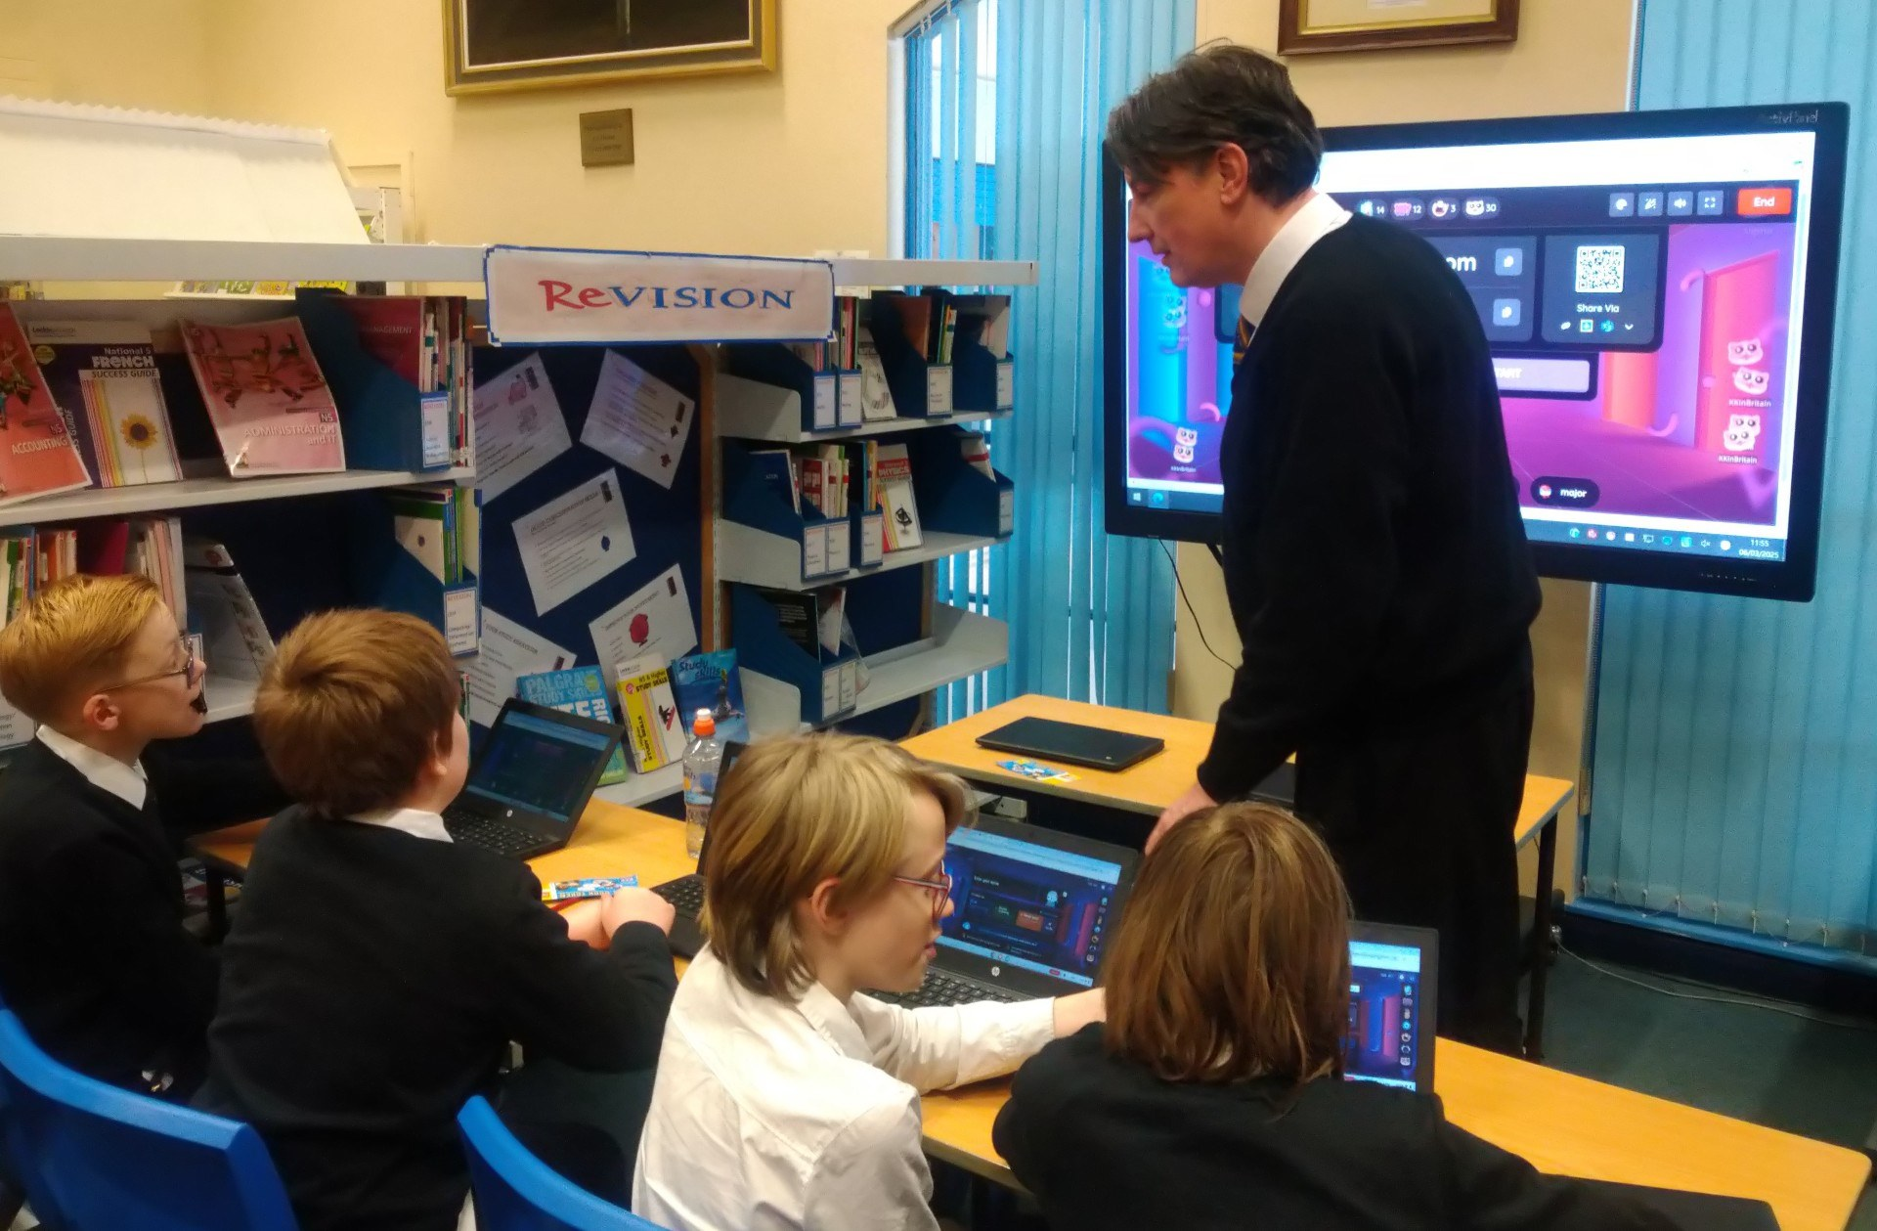
Colouring sessions have continued throughout the term for mindfulness and relaxation, with a good selection of topics.
The Paired reading scheme was a success this past term with some of our S6s reading alongside younger pupils in order to boost confidence and enjoyment. It’s great to see pupils using this time to work together, get to know one another a bit, and generally celebrate what we love in the library: reading!
Keep your book reviews coming in as we are always looking to send them to Teen Titles; the magazine on books aimed at high school pupils. Pupils who are published receive a contributor copy of the issue. We already have reviews confirmed for next term and would love to add to them!.
Here are the library’s Top Ten most popular books as loaned by Webster’s High pupils:
1.Diary of a Wimpy Kid 1 - Kinney, Jeff
2. Ronaldo Rules - Mugford, Simon, & Green, Dan
3.Dog Man 4: Dog Man and Cat Kid - Pilkey, Dav; Garibaldi, Jose
4.Diary of a Wimpy Kid 11: Double Down - Kinney, Jeff
5.Dog Man 5: Lord of the Fleas - Pilkey, Dav; Garibaldi, Jose
6.Lacazette - Oldfield, Matt & Tom
7.Pogba Rules - Mugford, Simon; Green, Dan
8.Demon Slayer 19 - Gotoge, Koyoharu
9. Diary of a Wimpy Kid 7: The Third Wheel - Kinney, Jeff
10. Kane - Oldfield, Matt
Strong showings for Diary of a Wimpy Kid, footballer biographies, and Dog Man, with manga favourite Demon Slayer also featuring. Just outside the top ten were Titanic : minute by minute, Assassination Classroom, and Guinness World Records.
The quiz to see in the summer this year is based on superheroes, with prizes including a Venom T-shirt (XL), Marvel keyring, Hot Wheels Batmobile, and books including: Skulduggery Pleasant: Death Bringer; My Story: Titanic; Artemis Fowl: The Arctic Incident; and Superman: Panic in the Sky. Twelve runners-up also receive a Marvel keyring. Alongside this, the documentary film Once Upon a Time: The Superheroes is showing in the library lunchtimes over Tues 24th - Thurs 26th June.



Thank you to all the pupils and staff for making the first half of 2025 as good as it was. Have a great Summer. Keep on enjoying reading over the holidays!
Mr. Robertson

The Love of Outdoors
Learning for Sustainability Goal 15: Life on Land
Webster's Bees
Webster's bees are thriving!
Our two bee hives have been very busy and, for the first time, we have a group of 8 pupils studying for their NPA Level 5 Beekeeping Qualification. The Qualification includes three units:
Unit 1 – Beekeeping: An Introduction
Unit 2 – Beekeeping: Practical Skills
Unit 3 – Beekeeping: Theory
4 of the pupils in the group are responsible for Hive 1 and the other 4 pupils are responsible for Hive 2. The two groups gave been going out to the hives on a Wednesday morning to cry out hive checks and learn the skills necessary to be a beekeeper.
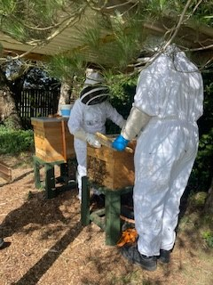
Our two bee hives have been very busy and, for the first time, we have a group of 8 pupils studying for their NPA Level 5 Beekeeping Qualification. The Qualification includes three units:
Unit 1 – Beekeeping: An Introduction
Unit 2 – Beekeeping: Practical Skills
Unit 3 – Beekeeping: Theory
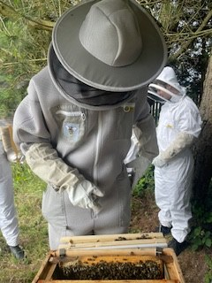
4 of the pupils in the group are responsible for Hive 1 and the other 4 pupils are responsible for Hive 2. The two groups gave been going out to the hives on a Wednesday morning to cry out hive checks and learn the skills necessary to be a beekeeper.
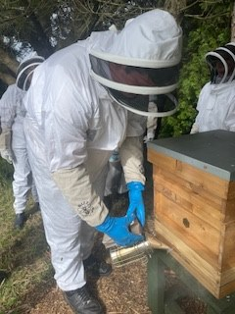
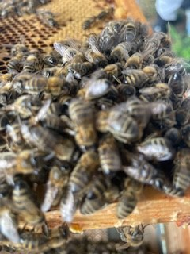
The school would like to say a massive thank you to Pathhead stables for developing the beautiful field growing crops and a range of flowers in front of the hives as well as Angus Glen's Rotary for donating funds to the school to run this qualification and Baldragon Beekeeping Association whose knowledge and expertise we would be lost without!
Spirit of Adventure
Webster's, once again, were invited to attend the Lord Lieutenants Spirit of Adventure Day at RM Condor. Great team spirit and encouragement from everyone taking part, not only their own team but for everyone taking part. The Ridgway Adventure Break was awarded to Angus Cameron for his tremendous efforts on the day.
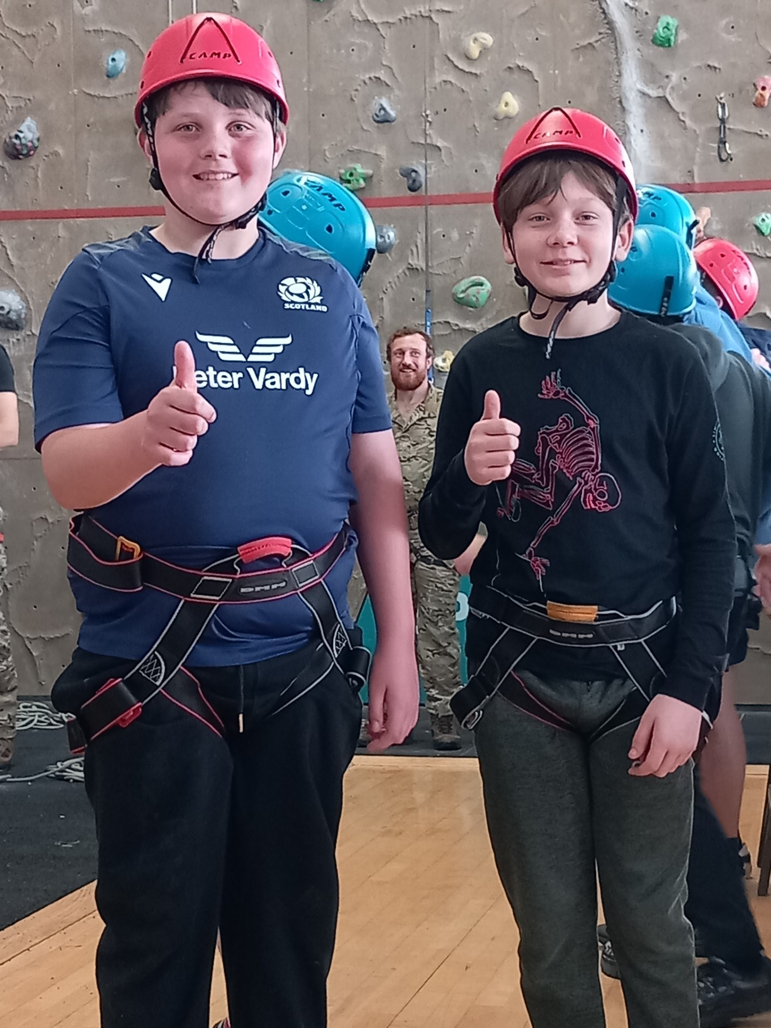
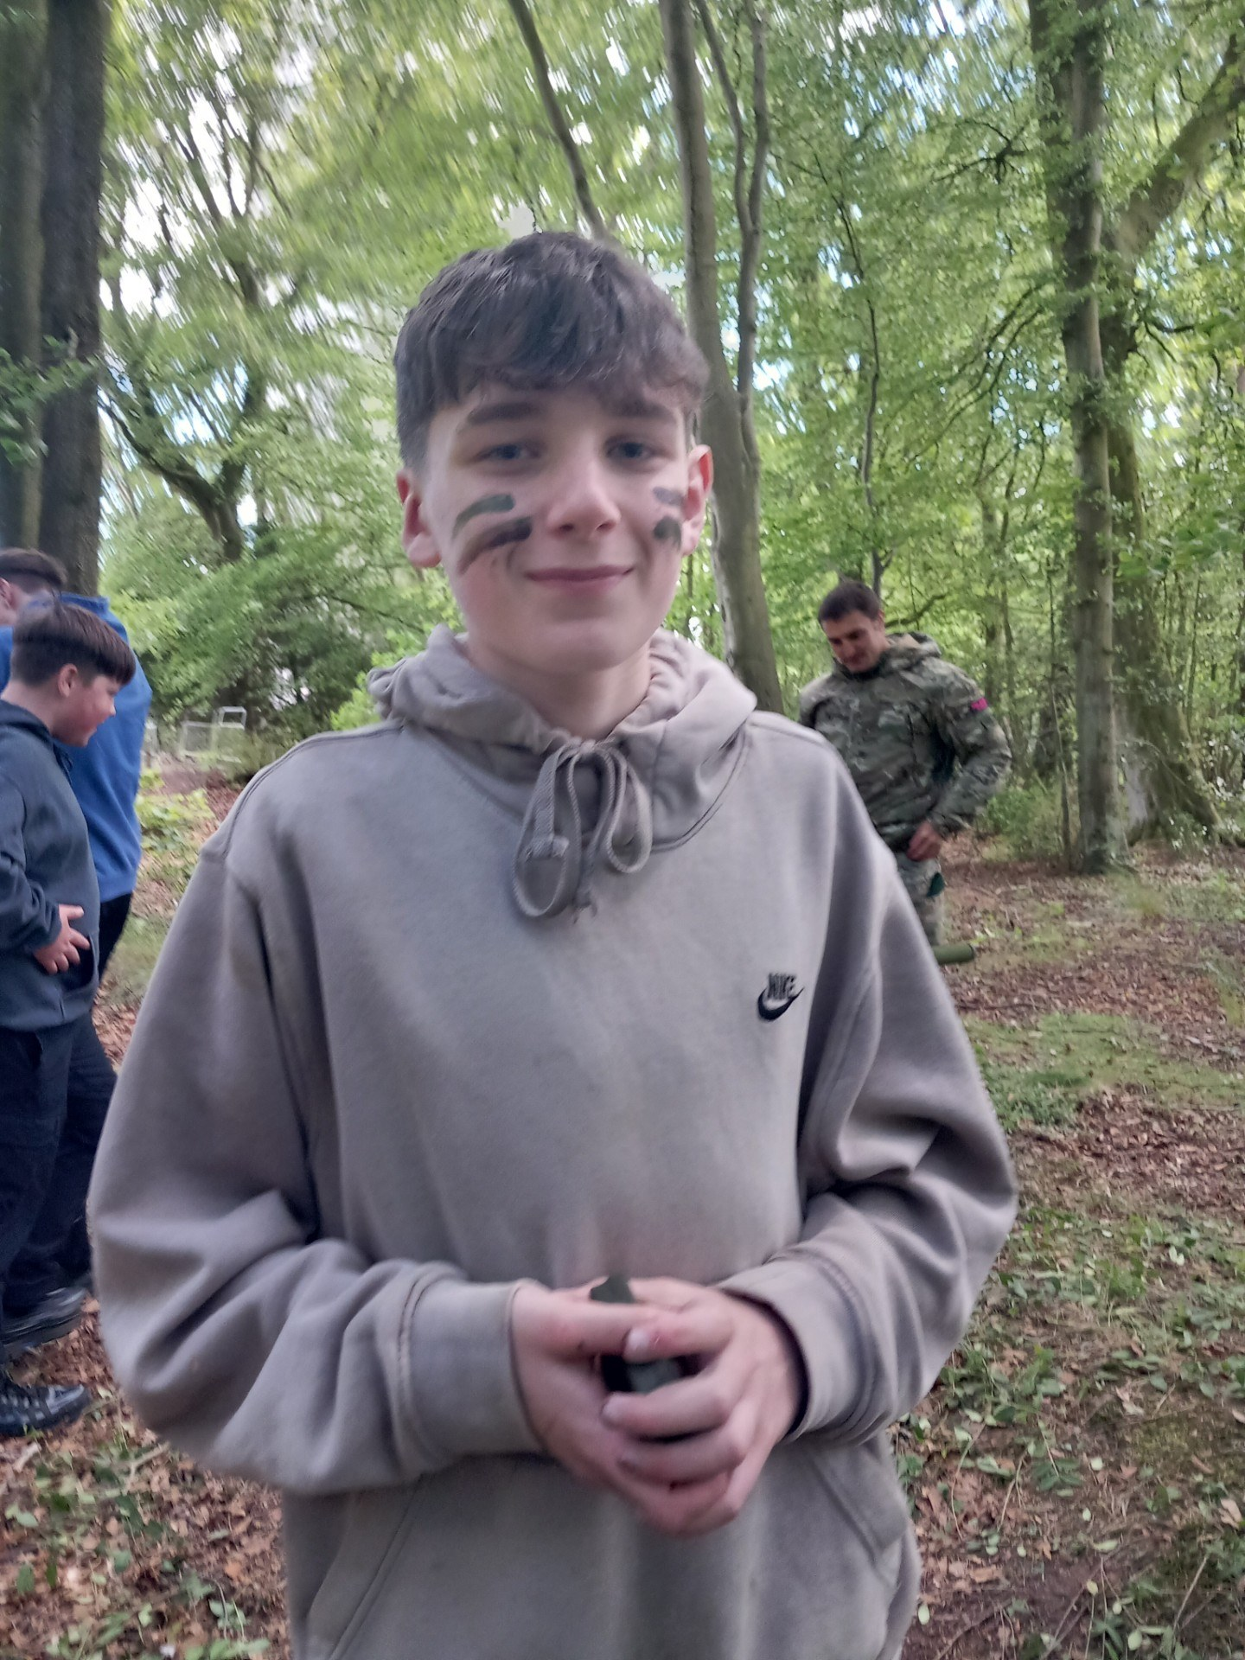
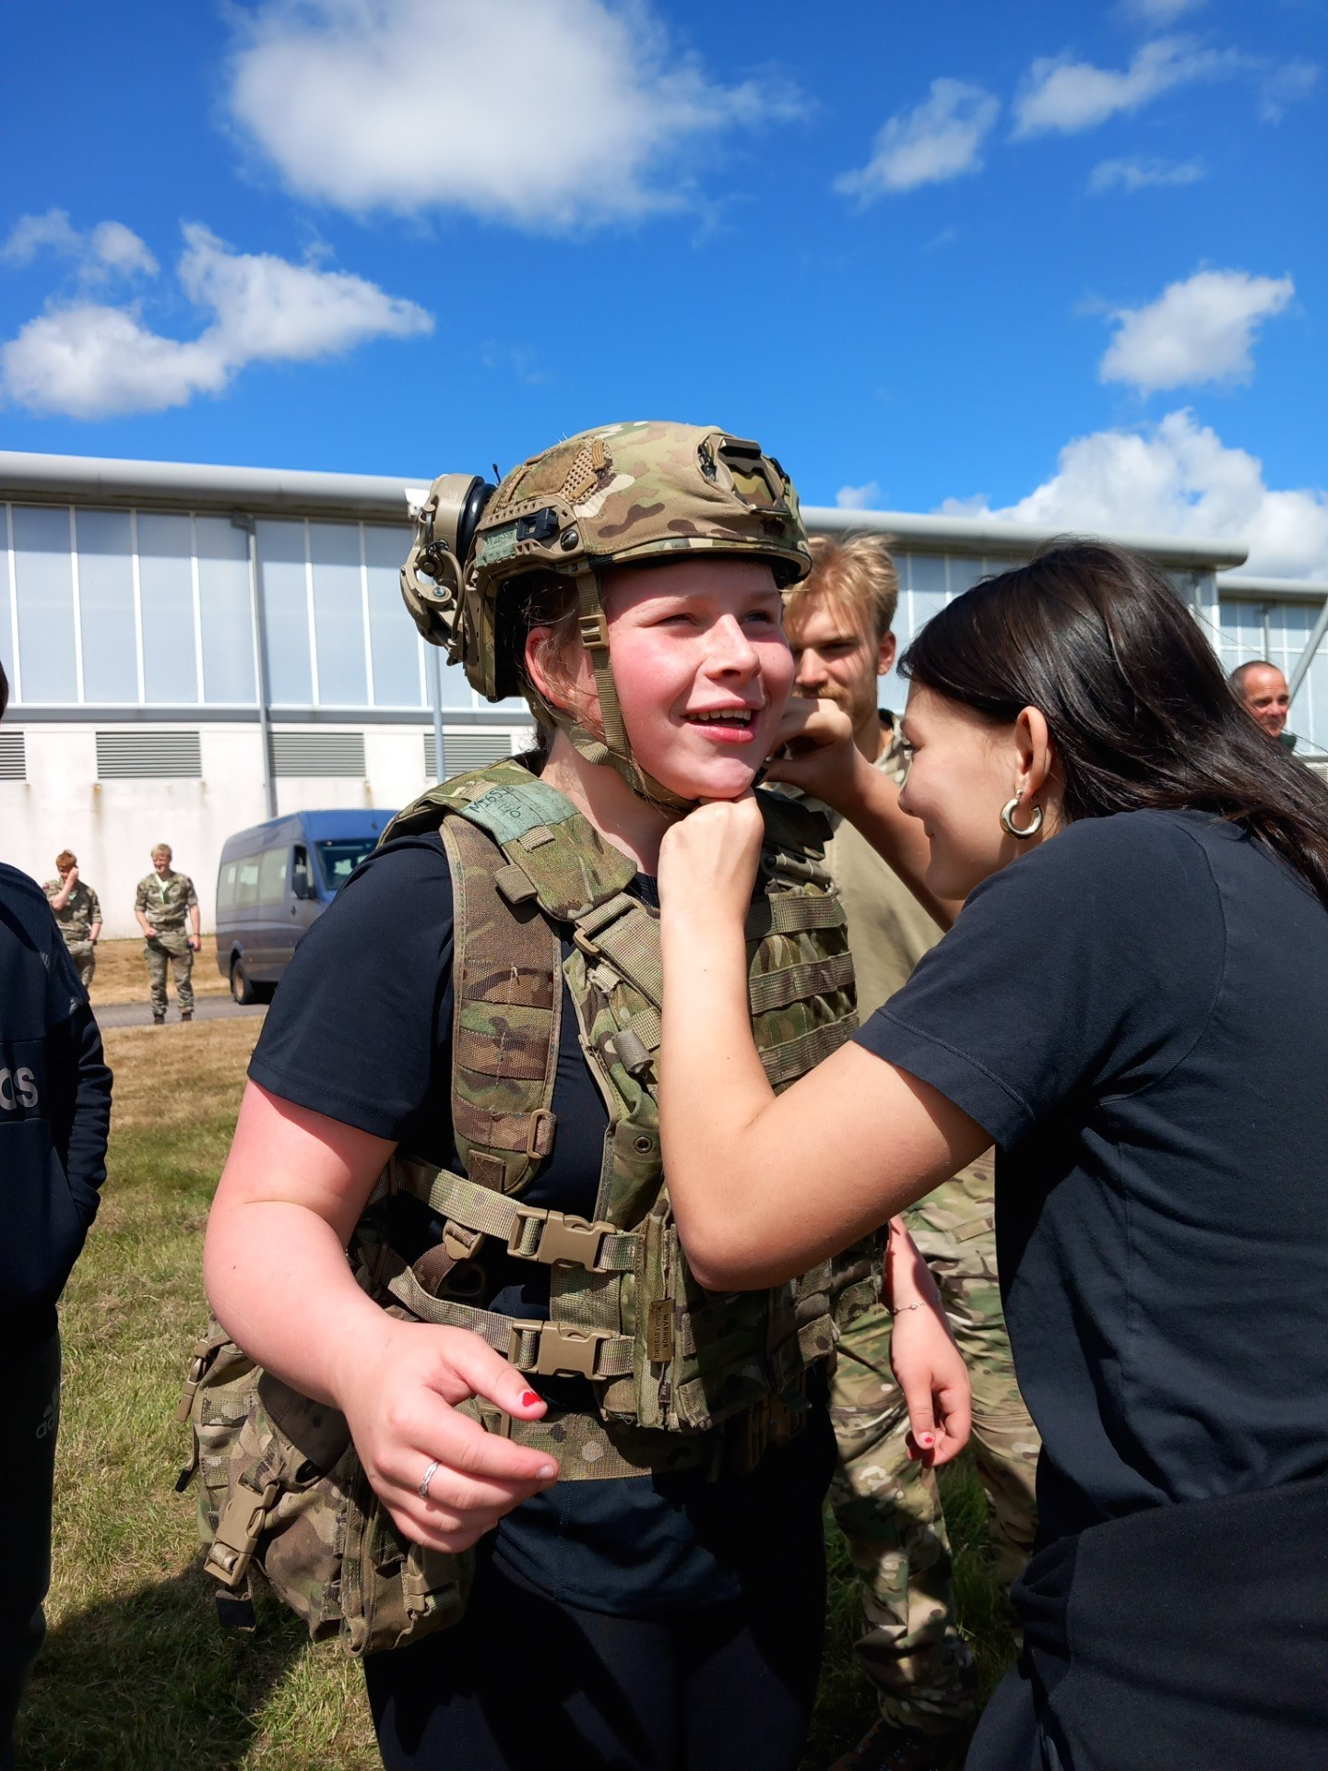
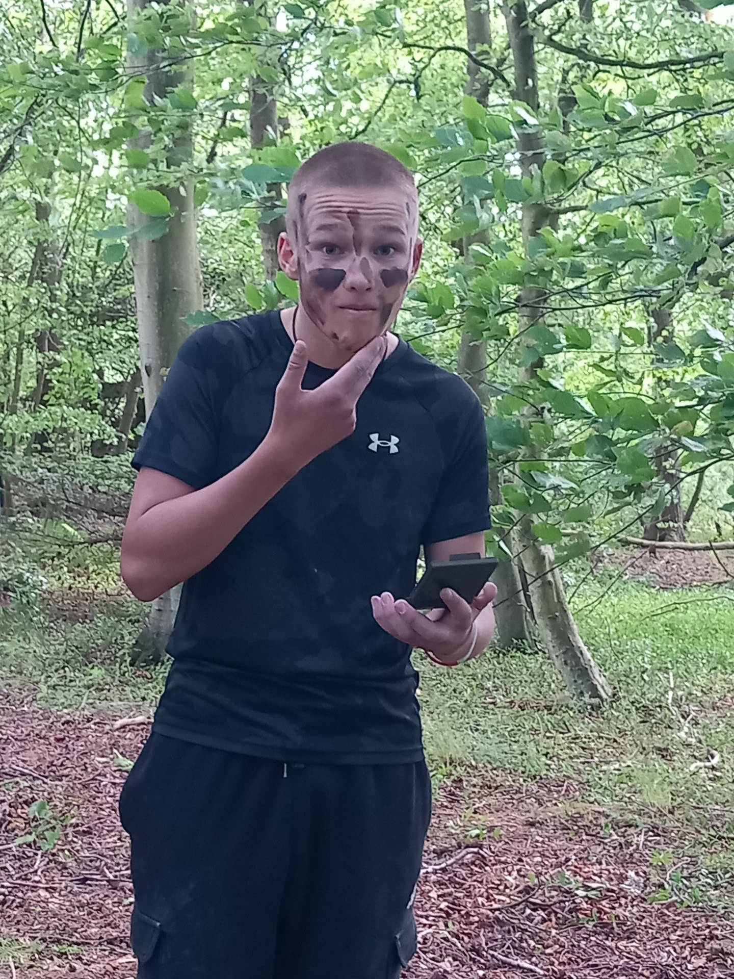
Outdoor Education 25 - led by Mr Milton
I would like to start this by thanking the local community in helping to facilitate the outdoor learning as without their support it would be more difficult to facilitate. This year, as in the past, we have been out and about from the start of the year, we have planted trees at the Sustainable Kirriemuir farm on the Kinordy estate, helping at the community garden, litter picking at the beach at Auchmithie, if you want to see more of what we do please follow the link. https://youtu.be/_5iSohWFwVY
S3 BioGeography trips to the Rottal Burn
At the start of June two field trips were taken to the Rottal Burn in Glen Clova with a group of S3 pupils who are interested in biology and geography. The trip allowed pupils to experience outdoor learning on how environmental scientists measure river processes and the biological health of river systems.
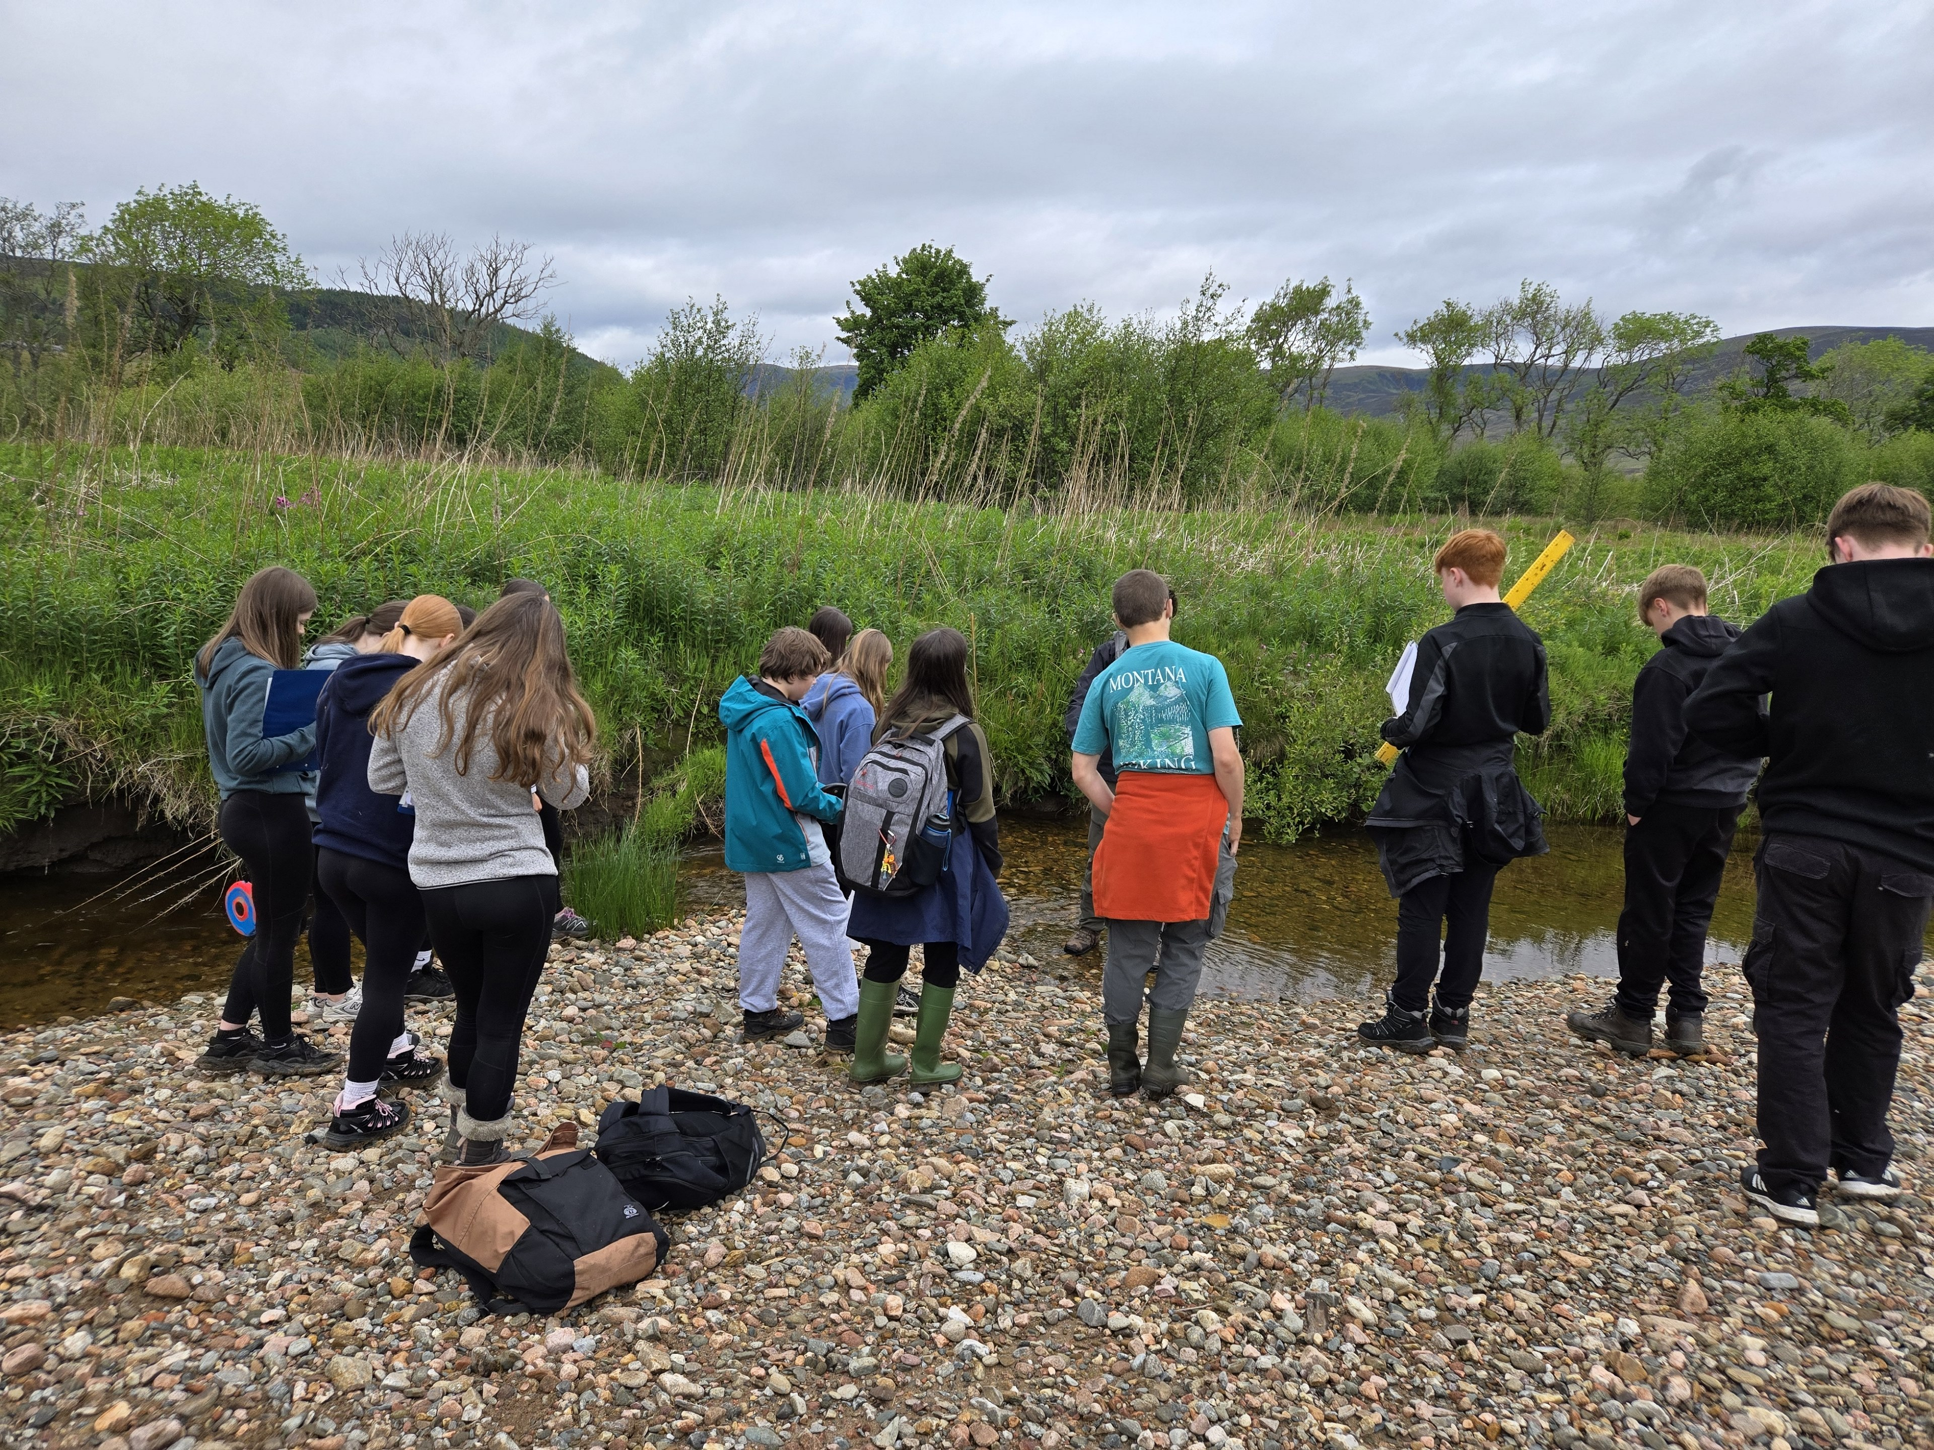
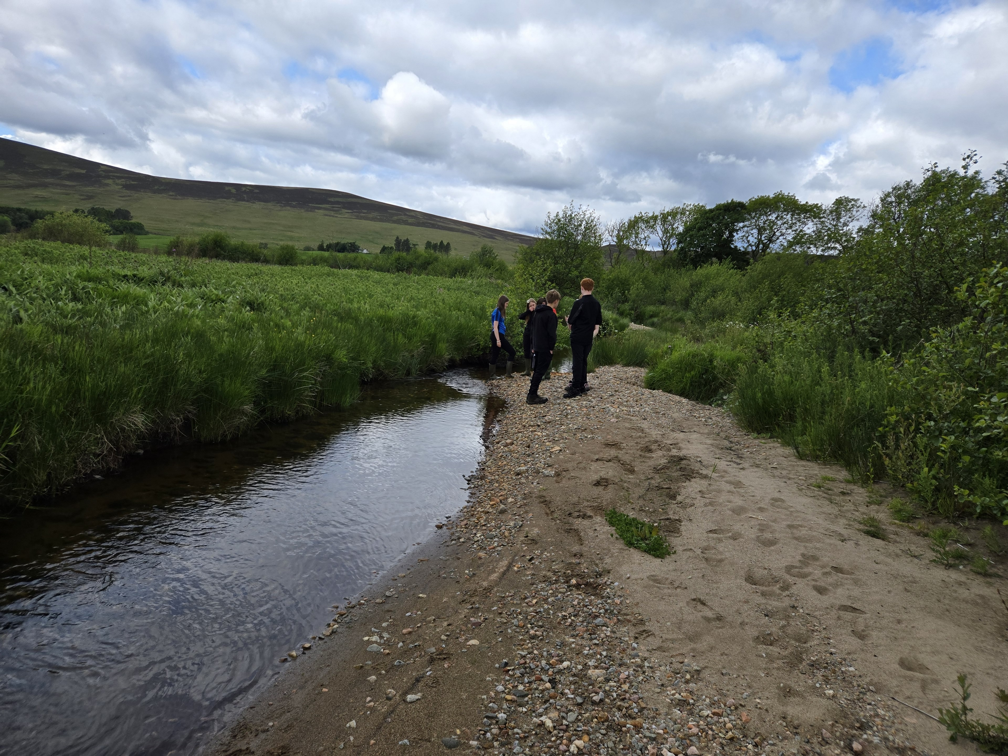
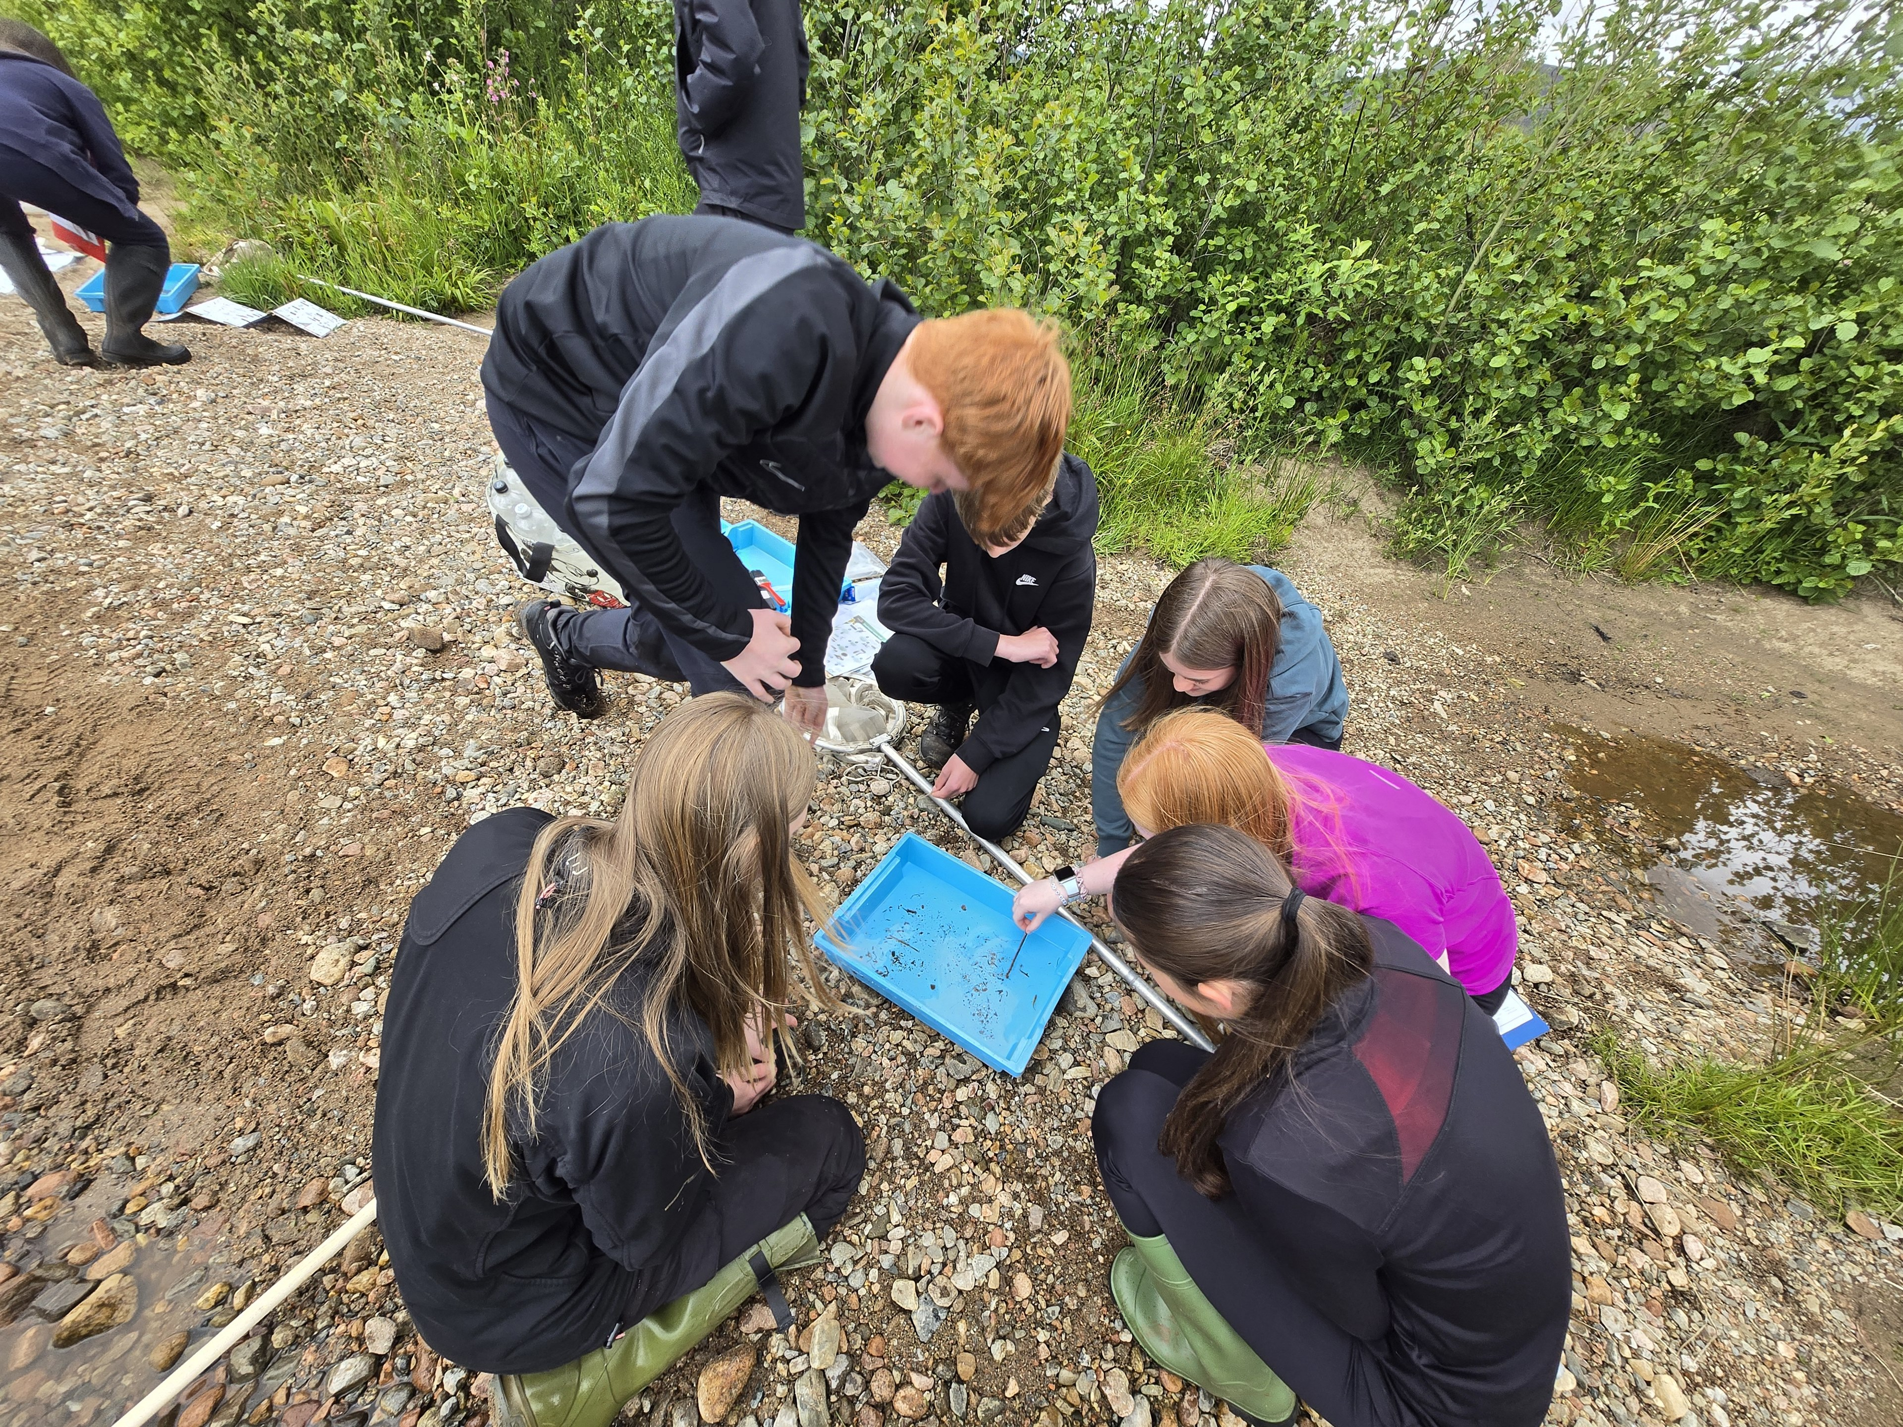
Highlights of the trips included learning about a fantastic example of sustainable river management in our local area, seeing aquatic creatures in their natural habitat and even being lucky enough to meet a water vole! We are incredibly grateful to the Rottal Estate for hosting us on these trips and we look forward to continuing to offer this opportunity to pupils in future years.
The Ski trip March 25
This year saw the return of the ski trip, twenty pupils from the school jetted off the Serre Chevalier in France for a weeks skiing. Some were new to the sport some were old hands but there is always room for improvement. The hotel was located at the bottom of the slopes so rolling out of bed and into the skis in the morning was greeted with joy and excitement, well Mr Milton did. The weather was kind and it was the first snow the resort had since Christmas, the feeling of powder snow and limited visibility was a real winner. The group progressed through the week and by the end of the week all were finding their inner Schiffrin. The evening entertainment extended the day and the highlights will be relived for a long time to come, thanks to the internet. The groups were outstanding in representing themselves and the school, the instructors commented on how fearless they were and would do as asked without any ‘feedback’ so well done to them. It is something that will be remembered for a long time.
Royal Highland Show - Edinburgh - June 2025

The 'old' S3 John Muir Gang had a fantastic time at the Royal Highland Show in Edinburgh this June. They attended horsing events, livestock shows, and much fun was had on the tractor simulators, giant ferris wheel, and farm machinery. The sun shone all day and everyone came home with full bellies and tired legs - a great day was had by all!
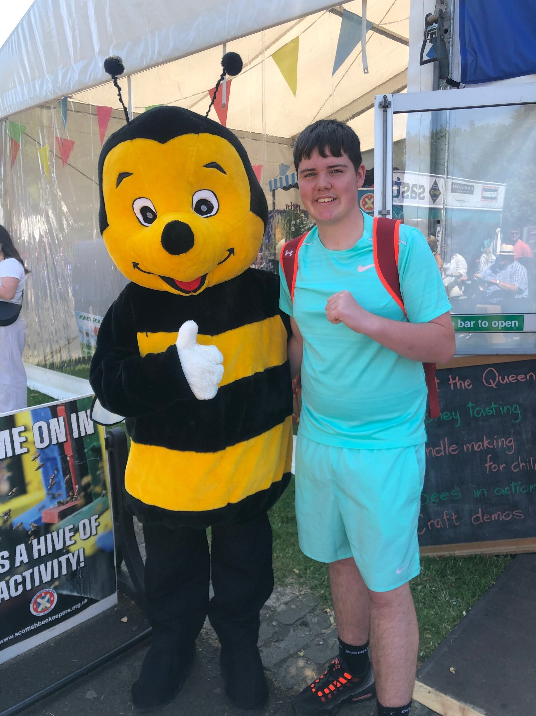
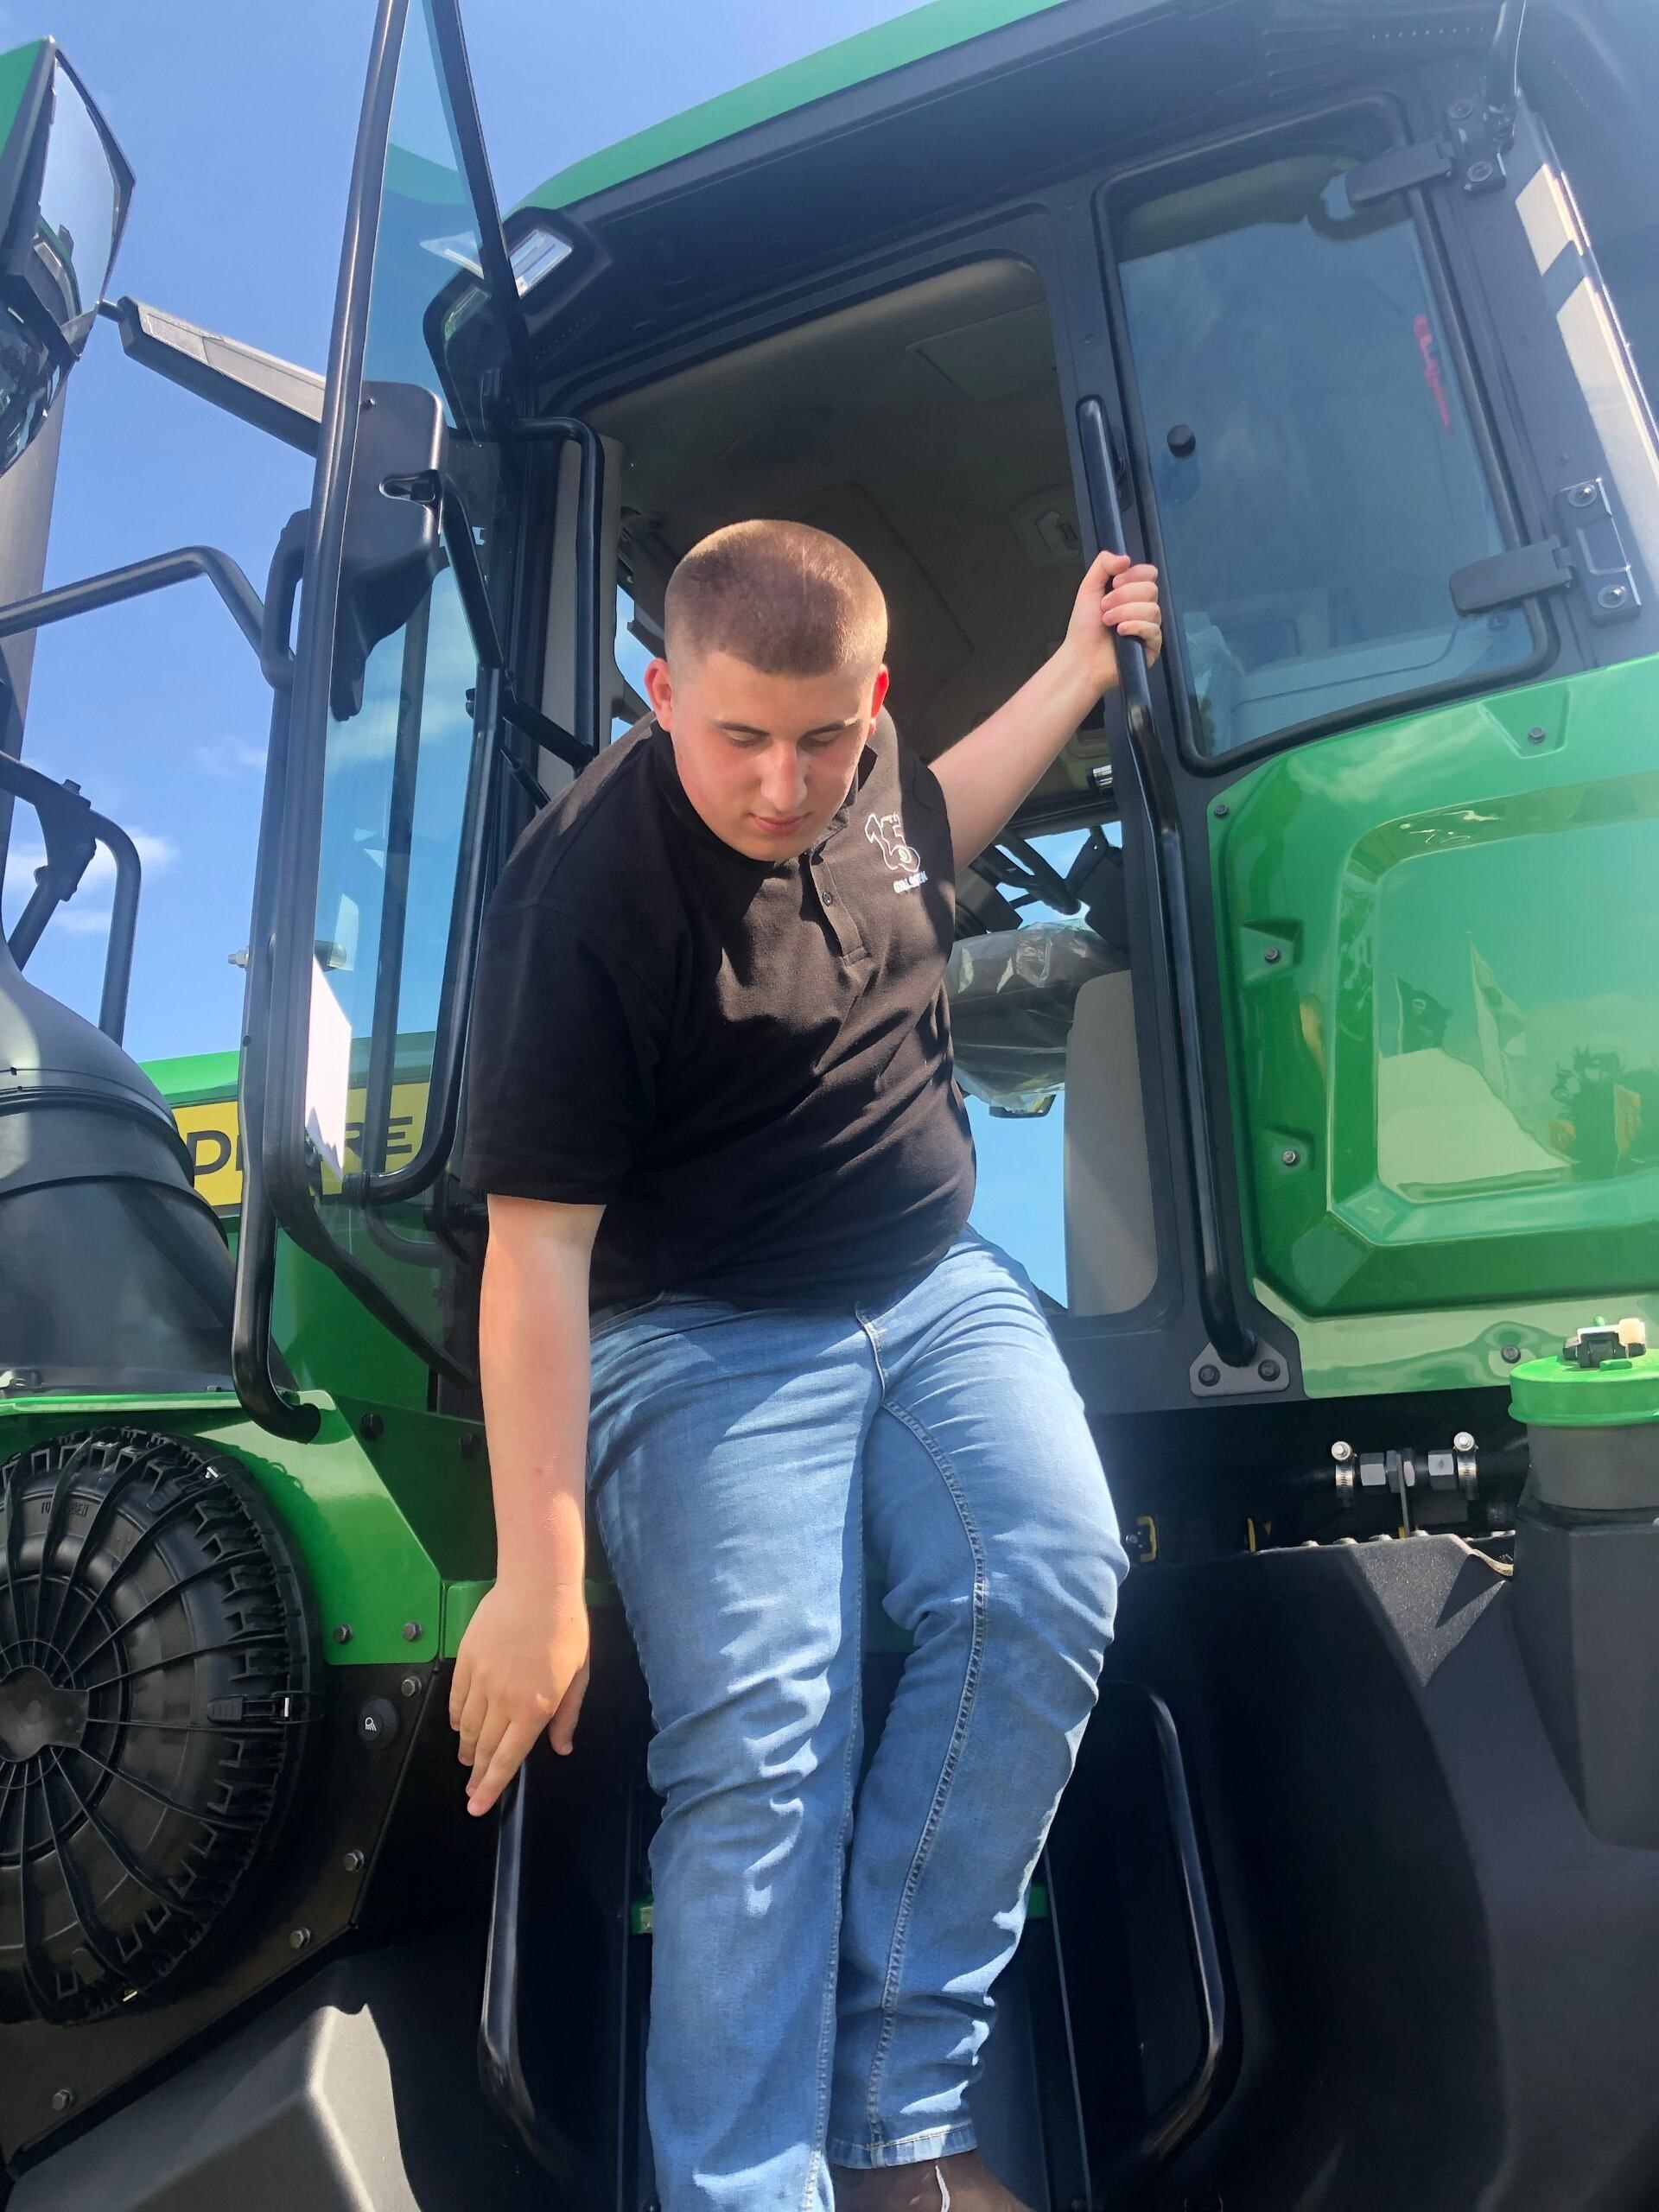

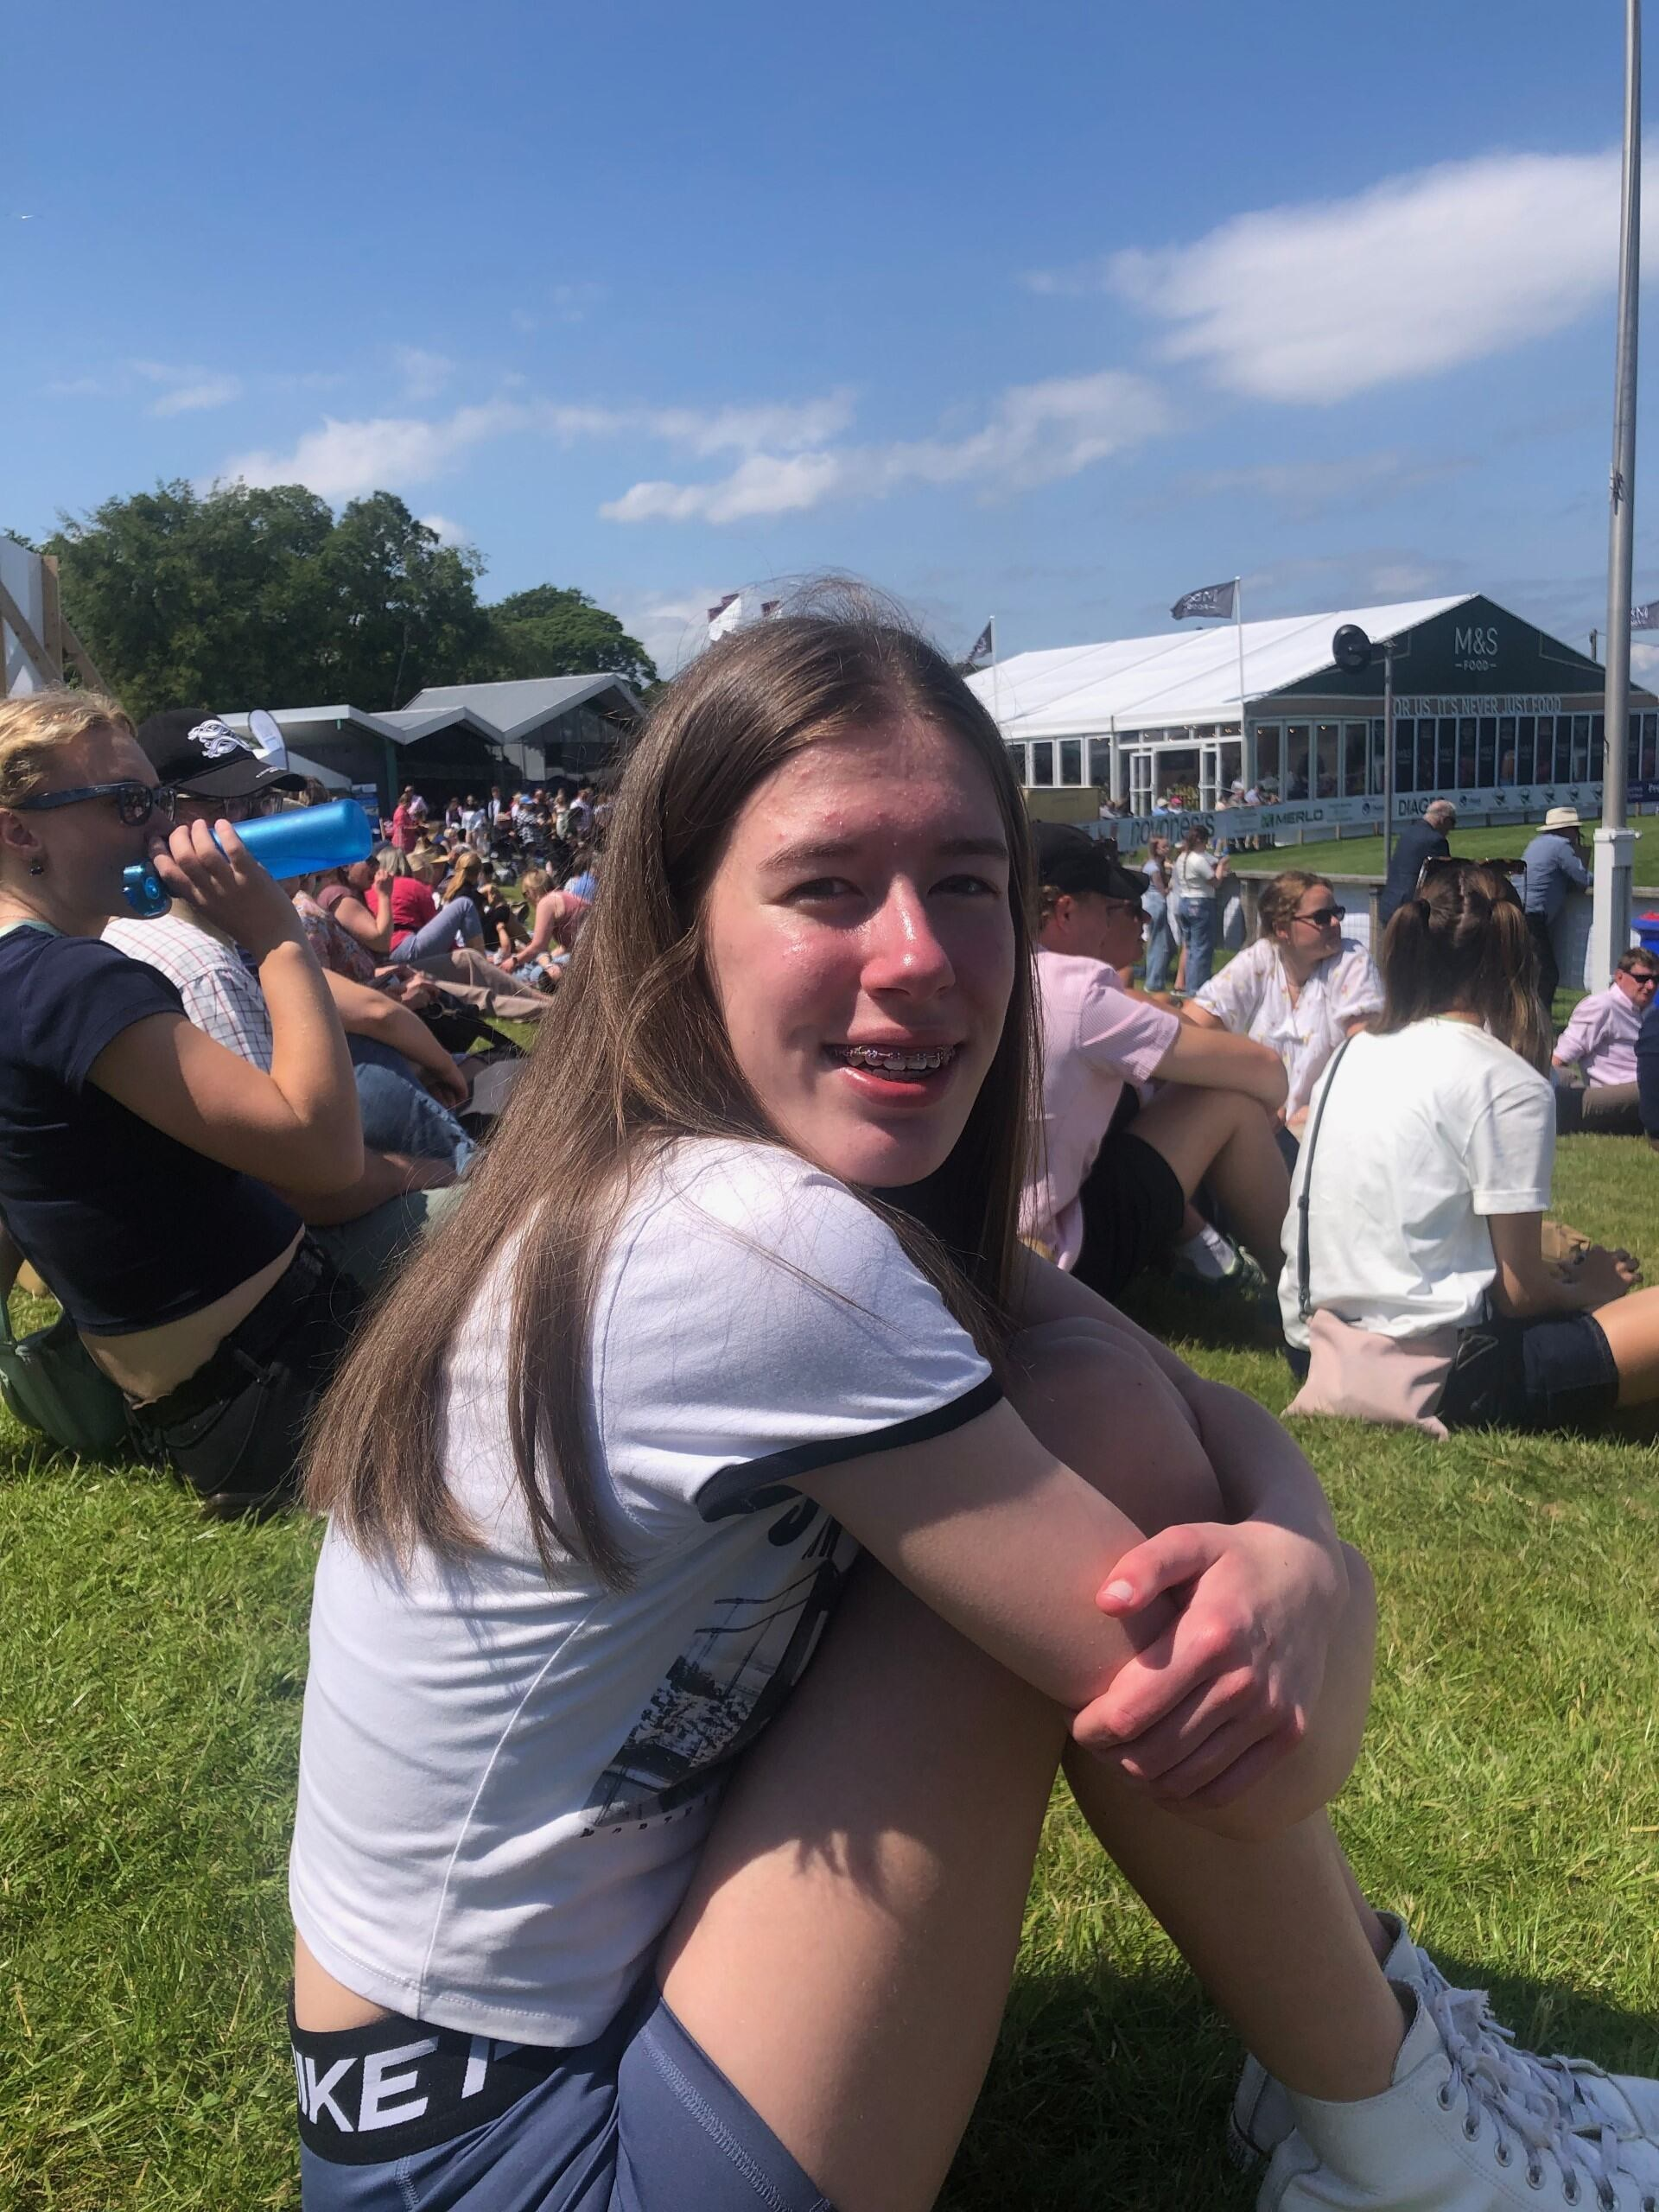
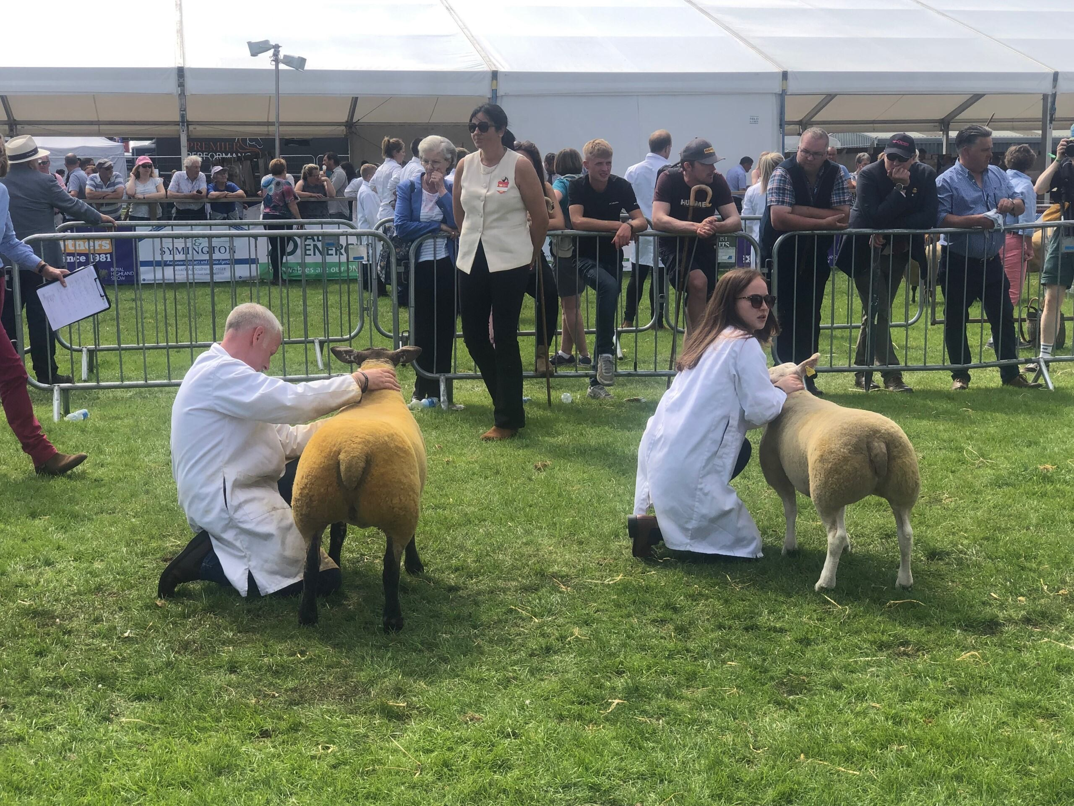
Animal Enrichment Murton - King's Trust & John Muir
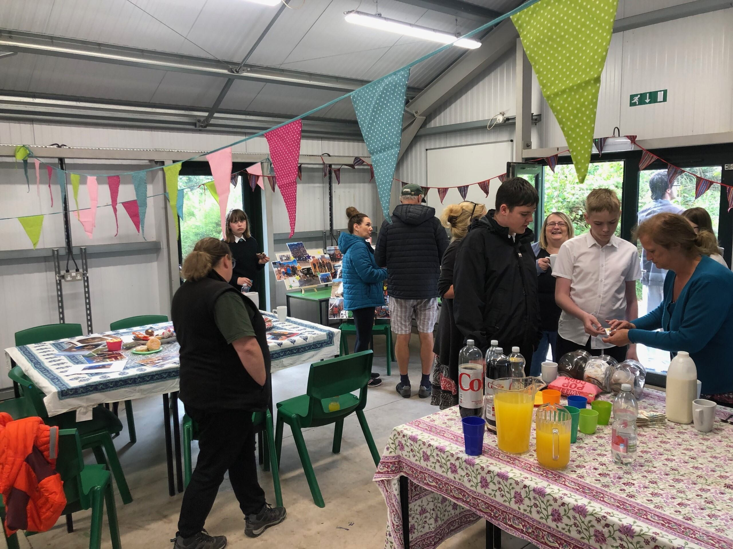
This month the King's Trust & John Muir group had a successful launch at Murton Nature Reserve for their Rabbit Enrichment Project.The group worked on enhancing four large rabbit pens to offer shelter from the sun and rain for the animals.Using their donated materials, the group decorated posts, finials and sails to create an eye-catching and practical solution to the problem of our ever changeable Scottish weather!The businesses involved joined the group for their launch and much fun was had by all - rabbits included!
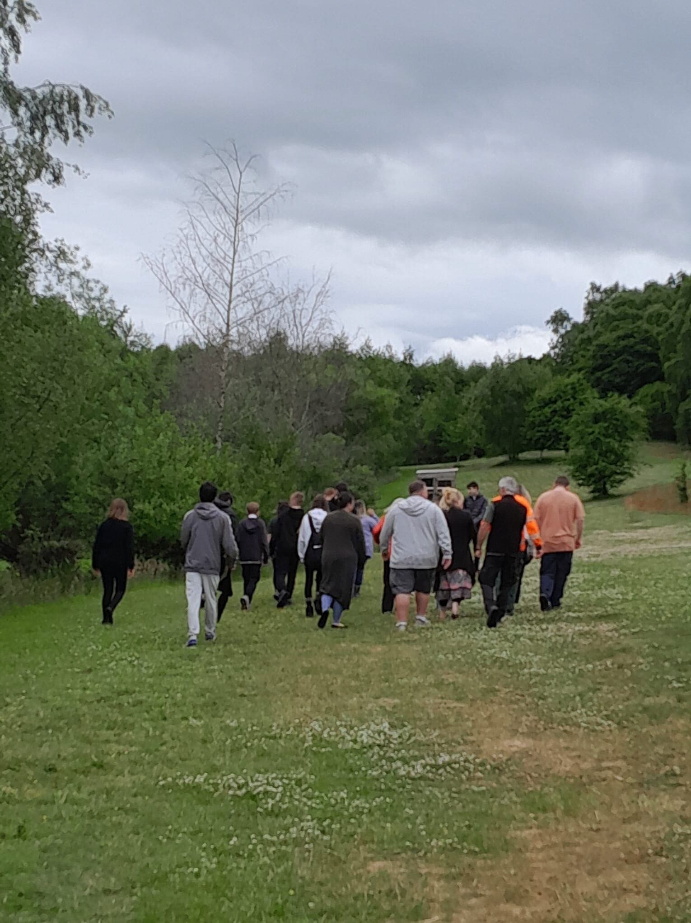
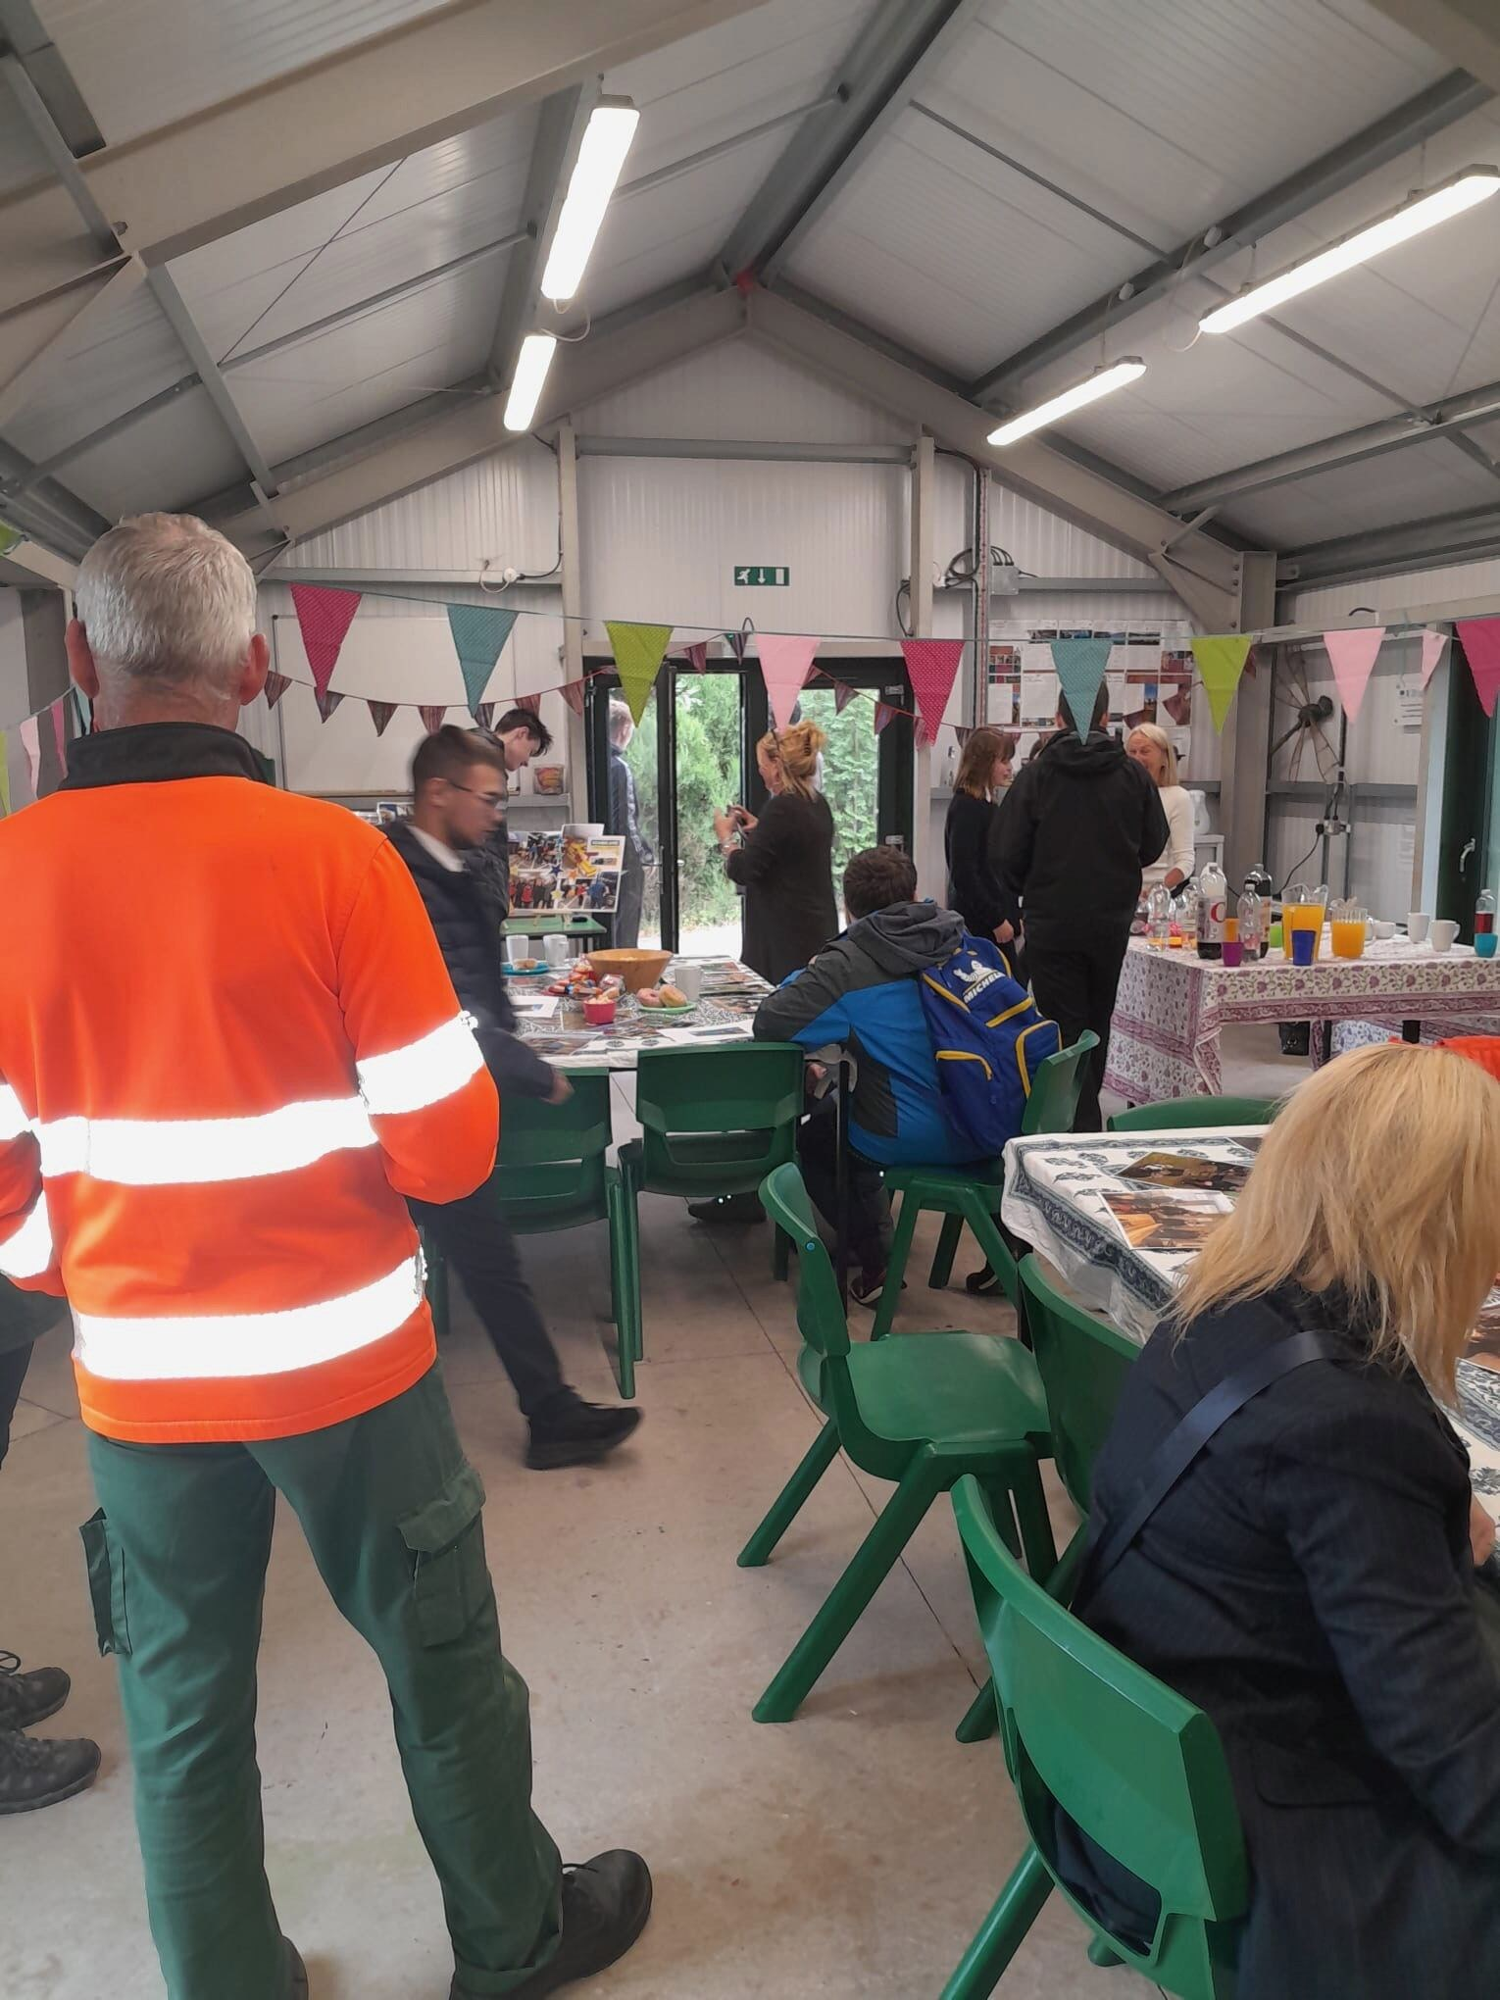
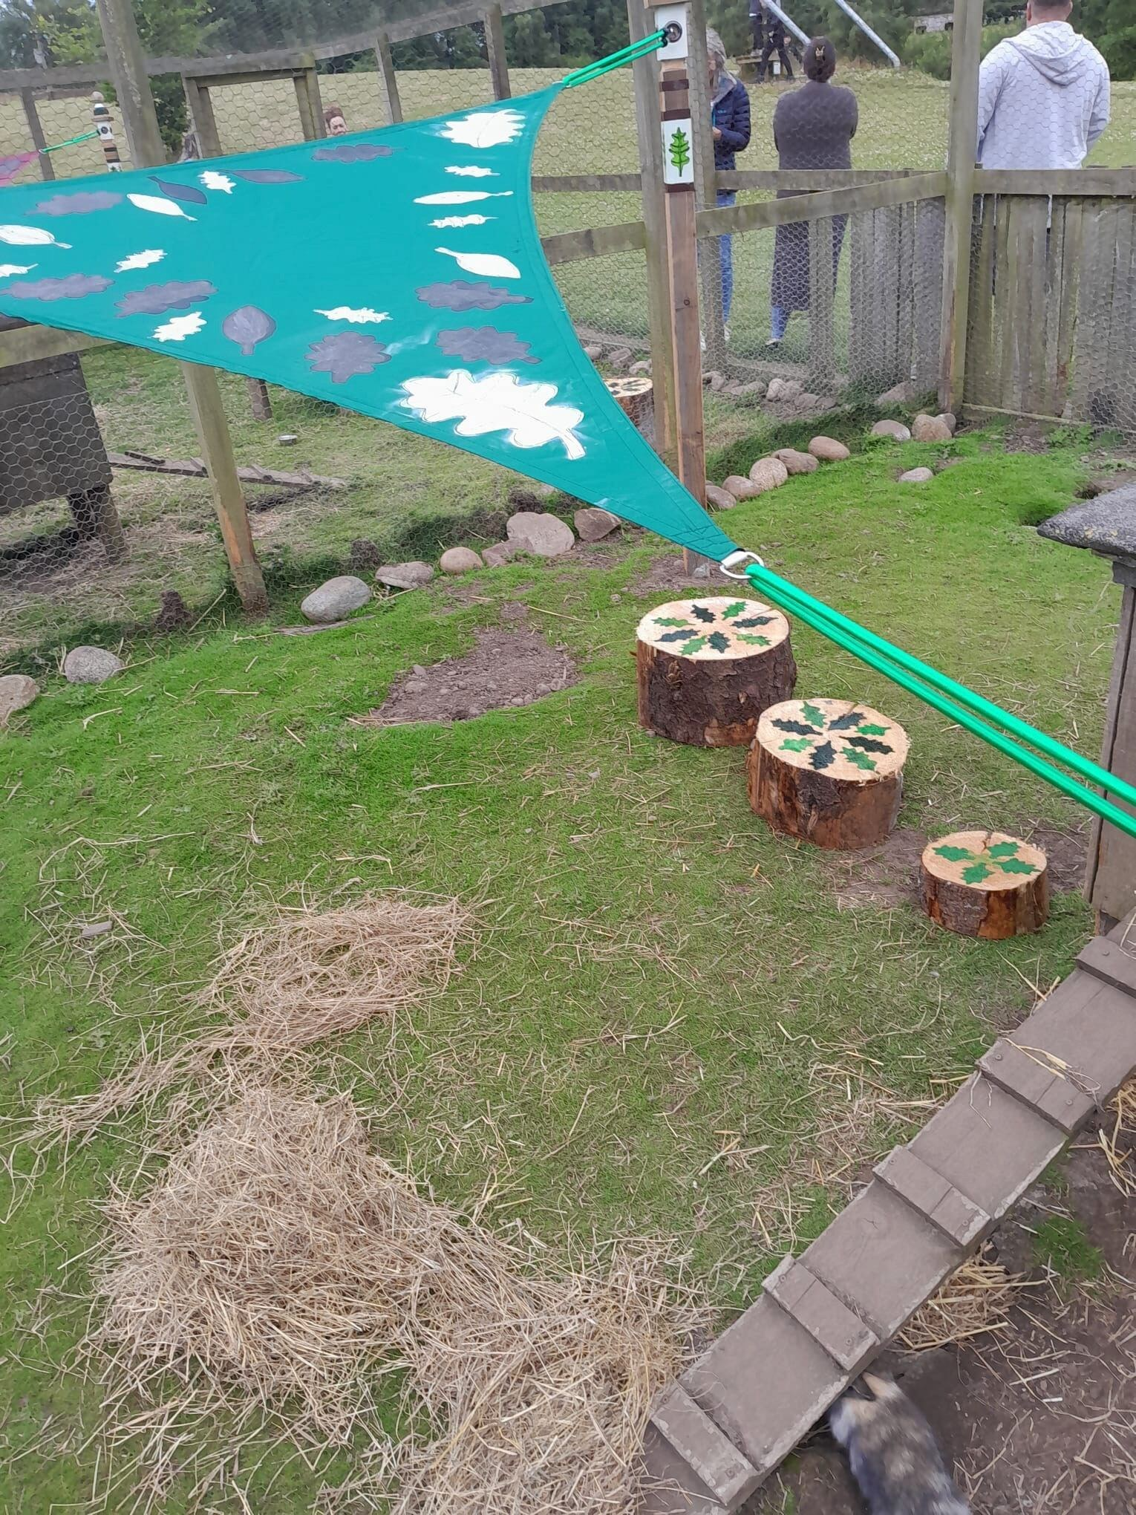
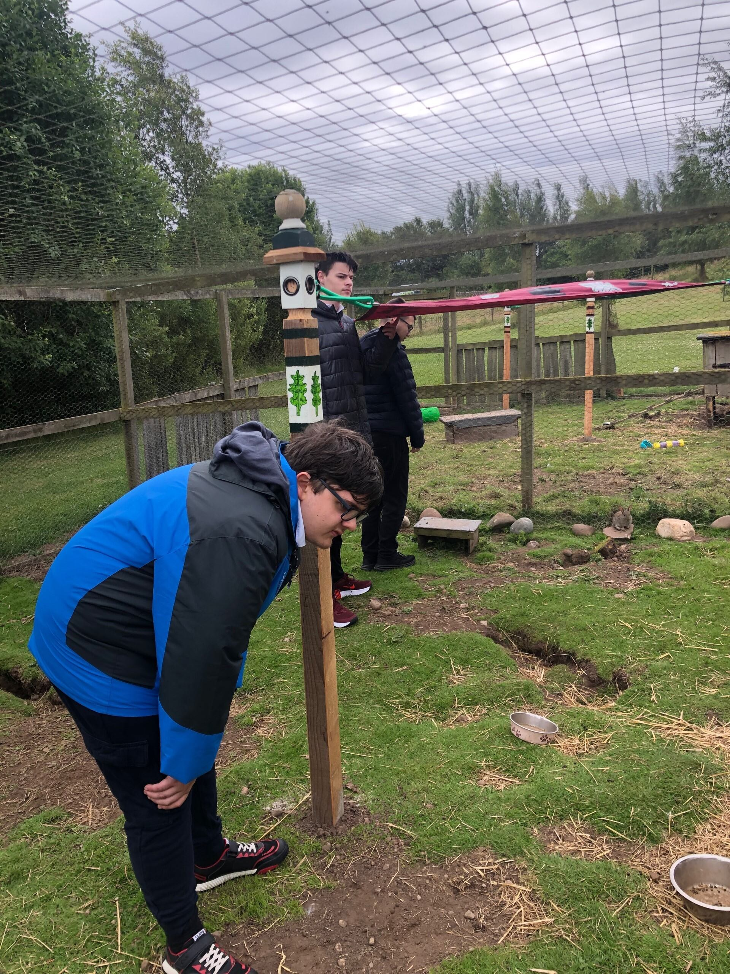
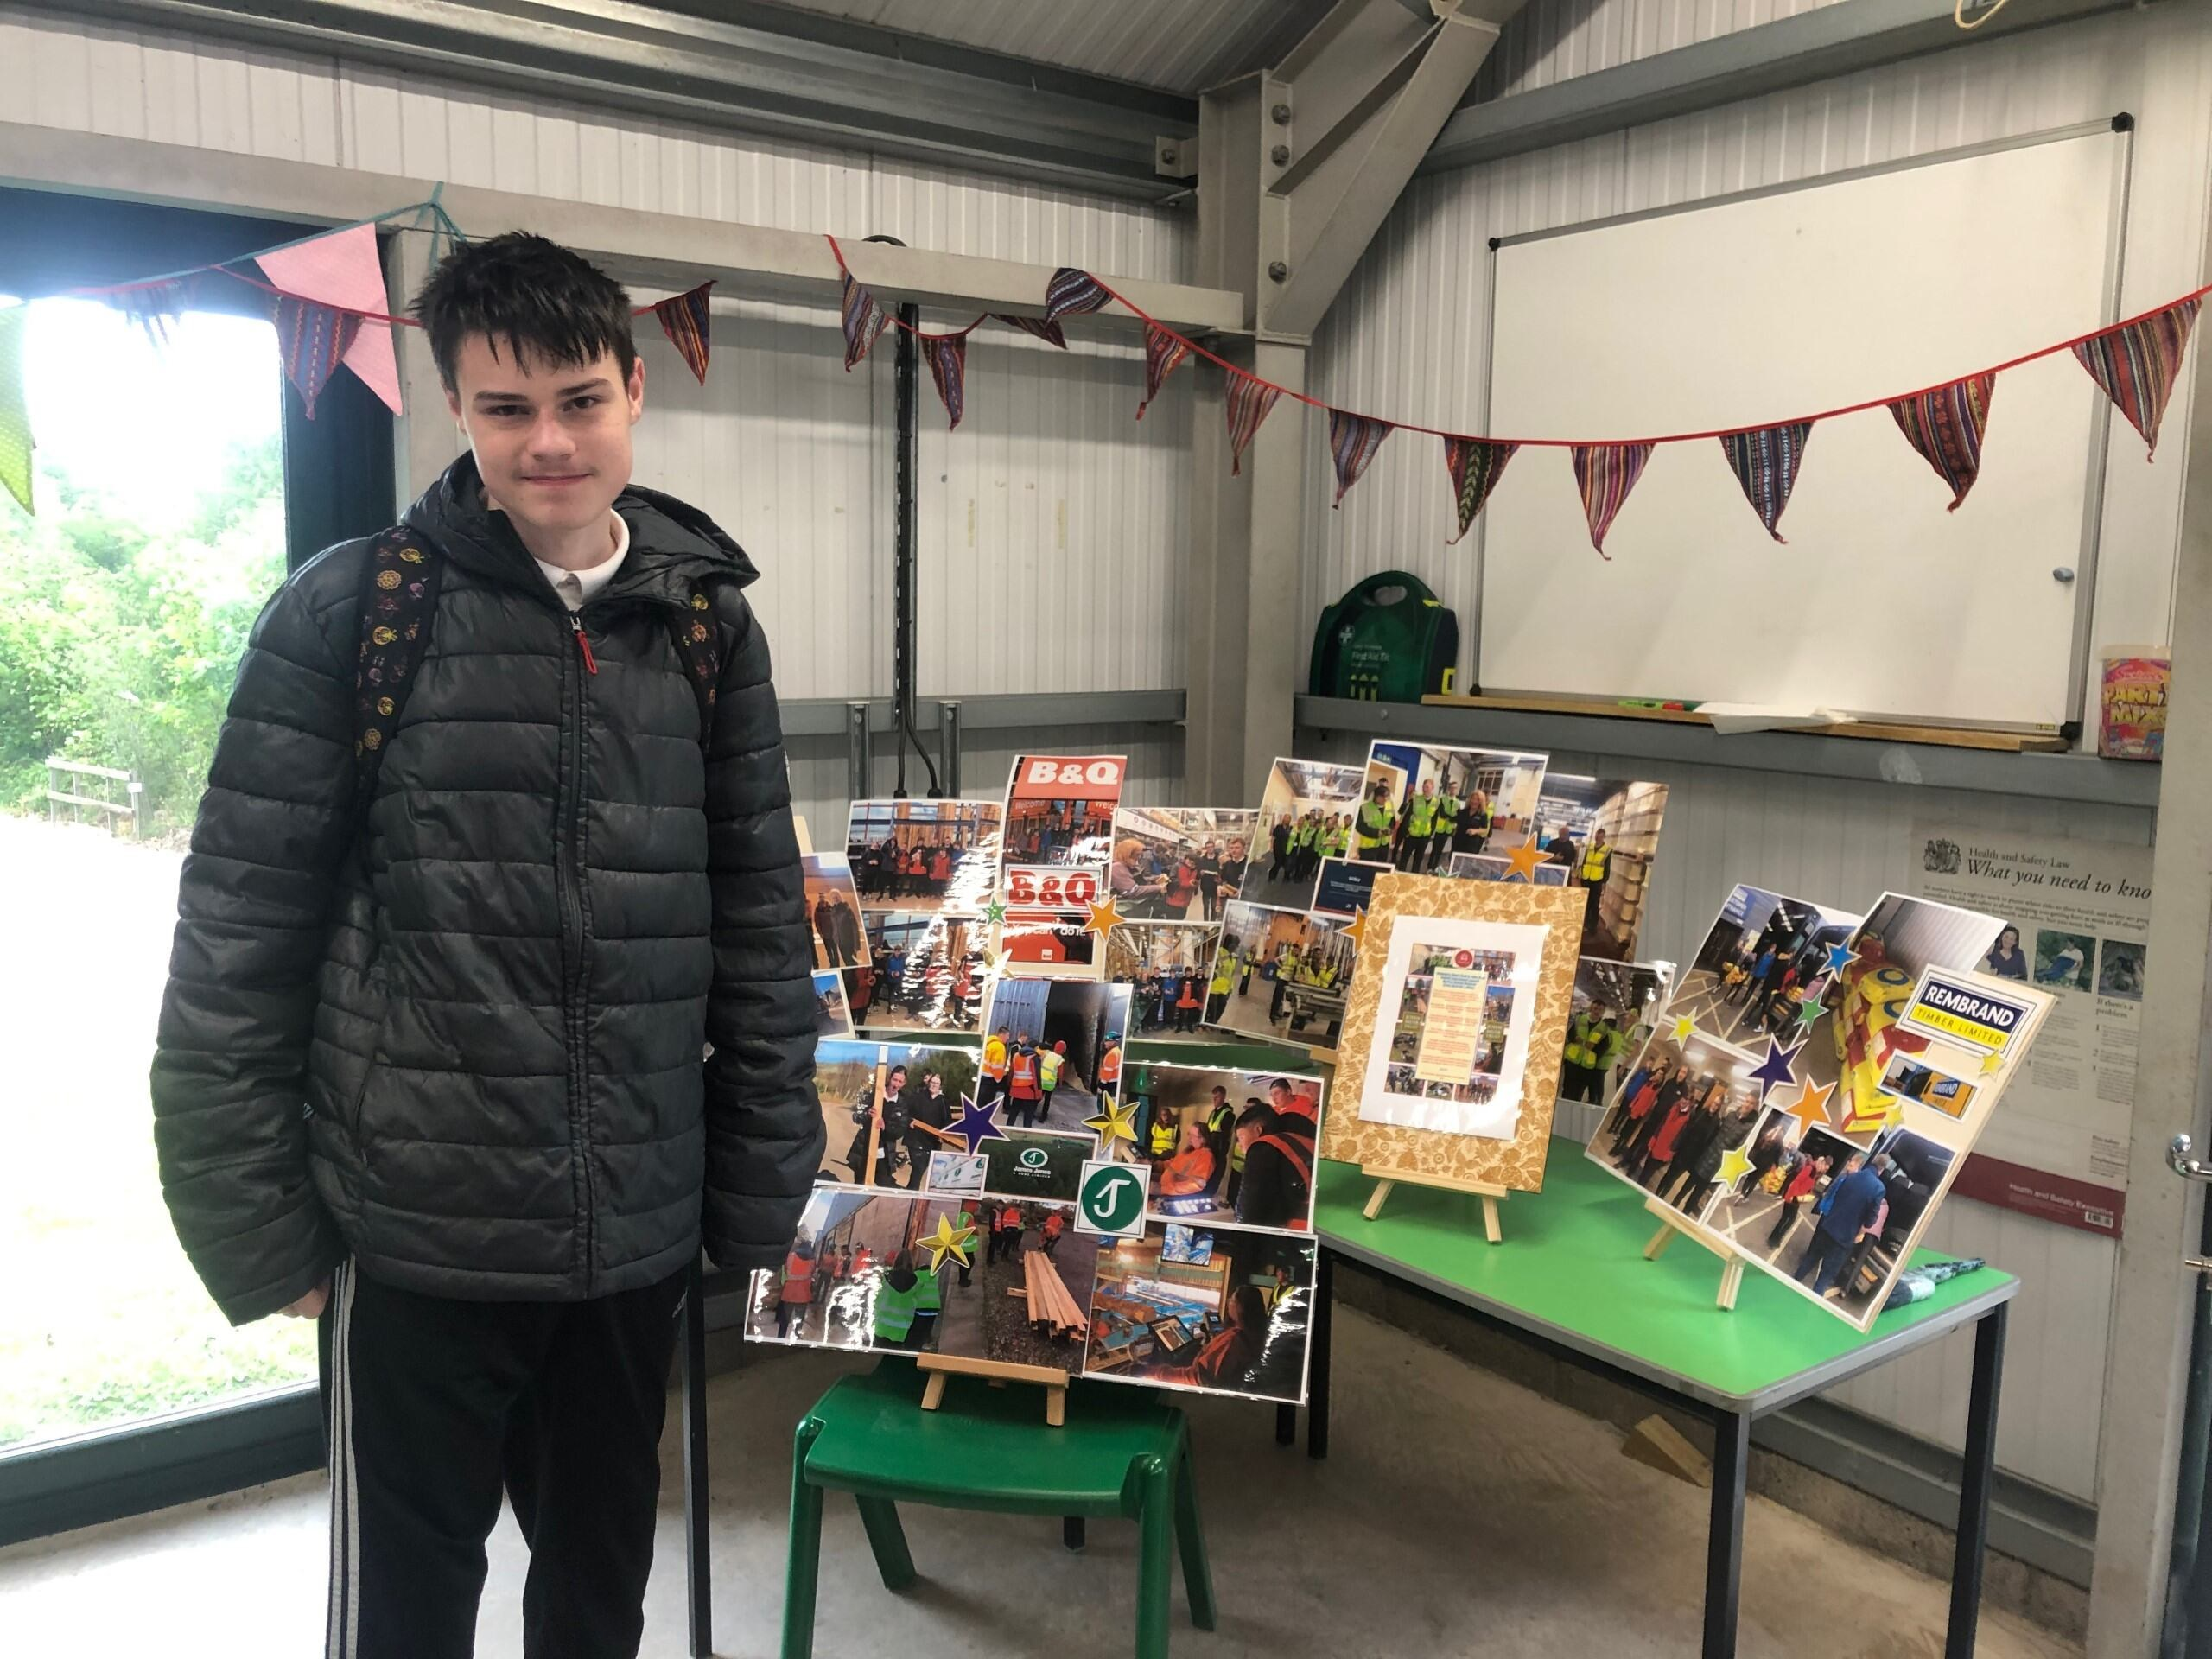
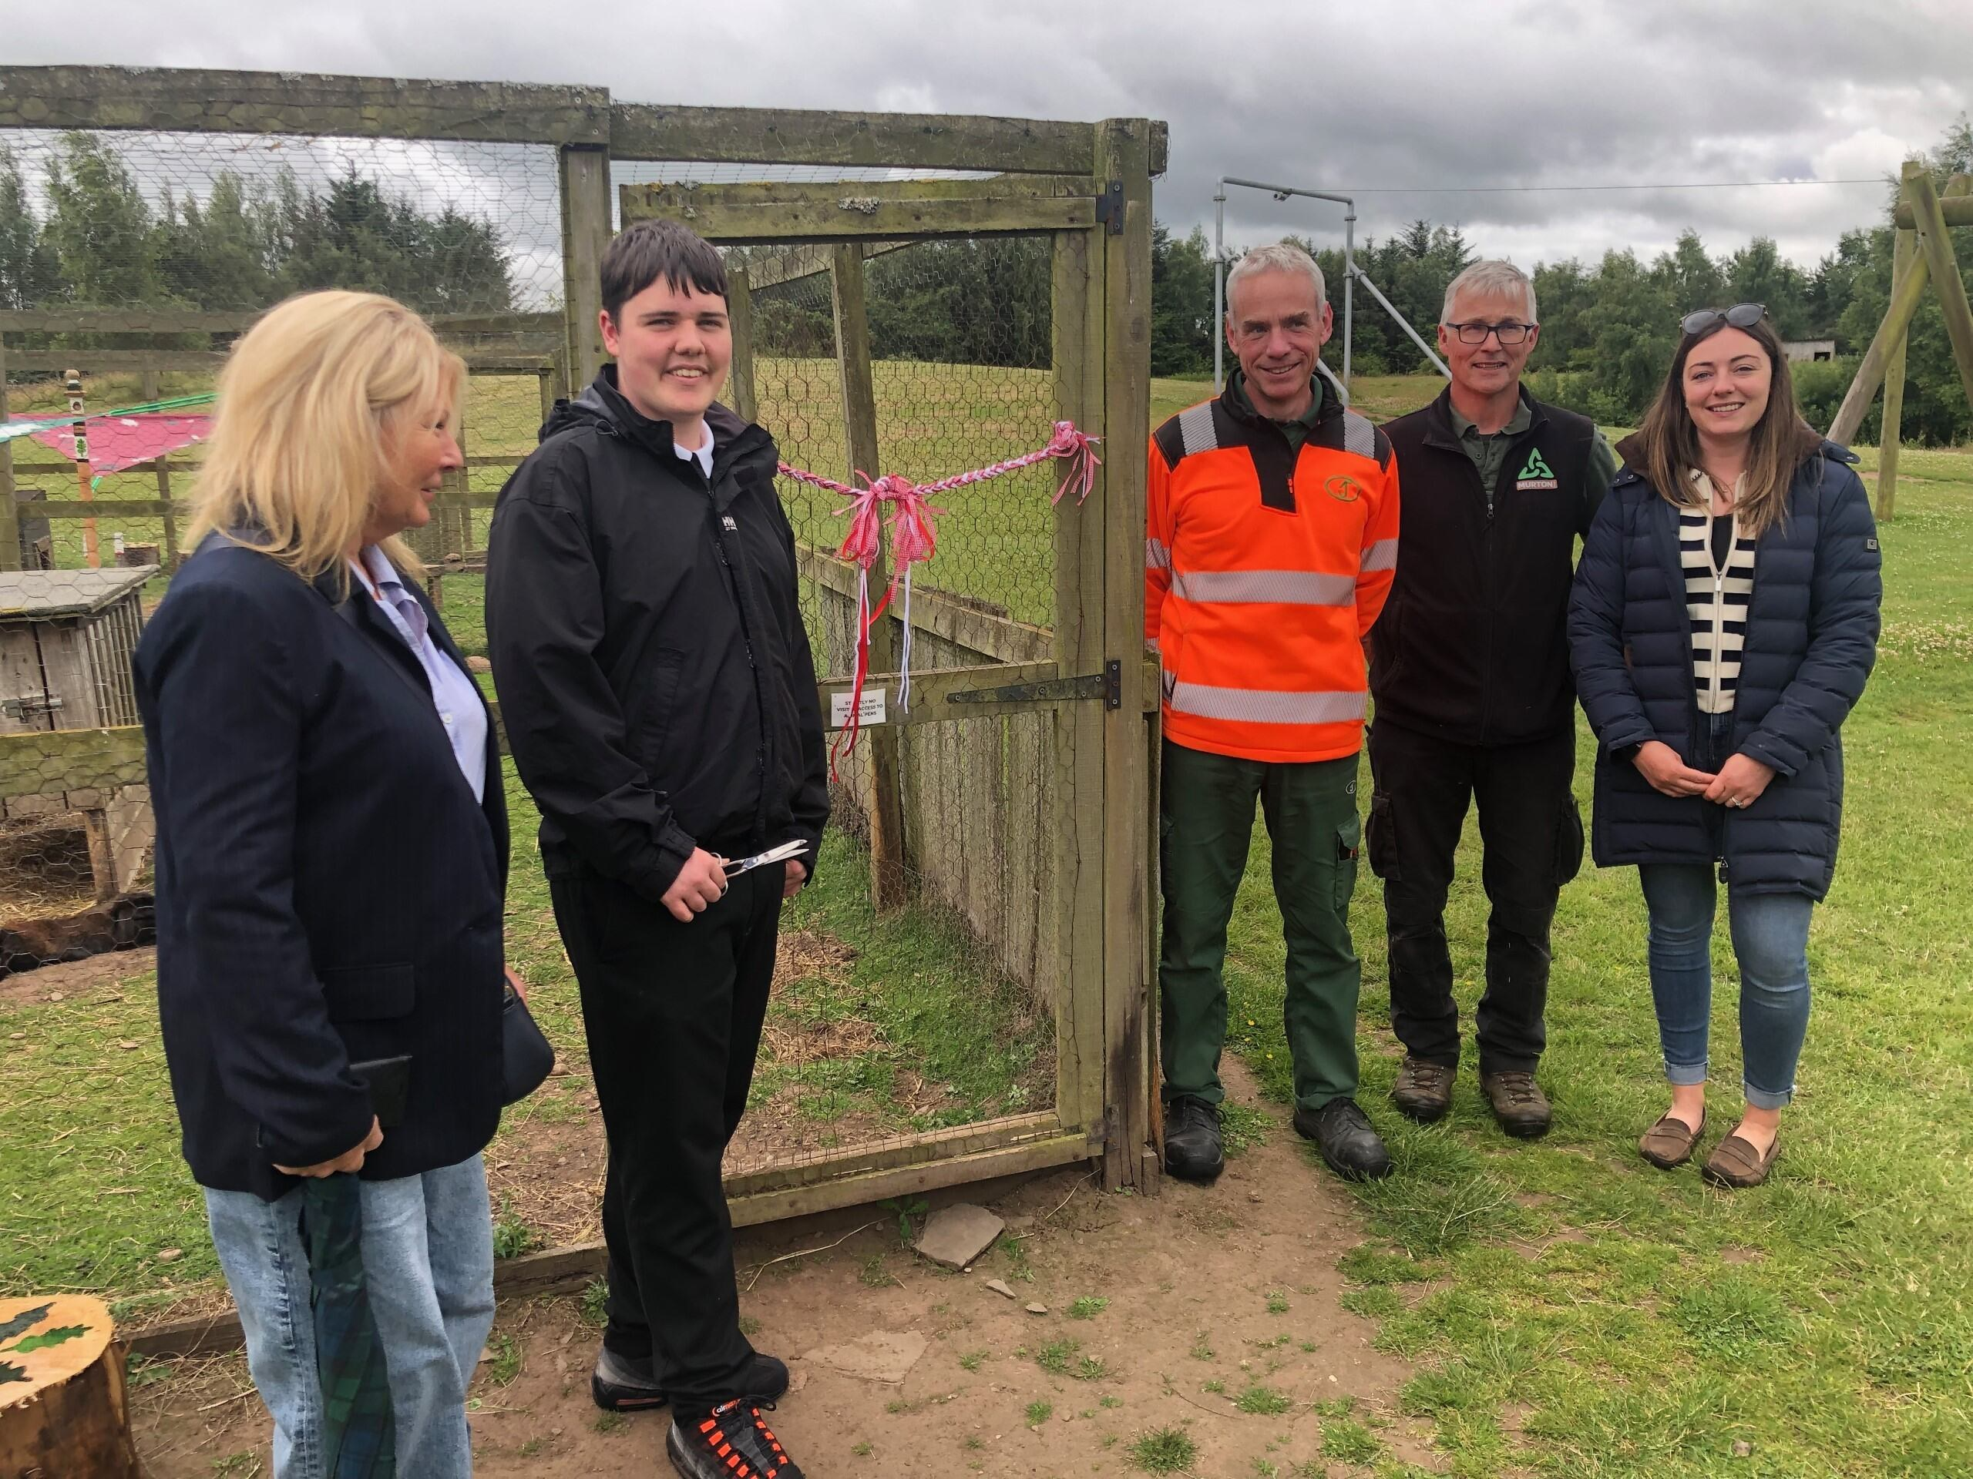
Trip to Edinburgh
The King's Trust Gang had another amazing couple of days away in Edinburgh for their end of year trip. They started off their travels with a stop in Kinross to make a donation to Rachel House, then off to Edinburgh Castle with lunch in the dungeons!
After a trip to 'World of Illusions' they all had a good luck rub of Greyfriars Bobby's nose, followed by a tour of the graveyard to spot the Harry Potter characters. Then off to the National Museum of Scotland which was filled with artefacts, dinosaurs and animals galore!
A few pennies had to be spent at the Lego Store followed by a wonderful meal at our hotel.
Our final day was spent at Edinburgh Zoo where pupils were able to handle a cockroach, snake, armadillo, giant snail and a human cranium - not for the faint hearted!
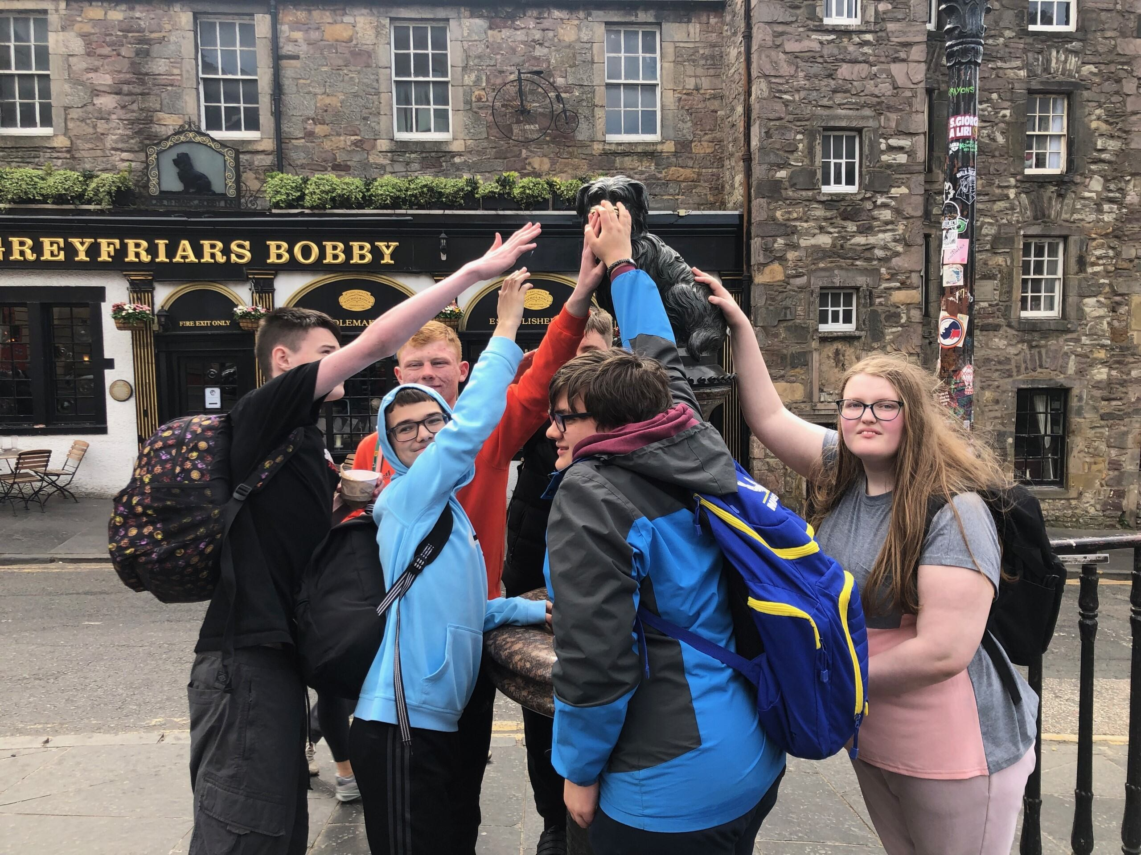
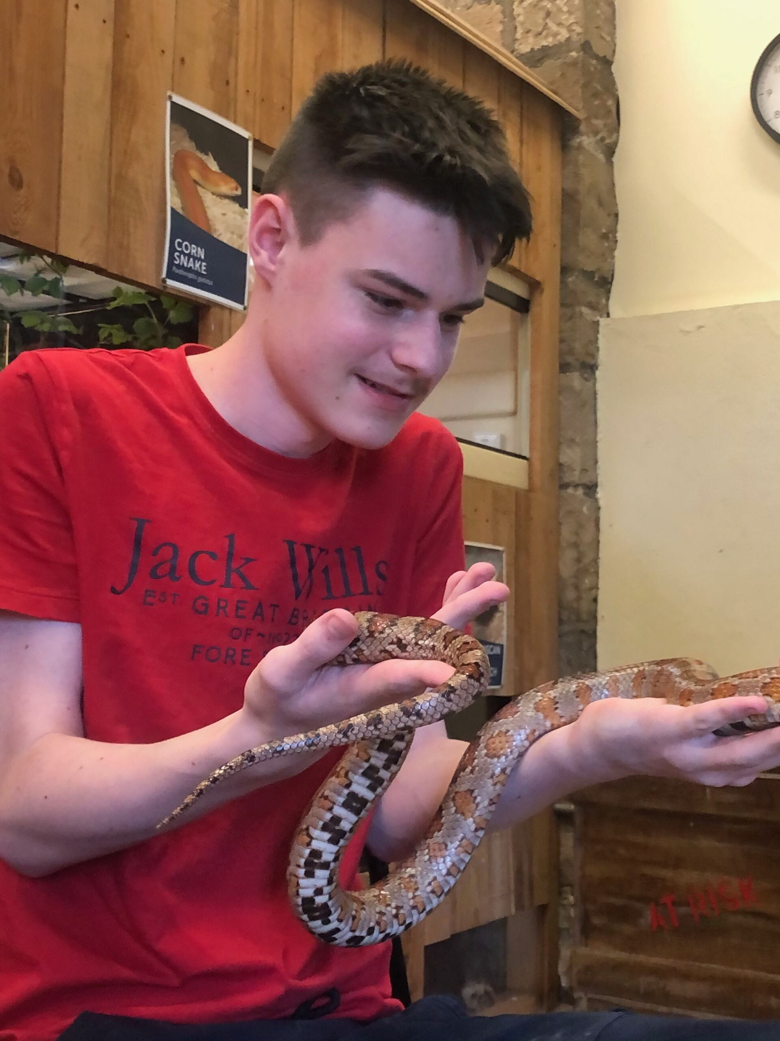
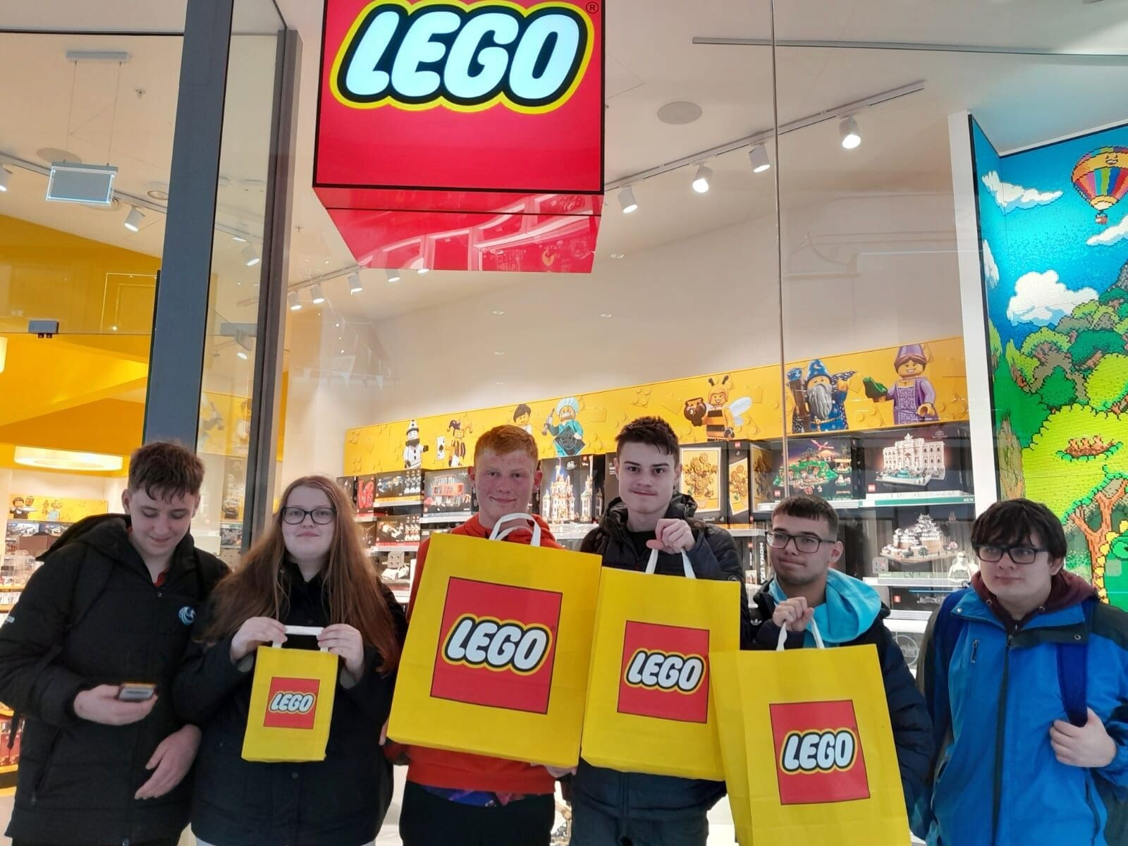

Some of our charity work...
Interact Club
Our dedicated pupils from the Interact Club have been working hard to raise money for charity throughout this academic session. After a successful first term raising over £300 for their chosen global charity, My Name’5 Doddie Foundation, the Interact team then focused their fundraising efforts on their chosen local charity, Roxburghe House. As Jennifer Downie, our Business Manager for many years, was cared for at Roxburghe House, it is a particularly close cause to the heart of our school community.
The Interact Club organised a bingo and raffle event in April, which raised £1,370.91 for Roxburghe House. The event was a sell-out with over 100 bingo tickets sold to teachers, parents and pupils, reflecting how much Jennifer meant to the school. Thank you to everyone who supported the event in various ways. Businesses across Dundee and Kirriemuir generously donated fabulous prizes and Interact are so grateful to all these businesses for their amazing support.
During a visit from representatives of Roxburghe House, the pupils has the opportunity to present the cheque and hear more about the impact that the funds raised will have. It was hugely encouraging to learn about how Interact’s efforts will make a real difference to people’s lives. In addition to the bingo event, Interact pupils ran a stall at the summer fair, which has brought the total to over £1428!
Webster’s High School Interact Club is looking forward to continuing to make a positive difference in their local community and around the world. The Interact pupils are wonderful ambassadors for the school. It is heart-warming to know such brilliant young people who want to make a difference, personifying the school values of Kindness, Ambition and Appreciation and Respect. We welcome more pupils to join Interact, particularly if they are seeking new leadership opportunities in the senior phase.
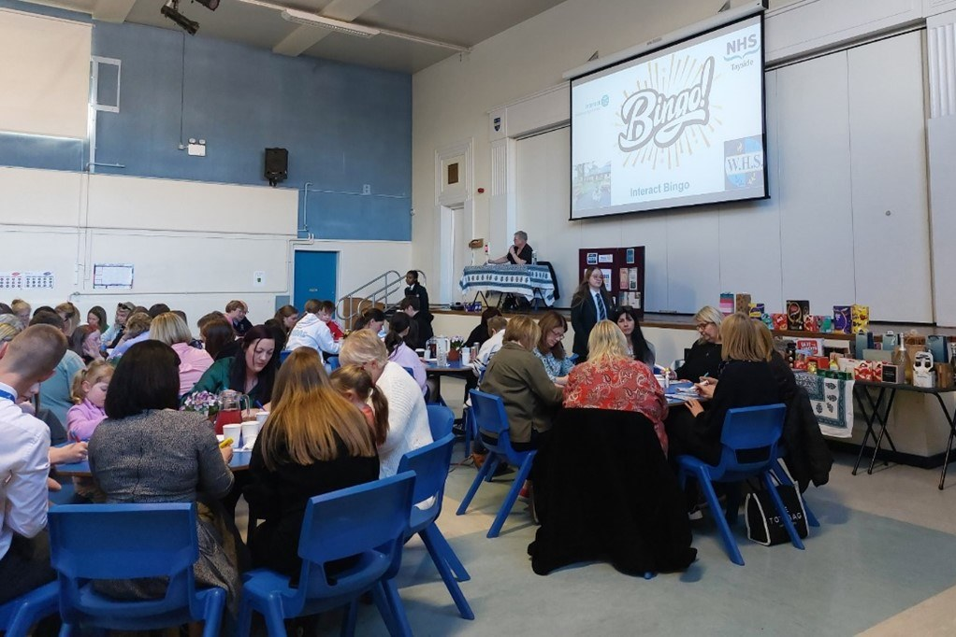
The Interact Club organised a bingo and raffle event in April, which raised £1,370.91 for Roxburghe House. The event was a sell-out with over 100 bingo tickets sold to teachers, parents and pupils, reflecting how much Jennifer meant to the school. Thank you to everyone who supported the event in various ways. Businesses across Dundee and Kirriemuir generously donated fabulous prizes and Interact are so grateful to all these businesses for their amazing support.
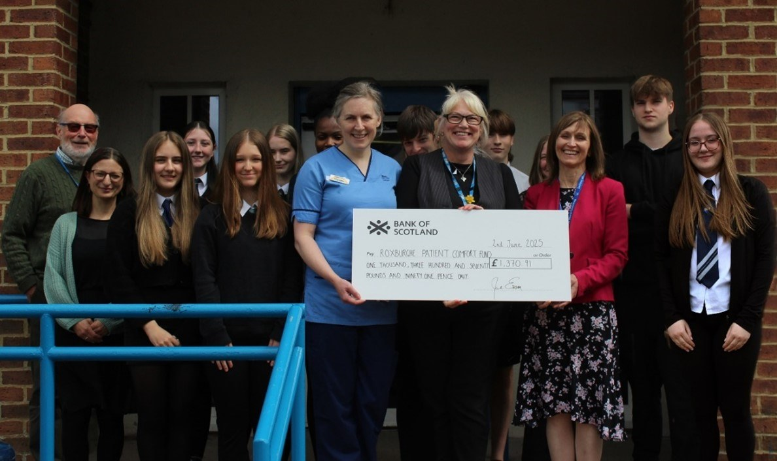
During a visit from representatives of Roxburghe House, the pupils has the opportunity to present the cheque and hear more about the impact that the funds raised will have. It was hugely encouraging to learn about how Interact’s efforts will make a real difference to people’s lives. In addition to the bingo event, Interact pupils ran a stall at the summer fair, which has brought the total to over £1428!
Webster’s High School Interact Club is looking forward to continuing to make a positive difference in their local community and around the world. The Interact pupils are wonderful ambassadors for the school. It is heart-warming to know such brilliant young people who want to make a difference, personifying the school values of Kindness, Ambition and Appreciation and Respect. We welcome more pupils to join Interact, particularly if they are seeking new leadership opportunities in the senior phase.

Developing the Young Workforce
A year of wonderful links in the community have allowed the King's Trust & John Muir Pupils to visit many local business as part of their course work.
An amazing trip to Ladywell Sawmill allowed the students to see 12 posts being processed from tree trunks into the finished product. The sawmill kindly gifted the group the materials for a project at Murton Nature Reserve.
The group also visited Rembrand Builders Merchants who generously donated the 12 bags of Postcrete to secure the posts at the reserve.
JD Wilkie's invited the group to see how the commercial textile industry worked and how it has changed over the years. We had a wonderful tour of the factory's museum also, looking at all the old looms, stencils and fibers. We left armed with bespoke sails which the company gifted the group for their animal enclosures at Murton.
Angus Biofuels gave the group a marvellous tour of their site at Padanaram and Tony worked his magic with slicing giant logs for rabbit jumps which the pupils decorated.
The Deputy Manager of B&Q Dundee gave the pupils a tour of the store and gifted them significant materials for their community project also.
With all the materials generously gifted, the work continued back at school - what a lucky bunch to have had so much support - a HUGE thank you to all involved!
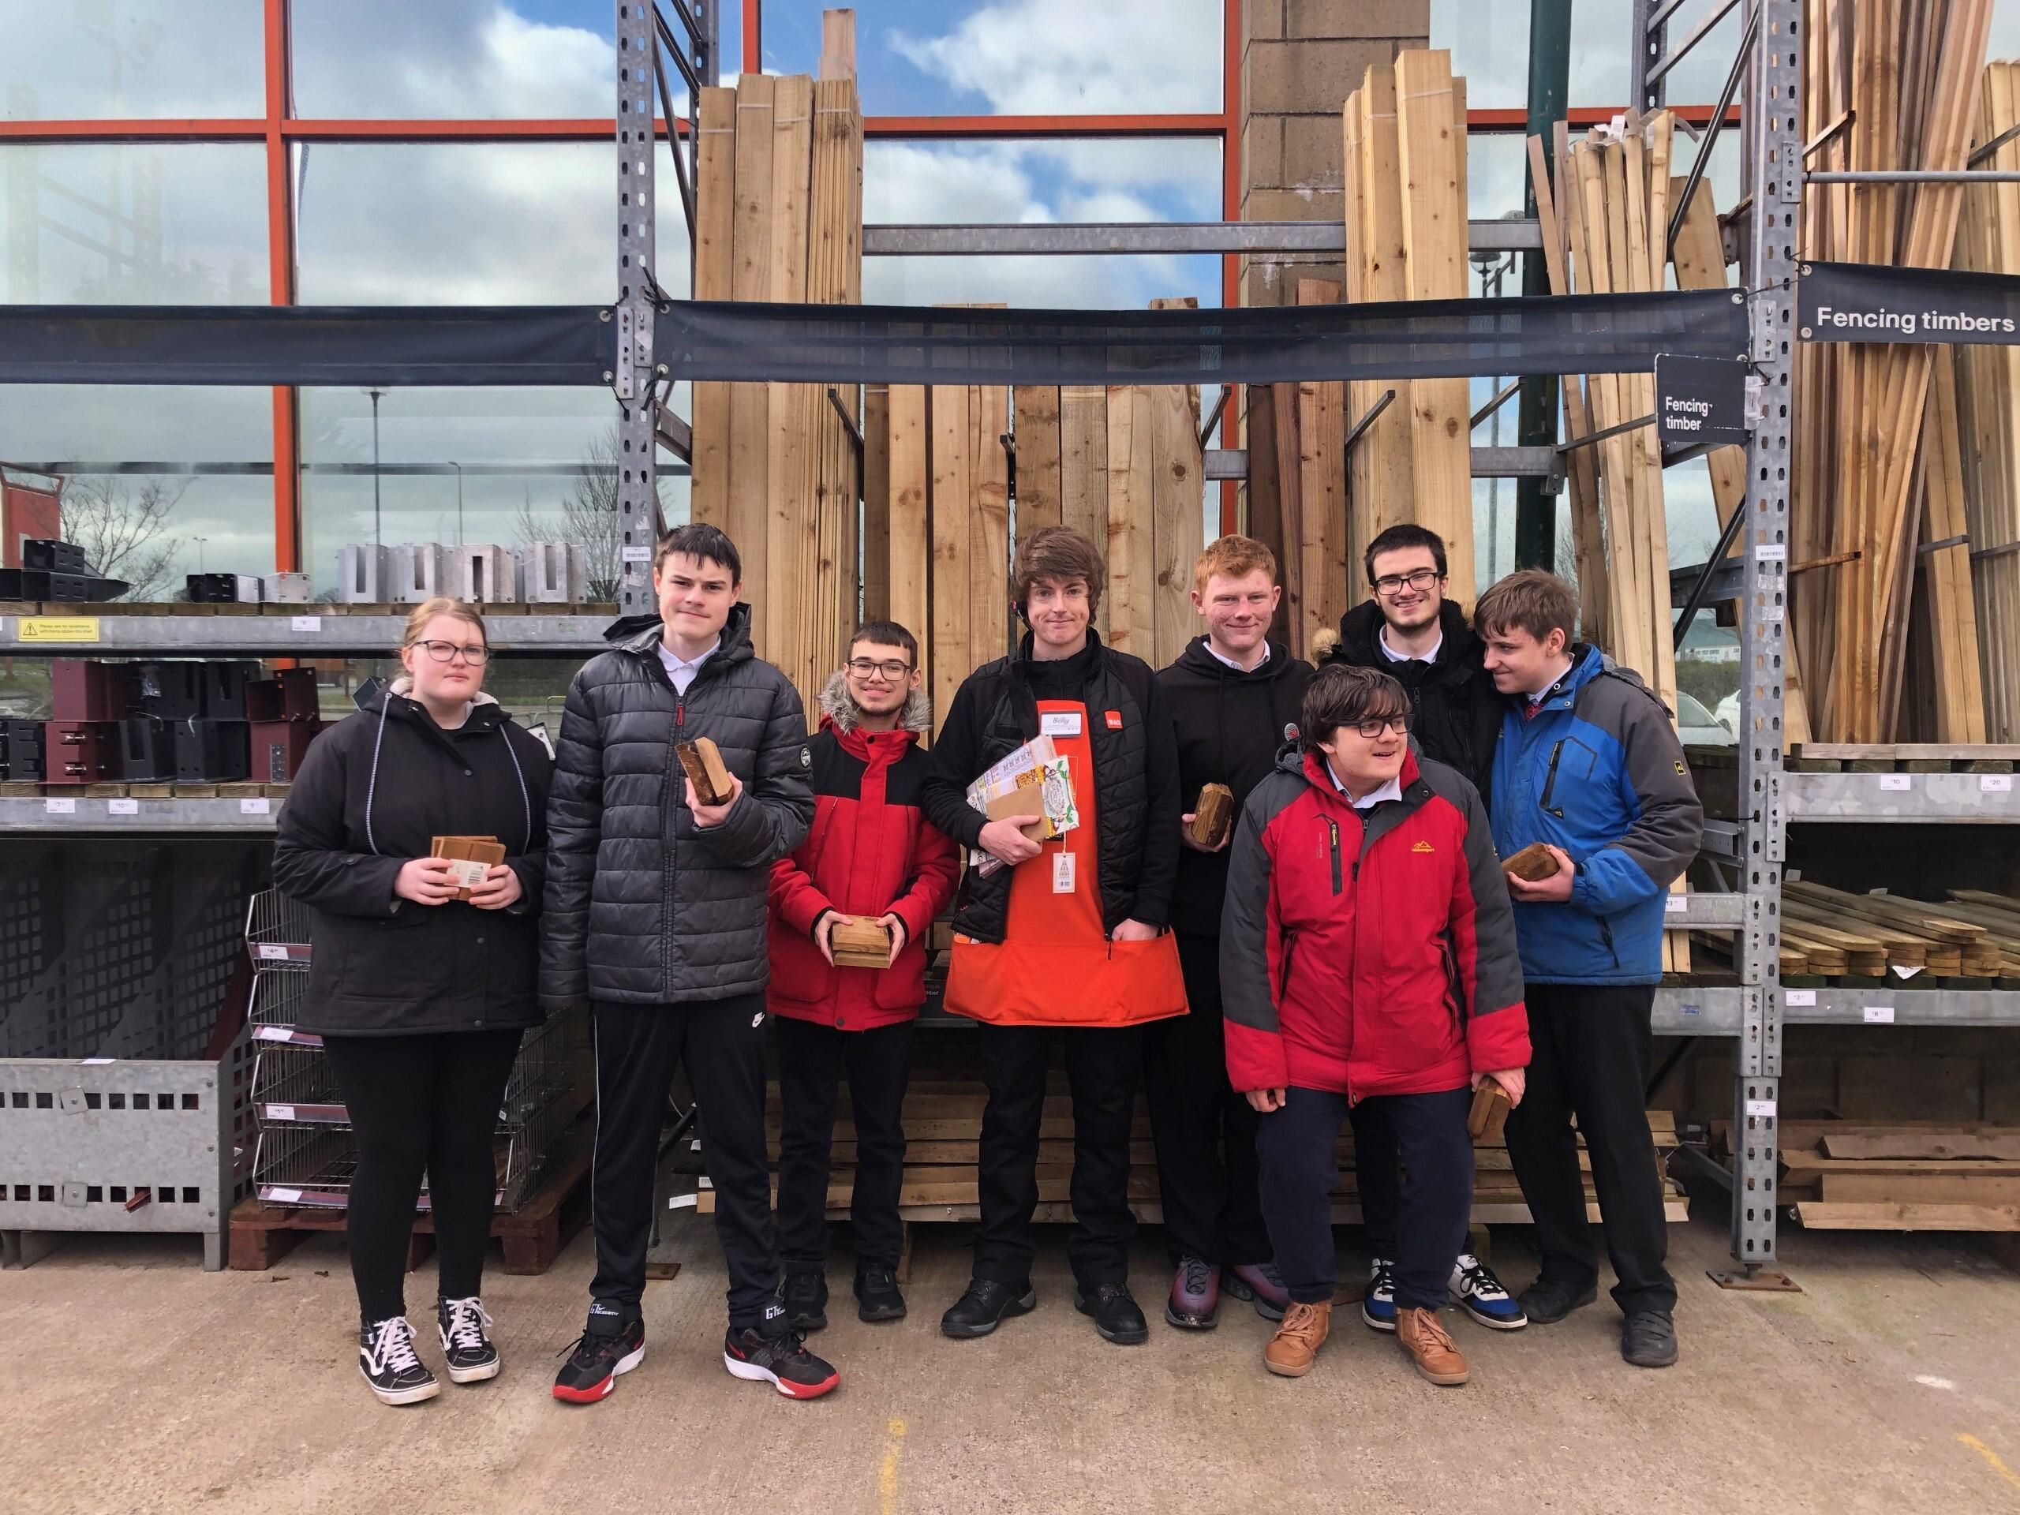
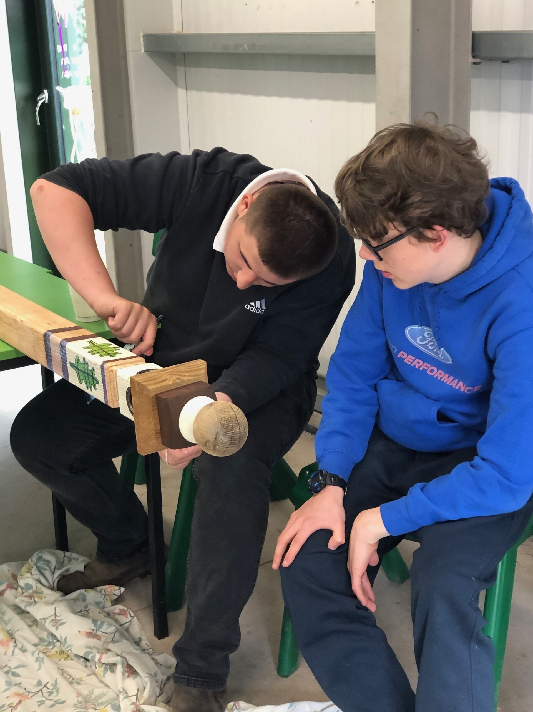
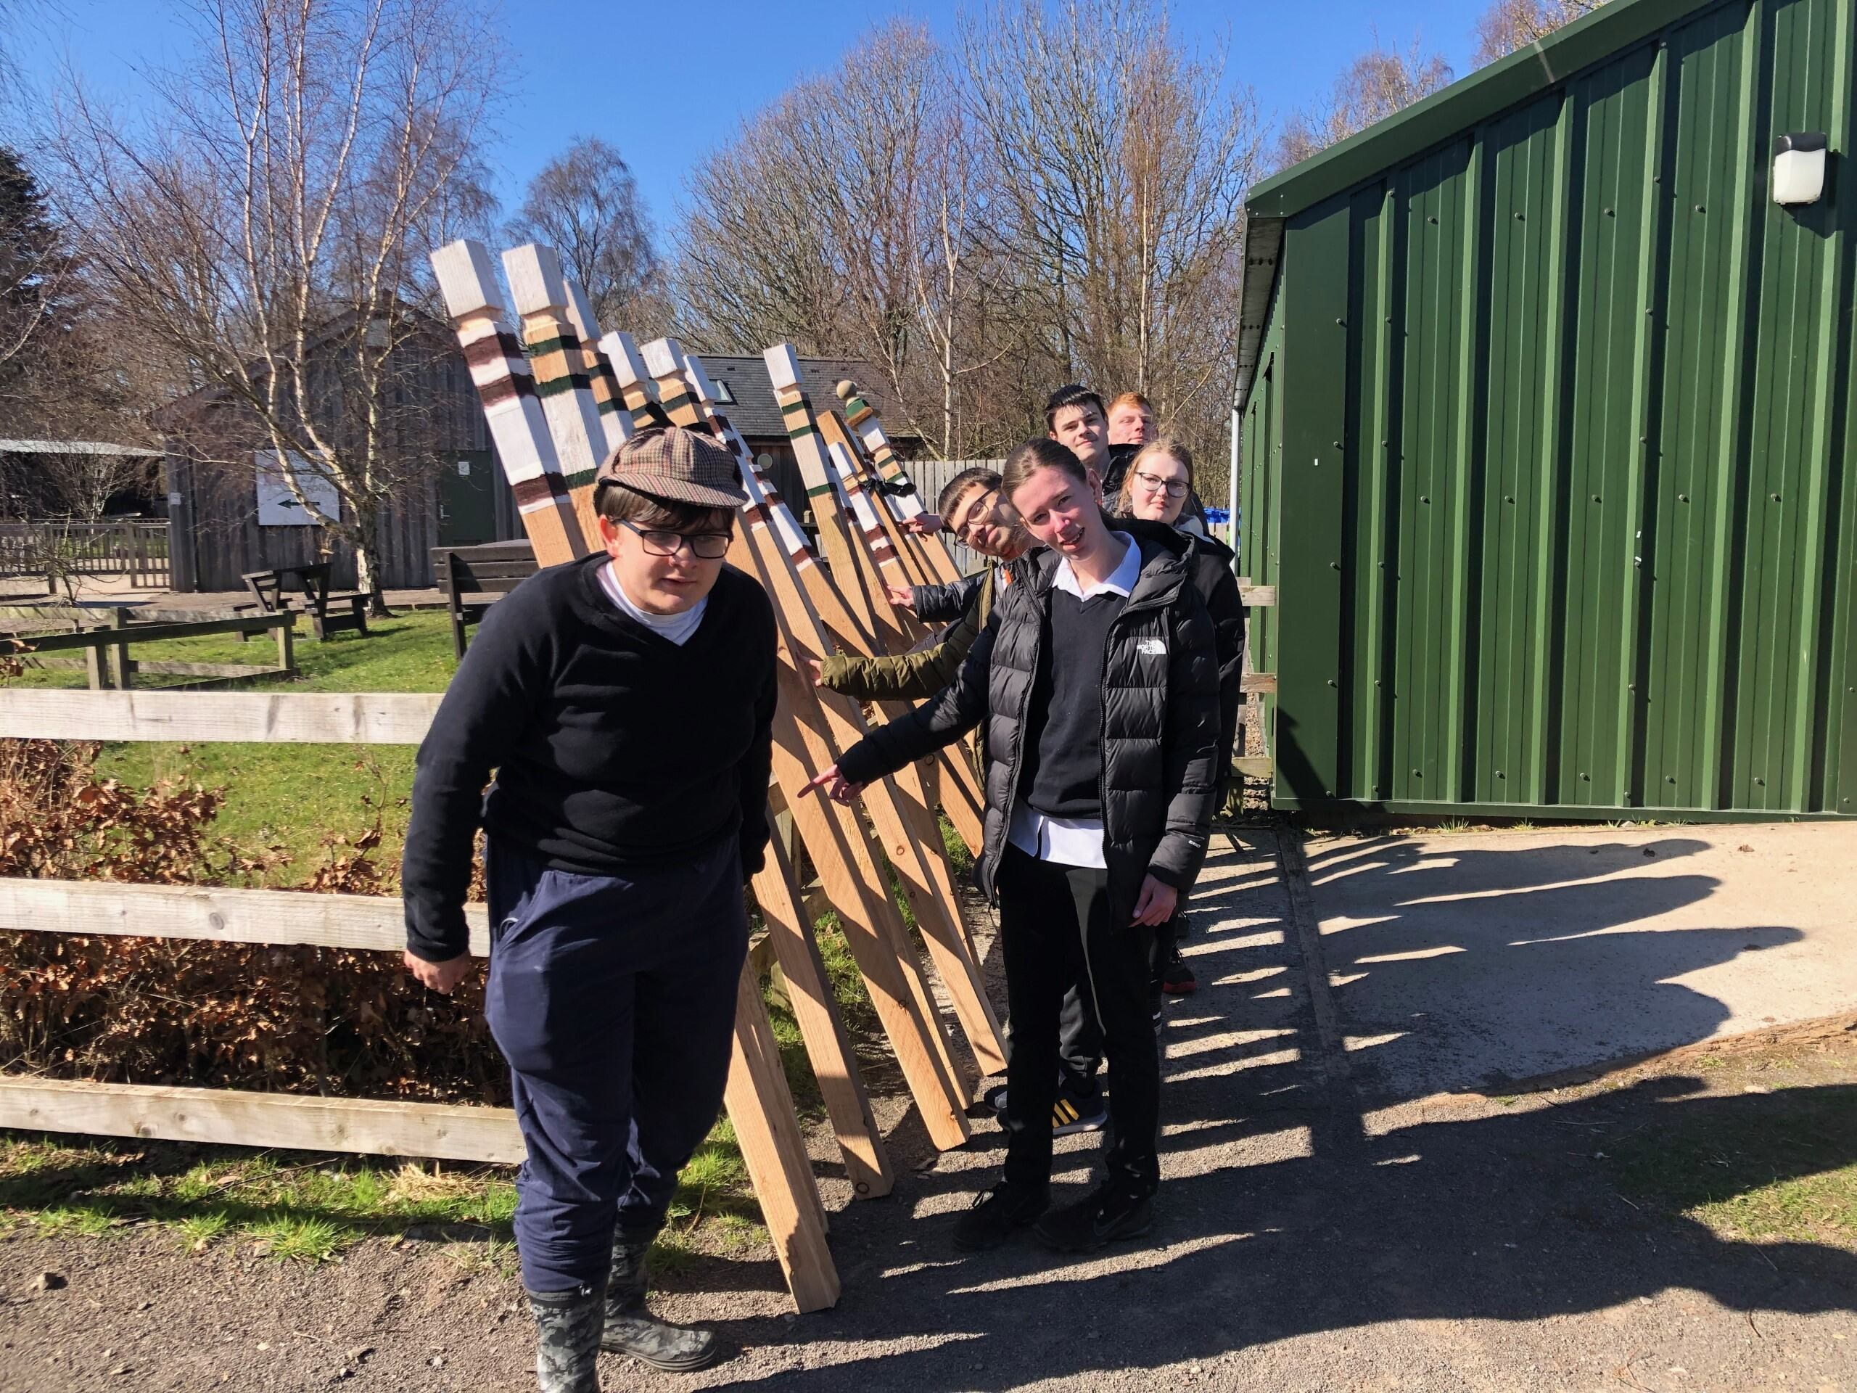

Celebrating Achievement
Article 29: Education must develop every child’s personality, talents and abilities to the full. It must encourage the child’s respect for human rights, as well as respect for their parents, their own and other cultures, and the environment.
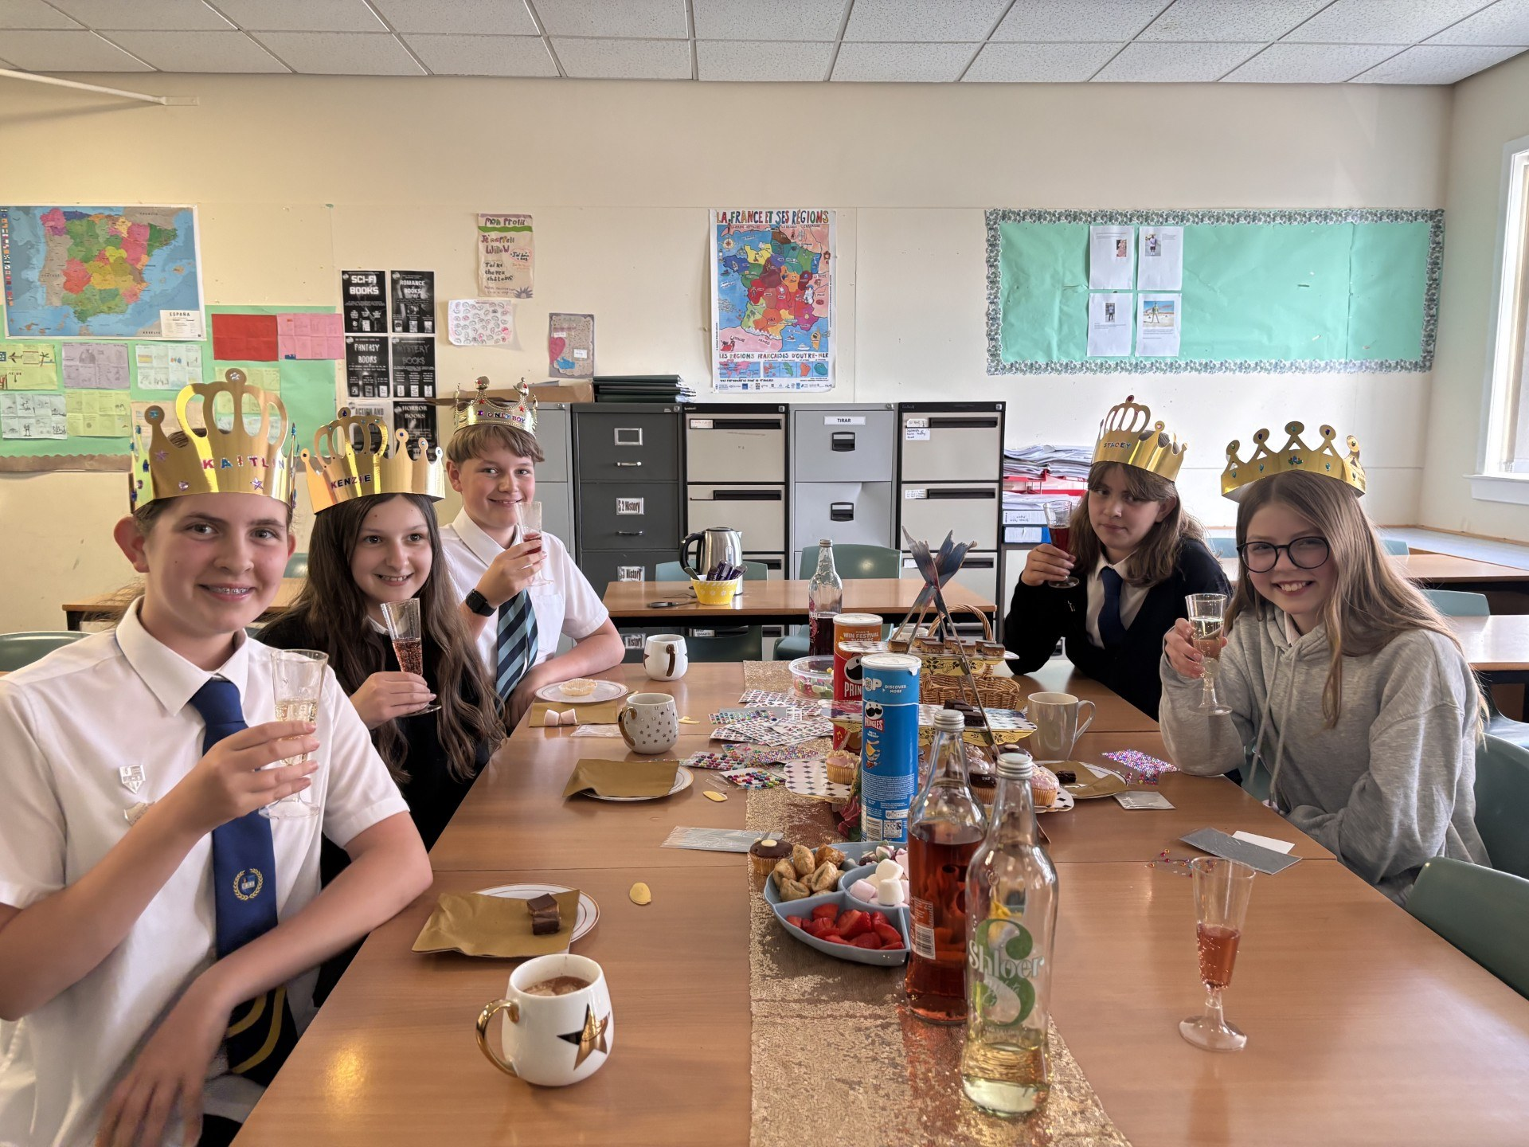
Gold Reading Award
Five of our pupils, Stacey Donald , Kaitlin Donald, Harris Ogilvie, Lottie Rook, McKenzie Wilson, enjoyed a tea pary with Mrs McRae, Head of Languages, after achieving their Gold Reading Award.

Sports' Award
The 10th Webster’s High School Sports Awards took place on Thursday 12th June and we were delighted to be sponsored by Colin M Smith and Thrums Vets, to celebrate the achievements of pupils and the amazing contribution of volunteers and community clubs on sport in the school.
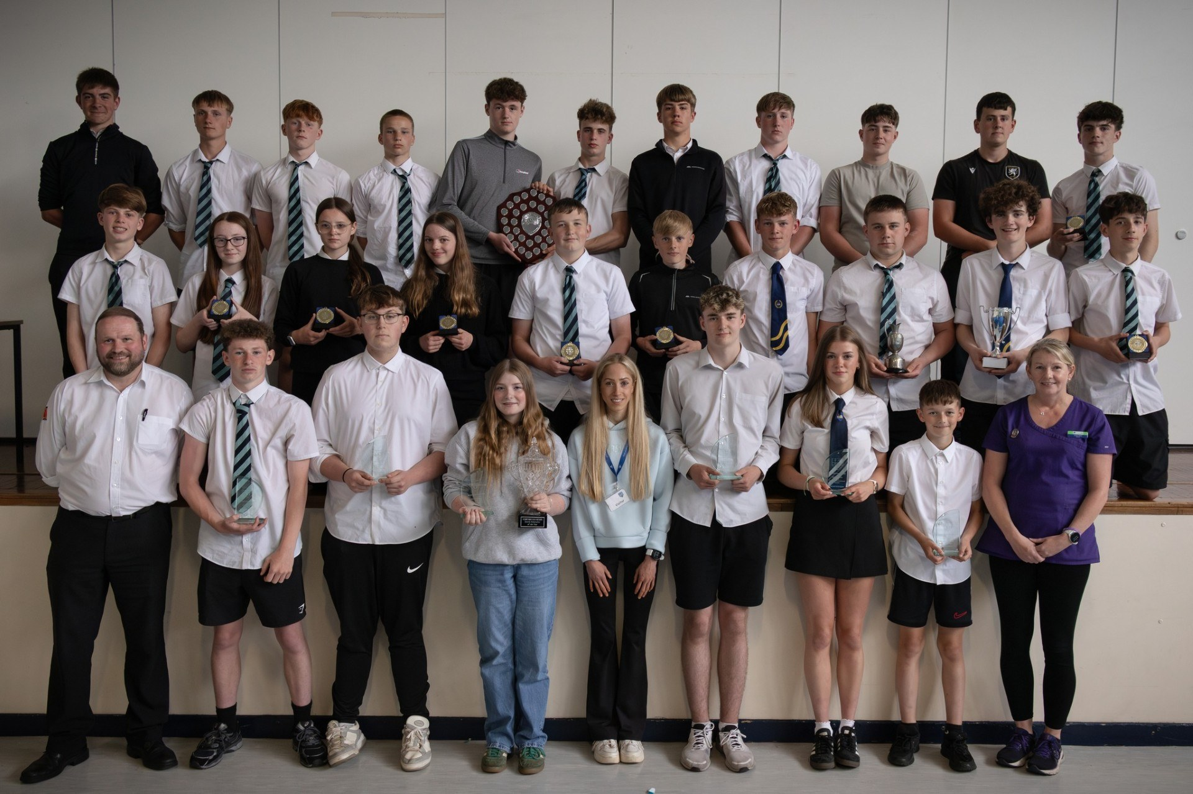
It was great to have former pupil, winner and current U20 European half marathon record holder Natasha Phillips as our guest speaker. She spoke so well about her sporting career even at such a young age and what she wants to work towards, which in the short term is getting to Glasgow 2026 Commonwealth Games, and I am pretty sure she will as well as go beyond that too.
Ashley Wilkie (Thrums Vets) presented the Team of the Year to the S3 rugby team who over the course of the year were nearly undefeated, a solitary defeat to Lathallan the day before the awards. An amazing achievement and a strong group of players. Ashley also presented the Volunteer of the Year award to three senior boys who have helped with the S1 football throughout the year.
Jonathan Smith (Colin M Smith) presented the Young Volunteer of the Year award to a pupil who has helped with the Kirrie Cluster Running Club throughout the school year, encouraging and supporting many young runners. Jonathan also presented the Lifetime Achievement Award to two pupils who have just left school, but have had such a sporting time at Webster’s, from competing in various sports and volunteering so much of their time to deliver, support and organise events at Webster’s and the cluster primary schools.
Our Sports Personality of the Year went to Heather Wilson who has done so well in her mountain biking this year. She was sitting in pole position for a large part of the season and if it was for an injury she would have likely gone onto to win the World Junior Championship. This will be her final year as a junior before progressing to the Elite competition.
A huge well done to all the winners and thank you so much to Colin M Smiths and Thrums Vets for their very kind and amazing support of the events.
Thank you to all the pupils at Webster’s for being part of school sport and making attendance at clubs and event such a positive experience for all involved.
Final thanks go to the staff at Webster’s who support school sport so much, those that deliver the school clubs do a fantastic job and just want to see kids involved and do the best that they can.
Thank you all once again and well done to everyone.
Saltire Summit Award Winners
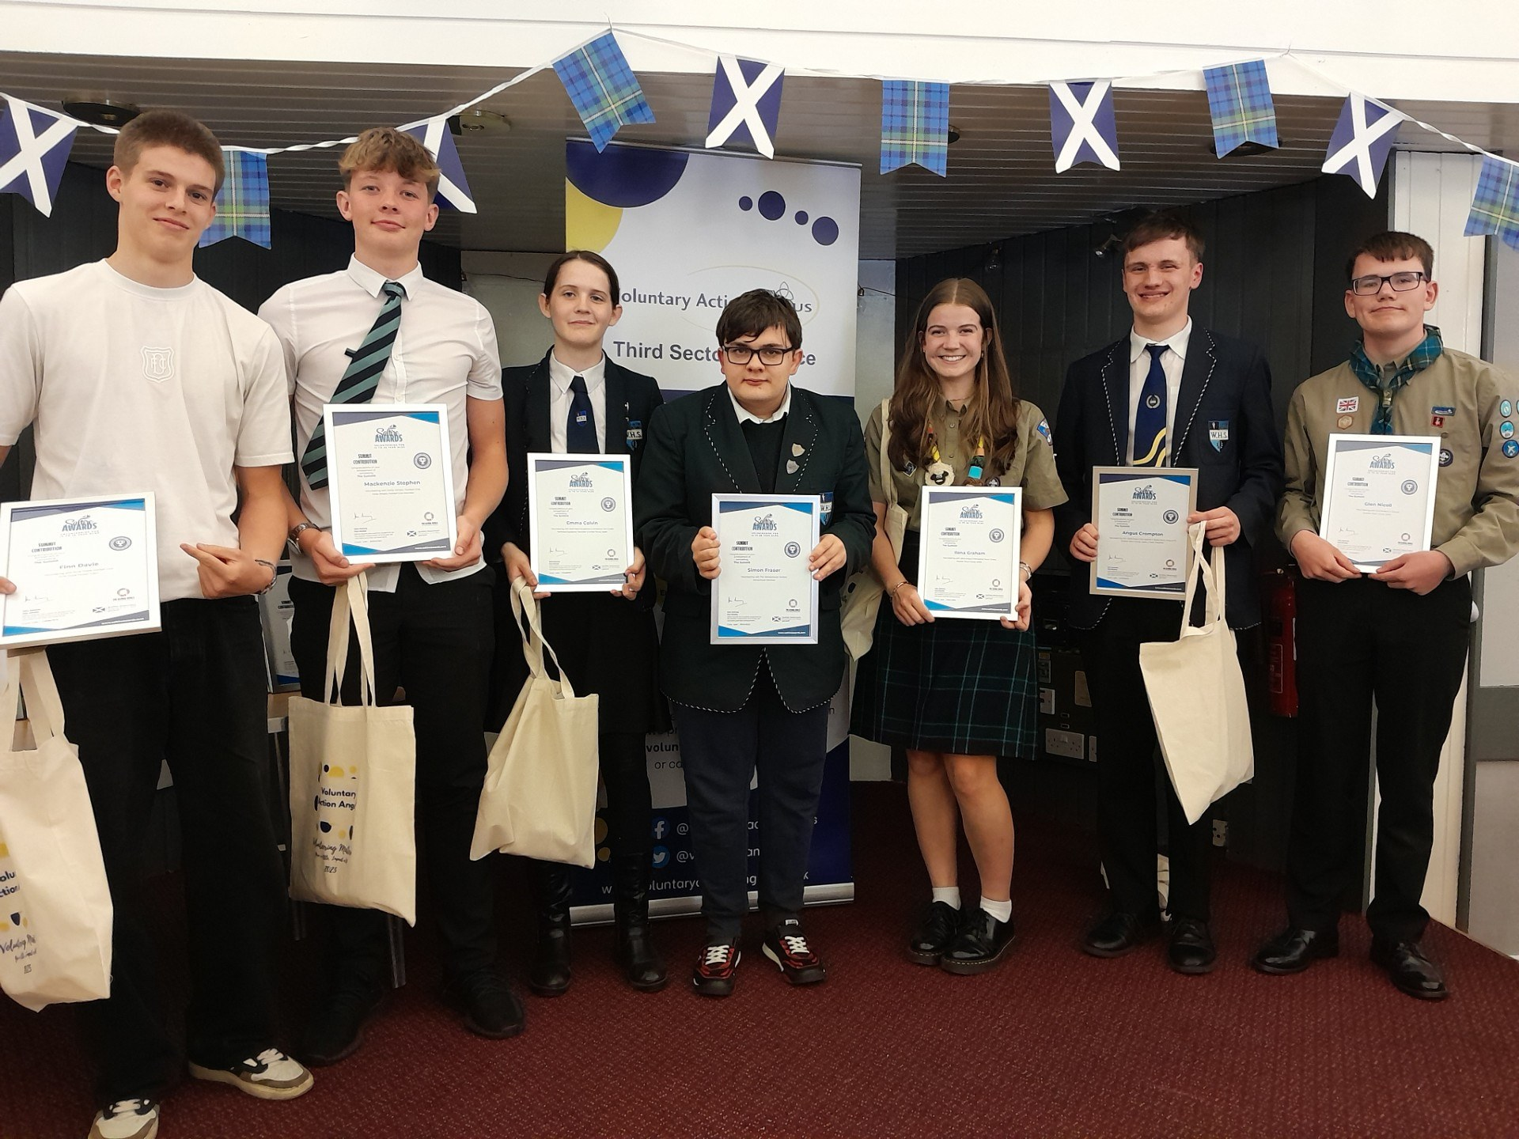
We are delighted to share that ten of our pupils were awarded Saltire Summit Awards in volunteering. After achieving their 200hour Saltire Award, pupils have to be nominated for the Summit Award and the nominations go before a panel. Our young people have done amazingly well. A truly selfless achievement, they are a credit to our school, their families and especially themselves
Prizegiving 2025 – Annual Celebration of Achievement
Webster’s High School proudly held its annual Prizegiving Ceremony on 17th June, celebrating the outstanding achievements, effort, and dedication of our pupils across all year groups. The event was a wonderful opportunity to recognise academic success, sporting endeavours, personal growth, community involvement, and excellence in wider achievement, with awards presented in a variety of subject areas and special categories.
Highlights included performances by our talented musicians’ students, a wonderful speech from both our head teacher Mrs Esson and our outgoing school Captain Rachel Leslie.
Congratulations to all of our award winners – we are incredibly proud of you and the hard work you've put in this year. A huge thank you also goes to our staff, families, and community partners for their continued support in helping our young people thrive. We would also like to thank our Parent Voice group and Angus Glen's Rotary for providing tea and coffee as well as the Angus Glen's Barista for opening and selling a fab range of hot and cold drinks..

House Award Assemblies – Celebrating Success Across Webster’s
During the week beginning Monday 23rd June, Webster’s High School hosted our annual House Award Assemblies, recognising the outstanding efforts, contributions, and achievements of our pupils across the school community.
Pupils were presented with Academic Merits and Diligence Certificates, recognising consistent hard work and commitment throughout the year. Merit Badges, Achievement Ties, and School Colour Awards celebrated those who have gone above and beyond in their studies, leadership, or participation sports or wider school and community events.
We were also proud to acknowledge pupils' contributions to the Youth and Philanthropy Initiative (YPI), as well as wider achievements such as Saltire Awards and other community-based recognitions.
A huge well done to all pupils who received awards – your dedication and involvement make our school community stronger every day. We are proud of each and every one of you!

Parent Voice
Our parent voice group have been busy this year!
They worked with Southmuir Primary to organise the Christmas fair and the summer fair, both of which were a great success. At the recent summer fair, £2000 approx. was raised to be split between both schools.
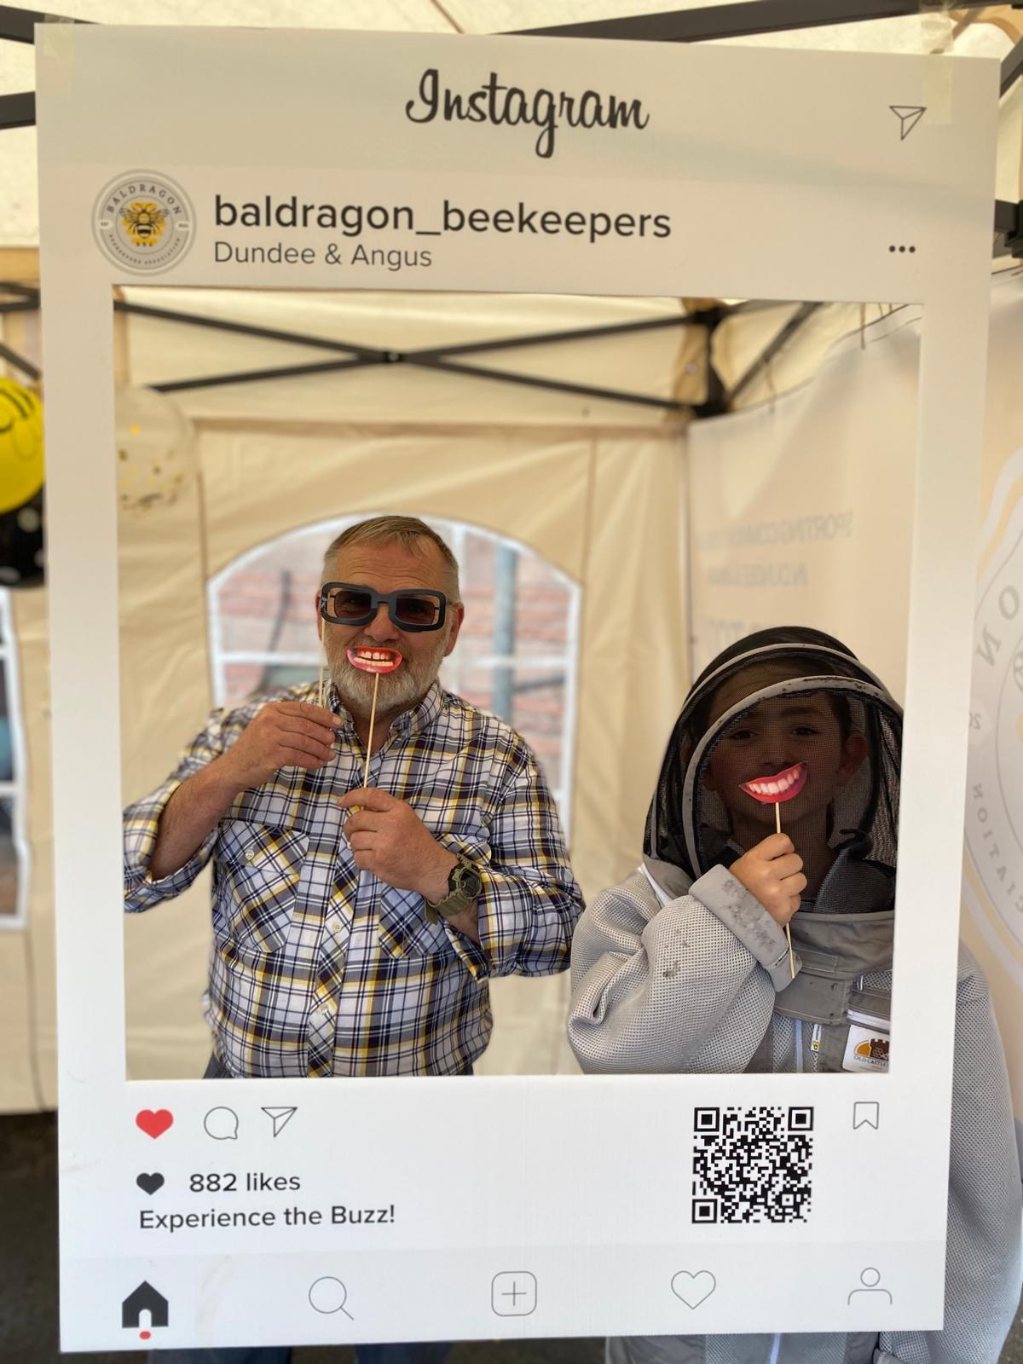
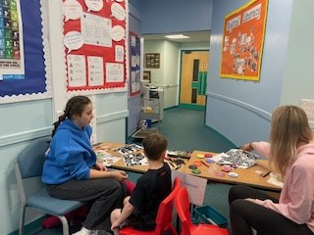
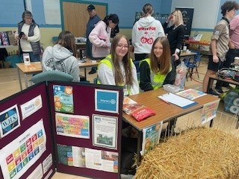
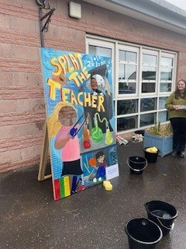
In addition to this, our Parent voice paid for the Soft exam start to help ensure that pupils had eaten food and drank enough water/fruit juice prior to entering their exam. The Parent Voice have supported this for several years now and pupils really benefit from the provision of fruit, cereal bars, water and fruit juice before and during exams.
The group also worked with some of our staff to organise a prom outfit event. We would like to thank everyone who donated a prom dress or suit that young people could choose to wear to their S6 Prom. In addition to, helping reduce the cost of such events, it supports our work on the Sustainability goals.
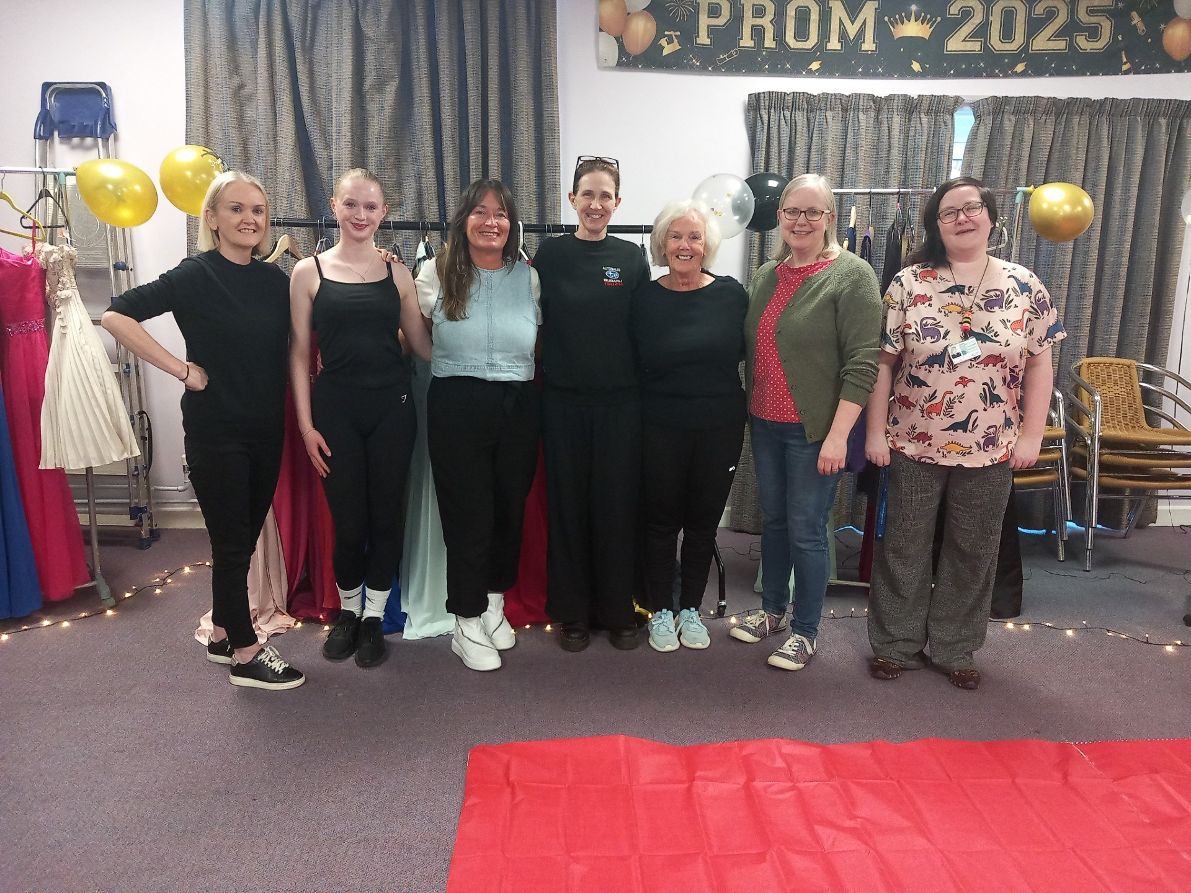
The Parent Voice group have also been involved in various discussions about qualifications on offer, school safety, use of mobile phones and our Standards and Qualities report. Please click the link to read our Report on our website: Webster's High School Kirriemuir - Home Page.
We thank the Parent voice group for their support and would like to invite everyone to join us in the new session. Meeting dates are sent out via Groupcall and the agenda items are set by yourselves. Meetings are very informal and their is always tea, coffee and snacks.

We look forward to seeing everyone in the new term.


